
Western Gateway Community
Trustees Annual Report
1/1/2025 to 31/12/25.

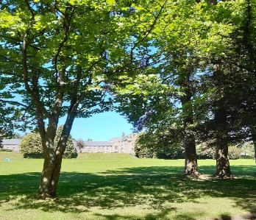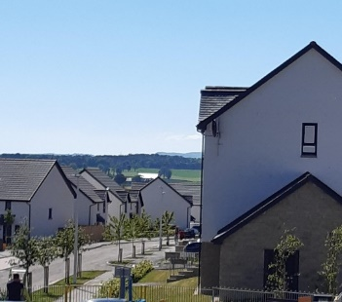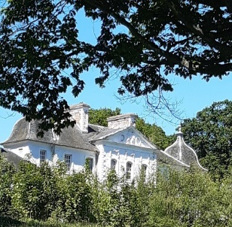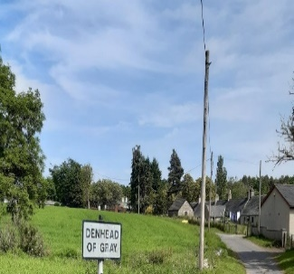

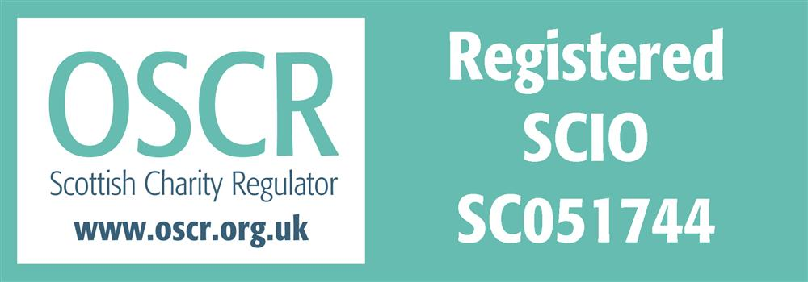

Charity contact information

Scottish Charity Number: SC051744
Address 47 High St, Dundee
Postcode DD2 3AU
Telephone number 07759992013
Email address billbat3@hotmail.com
Website: http://www.westerngateway.wixsite.com/community
Facebook : https://www.facebook.com/westerngatewaycommunity/

Charity Trustees
- Nicole Blues
- Simon Morgan
- Denny Reid
- Atholl Hutchison (Treasurer)
- Marc Prowe
- Sam Murphy
- W Batchelor (Chair).
- G Souter

Activities

We have had a busy year with some major projects being delivered, for example the new CP7 (Core Path 7) in April We also had some setbacks like the school area land sale and the continued delays on issues controlled by outside partners such as DCC (Dundee City Council) and Scottish Government. These of course have added to our workload with us continually having to chase and follow up.
This is our 6th year with our inaugural AGM happening back in October 2019 and by early next year we will reach a new milestone of 50 committee meetings.
Over the past 12 months our committee has met eight times and members have attended numerous other meetings involving groups such as: Paths for All, DCC, path contractors, the planning committee, Springfield, Barratt and Taylor Martin. Regular sub group meetings were also held for the CP7 build project and our community event. Behind the scenes we have been busy writing to various groups, particularly with follow ups on outstanding promises that they have made.
We have had a lot of support from our community. Many of you have attended our meetings and our direct emailing list has increased significantly over the year. Worth a mention is also the continuing growth in followers to our Facebook page which is now up to 1030 people. We continue to monitor our communities hopes and concerns through the various Facebook pages in our area and by listening and discussions issues with our neighbours. As for the wider audience, we have involved the press on a few occasions with local newspaper articles and contributed to discussions with other community groups.
There are currently nine members on our committee with 6 from D of G, 1 from WGP , 1 from Denhead of Gray and I staying in Invergowrie. Attending our meetings on a regular basis is also an officer from DCC’s neighbourhood services. Eight of the members are Trustees of our charity.

Key areas in 2025
Core Path 7 :
The upgrade of CP7 was finished by the end of March. This project started two years ago and was driven by Sam with the help of John an outdoor activity officer working for DCC. The total cost of the path was approximately £130k with the main funding coming from Paths for All . DCC also contributed to the 30% match funding requirement by building the connection paths at either end. As well as giving us permission to use their land FLS (Forestry Land Scotland ) will maintain the path edges. The path is being used on a regular basis now by many in our community and there is no doubt its use will grow with the decision to build a further 300 plus houses bordering it.
Continuing on the path theme and worth a separate mention is the tree plant and litter pick event that was organised to clean up the area surrounding it. 20 volunteers planted 600 trees gifted by FLS and the rubbish they picked up filled 10 large bags. A Big thanks to Dundee Conservation Group here.
We used the opening of the path as an excuse to have a community event or Fun Day. A sub group of four people from the committee including Sam, Simon, Marc and Bill had numerous meetings to organise the funding and events. Thankfully, Barratt and Springfield jointly funded most of the activities but we also receive some help from Tesco and The Carse of Gowrie Kirk. The event which included multiple inflatables, face painting , Dr Bike smoothie making and bike maintenance, a kids Disco and free food was attended by over 200 residents and was a great success.

Education.
It’s been a bit of an up and down year with the school. Shortly after Springfield secured planning permission they decided to sell all their land in the central belt. This was obviously seen as a major setback but fortunately a very positive approach by Barratt, David Wilson Homes means the project is back on track. We met numerous times with Barratt to stress the importance of delivering the school as quickly as possible. We also applied pressure to DCC officials to progress their tasks during the preparation of the planning application by the developers . Subsequently the application was approved In October and DCC officers confirmed that land transfer talks and infrastructure requirements are progressing well. They are preparing a report to present to committee early 2026. DCC politicians and officers continue to tell us they are committed to this project, only time will tell.
Swallow Junction
After years of pressure and a lot of committee hours the main work started on the Swallow Junction. It was finished well ahead of the MAY scheduled completion date and the amount of disruption was not as bad as we feared. With this and Springfields excellent updates keeping the community informed our involvement was minimal. The outcome and delivery of this junction has been quite controversial with major concerns regarding its safety and the delays it was causing to communities out with our area. After discussion and assurances by Springfield regarding independent safety auditing and implementation of any recommendations and based on positive feedback from the Western Gateway Community we decided in June to close this item and drop it from our regular discussions. We of course can place this back on our agenda should the need arise.
Path Network
The work on improving the path network to link our communities together and give us safe pedestrian routes into Dundee has been delayed yet again. This time it’s the Scottish government grant award. It’s been almost 5 years since we raised this as an issue and we are still on the first of the three steps to deliver something this community sorely needs. M Marra MSP and Cllr Tollan wrote to the Transport Secretary about the most recent hold up and received an answer with the reason for the delay but with no details on when a decision will be made .
Committee Recognition .
We are recognised by DCC as representing the community and by everyone we work with but we wanted to make it official under DCC’s Neighbour Hood Representative Structure (NRS) . This year DCC officers finished their review of the structure and it allowed us to apply for registration. We are now happy to report that at a meeting of the Neighbourhood, Housing and Communities Committee in October we were granted official recognition.

Future Objectives
So what about next year and our future objectives. These of course will be influenced by; events during the year, by the community feedback we get at our meetings, through discussion with our neighbours and by comments from social media, however there are a few certain items that are sure to keep us busy in 2026.

First and possibly most important will be the school. We have been discussing this since we were formed and have numerous broken promises throughout. We appreciate that all involved say they are committed to delivering this but we will not be happy until we see spades in the ground.

The paths in our area are poor and we think that we must be the only neighbourhood in Dundee that cant safely walk between our community and any amenities in Dundee after dark. The paths have no lighting , poor surfaces, are poorly maintained and there is no separation between pedestrian and cyclists. Delays by DCC and Scottish government are making this impossible. What other strategies do we need to follow because this is going nowhere.

There are a lot of new houses planned for next year with Barratt, David Wilson Homes and more recently the PoAn application for H41 which is the land to the west of D of G Inverarity. We will continue the constructive discussions that we have already had with Barratt and Springfield and try to achieve positive outcomes for our community whilst keeping them informed of any developments.

We are acutely aware that our community requires better public transport links and are alert to any potential national and local government initiatives that may aid us in this.

Declaration
Signed on behalf of the charity trustees:
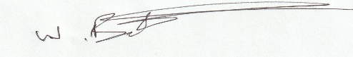

W Batchelor
Chairman
10/3/26

