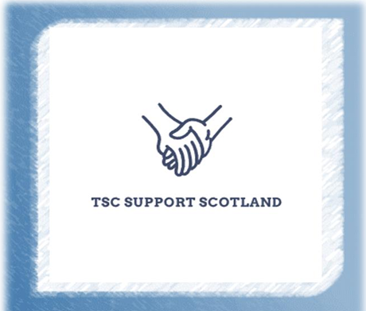
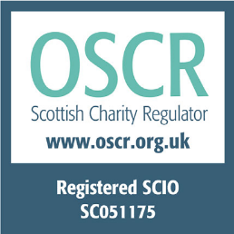
2024/2025
Annual accounts
TSC Support Scotland
These accounts cover the terms of 2024-2025.
TSC Support Scotland apologise for the delay, we plan to be running again at full capacity for the next date required for accounts.

Trustees’ Annual Report For the Year Ended 31 Aug 25
The trustees have pleasure in presenting their report together with the financial statement for the period of Aug 2023/2024 and 2024/2025.
Reference and Administrative Information
Charity Name: TSC Support Scotland
Charity Number: SC051175
Structure Governance and Management Constitution
The Charity is governed by its constitution which was created on 3rd August 2021.
Objectives and Activities Charitable Purposes
To promote the care, welfare and relieve the needs of persons affected from Tuberous Sclerosis Complex (TSC) in Scotland. We provide support and information to individuals affected by TSC through email, social media and telephone and on occasion, face to face via the TSC Clinic based in the Queen Elizabeth Hospital in Glasgow.
Achievements and Performance
During this reporting period, TSC Support Scotland has experienced a dip in activity and output due to a combination of factors affecting our small trustee team. Complex ill health challenging and family circumstances have contributed to reduced capacity. Despite these pressures, the charity has continued to provide meaningful support to families affected by TSC.
We have maintained our core services throughout the past two years, ensuring that families could still reach us via our dedicated phone line, email account and Facebook pages. These channels remain active daily, with at least one trustee or volunteer available to respond, offer guidance, and signpost families to various sources of additional appropriate support.
Plans for Future Periods
At present, the charity is operating with a Treasurer, Secretary, Chair and one volunteer. Our Chair has notified the board of their intention to step down later this year, and we have begun the process of recruiting a replacement to ensure continuity of leadership and governance.
Although our capacity has been limited, our commitment to supporting families has remained strong. We continue to prioritise stability, accessibility and responsiveness while working to build our volunteer base and strengthen the organisation for the year ahead.
In the year ahead, TSC Support Scotland intends to strengthen our governance and increase our capacity by recruiting additional volunteers and trustees. We recognise that expanding our team is essential to improving our resilience and ensuring the long-term sustainability of the charity.
Financial Review
The charity’s financial situation has remained stable during this reporting period, with no significant changes from the previous year. Our income and expenditure patterns have stayed consistent, and we continue to operate within a very small budget.
The only notable difference in our costs this year is the ongoing expense of our dedicated phone line, which is £9.50 per month. This remains an essential part of our service provision, ensuring families affected by TSC can reach us reliably for support and information.
Overall, our financial position remains unchanged, and we continue to manage our resources carefully to maintain our core services.

Approved by the trustees on 9th of May 2026 and signed on their behalf by:
Secretary - Craig Ireland
C Ireland

Financial Statement for years end 2025
Opening Balance = £1968.04
Income = £0
Expenditure = £110.4
Closing Balance = £1857.64

