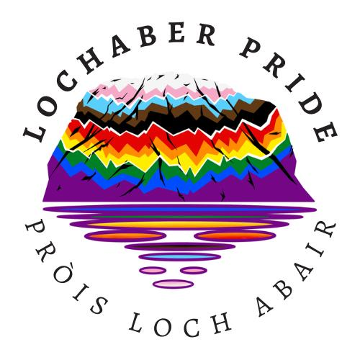

Trustees’ Annual Report
1st March 2025 to 28 February 2026

Charity contact information
Lochaber Pride
Scottish Charity Number: SC052441
Waverly House
High Street
Fort William
PH33 6XX

07803783617
info@lochaberpride.org
www.lochaberpride.org
https://www.facebook.com/LochaberPrideHighland



Charity Trustees

Name all of your charity trustees for the period, and the date they left if they were not in post for the whole year

- Iain Millar
- Kristabel Maccuish-Ross
- Gemma Macleod
- Iona McLeod (Feb 26)
- Rebecca Machin (Oct 25)

Objectives and activities

The mission of Lochaber Pride / Pròis Loch Abair is to enhance and sustain the well-being of the LGBTQ+ and allied communities by providing programs and services that cultivate community; advocate for LGBTQ+ interests; educate and empower, and provide social support.
We promote unity, inclusion, and awareness of sexual and gender diversity and aim to create a sense of community and safe spaces for LGBTQ individuals, their families and their allies.
We are committed to providing cultural, artistic, social and educational events which affirm the lives of lesbian, gay, bisexual, transgender, nonbinary, queer people and our allies and supporters throughout Lochaber.

Structure, governance and management
Type of governing document
We use a single-tier constitution governing document.

Trustee recruitment and appointment
Trustees are recruited within the volunteer pool of the charity. During this financial period, we have recruited one new trustee and have retired two trustees.

Achievements and performance


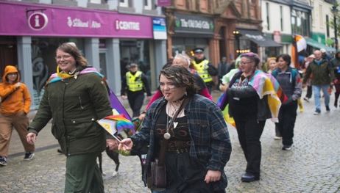
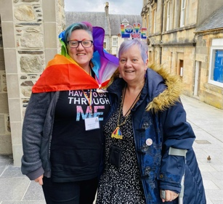
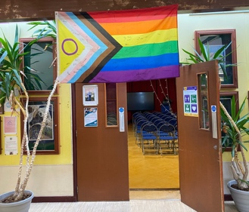

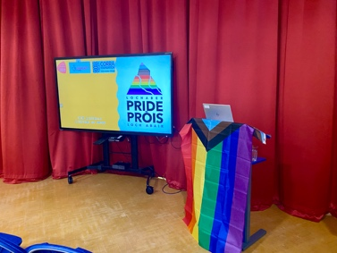

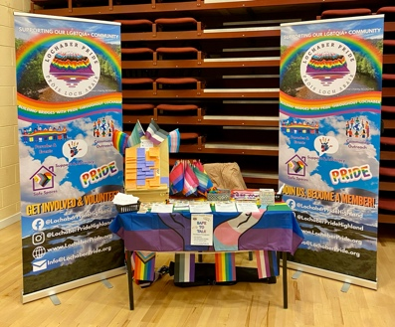
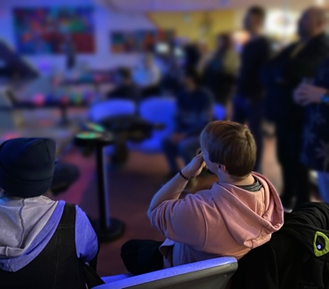
Achievements
- First Ever Pride Parade in Lochaber: Our biggest milestone was successfully hosting Lochaber’s first Pride Parade. The event welcomed over 200 attendees, supported by 20 stewards and first aiders. Highlights included a drag performance, an author's talk, poetry readings, and music and live broadcasting from Nevis Radio, who also provided coverage of the day. The Lochaber Times featured a spread on the event, amplifying visibility and celebrating our success.
- Website Launch: A new website was published, featuring a dedicated members’ area, events section, and resources section to improve communication and accessibility.
- Schools Outreach: We began our schools outreach programme, delivering presentations at Mallaig High School and Kinlochleven High School, hosting a stall at Ardnamurchan High School, and participating in the Youth Philanthropy Initiative (YPI) at Kinlochleven High School. This marks an important step in engaging young people and promoting inclusivity.
- Committee Strengthening: Three new members joined the committee, bringing fresh perspectives and skills to support our growth.
Governance and Office Bearers
- New Chair and Secretary: Elections resulted in a new Chair and Secretary, ensuring strong leadership and effective administration.
- Treasurer Role Created: A dedicated Treasurer role was established to strengthen financial oversight and accountability.
- Production Committee Member: A new role was introduced to support event planning and delivery, particularly for our festival ambitions.
Events and Community Engagement
- Festival in a Day: Building on the Pride Parade, we are planning a combined Pride Parade and Festival at the Nevis Centre. This will create a full day of celebration, visibility, and community connection.
- Community Events: We hosted Drag Bingo and 10-pin bowling, bringing people together in fun, inclusive settings.
- Rotary Club Christmas Fair: Lochaber Pride attended the Rotary Club Christmas Fair, strengthening visibility and connections within the wider community.
Fundraising
- Rainbow Lottery Membership: Lochaber Pride joined the Rainbow Lottery, providing supporters with a fun way to contribute.
- Easy Funding Platforms: We also registered with easy funding platforms, raising approximately £xxx through these outlets. These initiatives diversify our income streams and strengthen sustainability.
Financial review

Statement of the charity’s policy on reserves
We have a policy of maintaining a reserve of at least 25% of our annual income.

Details of any deficit
There was no financial deficit in this accounting period.

Future plans
- Continue expanding schools outreach to more communities across Lochaber.
- Deliver the Pride Festival in a Day, ensuring safety, inclusivity, and impact.
- Strengthen governance and financial sustainability through clear policies and active trustee engagement.
- Enhance member engagement via the website and dedicated resources.

Additional information
Lochaber Pride has made significant progress in outreach, governance, fundraising, and event planning. The successful hosting of our first Pride Parade stands as a landmark achievement, showcasing the strength of our community and the commitment of our trustees. The trustees remain dedicated to transparency, inclusivity, and empowerment as we move forward into the next year.
Declaration
Signed on behalf of the charity trustees:


Print name Iain Millar

Designation Chair

Date 01/02/2026

