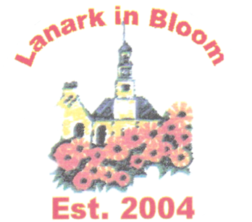

Lanark In Bloom
Trustees’ Annual Report
Period From 1st April 2024 to 31st March 2025

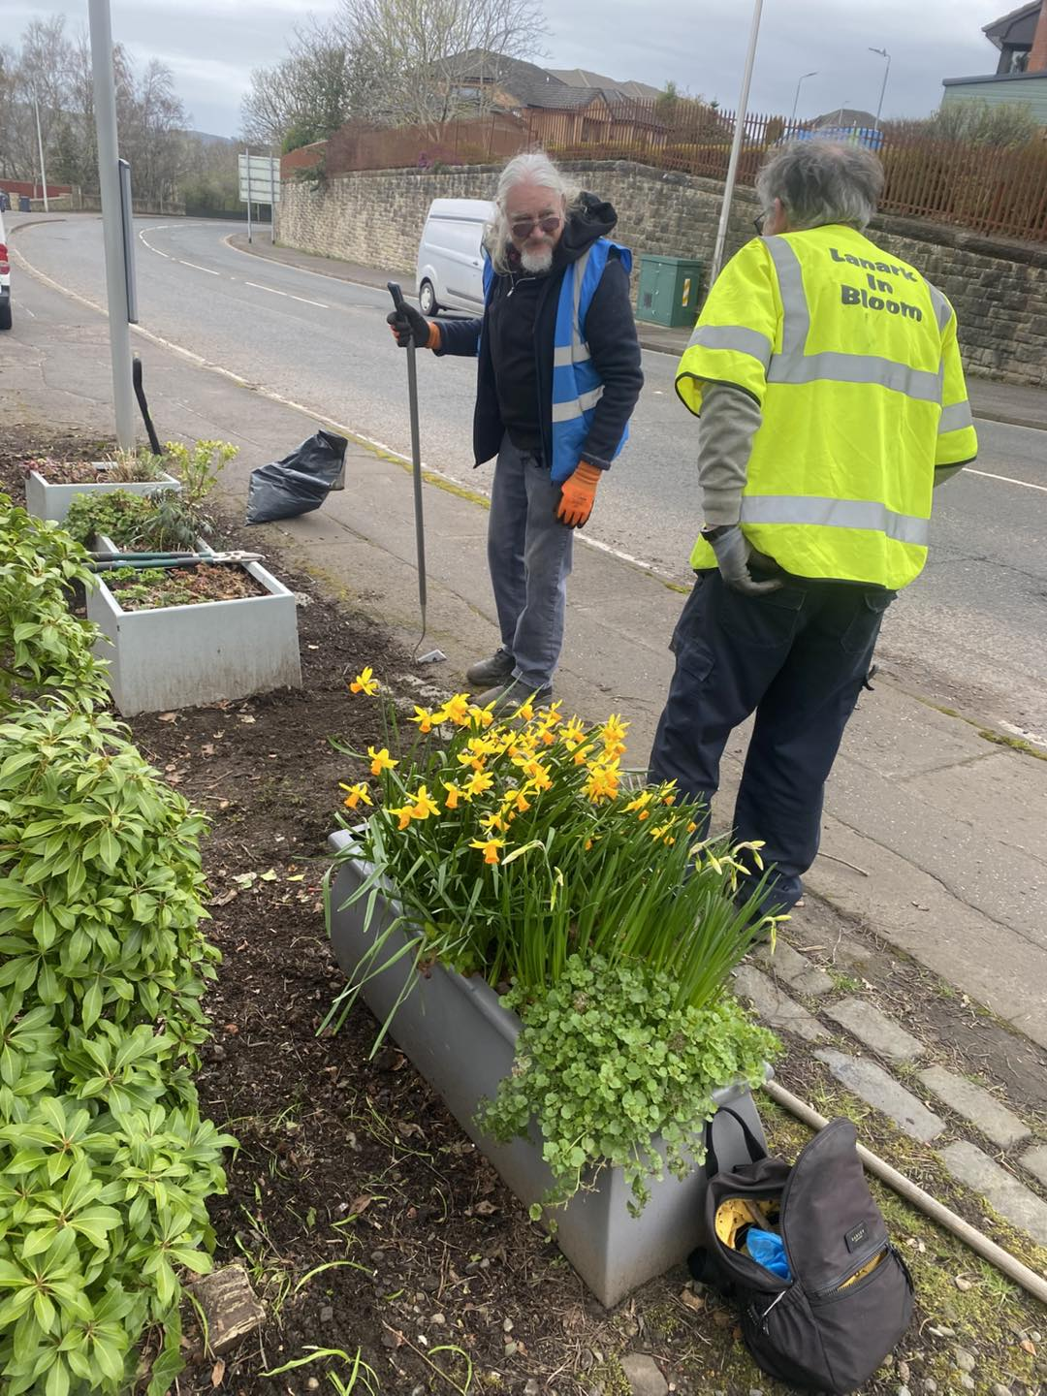
Charity contact information


Lanark In Bloom
Scottish Charity Number: SC036000
20 Westport, Lanark
ML11 9HD

Telephone number 07792110956
Email address valerie.paton@hotmail.com
Facebook Lanark in Bloom

Charity Trustees
Name all of your charity trustees for the period, and the date they left if they were not in post for the whole year

- John Morrison Resigned January 2025
- Emma Gibson Resigned January 2025
- Margaret Grant
- Gavin Paton
- Valerie Paton
- Lisa Archibald

Objectives and activities
The aim of the charity is to promote floriculture, arboriculture and horticulture for the benefit of the public generally, especially those who live in or visit Lanark. We aim to work with other local groups to enhance and maintain areas in and around the town as well as growing food for the local foodbank. We work closely with South Lanarkshire Council, as well as local schools and playgroups etc.

Structure, governance and management
Type of governing document
Our governing document is our Constitution which sets out our purpose, membership, committee and general guidelines for meetings and finance.
Trustee recruitment and appointment
The Trustees of the group are the Office Bearers who are appointed at the AGM by a vote of committee members. In January 2025, we elected Margaret Grant, Gavin Paton and Lisa Archibald as Trustees to join Valerie Paton.

Achievements and performance
This year was difficult for the charity. Many of the members were badly affected by the death of our beloved founder and chairman, Ernest Romer at the end of 2023. A number of volunteers felt they could no longer continue with the group and left. At one point it looked doubtful if the group would continue. However a small group of volunteers continued to maintain areas throughout the town and managed to continue to grow a good amount of vegetables for the local foodbank.By using donations of perennials and other plants we had grown from seed, we managed to add colour to the town without spending a large amount of funds. Indeed,our only expense was for the upkeep of the charity van and our public liability insurance.

Financial review

Reserves
The group aims to have reserves of £1000. At the close of the financial year we held £1650.

Details of any deficit
There is no deficit.

Donated facilities and services
Our compound is on ground belonging to Clydesdale Community Initiative. As rent we grow food for the foodbank and donate any spare plants we have to CCI for them to sell in their garden centre.

Future plans
The group has reduced some of the areas we were responsible for in Lanark. It is hopefully a temporary measure due to financial restrictions and the number of volunteers. We have approached CCI with a view to sharing responsibility for the planters at Lanark Railway Station.
As previously stated, this was a very difficult year for the group, but we are very hopeful that the next year will be much more positive.

Declaration
Signed on behalf of the charity trustees:
Valerie A. Paton

Valerie Paton
Print name
treasurer
Designation
12/04/26
Date

