The Trustees Annual Return for
Enter Holistic Healing SC052850
Clyde Offices, 2nd Floor, 48 West George Street, Glasgow, G2 1BP

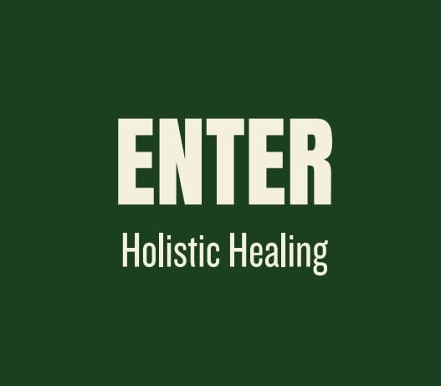

Trustees
The trustees are self-appointed by election at trustee meetings as of 30/09/2025 the trustees are, Steve Davie, Pamela Docherty, Ross Geddes
Charity Structure
Enter Holistic Healing is incorporated as a SCIO regulated by OSCR.
Charitable Purposes
The organisation’s purposes are set out in our governing document are:
4.1 The advancement of health, by signposting the services of wellbeing practitioners to aid those suffering from poor mental health and experiencing financial hardship. Offering individuals' access to wellbeing practitioners through regular groups, community events and one to one sessions.
4.1 (a) The triaging of and defining people suffering from poor mental health will be determined in the following ways, a person referred by a doctor or other health professional working in psychological practice or if the individual has self-diagnosed themselves as suffering from poor mental health
4.2 The relief of those in financial need experiencing poor mental health, by paying or partially paying for the services of said wellbeing practitioners.
4.2 (a) The determination of hardship will be determined by asking all potential beneficiaries to fill out a contact form outlining their level of income. The answers of which will be taken on good faith.
4.3 These activities algin to the fuller described OSCR outlined purposes of:
(d) The advancement of health
(n) The relief of those in need by reason of age, ill-health, disability, financial hardship or other disadvantage

Why was Enter Holistic Healing set up?
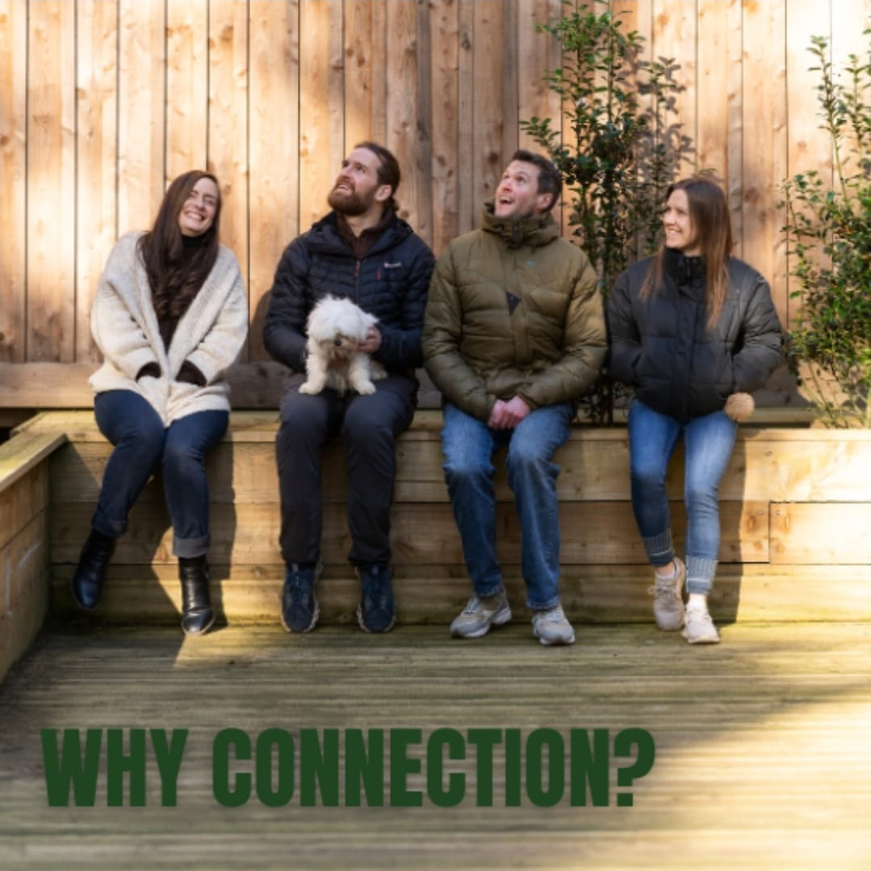

At Enter all the trustees have felt the power of connection on our healing journeys. When we gather in groups to share our current reality it is a powerful tool for release, to be heard, and understood. Above and beyond the modalities we will be providing, connection accounts for much of the medicine on offer.

Who Does Enter Holistic Healing Benefit?
There is a clear the link between poor mental health and lower income. Often the people who need help the most are those who do not have the means to pay for help. People who fit this category will be who Enter will be reaching out to.

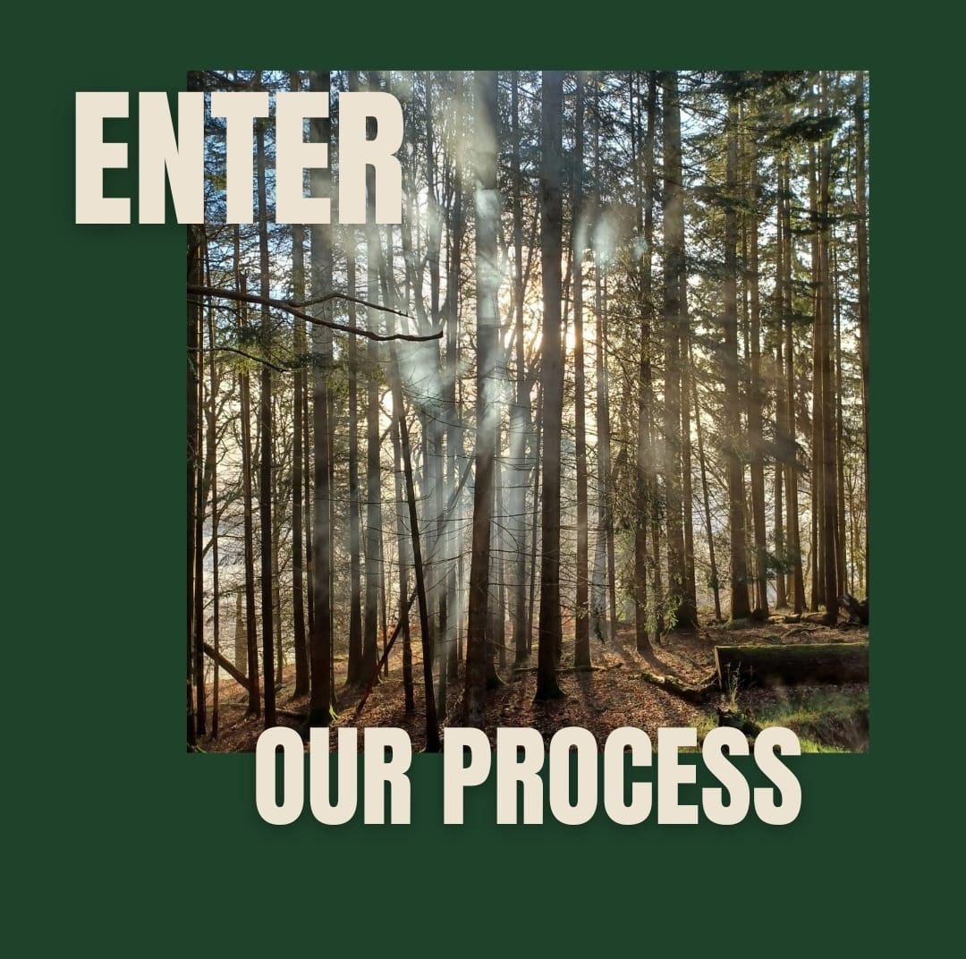

What have we been up to since April of 2024
Last year was very busy, here are some of the activities and programs we ran or funded
- Connected April, May and June - a program that involved online and in person meet ups, and everything from walks, meditation, journaling to Thai boxing
- Funding an individual to work with an expert on their nutrition
- Community painting events
- Sound bath and breathwork session with Andy’s Man Club
- Funding three people to work with an coach to address their relationship with alcohol all of which successfully staying sober
- Providing some funding to help a women menstrual health group for those who suffer from PMDD

What’s next for Enter Holistic Healing?
We are busy looking for more funding this year and are working through what events and initiatives we want to do for 2026/27
Accounts
We continue to be self-funded for the third year running and still have a healthy balance to fall back on
Statement Of Balances
- All funds held in the account for the financial year 26-26 are unrestricted.
- No investments were made in this period
- No assets were gifted or are held by the charity
- We have no outstanding liabilities

Notes To The Accounts
A total of £92 was claimed in expenses by our trustee Pamela Docherty, this was for renumeration of payment for our statutory GDPR requirements
Thank you for reading our trustee's annual return you can find out more about us on our media channels below.
Website: www.enterholistichealing.com
Instagram: Enter Holistic Healing
Email: info@enterholistichealing.com

Signed by Steve Davie, treasurer
Date: 08/05/2026

