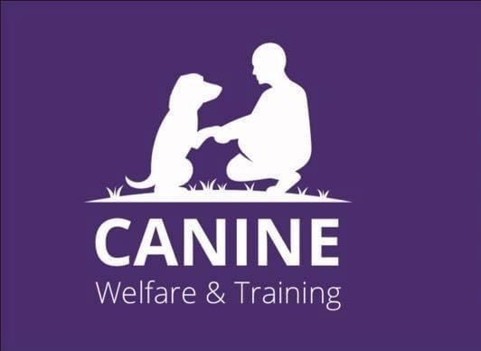

Canine Welfare & Training
Trustees’ Annual Report
Period From 1 November 2024 to Period End 31 October 2025

Charity contact information
Canine Welfare & Training
Scottish Charity Number: SC050516
Address 52 Pentland Terrace, High Valleyfield, Dunfermline
Postcode KY12 8SG

Telephone number – 07871 359530 Michelle Atkinson
Email address – caninewelfaretraining@gmail.com
Website - www.caninewelfaretraining.co.uk
Facebook – Canine Welfare & Training

Charity Trustees

- Michelle Atkinson
- David Nurse – resigned 13/12/2024
- Eileen Fowler
- Lisa Calder
- Kevin Mcauley – resigned 15/8/2025
- Barbara McBride
- Jayne Hodge – resigned 22/6/2025

Objectives and activities
The charity was set up to support people and their dogs, to develop skills, knowledge and confidence and to have the best relationship with their dogs through reward-based training.
We cover all aspects of dog education, training and care.
We have a rental lease over unit 8, Lyneburn Industrial Estate, Dunfermline, KY11 4JT.
We also rent the use of the unit to dog sports groups for an hourly rate.
We hold positive reward-based dog training classes at a subsidised rate so that they are available for lower income families.
This training can be held at the unit or on a one-to-one basis in the person’s home.
Our objective is for training to be available to all families and their dogs. So that our communities are safer. This training is also with community groups, schools, individuals and families. We want to build on our relationship with Safer Communities Fife and the Dunfermline Dog Wardens.
There are deprived areas of Fife which are seeing an increase in dog attacks, and we are working with Fife Council so that our trainers will be first contact to evaluate the dog and family and put a training programme in place.

Structure, governance and management
Type of governing document
The charity is an unincorporated association, and its governing document is a constitution.
Trustee recruitment and appointment
Trustees are elected or re-elected at the AGM which is held in April of each year.
We have not recruited any new trustees this accounting year.
The charity has several volunteers who have strengths in fundraising, bookkeeping and dog activities and we have a couple who would be a great asset to the Trustees.

Achievements and performance
We started this financial year in premises at Lathalmond, M90 Commerce Park, Kelty.
We fitted the unit out with new Astroturf and tuffspun flooring, and equipment for flyball & agility.
This set up was bringing the charity to the attention of dog training groups and clubs. We were starting to get hires most weekends and holding classes for puppy training etc.
We had two fun days where we had stalls and ran a dog show and come & try flyball and agility.
Then in March 2025 we had to vacate our premises at Lathalmond, as the Landlord had not repaired the roof in line with the conditions of our lease with them.
The new equipment & flooring which had been purchased for these premises was damaged due to rain & water coming through the roof.
https://www.thecourier.co.uk/fp/news/5201478/dunfermline-dog-charity-flees-premises/
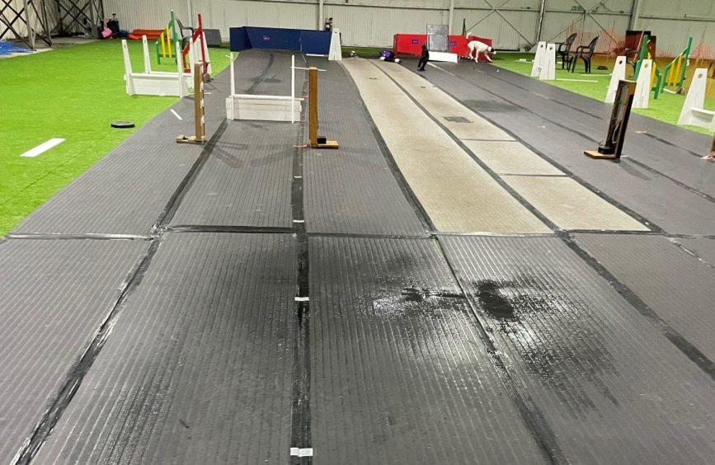
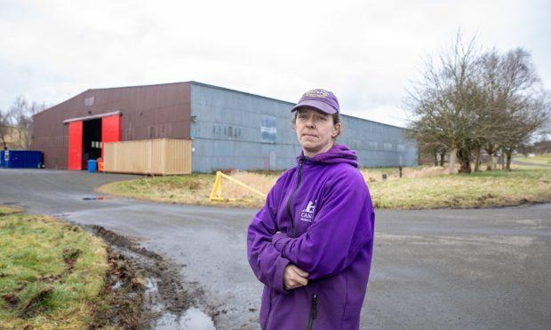
We took advice from our Solicitors and looked to secure the rental of Unit 8 Lyneburn Industrial Estate in Dunfermline.
This involved the lifting and refitting of all the astroturf and tuffspun, and relocation of all our assets and resources.

This new unit is more central to Dunfermline town centre. It is slightly smaller but has the bonus of dedicated male & female toilets, a kitchen, an office and five other office spaces.
It has been easier for people to find us and we now have people dropping in to see what we do.
We applied to Fife Council for a change of use for the unit, which has been granted as of 18th February 2026. Please see article -
https://www.dunfermlinepress.com/news/25870865.plans-dog-training-facility-dunfermline-approved
The rooms are a good size for renting out for Dog First Aid classes and Canine Massage treatments.
We have held more fundraising event days where we have had more stall holders who can use the smaller offices. On these days we have our own snack van which is run by our volunteers.
We are running three one-hour Puppy classes a week, six agility classes a week, four loose lead and recall classes a week, as well as countless one-to-one sessions.
We are also working with Fife Council where we are invited into primary schools to talk to children about dog safety including how to read a dog’s body language, reactions, safe ways to approach strange dogs in the street and how to recognise what their own pet dog may be feeling.
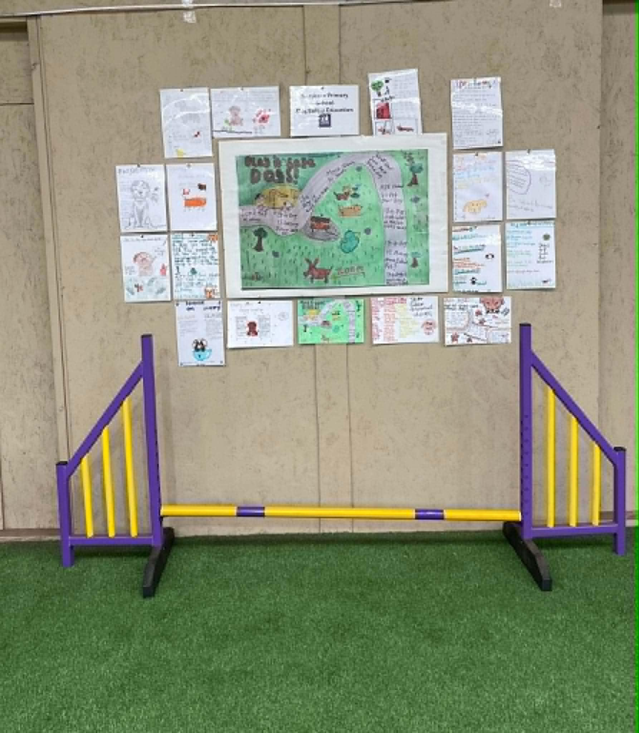

REVIEWS
This is some of the reviews we have received on google.
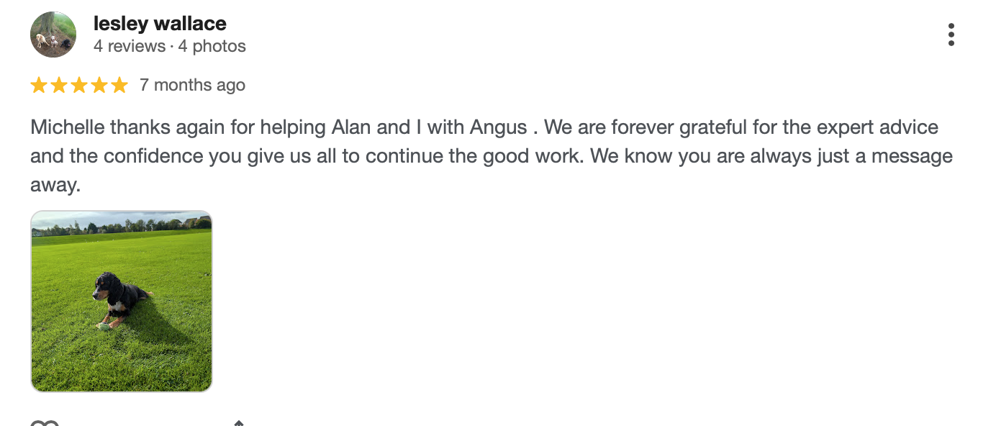
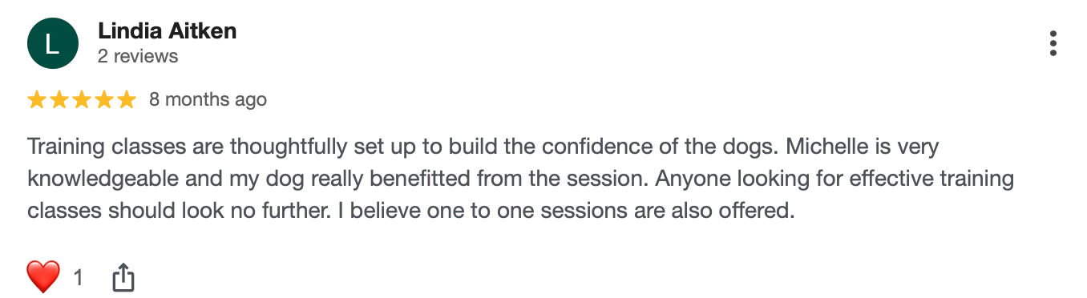
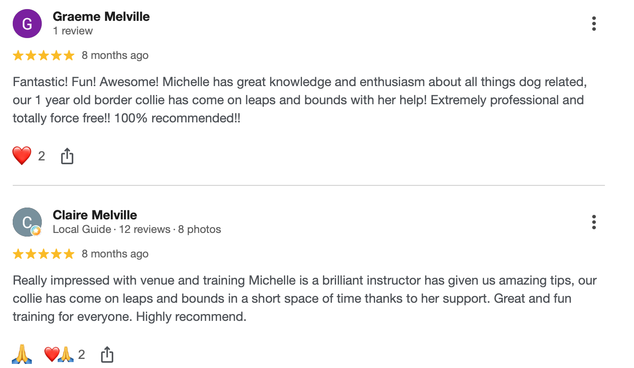

Financial review

Statement of the charity’s policy on reserves
As a charity, we fully appreciate the importance of maintaining an appropriate level of reserves to ensure longevity of the charity and its financial stability. To do this, we aim to maintain unrestricted free reserves that is equivalent to 3 months’ operating costs of approximately £20,000 clear in our bank account to enable continuous delivery of our objectives.

Details of any deficit
No deficit in funds during this period.

Donated facilities and services
We have an arrangement with the Big House Multibank in Lochgelly, where we receive donated items such as bags or tins of dog food, leads, collars, dog beds etc. These are then distributed to clients on low incomes, or those in immediate need.
Future plans
As previously mentioned, we have started to build relationships with local community groups and Fife Council schools. We are passionate about educating the younger generation and aim to work alongside the different groups to bring dog training and safety to a wider audience. We have recognised that children have a keen interest in animals but are not often knowledgeable in the current methods of approach and integration with dogs. Too often, the media reports on negative instances of poor interaction,and we aspire to alleviate this, even if it is just for 1 person.

We are in the process of formulating a structured plan to work within the community groups and deliver training sessions, and build a better awareness within the area.

We are also in discussions to form a partnership with Safer Communities Fife and local dog wardens to offer a training programme/rehabilitation for those who may have issues with their dogs being out of control or regular escapees.

We feel that by being in a more centralised locality in Dunfermline we are able to take the opportunity to reach out to a wider audience and have become more accessible through transport links in the central belt. We will continue to build on our training classes for puppies and younger dogs, as well as being able to continue offering dog sport participation in flyball and agility to a wide range of the public.

Additional information
Got something else to say? Here is your chance!


Declaration
Signed on behalf of the charity trustees:

Print name SCOTT MATHEWSON

Designation Chairperson

Date 2 July 2026

