APPENDIX 1

OSCr | Trustees’ Annual Report for the period
OSCr |  | Period start date |  |  |  | Period end date
OSCr |  | Day | Month | Year |  | Day | Month | Year
OSCr | From | 1 | 1 | 2025 | To | 31 | 12 | 2025
Office of the Scottish Charity Regulator

Reference and administration details

Charity name |  | Stretch a Nickel Foundation
Other names charity is known by |  | Stretch a Nickel
Registered charity number |  | SC043585
Charity’s principal address |  | 105 Merrylee Road
 |  | Cathcart
 |  |  | Postcode G43 2QY

Names of the charity trustees on date of approval of Trustees’ Annual Report

 | Trustee name | Office (if any) | Dates acted if  not for whole year | Name of person  (or body) entitled to  appoint trustee (if any)
1 | Helen MacVey | Chairperson
2 | Helen Waugh | Treasurer
3 | Aileen Donaghy | Vice-Chair | September 2025
4 | Caroline MacVey | Trustee
5 | Suzanne Chase | Trustee
6 | Claire Jolly | Trustee |  | December 2025
7
8
9
10
11
12
13
14
15
16
17
18
19
20

1
APPENDIX 1

Reference and administration details

Names of all other charity trustees during the period, if any, (for example, those who resigned part way through the financial period)

Name | Dates acted if not for whole year

Structure, governance and management

Type of governing document | SCIO Constitution  Trustees usually meet three times a year and these meetings are minuted. A Chairperson’s report is prepared for the AGM at the year end.
Trustee recruitment and appointment | Aileen Donaghy sadly died in October 2025. We recruited Claire Jolly in December 2025 as our new Trustee. She is a primary teacher with particular expertise in early years literacy and reading.

Objectives and activities

Charitable purposes | Our charitable purposes for OSCR are listed as A,B,D,F, J and K. This encompasses the prevention of relief of poverty (A); the advancement of education (B) (F); the advancement of human rights (J); and the promotion of religious and racial harmony (K  Our projects are designed to address unmet needs in our communities across Glasgow. Our volunteers and partners help to make our projects happen.We support communities in the Greater Glasgow area, by addressing the needs of local people. We create projects that promote positive health and well-being by connecting people to services in their community. We aim to build strong resilient families who can grow together through family learning, outdoor activities, sport and the arts.
Summary of the main activities  in relation to these objectives | Beanie Hats for Refugees:. This initiative has been a great success with 900 hats being sent out. This initiative has now ended. A big thanks to Helen W for running the initiative. (A, F, K)  Bright Sparks Readers: Another very successful year, Bankhead achieved its Reading Schools Bronze award this year and continues to see the benefits to 1 to 1 reading with our volunteers. We have 6 volunteers reading with EAL (English as an additional Language) and children with learning needs, 2 days a week at Bankhead Primary. (B, K)  Baby Bank Southside: Ran a drop in service for families to pick up free nappies, wipes, fruit pouches and pre-loved baby clothes. We helped them to purchase better storage for organising the clothing into size bundles ready for families to take. We also purchased some new equipment and eco-friendly sippy cups for them also. The Trustees approved the spend on equipment and storage. Unfortunately, they have paused the service due to a lack of volunteers. SANF will continue to support the project and try to re-establish it in 2026. (J, K)  Glasgow City Mission Families and Children Project: They were struggling to continue to provide services for the families at the project due to the closure of their nursery and many changes within their organisation. We felt we could meet this need by partnering with them in the short term to bridge this gap. We have continued to support them in 2025 with running costs and the project is going from strength to strength. (A, B)  Fields of Hope: Namutumba School Build in Eastern Uganda. We donated £1,000 and received a thank you from Tony Gaston the CEO. He has managed to raise the £90,000 to start the project and the School block project is going ahead. (B)  Creatovators: Are a charity supporting autistic children and families who approached SANF for support through Aileen. We donated to their Christmas gifts for the children, families and volunteers fund and purchased EduEducational blocks for their family sessions. (B)  City Wise partnership: We have partnered with them at their family days, we have provided arts workshops with professional community artists, books and activity packs to 3 family events this year. We have worked with Susan Laws Artist and CLAASH collective’s Claire and Julie Sheridan to create high quality take-away items. (B, K)  Royston Primary Christmas Gifts for Mums: An appeal was made by the Head Teacher (Jane McShane) for toiletries to help the primary 1-2 children make up gift sets for their mums. Royston were one of the original Bright Sparks locations and continue to serve a very deprived community. We contributed a selection of small toiletries. (A)
2

APPENDIX 1

Achievements and performance

Summary of the main achievements of the charity during the financial period | 2025 has been a successful year of partnerships with eight organisations and charities who match our vision of meeting unmet needs to achieve positive change in the lives of people living in Glasgow and beyond. We made a donation to Fields of Hope, who were able to build a school block of classrooms in Uganda. We partnered with City Wise mentoring family days over the year we put on different creative workshops by employing local community artists. We continued to support the Glasgow’s City Mission Family project in Govan.  We are aiming to close SANF in 2026 and want to ensure that all funds have been used for our charity objectives.

Financial review

Brief statement of the charity’s policy on reserves | Our trustees adhere to competent financial diligence. The board has to consider any potential risks to income and expenditure associated with SAN’s current or potential projects. Trustees aim to utilise SAN’s assets wisely. There are no paid employees. Income streams and resources are sufficient to cover the core activities and liabilities, and include basic reserves. Gift Aid is actively claimed wherever possible.

Details of any deficit
Donated facilities and services (if any) | Our volunteer tutors donated their time and expertise to help fill learning gaps for specific SAN projects.  Some of our SANF partners also donated venue space or offered it at a reduced rate to promote community partnership.

3

APPENDIX 1

Other optional information

SaN Foundation has a Safeguarding policy for volunteers in line with OSCR and statutory requirements. All its volunteers are PVG disclosed.

Declaration

The trustees declare that they have approved the trustees’ report above.

Signed on behalf of the charity’s trustees

Signature(s) | 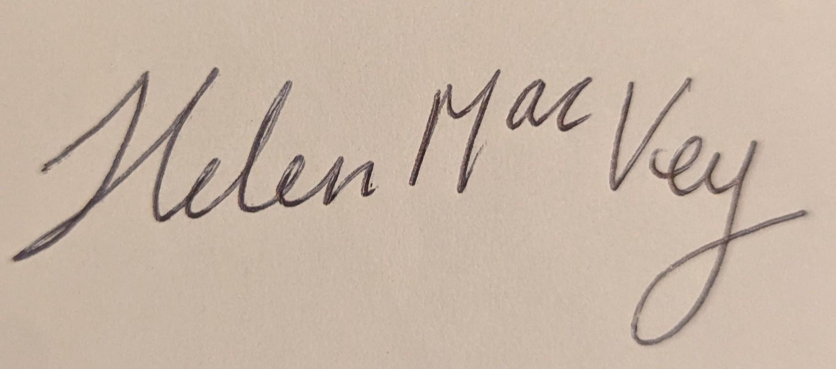
Full name(s) | Helen MacVey
Position (e.g. Chair) | Chair
Date | 07.12.2025

4

