APPENDIX 1
 | Trustees’ Annual Report for the period
 | Period start date |  |  |  | Period end date
 | Day | Month | Year |  | Day | Month | Year
From | 01 | 01 | 2025 | To | 31 | 12 | 2025
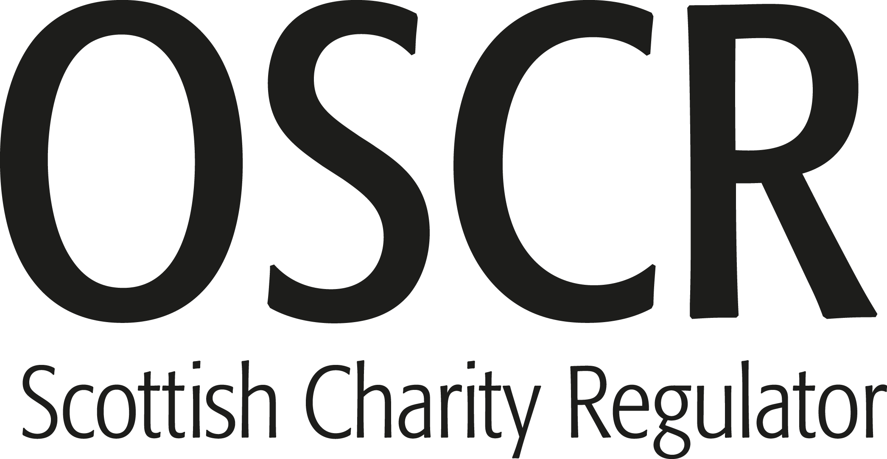

Office of the Scottish Charity Regulator

Reference and administration details

The Bertie Auld Legacy
SC051826
Block 7, 20 Clydesmill Drive
Cambuslang Investment Park
Glasgow
Postcode G32 8RG
Charity name
Other names charity is known

by
Registered charity number
Charity’s principal address

Names of the charity trustees on date of approval of Trustees’ Annual Report

 | Trustee name | Office (if any) | Dates acted if not for whole year | Name of person  (or body) entitled to appoint trustee (if any)
1  2  3  4  5  6  7  8  9  10  11  12  13  14  15  16  17  18  19  20 | Robert Auld
 | Martin McHugh
 | Ian Cairns
 | John Haughey
 | Declan McConville

1
APPENDIX 1

Reference and administration details

Names of all other charity trustees during the period, if any, (for example, those who resigned part way through the financial period)

Name | Dates acted if not for whole year

Structure, governance and management

SCIO Constitution
No changes to date
Type of governing document
Trustee recruitment and appointment

Objectives and activities

The prevention or relief of poverty. The relief of those in need by reason of age, ill-health, disability, financial hardship or other disadvantage
The organisation exists to carry on the tireless and dedicated work of the sporting legend Bertie Auld to help the disadvantaged people of Glasgow, Scotland, Ireland and across the UK. Its mission is to help vulnerable and disadvantaged people to live a more comfortable, enjoyable life and to give them the support they need to do that. The organisation's purposes are: The prevention or relief of poverty. The relief of those in need by reason of age, ill-health, disability, financial hardship or other disadvantage.
Charitable purposes
Summary of the main activities in relation to these objects

2
APPENDIX 1

Achievements and performance

Financial support provided to various charities including Tommy Gemmell Community Project, St Margarets of Scotland, Dunard Primary School, Kilbryde Hospice, Alan Kinsella & Family.
Summary of the main achievements of the charity during the financial period

Financial review

We are focused on running with minimal level of reserves where we can use the funds to charitable purposes.
Due to monies held at end of 2024 there was a small deficit in the year due to donations however there is a healthy balance carried into 2026.
Brief statement of the charity’s policy on reserves
Details of any deficit
Donated facilities and services (if any)

3
APPENDIX 1

Other optional information

Declaration

The trustees declare that they have approved the trustees’ report above.

Signed on behalf of the charity’s trustees

Robert Auld
Martin McHugh
Ian Cairns
John Haughey
Robert Auld
Martin McHugh
Ian Cairns
John Haughey
Trustees
11/03/2026
Signature(s)

OSCR will accept digital or typed signatures Full name(s)
Position (e.g. Chair)
Date

4

