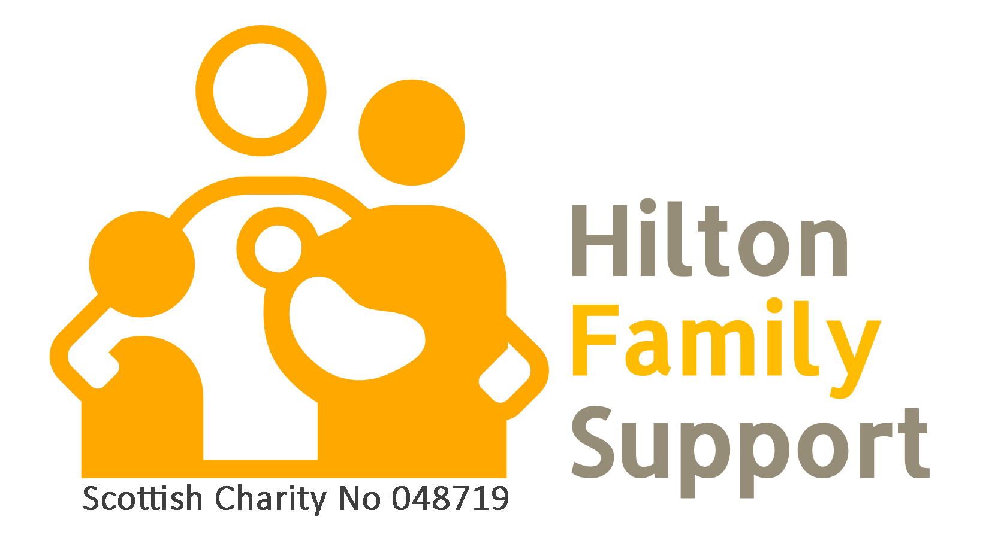

Hilton Family Support
SCO48719
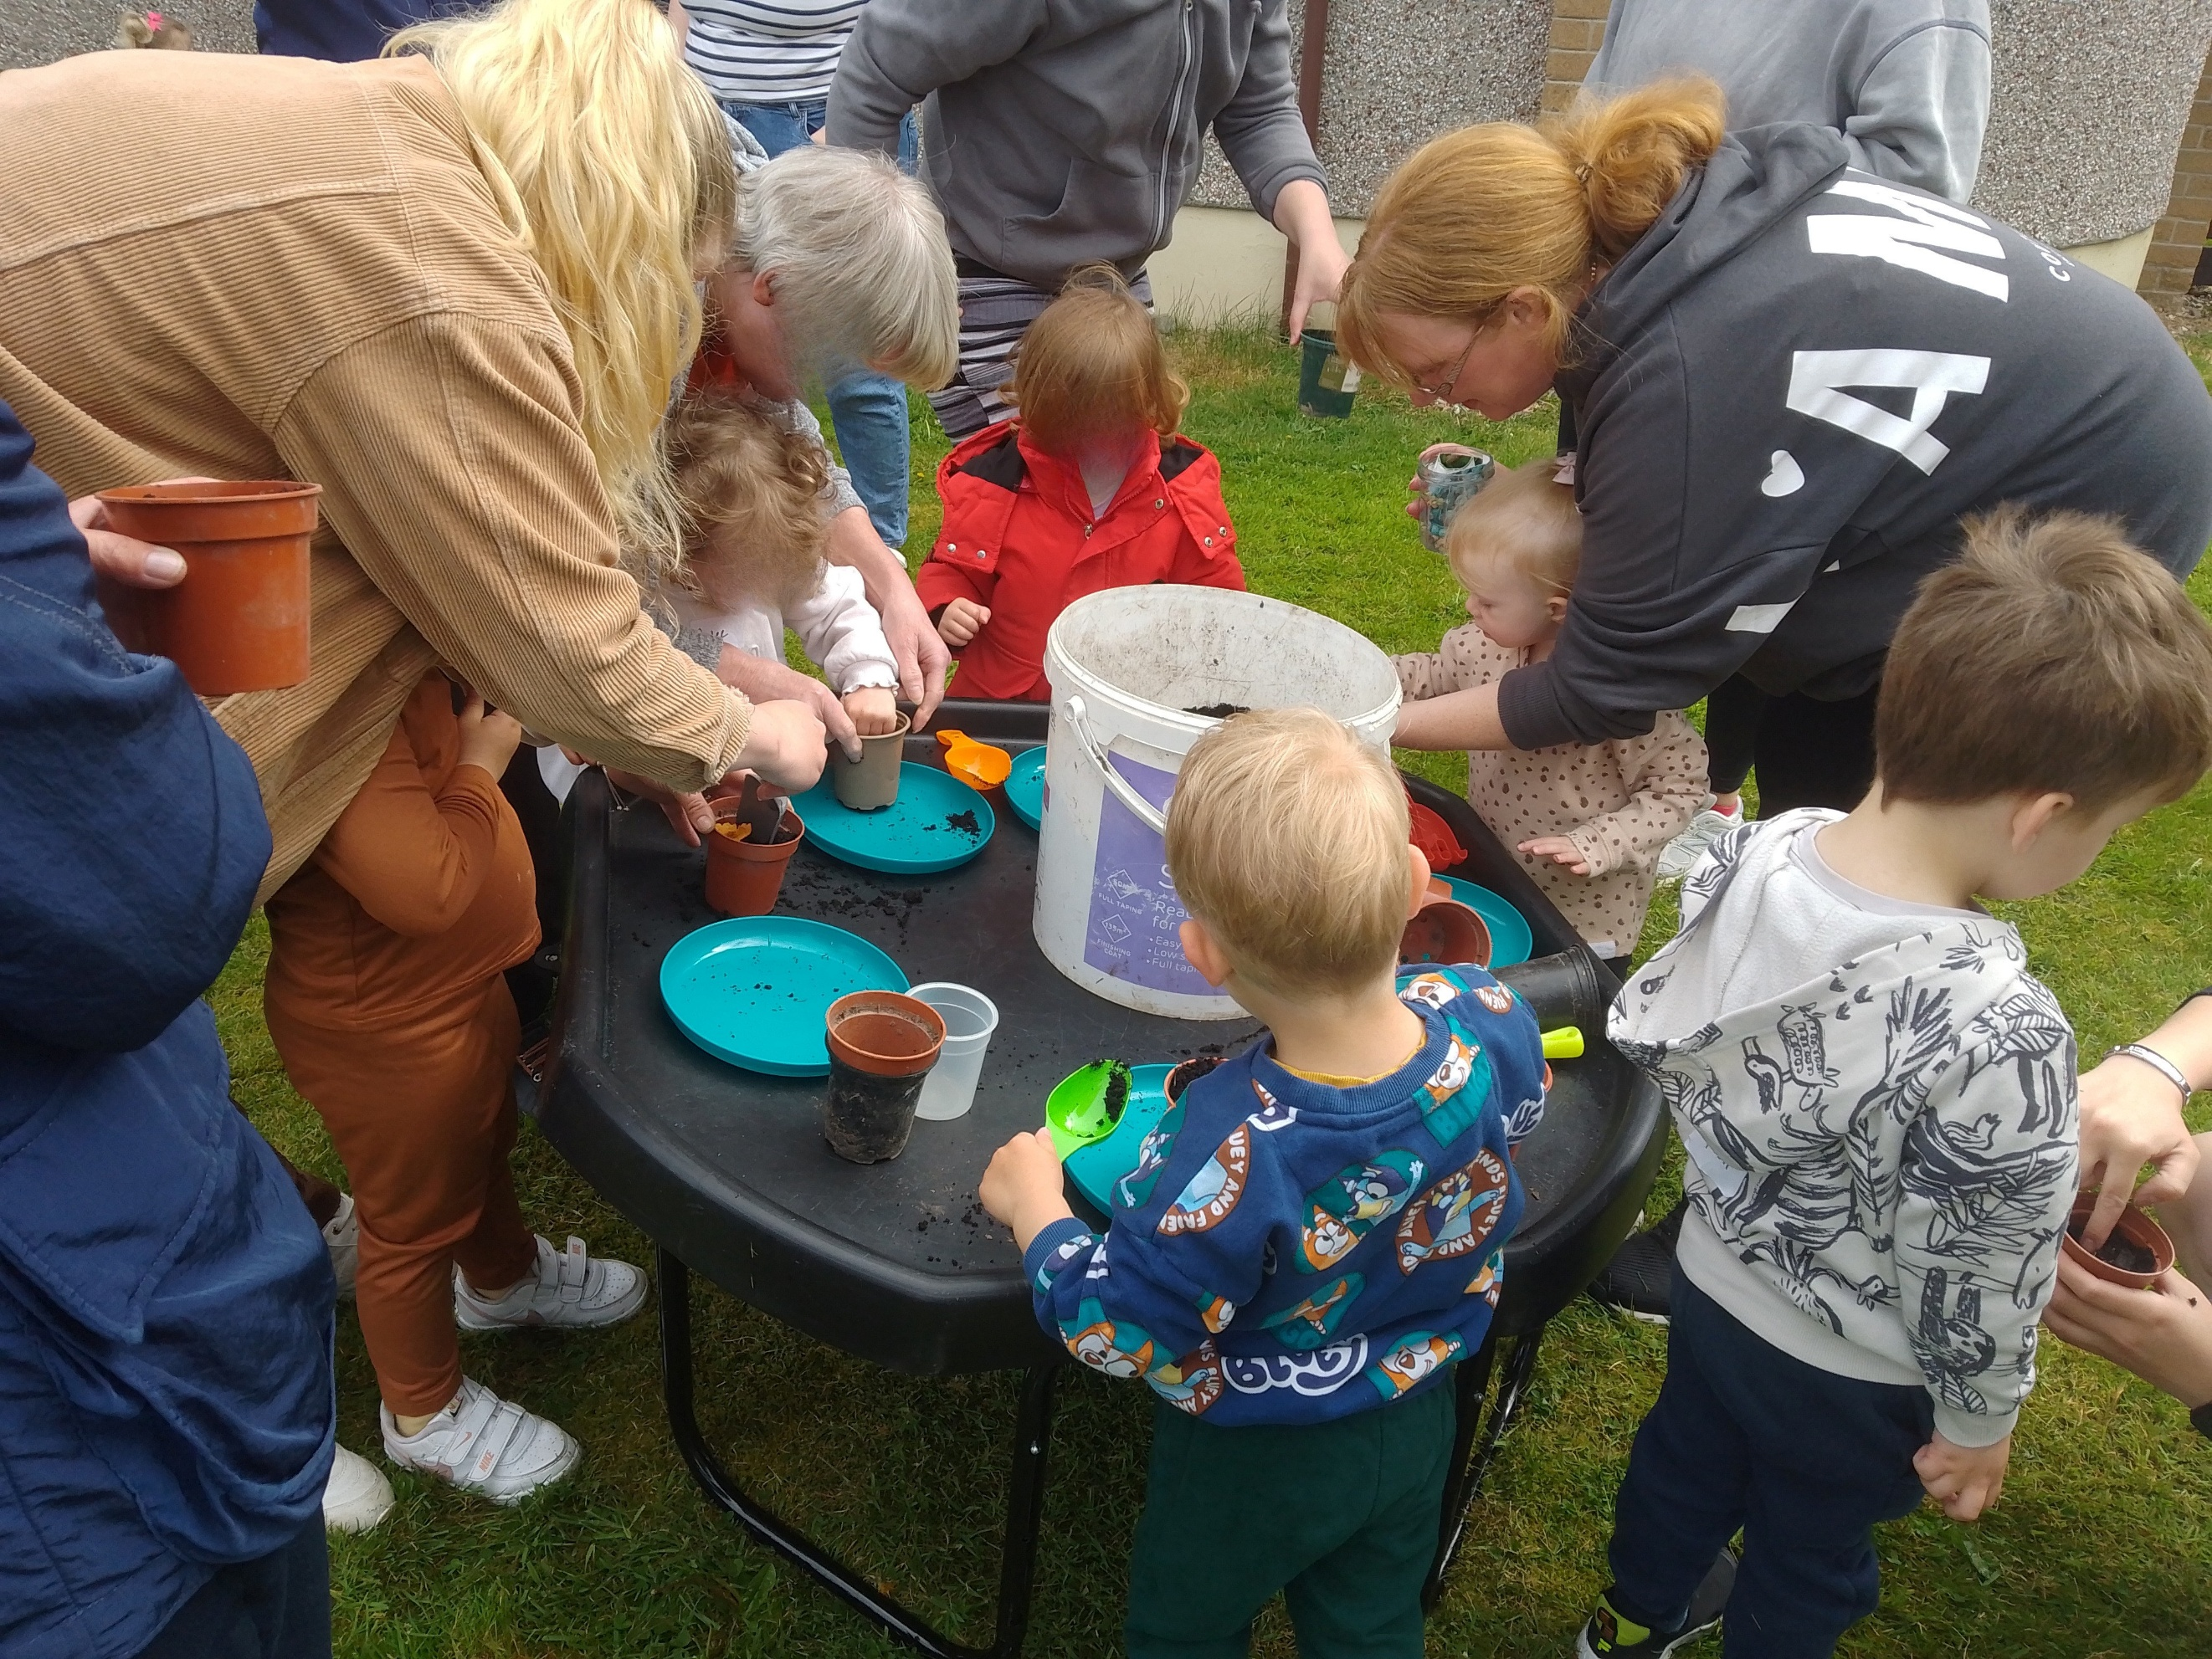
Trustees’ Annual Report
1 January 2025 to 31 December 2025
Charity contact information
Hilton Family Support
Scottish Charity Number: SC048719
c/o The Light House
4 Tomatin Road
Inverness
IU2 4UA

Email address: admin@hiltonfamily.support
Website: www.hiltonfamily.support
Facebook: https://www.facebook.com/Hilton-Family-Support-113255910311359

Charity Trustees
1. Pat MacQuarrie, Chairperson
2. Carol Baker, Secretary
3. Ron Archer
4. Barry Dennis
5. Ingrid Hutchison
6. Margaret Johnston
7. Helen Stradling
8. Carolyn Cload, appointed January 2025

Objectives and activities
The Charity’s purposes are:
- The prevention and relief of poverty
- The advancement of education amongst poor and disadvantaged children
- The relief of those in need by reason of age, ill-health, disability, financial hardship or other disadvantage
- The provision of recreational facilities or the organisation of recreational activities, with the object of improving the conditions of life of those in need.
Structure, Governance and Management
Type of governing document
Hilton Family Support is a charitable incorporated association, and the purposes and administrative arrangements are set out in our constitution.
Trustee recruitment and appointment
During 2025 there were 8 trustees. There was one new Trustee appointed in January to replace the Trustee who retired in 2024. New Trustees may be appointed by the current Trustees. Only individuals approved unanimously by the current trustees shall be appointed as Trustees. The appointment of a new Trustee or Trustees should be effective by way of a minute signed by all existing Trustees and the Trustee or Trustees to be appointed. The minimum number of Trustees should be three.
Trustees should be recruited according to their knowledge and experience of both the locality in which we operate and of the ethos of the Charity. Trustees are attached to one of two groups, Governance or Service Delivery. Formal meetings are held on a monthly rota basis with a joint meeting of all Trustees every third month. The staff attend the Service Delivery group and provided reports for these meetings. An important work of the Trustees is to ensure that all Policies are monitored, reviewed and updated on a regular basis and Policies were reviewed at least once during the year.
A part-time administrator is employed.
Achievements and performance
2025 began with just one family Support worker due to the retiral of the previous worker in August 2024. Sufficient funding was sought and was successfully granted to enable two Support worker posts to be in place. The paid staff were assisted by 10 volunteers some of whom are also Trustees.
The early part of the year was taken up, in part, with the recruitment and selection process to identify a second worker. While this process was ongoing, Trustees provided additional support to ensure that all the support groups were able to meet. Recruitment and selection processes enabled us to appoint a second worker in June 2025.
The delay in making this appointment inevitably meant that numbers attending the two support groups decreased as no new families were actively identified. Subsequent to June one support group was reinstated and the numbers attending gradually grew to the level agreed as optimum for delivering good support. Throughout the year the early years worker continued to develop the groups supporting families with children under three.
The appointment of a second worker in June 2025 enabled a range of groups with different aims to meet each week. We ran each week a toddler group, a baby massage group, a buggy walks group, a PEEP group (Parents as Early Education Partners) and a support group for families specifically referred to us. The numbers attending each group were determined by the activities. The toddler group had 20 families deemed to be at greatest need with a waiting list if a space arises. The other groups are all set at 10 families per group to suit the activities. In addition, both workers provide 1:1 support as required.
Following a slow start our toddler group grew to become a key community weekly event, with up to 20 families coming each week. The group hosted group activities, child-led play, communal snack and finished with story and song time. Songs and story time were popular with the children. Children were engaged by being able to interact with each other during the stories e.g. lifting flaps, pointing at the pictures etc.
With the second appointment in June, and following his training and induction, we were able to provide two members of staff and two volunteers trained to deliver Peep. This group promotes play and interaction with other children and also has interactive songs and stories. Babies also loved sharing a messy play space where they explored the sensory experience together. This group has been very beneficial to the families we worked with and feedback after each group of topics show that parents have noticed the improvement in their own and their child's confidence. Furthermore, we have seen that parents and children in this and other groups, have become close friends and meet up outside of our groups for playdates. At Peep, parents gain greater knowledge of supporting their child’s health and development, learning how parenting can impact a child’s emotional wellbeing well into adulthood. Our sessions helped parents learn how to recognise their child’s needs, how to offer opportunities to their children to learn, how to interact and be a model for their children.
Our groups also offered sessions on healthy eating and screen time and helped children have the best start in life with healthier diets and habits. Our support groups, with the more intimate setting, promoted child-child interaction and parent and child interaction, particularly for children who often don’t play with others. We were. particularly pleased to have a number of Dad's coming regularly to some groups. Visits from external organisations provided singing, dancing and music-based activities for the children in our support group. This was immensely popular with some more shy children keen to interact with others through musical expression:
We were also conscious of modelling healthy eating and healthy habits in our groups, with staff having taken courses in the preparation of healthy food and we provided a selection of nutritious, minimally processed foods to the children. For many families, some of whom are low-income or have children with a range of difficulties, these groups were an opportunity to include more healthy food in their children’s diets. All our groups which served snacks for the children, had a children’s table which waa supervised by parents and staff. Children all sat and had snack together at the same time. It was fed back to us that parents really appreciated this and that it was “like every week was a birthday party”. This also offered the opportunity for children to model to each other, thus promoting social development and helped children get ready for school where they’ll be expected to sit and eat with other children. Our groups have a policy of keeping phones and screens hidden away to encourage parents to be actively involved with their children/children.
Our toddler group presented many opportunities for children to play together. We set most of our groups with different ‘stations’ which host different activities such as arts and crafts, climbing frame/ slide, toy cars and trikes. These tended to have multiple children interacting at each time and observed by volunteers and/or parents. Children learned cooperation, turn-taking and other social skills as well as the developmental benefits the activities themselves presented.
In Spring and summer months, we hosted park meet-ups, an opportunity for children to play outside and combat the social isolation of children. Here older children also got involved to meet as a whole family outing and to play with other families. This is an area we want to expand as combatting social isolation for families is a key area of focus for us going forward.
Parents said that our support groups were a “lifeline” for them, with space to socialise and make friends who offered peer support. The visits the workers arranged for outside organisations to provide advice to help deal with the struggles of family life were also much appreciated. Some of these outside agency visits offered assistance with eg helping families reduce their energy bills and allowing them to have warmer homes through the winter months. A local charity delivered music sessions to children and parents found their babies responding really well to music and that music helped them settle and relax.
At our groups, we encouraged everyone, staff, parents and children, to get involved during tidy-up time. This provided children with good behavioural habits instilling a sense of responsibility. We’ve noticed as we do this week after week, children who don’t include themselves much in tidy-up when they start attending our groups, over time, join in more and more and enjoy having that responsibility.
Toddler group had activities designed to help parent-child interaction with the task requiring guidance from staff and children’s parents/ carers. This included obstacle courses, where children were guided on how to overcome obstacles and craft workshops, where children were encouraged to follow steps to complete a craft activity.
We include at the end of this section some feedback from families.
It has been our experience that our charity can't operate in isolation and the work done by staff in developing relationships with a variety of outside agencies and other local services has had a significant effect. We began to develop the use of social media to raise our profile in the community and this has also helped in identifying new families. Another aspect of social media has been the ability of families to link together and be reminded of group activities/times. Some of our families lead quite chaotic lives but we have found that they engage with social media. Getting daily reminders of groups not only encouraged them to attend but also enabled them to be active participants. Tired new mums with new babies also found the daily reminders a help. Families began to provide support to each other using social media. (Our Policies on Social Media and Data Protection have had to be regularly reviewed to ensure they are robust.) The role of our unpaid volunteers has also been a factor as they quietly engage on a more individual basis with families and notice when particular additional support may be needed.
We encouraged our families to be actively involved in all aspects of our charity. They were involved in planning activities and feeding back any comments. We encouraged them to share their opinions in a constructive way, and we endeavoured to show that their opinion was valued. Some families come to us with a very low opinion of their worth and even the smallest achievements were celebrated.
Last year we became included in a local partnership set up by our Local Authority to co-ordinate family support that addresses needs when they arise and not just at point of crisis. The aims of this partnership are to ‘encourage timely, holistic and prevention focussed support that will strengthen family resilience to enable children to be raised and thrive in their own family’. In 2025 we have made contacts with other agencies through this that have given us material and practical resources. In addition, regular meetings with the partners involved ensured that we had access to a range of support for our families.
Feedback from families
I currently attend the PEEP group on a Tuesday, and previously went to Baby Sensory and Baby Massage on Mondays, as well as the Buggy Walk on Thursdays. Each group has been so well thought out, with a great range of activities and resources that really support both me and my baby.
I would especially like to acknowledge the staff (and volunteers) who run the groups. They are all incredibly lovely, friendly, and welcoming, and always so accommodating. They create such a relaxed and inclusive atmosphere, which makes it easy to feel comfortable attending, even on those days when being a tired mum can feel overwhelming.
The groups have been a huge help to me in terms of socialising, sharing advice, and spending time with other parents who have children of similar ages. It has made a real difference to my confidence and wellbeing, and I’m very grateful for the support these groups provide.
“Then there is the staff. Who are beyond amazing so welcoming and comforting. You know if there is anything you are struggling with you can approach any one of them and they are there to help or guide you in the best way they can. They are also so involved with the children and engage with the children in such a caring, friendly manner. They have become like family to us.” - Parent
“I also like that the staff get other organisations involved who are very helpful. Whether it be people talking about how to save money with electric, housing issues even down to fire safety. All very useful information that we all benefit from or have issues with but don’t know where to reach out to for help, or sometimes didn’t know that some things could be an issue until these people come and had a chat.” - Parent

Role of Volunteers
In addition to our two paid workers, we also value the support of a number of volunteers. Some of the volunteers are also Trustees so they are able to have a knowledge of what happens at groups when advice or information is required at Trustees’ meetings. Without their help and support many of our activities would be limited in impact. The knowledge and skills of the volunteers complement the planned work of the staff. The volunteers provide a listening ear and can feed back to the staff any unmet needs. They also provide quiet encouragement to the staff.
Openness to Learning

During the second half of the year, we tried out a breakfast group as an alternative to one of the support groups in a response to meeting some identified needs. When numbers did not match our expectations, we looked at other ways to address needs. One of the key learning outcomes has been a need to recognise that our families live often chaotic lives and we have learnt not to be surprised or disappointed when our plans need to be changed or cannot be implemented. We have maintained an openness to learning and opportunities when they have arisen have been followed up. The following recognised training has been accessed by staff or volunteers: Parents as Early Education Partners, Transforming Lives for Good, Child Protection, Healthy Eating, Food Preparation. Trustees attended safeguarding training in March, and they held one training evening in September when Trustees, staff and volunteers got together to look at Policies and review activities.
We also produced a Newsletter four times in the year and we made the newsletters available on our website. Our part time administrator provided all the digital support to ensure that newsletters and website were up to date and active. She also provided invaluable support for the treasurer by ensuring that expenditure and income spreadsheets were available at each meeting.

Future Plans
The appointment of a second worker enabled one support group for families to develop and various other activities to be tested eg weekly breakfast group. Our aim will be to have two support group in operation and regular contact established with schools and local community centre. The challenges are ever growing to help meet the needs of families in our community. We hope to work more closely with other organisations both to learn what we can do better and to co-operate in improving our services. We will involve the parents as much as possible in this. One of the challenges arising is a need to ensure that we are reaching the needy in our community and engaging with them so that they feel confident to access the groups we can offer. Discussion with other agencies locally highlighted that this is a common issue. We will continue to monitor the most effective use of Social Media/advertising.
Financial review
Income | Unrestricted funds |  | Restricted funds
Donations | 17,579
Fundraising | 1,248
Grants | 20,750 |  | 48,690
Gift Aid | 1,924
Activity Income | 741
Total | 42,242 |  | 48,690
Expenditure | 12,466 |  | 51,626

Statement of the charity’s policy on reserves
HFS aims to hold a minimum of 3 months annual expenditure (around £25,000) in unrestricted reserves. This will allow the charity to continue to operate for an acceptable period, if there are any delays or gaps in funding. It will also allow time for the Trustees to assess what decisions need to be made within the organisation if future funding does not look achievable.
At the end of 2025 we held around £56,000 in unrestricted reserves.

Financial Summary
HFS finished 2025 with a surplus of £27k. Funding has been secured for the next 2 years, this will see us through to almost the end of 2027.
We rely on volunteers to support our Project workers in delivering our services. This enables HFS to provide a wide range of services to a larger number of users, cost effectively.
We would like to thank all the individuals who support HFS financially and the following funders and companies -
Cattanach The Volant Trust The Stafford Trust
Hugh Fraser Foundation The Robertson Trust Children In Need
NISA Envoy Garfield Weston
Trusthouse Charitable Foundation Highland Council, Common Good Fund
Highland Family Wellbeing
We were also indebted to two separate local supporters who provided additional funding for us by organising two evening concerts and entertainment. We also appreciated the thoughtfulness of the family of one of our longest serving volunteers who donated the proceeds from her funeral in her name.

Declaration
Signed on behalf of the charity trustees:
Pat MacQuarrie

Pat MacQuarrie
Print name
Chair of Board of Trustees
Designation
31 August 2026
Date

