APPENDIX 1
OSCr | Trustees’ Annual Report for the period
OSCr |  | Period start date |  |  |  | Period end date
OSCr |  | Day | Month | Year |  | Day | Month | Year
OSCr | From | 1 | 09 | 2024 | To | 31 | 08 | 2025
Office of the Scottish Charity Regulator

Reference and administration details

Charity name |  | West Barns Hall Club
Other names charity is known by |  | West Barns Village Hall Committee
Registered charity number |  | SC017955
Charity’s principal address |  | West Barns Village Hall
 |  | Edinburgh Road
 |  | West Barns
 |  | East Lothian | Postcode EH42 1UP

Names of the charity trustees on date of approval of Trustees’ Annual Report

 | Trustee name | Office (if any) | Dates acted if  not for whole year | Name of person  (or body) entitled to  appoint trustee (if any)
1 | Mrs Nicola Craig | Chair
2 | Mr Alan Gray | Bookings Coordinator
3 | Ms Catherine Campbell | Secretary
4 | Mr Angus Kennedy | Treasurer
5 | Mrs Jo McNamara | Advisor
6 | Mrs Kirsty Tyrell | Member
7 | Mr Mark James | Member
8 | Mrs Cathy West | Member
9 | Ms Moira Warren | Member
10 | Mr Edward Thomson | Member | Until December 2024
11
12
13
14
15
16
17
18
19
20

1
APPENDIX 1

Reference and administration details

Names of all other charity trustees during the period, if any, (for example, those who resigned part way through the financial period)

Name | Dates acted if not for whole year
Mr Edward Thomson | Until December 2024

Structure, governance and management

Type of governing document | Deed of Trust, 1978
Trustee recruitment and appointment | Trustees are appointed during annual AGM.

Objectives and activities

Charitable purposes | ‘The said subjects and the building erected or to be erected thereon (thereinafter referred to as “the Trust subjects) are dedicated and shall be held by us and your successors as Trustees in all the time coming for the purposes of Village Hall for the use of the inhabitants of the West Barns and District and environs without distinction of political, religious or other opinions, including use for meetings, lectures, and classes, and for other forms of recreation and leisure time occupation, with the object of improving the conditions of life for the said inhabitants’.
Summary of the main activities  in relation to these objects | The members of the WBVHC have continued improving the building and its furnishings and coordinating ever increasing bookings. Many community events such as coffee mornings, film screenings, parties, dances and concerts took place in the hall over the course of 2023 and 2024. A rich programme of regular activities for children, older people and the rest of community was on offer.

2

APPENDIX 1

Achievements and performance

Summary of the main achievements of the charity during the financial period | - Hosted many regular bookings including children’s sports activities, parties, meetings, coffee mornings, early years groups, yoga and dance classes, vocal groups, film screenings and concerts.  - Undertaken several refurbishment tasks inside and outside the hall including fitting fire safety doors, upgrading of disabled toilet facilities and external doors.  - Continued with the established booking procedure including Conditions of Let document; Risk Assessments documents, Booking Form, and invoice forms – all available electronically and in hard copies.  - A booking calendar has been updated on a regular basis and made available to all the WBVHC members as well as any interested parties.  - Updated a Members Contact Details List (available upon request) and The Key Register for the safety of the hall and its users.  - Promoted the hall through numerous posters, information flyers, emails sent via distribution lists and social media activities.  - Updated the Village Hall Listings website and increased following on our Facebook page and Instagram.  - Continued the improved process of and signage regarding recycling around the hall and eco-friendly cleaning products.  - Collaborated with various local organisations to promote inclusion and diversity.  - Continued our weekly Wee Bite & Blether sessions to help neighbours come together over food and conversation. Introduced more activities for participants such as indoor kurling and volunteering opportunities in the community. Received funding from Amos Trust for Co-ordinator to continue these sessions, which have grown with 40-50 people attending weekly.  - Improved facilities and recommendations of our accessibility audit.  - Replaced windows in main hall to improve the efficiency of the hall. Received funding from Tyne and Esk Development Fund towards cost of windows.  - Collaborated with other local organisations to represent West Barns Community on the Local Place Plan.

Financial review

Brief statement of the charity’s policy on reserves | N/A
Details of any deficit | N/A
Donated facilities and services (if any) | N/A

3

APPENDIX 1

Other optional information

Regular and one-off activities which took place in the hall in 2022 and 2023

• Meetings of West Barns Village Hall Committee; West Barns Community Council
• ELC Councillor’s surgeries
• Carols by Candlelight (annual event)
• Remembrance Day celebrations (annual event)
• Christmas light switch on (annual event)
• Vocal coaching sessions
• Music events and ceilidhs
• Adult Pilates, yoga and pregnancy yoga classes
• Brownies, Rainbows, Church meetings, personal tuition and training sessions
• Gymnastics, children’s yoga, children’s music groups, parties and weddings
• Children’s birthday parties, coffee mornings and film screenings
• Breastfeeding support group, baby massage, new parent peer support groups and playgroups
• Dog training classes
• Additional support needs sessions for children and young people
• Community café, indoor Kurling sessions and an intergenerational group
• Parent council fundraising events

Declaration

The trustees declare that they have approved the trustees’ report above.

Signed on behalf of the charity’s trustees

Signature(s) | 1.  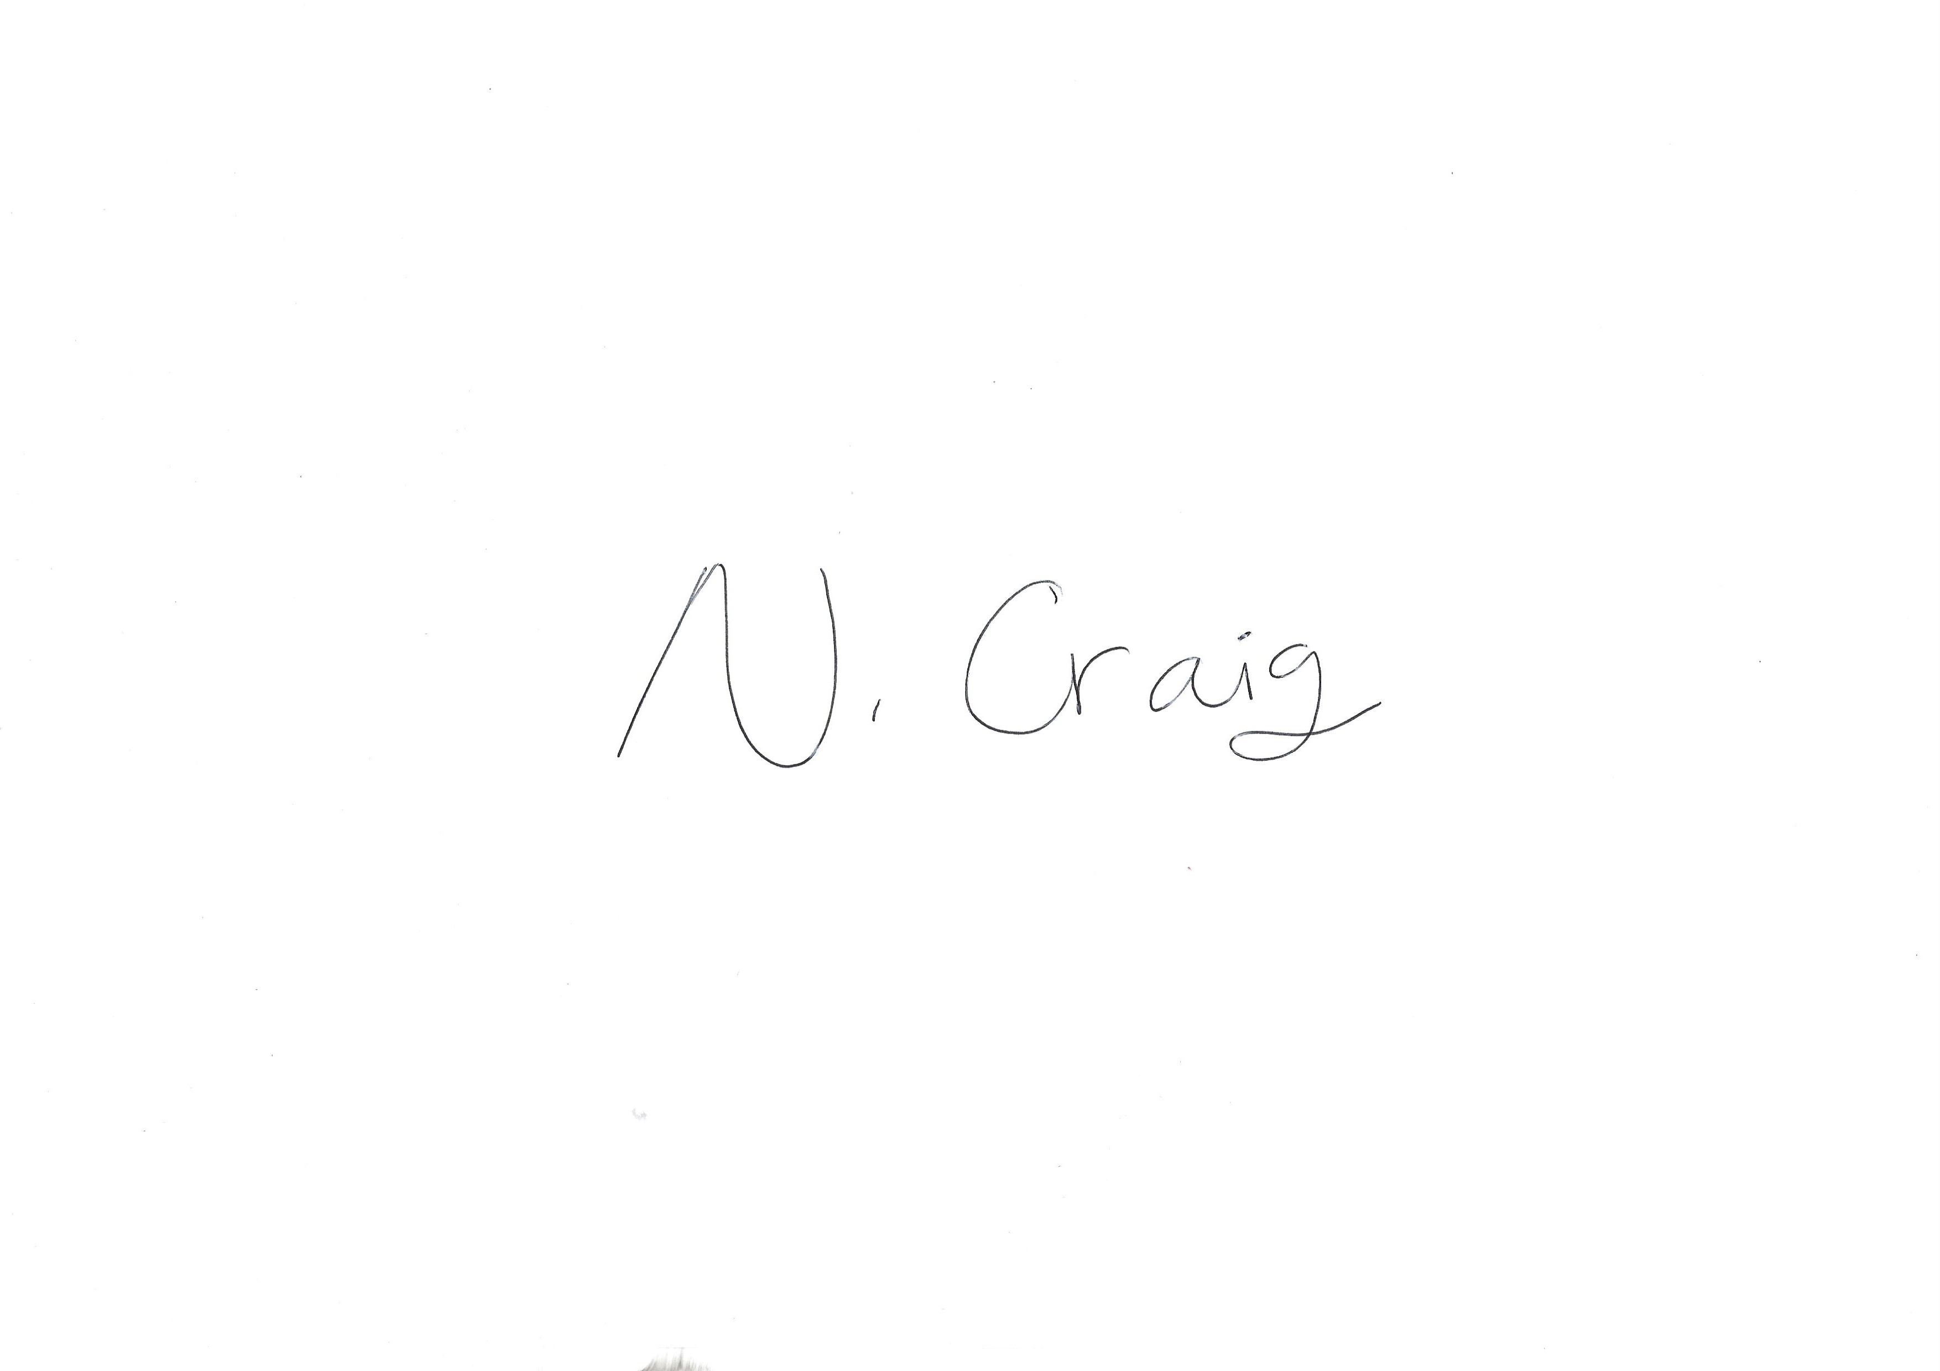  2. | 3. 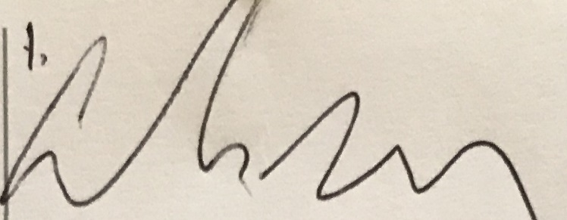
Full name(s) | 1. Nicola Craig  2. Alan Gray  3. Angus Kennedy
Position (e.g. Chair) | 1. Chairperson  2. Bookings  3. Treasurer
Date | 30/05/2026

4

