Trustees Annual Report for the period:
 | Period start date: |  |  |  | Period end date:
 | Day | Month | Year |  | Day | Month | Year
From | 1 | Oct | 2024 | To | 30 | Sept | 2025
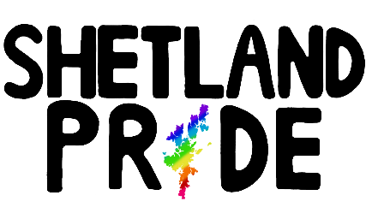

Shetland Pride (SCIO) - Trustees Annual Report 2024-2025.

Reference and Administration.

Shetland Pride (SCIO)
Shetland Pride.
SC051271
www.shetlandpride.co.uk.
34 Bruce Crescent, Lerwick, Shetland Islands.
Postcode: ZE1 0PB.
Charity Name:
Other names charity is known by:
Registered Charity Number:
Website:
Charities Principal Address:

Names of the charity trustees on date of approval of Trustees’ Annual Report:

Trustee name | Office (if any) | Dates acted if  not for whole year | Name of person  (or body) entitled to  appoint trustee (if any)
Gary Mouat | Chairperson. |  | Shetland Pride board of Trustees and its members.
Wayne Leask | Treasurer. |  | Shetland Pride board of Trustees and its members.
Sarah Cooper | Secretary. |  | Shetland Pride board of Trustees and its members.
Tamarra Stevenson | Trustee. | 02/03/25 to present. | Shetland Pride board of Trustees and its members.
Ross Mcginnes | Trustee. | 29/06/25 to present. | Shetland Pride board of Trustees and its members.
Quinn Martin | Trustee. | 29/06/25 to present. | Shetland Pride board of Trustees and its members.

Names of all other charity trustees during the period, if any, (for example, those who resigned part way through the financial period)

Name | Dates acted if not for whole year
Maurice Irvine | Elected as Trustee at committee meeting on 29/06/2025.
Milena Irvine | Elected as Trustee at committee meeting on 29/06/2025.

Structure, Governance and Management.

Type of Governing Document:
Shetland Pride (SCIO) is governed by its constitution.

It has a two-tire structure:

Members – who have a right to attend and vote at members meetings (including the AGM), and have important powers under the constitution.

Board – who hold regular meetings, and generally control the activities of the organisation; for example, the board are responsible for monitoring and controlling the financial position of the charity.

The people serving on the board are referred to in the constitution as Charity Trustees, but may also be
referred to as “committee members” or “the committee” in this report.

Trustee recruitment and appointment:
The current board of Trustees of Shetland Pride (SCIO) was elected in line with the procedures set out in its constitution.

Election of new Board of Trustees at our AGM, held 2nd March 2025:

Gary Andrew Mouat – nominated and elected as Chairperson, no objections. .

Wayne Leask – nominated and elected to continue in Treasurer role, no objections.

Sarah Cooper – nominated and elected as secretary, no objections.

Tamarra Stevenson – nominated and elected as Trustee, no objections.

New appointments to the Board:

Quinn Martin - elected as Trustee on 29/06/25.
Ross Mcginnes – elected as Trustee on 29/06/25.
Maurice Irvine – elected as Trustee on 29/06/29.
Milena Irvine – elected as Trustee on 29/06/25.

All trustees appointed after the AGM were members of the organisation prior to being elected on to the Shetland Pride (SCIO) Board of Trustees.

Objectives and Achievements:

Charitable Purposes:
Shetland Pride (SCIO) was established in 2021 to help, support and champion the LGBTQ+ community living in the Shetland Islands. The charitable purposes set out in our constitution are as follows:

1. to promote equality, diversity and inclusion.

and

2. the advancement of education and community development.

Summary of main activities in relation to these points:
Shetland Pride (SCIO) hosted its fourth Shetland Pride Festival on the 14th June, 2025. The festival took the usual format which included the Pride March in the morning, Pride Village event in the afternoon, and finished the night off with two Shetland Pride parties, one for adults, and one for the LGBT+ youth in Shetland. In addition we hosted a number of activities in the week before, including; arts and craft sessions, pop up shops, media campaigns, and training sessions for the volunteers. The weather turned out to be kind to us this year, and there was a real buzz around the town.

We had two main objectives for the Pride Festival this year:

- The first was that we wanted to make the festival more financially feasible. This meant we introduced more things that generated a small profit which allows us to become less reliant on sponsorship funding. The Shetland Pride festival costs a lot of money every year, and the committee want to ensure the charity is in a strong financial position to continue for many years into the future.

- We wanted to put a focus and emphasis on promoting trans rights and issues after the high court's ruling in April 2025 around what constitutes the term biological“sex” in the Equalities act. We ran a number of posts on our social media platforms, and also tried to raise awareness… around the issue through local media outlets. We had some really positive conversations, but also met some pretty nasty comments online, showing the need for Shetland Pride in the community.

Pop-up Shop, Arts and Crafts, and Training Workshops:

In the week running up to the Pride festival, we ran a pop-up shop where people could come buy some of our merchandise, ask about festival plans, or just have a chat with us in general. It was held in the Islesburgh Community Centre this year, and we had a number of people coming and going throughout the day which was lovely to see. We also held a number of training sessions for Parade and Pride Village stewards in the evenings which were all very well attended. We had a great bunch of volunteers this year, everyone worked very well together and we had a lot of fun.

We also held “arts and crafts” workshops in the evenings. It was important to us that the community had an opportunity to have their voices heard, and hosting these sessions enabled people to come along and make posters for the parade, decorations for Pride events, or just something for a friend or family member. It also provided a safe space to build community and enable people to come along and share their own stories.

Shetland Pride Parade, Lerwick:

There were hundreds of people from all over Shetland that came out to join in protest and solidarity with LGBTQIA+ community in Shetland.

Once again, the Bigton Samba Band led the way and a good 500 strong parade followed them through the stress of Lerwick to our Shetland Pride Village event at the Gilbertson Park. Shetlanders, tourists, organisations, religious groups, clubs, and health and emergency services all made a great effort to be involved in the parade. With increasing uncertainty concerning trans and LGBT+ rights being eroded around the world, Shetland Pride (SCIO) feels there is an increasing need to enable communities to show their support and solidarity with the LGBTQIA+ community.

The committee would liek to give a assive thanks, once again, to the Bigton Samba Band who steer the parade and add so much energy and enthusiasm. We also want to thank all the emergency services who took time to come along and be a part of the parade. We firmly believe that it is important for emergency services to show their support for the LGBTQ+ community. As one of the most vulnerable and harassed minority groups, good relations with the emergency services are essential. Another amazing addition this year was the 1st Sandwick Rainbow Group, a group of around 17 young girls that came along and walked the parade with a pretty powerful message. Last but not least, thanks to all our amazing volunteers who took the time to come along to one of our training sessions and helped steer the parade to the gibby. Everyone was on point, followed their training, and handled themselves very well.

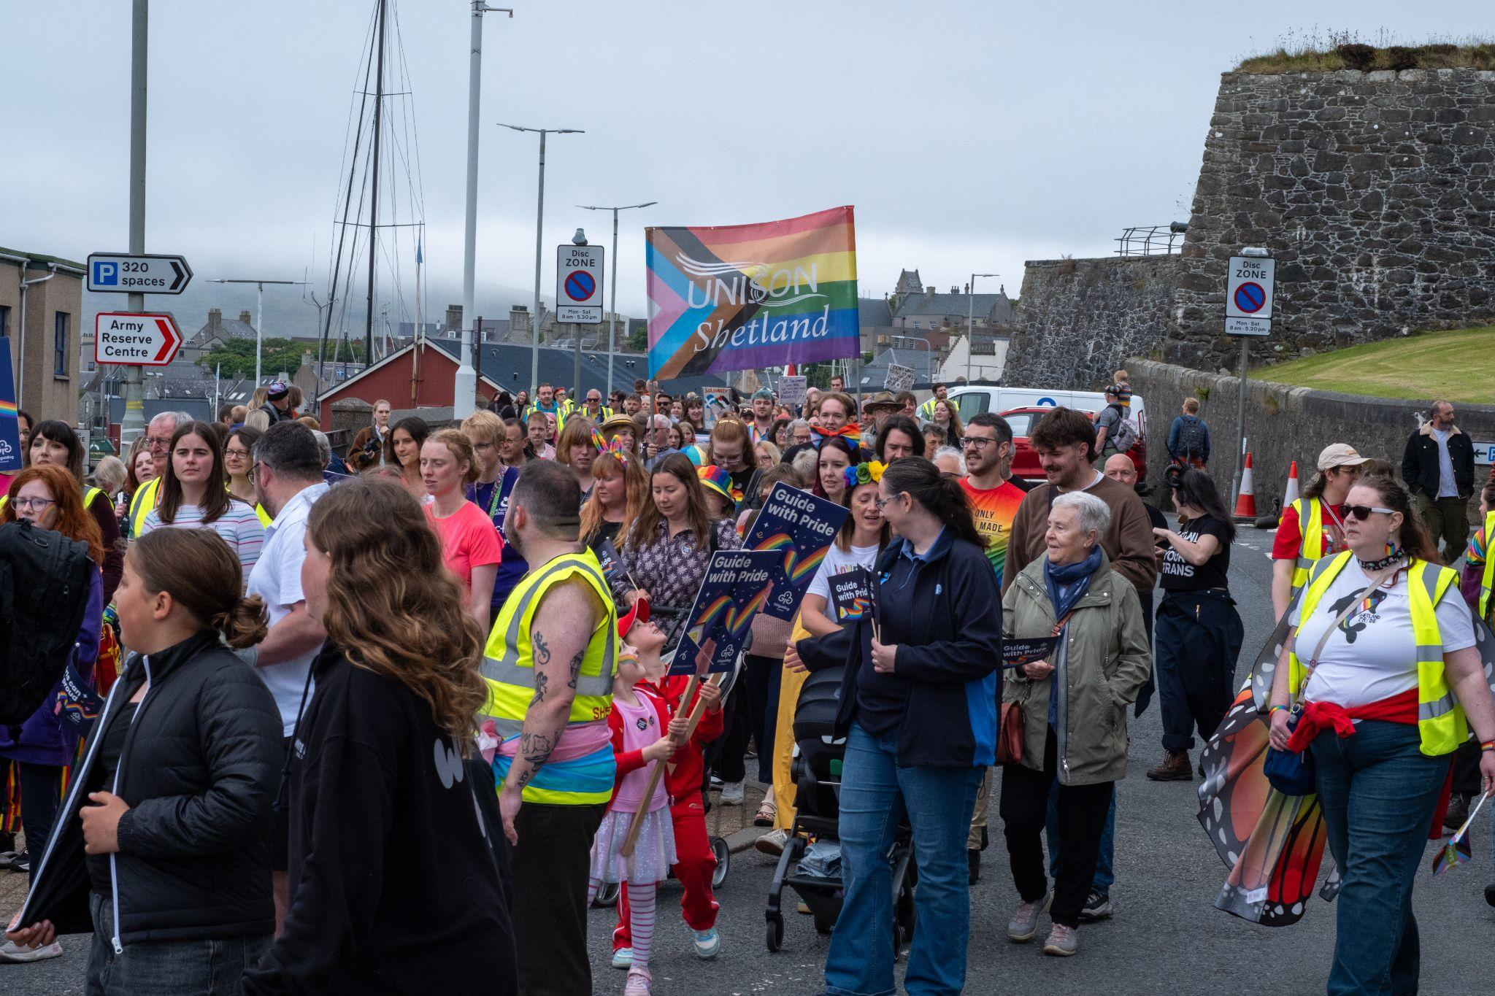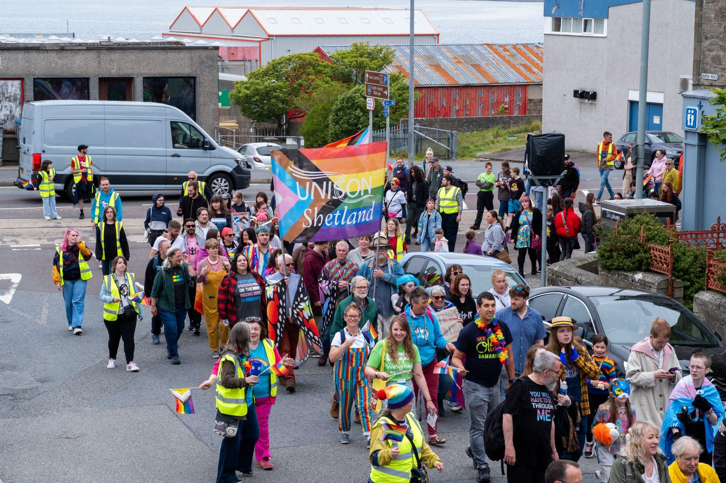

Figure : The parade marshals 2023.

“Pride Village” @ Gilbertson Park, Lerwick:

The parade ended at our “Pride Village” event. Pride village is our family friendly event, where we try to invite as many local businesses and organisations with links to the LGBTQ+ community as possible. After two long years of weather disruptions cancelling all our outdoor plans, we were finally able to set up our stalls and marquee outside again. Thanks to Astral Ariels who came along and let folk try using the Areal hoop, and to Hilary Seatter who also came along to teach Tai chi Quigong. It all helped add to the atmosphere of the day. There were also a number

Inside the main hall, the committee had decided to do the catering this year in a bid to make the festival more financially sustainable. A team of volunteers, headed by Marlyn Watt and Louise Cooling, served sandwiches, cake, tea, coffee, and juice to see the waves of people coming to have a look at what was on offer from our stallholders. Craft items, games, info stalls, local charities and NGO’s lined the four walls of the hall, ready to chat to everyone. We also hired a number of children’s games, played a tombola, and also a raffle prize too.

There was a steady flow of people coming throughout the day, but as the rain set in around 3pm, the crowds started to dissipate, and volunteers began packing up the village for another year.

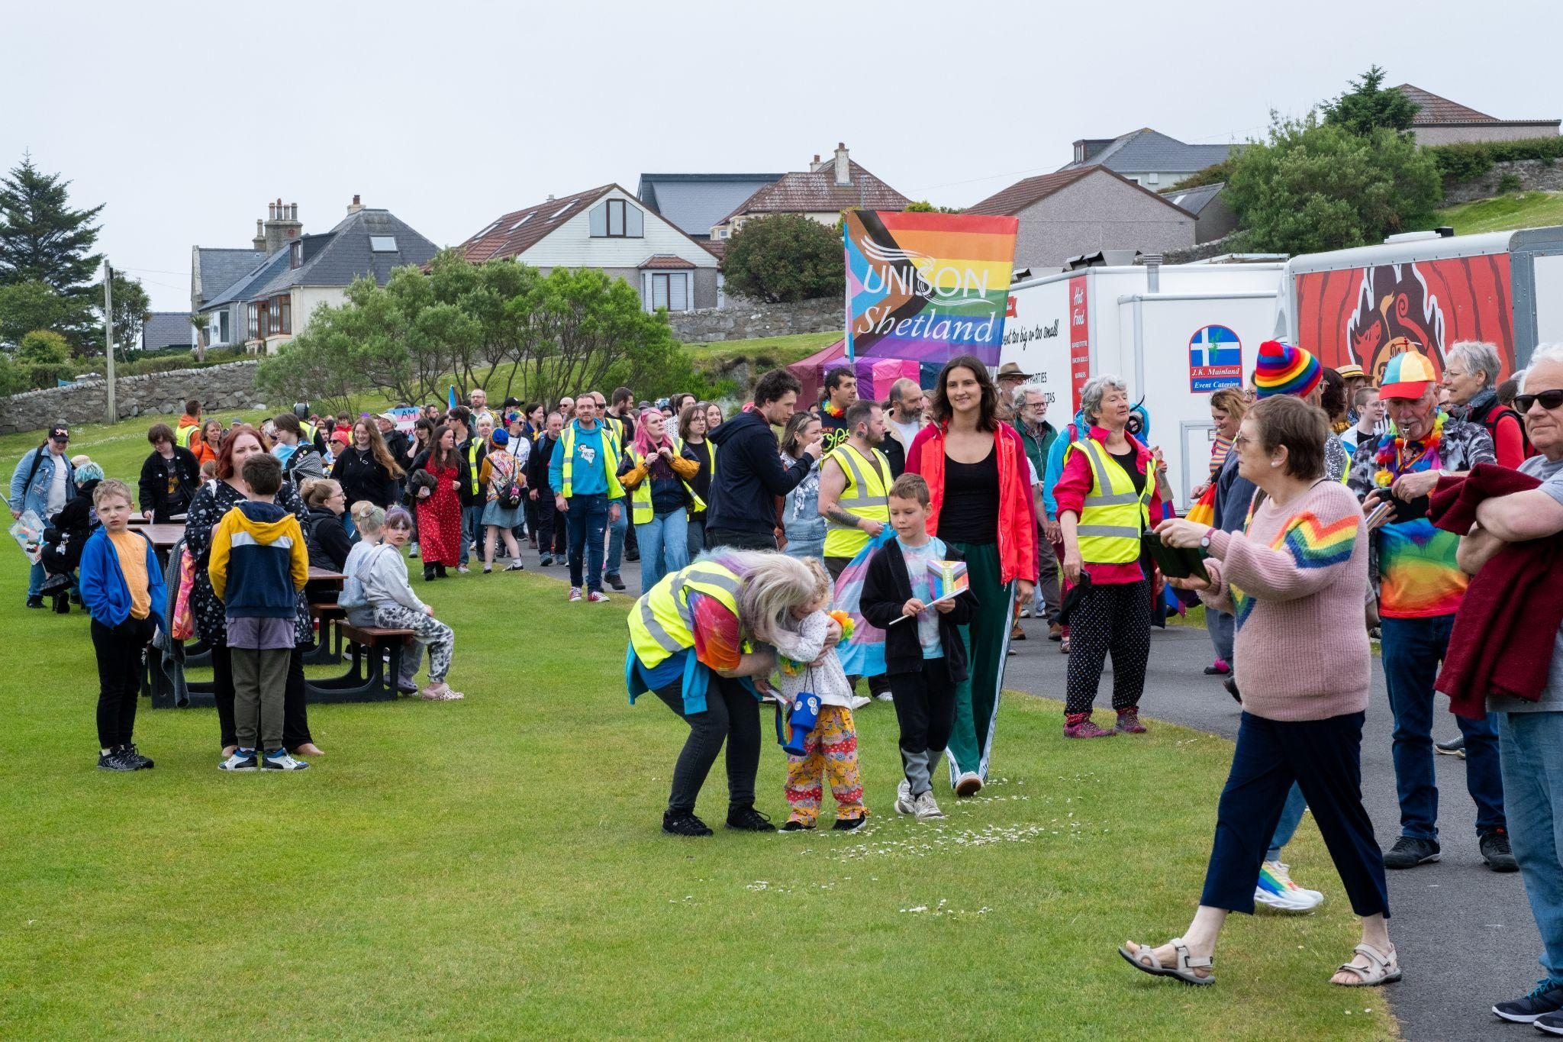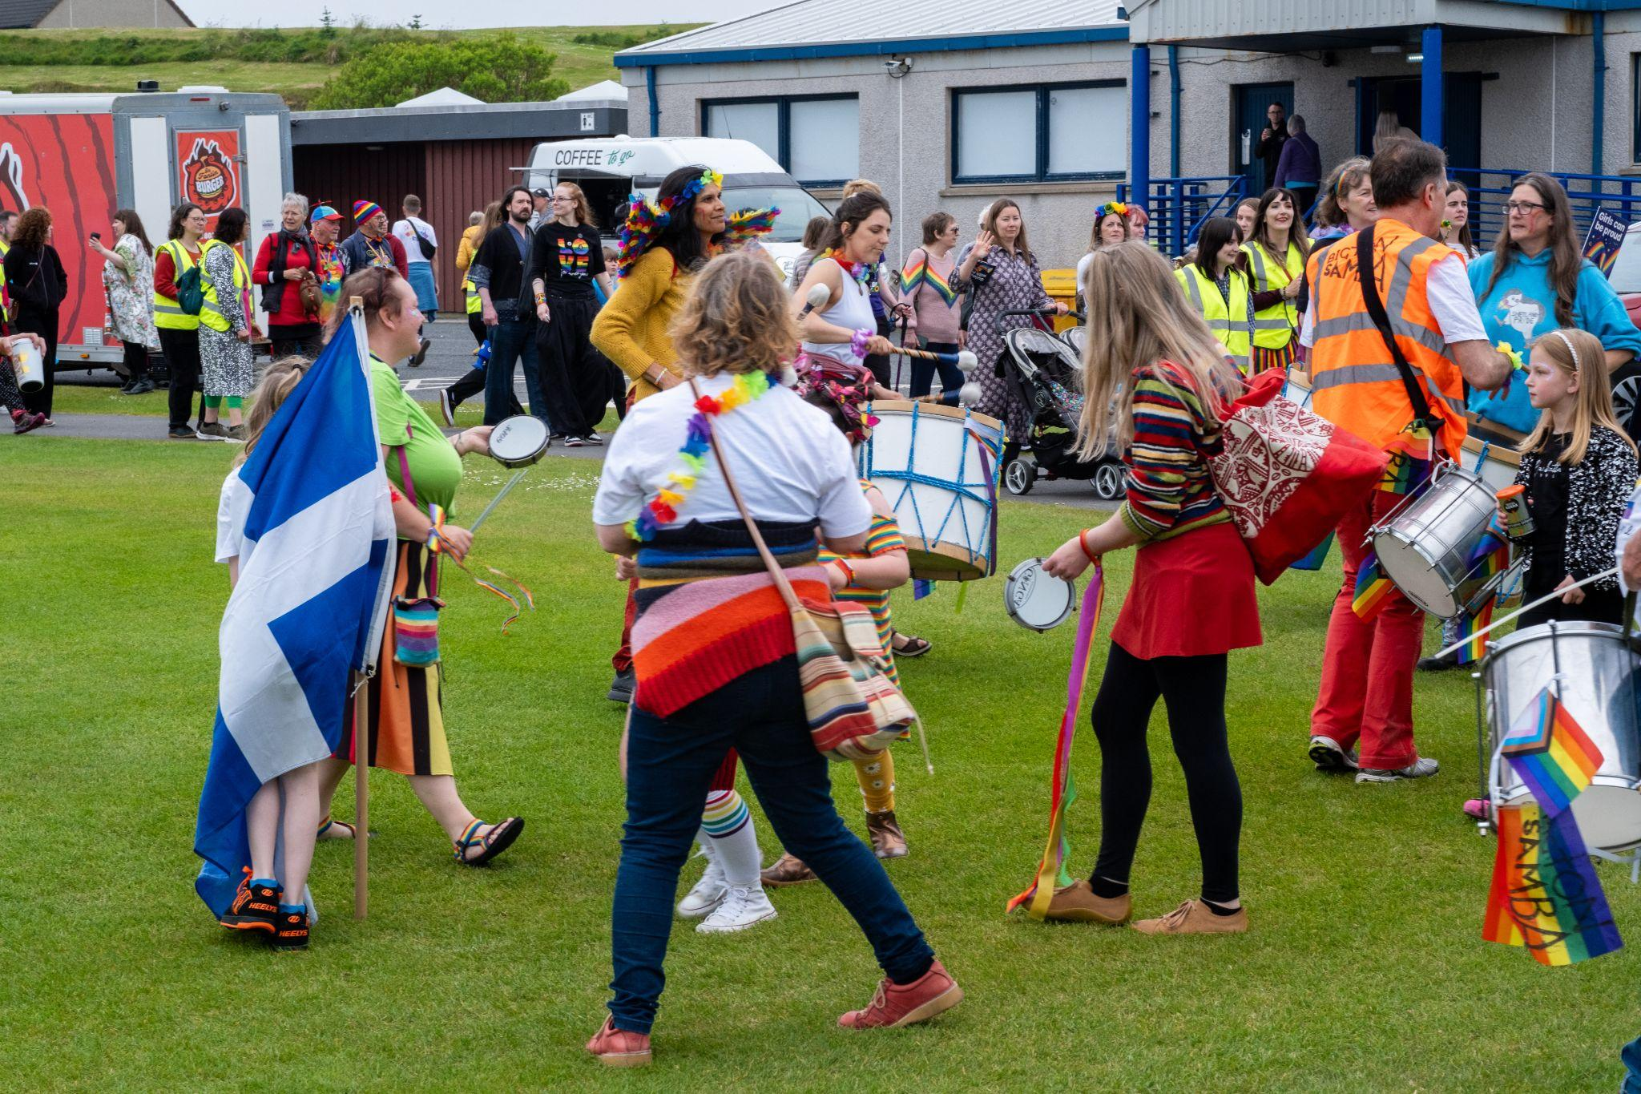

Shetland Pride Adult Evening Party:

Similar to last year, the Adult Shetland Pride evening party (18+) was held at the Sound Hall. The event was well attended and was great way of letting the LGBTQ+ community come together to enjoy themselves and reflect on the day. Local cover band, Toadfish (a Shetland born cover band who also have great connections to the LGBTQ+ community) kicked off the night with some high energy, nostalgia-inducing music that fairly got the crowd going. The committee would like to thank Toadfish for offering to play free of charge as a token gesture to Shetland Pride. It was very much appreciated.
Figure : Main stage at Shetland Pride evening party.
Figure : Drag Queens having some fun with the audience.

The band were the followed by a back to back night of Drag. This year, we had Shetland's very own Victoria Pier, Miss Lily Minogue, Ivy Queen, Krystal Klear, and Daddy Delight. It was a fantastic night of dance, drama, playful insults, laughter, and of course some audience participation to get everyone on their toes. The committee decided to reduce the size and format of the event this year by only hiring one side of the building, and it was commented that this made it a much more relaxed and intimate event.

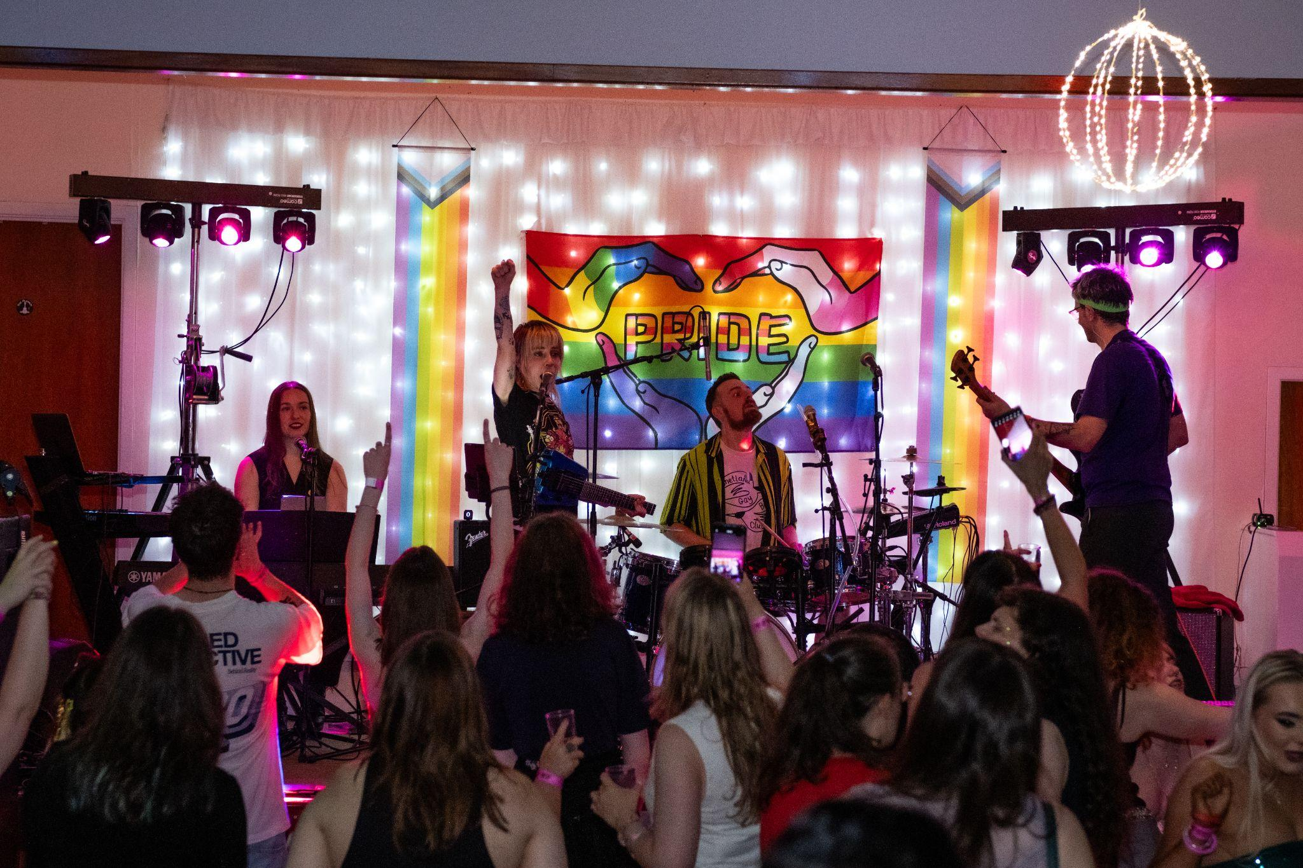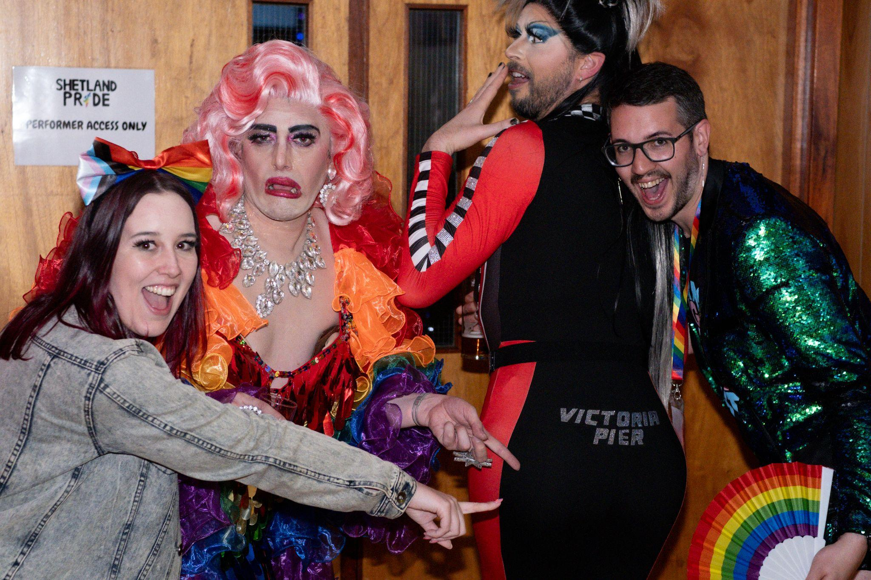

Shetland Pride Youth Party:

The Shetland Pride Youth Party (14-18) was also reasonably well attended. It was held at the Lerwick Legion again, with two local bands, Joking Aside and One Man Disco Band, and three of the Drag Performers also did some *age appropriate* drag performances to finish off the night. We would like to see more young people get involved with this event, but we understand the importance of also providing a space for LGBTQ+ youth to celebrate one of the only LGBTQ+ focused events in Shetland throughout the year.

Shetland Pride Socials - Monthly Meetups:

We launched the first of our monthly meetups in August 2025, which aims to host a monthly meet on the last wednesday of the Month. There has been a number of people, friends and allies alike, from a range of ages and backgrounds, come along for a chat and get to know each other. We played a number of board games to help ease any awkwardness, and got a number of suggestions for some other Ice breakers to play in future meetups. We plan to continue this as time goes on, and couple it with more social outings for Shetland Pride members.

Achievements and Performance:

Summary of the main achievements of the charity during the financial period:
Drag event: An evening with Lily Minogue and Victoria Pier:

Although this event was held in 21st September 2024, so was included in the previous financial year, payment for ticket sales was only received during this financial term. When all expenses were paid, Shetland Pride (SCIO) made around £1300 profit from the event. The proceeds helped to fund the Shetland Pride festival 2025, and also social events that were planned outwith the festival. Another Drag event has been scheduled again for this year, and will take place on the 30th October 2025.

Main sponsorships for Shetland Pride 2025:

This year was relatively low for sponsorships. We received just over £1100 in financial support from external funders. A massive thank you to Sutherland Building Contractors, AEGW Ltd, Unite Aberdeen, and Shetland Aerogenerators for providing sponsorship money this year, it was very much appreciated.

Shetland Pride 2025.

The Shetland Pride Parade was attended by over 450+ local residents, tourists, and a range of organisations throughout Shetland. One of our sponsors, Bolt’s Car Hire Ltd, kindly donated use of one of their flatbed vans to transport our Drag Queens during the parade. A licence to hold the procession was obtained from the local council well in advance of the event. A room was hired in the local community centre to train parade marshals in the week up to the event. We also hired some “boom boxes” to play some loud music during the parade.

At our pride village event, we made a number of adjustments this year in order to make the event more financially stable. The price for business stallholders and food vendors was increased, and the committee also introduced a small payment fee for charities and NGOs this year. The fee for charities and NGOs was waived in previous years because we had excess funding in place, and we felt in the initial years of the Shetland Pride festival, it was important as many organisations with services or links to the LGBTQ+ community could come along and show what they have to offer. We also provided the catering this year, which only made a small profit, that we hope to improve on in future years. We also had a number of children's games, a tombola, and raffle, which also gave us a little extra revenue to help cover the cost of the event.

Ticket sales for the two evening parties were down from last year, but this could be attributed to a number of other high profile events that were on at the same time. The committee received very positive and encouraging comments from those who attended, and participants said they were looking forward to coming back the following year.

Financial Review:

Brief statement of the charity’s policy on reserves:
The Trustees have examined the charity’s requirements for reserves in light of the main risks to the organisation. They have established a policy whereby the unrestricted funds held by the charity should be between 3 to 6 months of expenditure. However, the trustees recognise this sum may only be achieved by building on reserves through operating surpluses that may be subject to grant condition restraints.

Details of any deficit:
Through its activities during 2024-2025, Shetland Pride (SCIO) has acquired a deficit of £1959.54.

Donated facilities and services:
No facilities or services were donated or transferred.

Declaration:

The Trustees declare that they have approved the Trustees’ report above.

Signed on behalf of the charity’s Trustees:
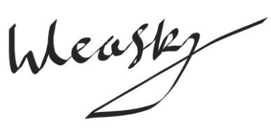
Wayne Robert John Leask

Treasurer

15.06.2026

Signature:

Full Name(s):

Position:

Date:

