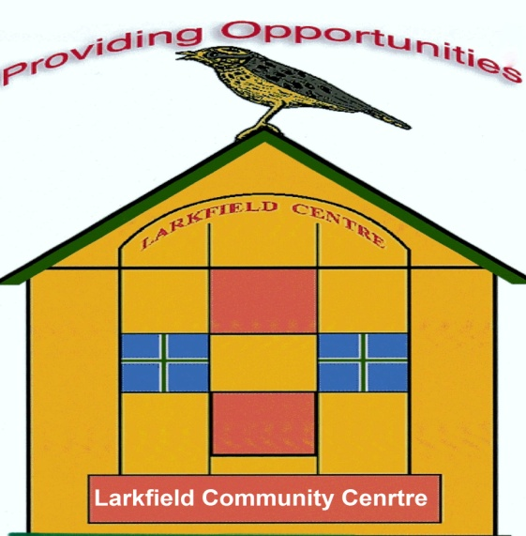
Larkfield Community Centre
39 Inglefield Street, Govanhill
Glasgow G42 7AY
0141-424-1797
Http://larkfieldcentre.weebly.com/index.html
larkfieldcentre@btconnect.com



Board Members/Trustees 2025/2026 and 2026/2027

Board Office Bearers/Trustees

Chairperson/Trustee Marion Nisbet
52 Bennan Square
G42 8SX

Vice-Chairperson/Secretary/Trustee Louise Laing
433 Kilmarnock Road
Glasgow G43 2NT

Treasurer/Trustee Carol Ann Graham
3/1 42 Pollockshaws Road G41 1PY

Board Member/Trustee
Margaret Walker
347Calder Street
G42 7NS

Patricia Gaffney
54 Inglefield street
G42 7AT

Andrew Carberry
37 Bennan Square
G42 8SU

