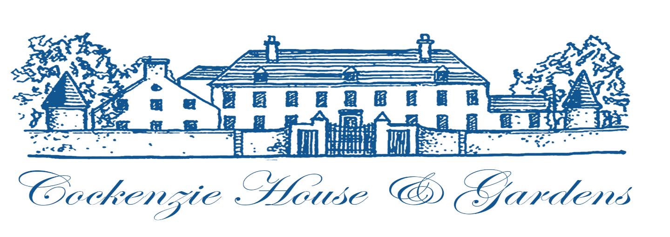
Trustee Statement 2024 – 25

ACHIEVEMENT AND PERFORMANCE
Charitable Activities
This year to end September 24 completes our twelfth year of operation in Cockenzie House and its gardens. We continue with our low cost workspaces or studios, self-catering accommodation, a popular café, meeting space and local heritage exhibitions.

Our 50 studies continue to enjoy full occupancy and our community of dynamic and entrepreneurial small businesses, therapists and artist thrive within the building. They have created a vibrant community within the communities of Cockenzie & Port Seton. Supplementing the activity of the studioholders, the small core team continues to offer No 22 Gift shop selling largely locally made crafts and the gallery spaces used by local artists.

As in previous years, we hosted a number of events including the monthly summer Retro, Collectables and Flea Markets and live music events, EH32 Live featuring local youth bands. We are delighted to say that Cockenzie House & Gardens continues to be the much loved and very well frequented hub used by locals and visitors to East Lothian alike.

Cockenzie House & Gardens is run by a small core team. This team relies heavily on the time and support provided by our volunteer team. Without the help of these volunteers, Cockenzie House & Gardens could not have operated throughout the year.

In April 2024, the charity purchased Cockenzie Old Parish Church and its Hall from the Church of Scotland, now known as the Auld Kirk and the Auld Kirk Hall respectively. This was made possible by an award of £227,000 from the Scottish Land Fund. With the help of £45,000 from East Lothian Council’s Community Intervention Fund, refurbishment work commenced to bring the buildings up to modern regulations. This award was quickly exhausted and the Charity met the remaining costs from its reserves. The Hall started to provide low cost spaces to rent for two small businesses.

FUTURE PLANS
The charity has no plans to change their current operations. Their aim is to complete the refurbishment of the Auld Kirk so that it can be used by the community. Cockenzie House and its gardens are limited both in size and by their Category A status. This prevents expansion. Nevertheless the charity is committed to finding new and innovative ways to enrich the lives of those in the growing communities of Cockenzie & Port Seton.

The Trustees
Cockenzie Houses & Gardens
SC044016

