Evie Community Association

Registered Scottish Charity SC 051071

Trustee Annual Report

Annual Report

For The Year Ended 31 July 2025

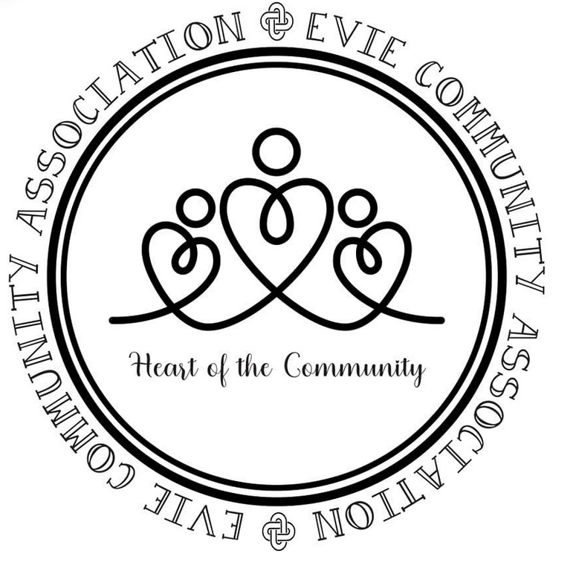

Contents | Page
Charity information………………………………………………… | 3
Trustee Annual Report ……………………………………………. | 4

Note:
The Evie Community Association Accounts and the associated Independent Examiner’s Report are uploaded to the OSCR website as a separate submission, and as such is not discussed within this report.

Charity Information
Trustees: | Mrs R Scott – Chair  Mr R Foubister – Vice Chair  Miss M Garriock – Secretary  Mrs Nicola Scott  Mrs M Hinckley  Mrs Lynda Heddle  Miss Ginette Spence
Charity Number: | SC 051701
Principle Address: | Stenso  Evie  Orkney  KW17 2PJ
Independent Examiner: | AJB Scholes Limited  8 Albert Street  Kirkwall  Orkney  KW15 1H
Banker: | Bank of Scotland  56 Albert Street,  Kirkwall,  Orkney  KW15 1HJ

Trustee Annual Report for Year Ended 31 July 2025
Structure, Governance and Management
Constitution
The Evie Community Association was successfully registered as a Scottish Charitable Incorporated Organisation (SCIO) by the Office of the Scottish Regulator (OSCR) on the 22nd April 2022. All assets previously held by the unregistered Evie Community Association (also referred to as the Evie Link Centre) were transferred to what is now known as the Evie Community Association SCIO – SC 051701. The latest Constitution of the Evie Community Association (SCIO) is at Version 1.1, dated 20 April 2022.

Appointment of Trustees
In accordance with the Evie Community Association (ECA) Constitution, trustees are elected/re-elected at the Association’s Annual General Meeting.

Trustee Changes
No changes.
The treasurer, Nicola Scott, stepped down at the AGM on 20 March 2025 and Emma Chattington was elected as Treasurer on the same date. Nicola remained a trustee for the time being.

Management
A Management Committee is made up of Community Association trustees along with other members of the ECA. There must be a minimum of 4 elected trustees to take up the roles of Chair, Vice-Chair, Secretary and Treasurer. The Management Committee is responsible for the running of the association and managing the operation of the Community Facility.

The Evie Community School Headteacher is responsible for the care and maintenance of the Community School buildings and services. The care/maintenance of the Community areas used/managed by the Evie Community Association fall within the School Headteacher’s area of responsibility. However, the Community Association has a responsibility to the School Headteacher to report any matter that may affect their ability to achieve the safe and satisfactory management of the Community School estate.

Objectives (Public Benefit)
The objectives of the Association, as laid out in the constitution are:
- To maintain and manage a community centre for activities;
- To enhance the wellbeing of the Evie and Rendall parish residents and the wider community by improving the opportunities in a rural environment.

Activities
The Community Areas are used for a wide range of meetings, and is hired out to groups, clubs and individuals from the parishes of Evie and Rendall, along with the surrounding area, in accordance with the objectives.

Staff and Volunteers
The Evie Community Association (ECA) employ no staff; but may be assisted by volunteers in the organisation and running of events sponsored by the ECA.
Trustee Annual Report for Year Ended 31 July 2025 (Continued)

Booking Charges
Main Hall | £20.00
Main Hall – for regulars | £15.00
Community Room | £15.00
Community Room – for regulars | £10.00
Main Hall & Community Room | £30.00
Children’s Parties – Bouncy Castle Hire (including hall hire) | £60.00
Wedding or similar function – Main Hall & Community Room – by Arrangement. School Kitchen hire by separate arrangement | From  £200.00

Notes:
- Rates are for hires up to 3 hours, unless otherwise denoted, and includes the use of the Community Kitchen.
- The above prices do not include any cleaning which may be needed. All users must leave the facilities in an orderly and clean fashion, ready for the next user.

Achievements
Usage of the Community Areas 2022 – 2025
 | 2022 - 23 | 2023 - 24 | 2024 - 25
No. of Bookings taken for year  (3 rooms plus kitchen) | 177 | 161 | 171
Community Association Sponsored events | 3 | 4 | 3

No. of Hirers of Rooms in Community Areas | 2022 - 23 | 2023 - 24 | 2024 - 25
Regular (Monthly) | 2 | 2 | 3
Regular (Weekly) | 3 | 3 | 3
Occasional (less than monthly) | 5 | 4 | 5
Casual (once only) | 24 | 15 | 12
Total No. of hirers | 34 | 24 | 23

Trustee Annual Report for Year Ended 31 July 2025 (Continued)

Groups and Organisations using the Community Areas
Evie Community Association
Evie Community Council
Evie and Rendall Steering Group
Evie and Rendall Community Park Group
External organisations for their own AGM, or other public meetings
Evie Community School Parent Council
Baby and Toddler Group
Children’s parties
Children’s End-of-Term Discos
Costa Scottish Women’s Institute
Craft Group
Over 60’s Lunch
Netball Training
Excursions Limited

Trustee Annual Report for Year Ended 31 July 2025 (Continued)

Summary of Achievements

The Community Association continued to respond to demand for the use of the Community rooms for children’s Birthday Parties with the Bouncy Castle being booked alongside, on many of these occasions. The annual safety check on the bouncy castle took place in the summer and the committee are pleased that it is still in very good condition.

We have continued to receive bookings for tour bus comfort breaks, which is a straightforward and quick boost to funds.

The Evie Community Council continued to meet in the Community Rooms, thus enabling a more efficient environment through which to help bring improvements to their constituents. In addition to the Community Council, a Local Place Plan Steering Group have been set up to work alongside the Community Council. They have been meeting regularly and have been feeding back to the ECA on progress and the types of things people have suggested that the ECA may be able to help with.

From this feedback, we ran a “Supper and Swadge”, which is a community run supper evening, and was exceptionally well attended. We have two new committee members who came on board to specifically look after this and it covers its own costs. As it was so popular it was agreed that it would become a regular event going forward. We have linked in with Environmental Health to carry out the necessary inspections.

The Over 60s Lunch Club, held on the first Wednesday of the month (during the School Term), continued to be supported by the Evie Community School Catering Team, and thus was able to provide a lunch to the senior citizens of the parishes, with the average attendance at each event being in the order of 20+ diners. The Christmas Lunch Club was attended by 35 diners and this year the children of the school came to share Christmas cards and songs. It was a great opportunity for intergenerational working.

The Baby and Toddler group have maintained a good level of attendance and have also had a couple of outings together in the last year. They are looking at possible funding to purchase new play equipment.

Netball training was held each Friday evening, during term time, with an average of 13 attending each session.

Our craft group meets weekly and has welcomed several new members this year to an enjoyable and productive couple of hours.

Costa SWI holds monthly meetings and has been entertained by some excellent speakers during the year.

The ECA also hosted a Craft Fair, and provided a café all day. This is the main fundraiser for the group and was very well attended. The ECA offer the parents of the primary 7 (P7) pupils the opportunity to fundraise at this event for their annual school trip to Hoy. In addition to this, the ECA also gave free hire of facilities to the P7 group to host a family games night which was very successful.

The annual Christmas Tree switch-on festivity continued to be a popular event with the members of the parish. This event receives very positive feedback and we are delighted to be able to offer it as a free event. We have agreed to request funding to support this through our Community Council.

Approved by the Evie Community Association Trustees at the Annual General Meeting on 21 April 2026 and signed on their behalf:

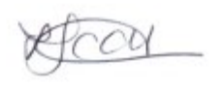

R Scott – Chair

