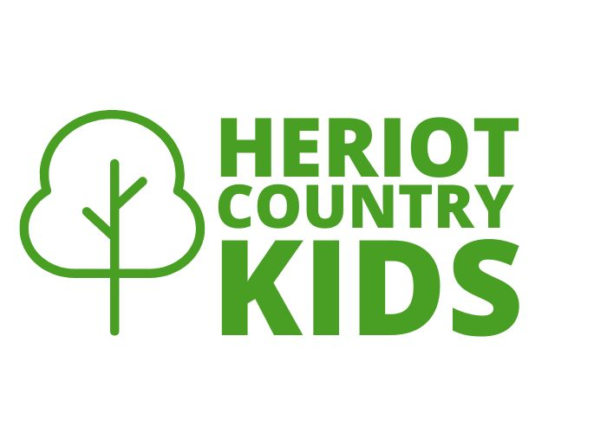

High quality out-of-school care in
A rural setting

Trustee Report
2024-2025
Our purpose
Heriot Country Kids was set up in 2019 by a group of parents, with the aim of providing the best out of school care for the children in the Heriot community, and surrounding communities. We do this by:
- providing a safe, caring and stimulating environment for the children attending the group
- ensuring that a wide variety of activities are available
- employing staff and supporting them in their training and development
- raising the profile of the group within the community and surrounding area
- encouraging other charitable activities through which local families can support the development of children and raise money for Heriot Country Kids
Who we help
We currently have 12 children attending afterschool club on a regular basis, with additional ad hoc bookings.

Regular booked sessions are currently at around 15 per week.

We employ 2 permanent staff members and have 3 who can support on a casual basis.

Through 2024/25 we have been extremely fortunate to be running Easter and summer holiday with the license allowing us to operate outside term time. 14 children attended our one-week Easter club with 19 attending our summer holiday club over the course of two weeks.

We continue to promote Heriot Country Kids via email, social media and the school parents WhatsApp group.

Feedback from families we help
“My kids attend afterschool club on a casual basis and really enjoy their time there. I find it really easy to book them in at the last minute should something have come up or if they just decided they’ll really like to go for the afternoon. It's wonderful that the booking system is so flexible.”

“My daughter has really enjoyed every time she has been to heriot country kids club.”

“A wonderful service to have with great staff and committee running it. It’s a huge asset to the school and local community.”

“Our kids love going to after school club, especially doing all the amazing crafts, baking, quizzes and putting on performances with their friends.”

What we did in 2024-2025

We continue to have Maelle Guizard as our manager with her continuing to expand on her national qualifications. We recruited a new permanent play worker to work alongside Maelle. Jan Coom, who has been the dinner lady at our sister school Fountainhall Primary, joined us in August 2025 and all the kids already know her which has been very successful.

We started theme weeks which the kids have enjoyed as well as some themed party events including Halloween, Christmas andEaster. We also had a movie afternoon at our local Macfie Hall.

Funding
As a small rural facility, our setting is not self-sustaining via user fees. 2024/2025 was year 3 of the Greencoat Carcant Community Fund, a three year funding agreement. We were also granted several small community micro grants for various outgoings throughout the year including equipment and snack funding during holiday clubs.

We received a grant of a total of £40,000 from the Bacon Foundation with the final installment of £20,000 on 5 July 2024.

This second grant installment enabled us to cover the following: additional staff support, healthy snack provision, insurance costs, accounting software for 1 year, team building activities, indoor play equipment, a new outdoor climbing frame and a portion of additional staff member’s wage.

We continued to be supported in kind by Heriot Primary School and Scottish Borders Council, who again permitted us to use their facility for afterschool club - our continued thanks go to them.

What we achieved
- We continue to get positive feedback from club users, retaining our staff team and providing a stable, nurturing environment for our children.
- In a challenging time for childcare services, when many settings are struggling amid the cost-of-living crisis, we've performed well this year and maintained our position.
- Both playworkers continue with national qualifications.
- We hosted our annual Heriot Community Bonfire Night again which raised much needed funds for Heriot Country Kids. This is always a very successful event and is well attended by the local communities.
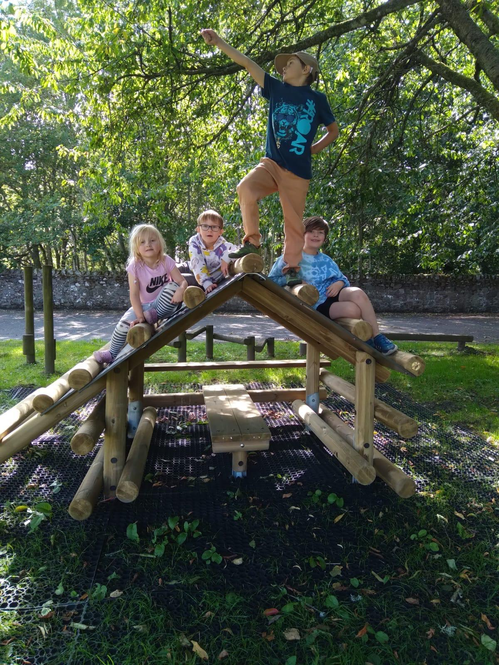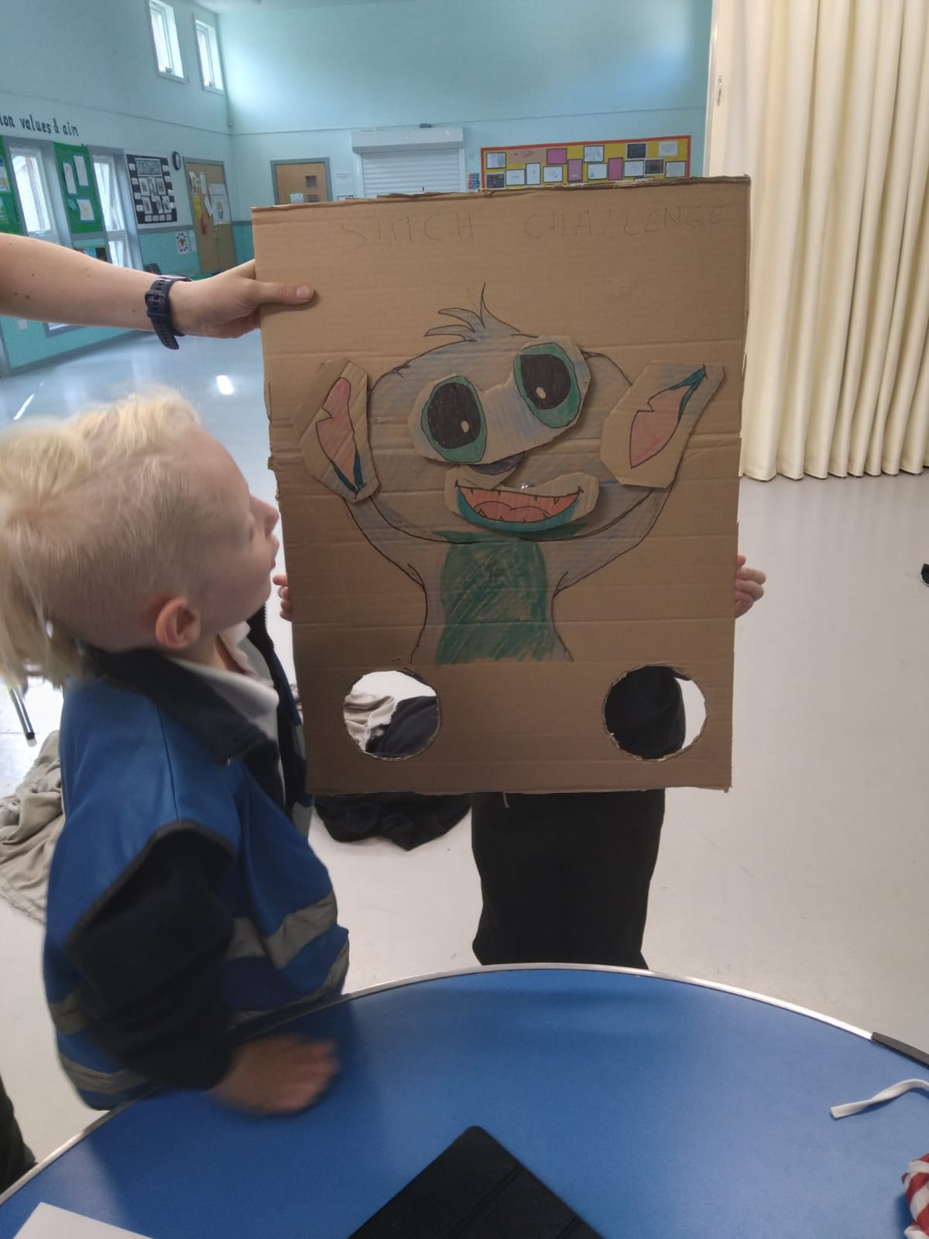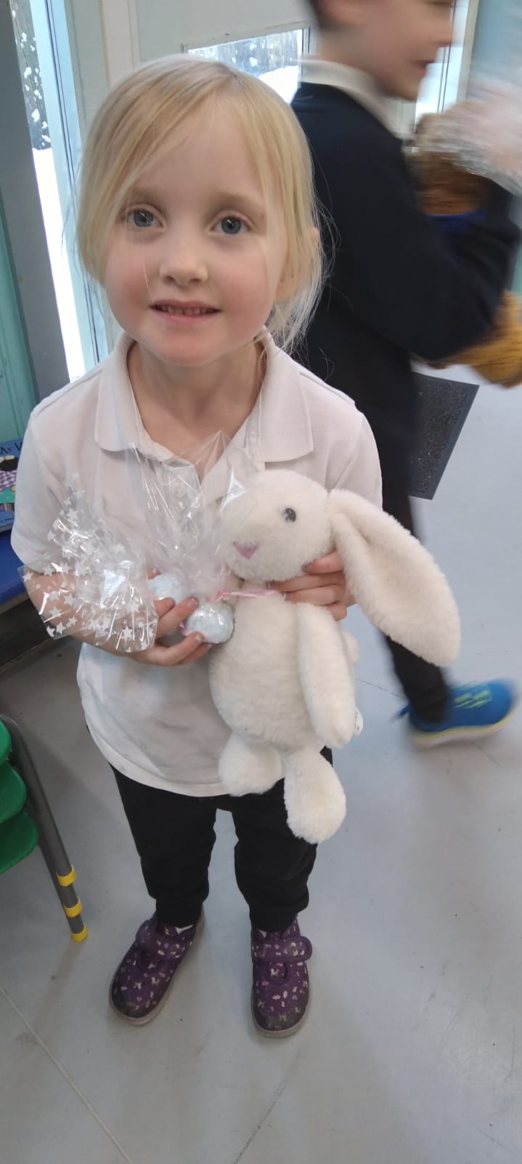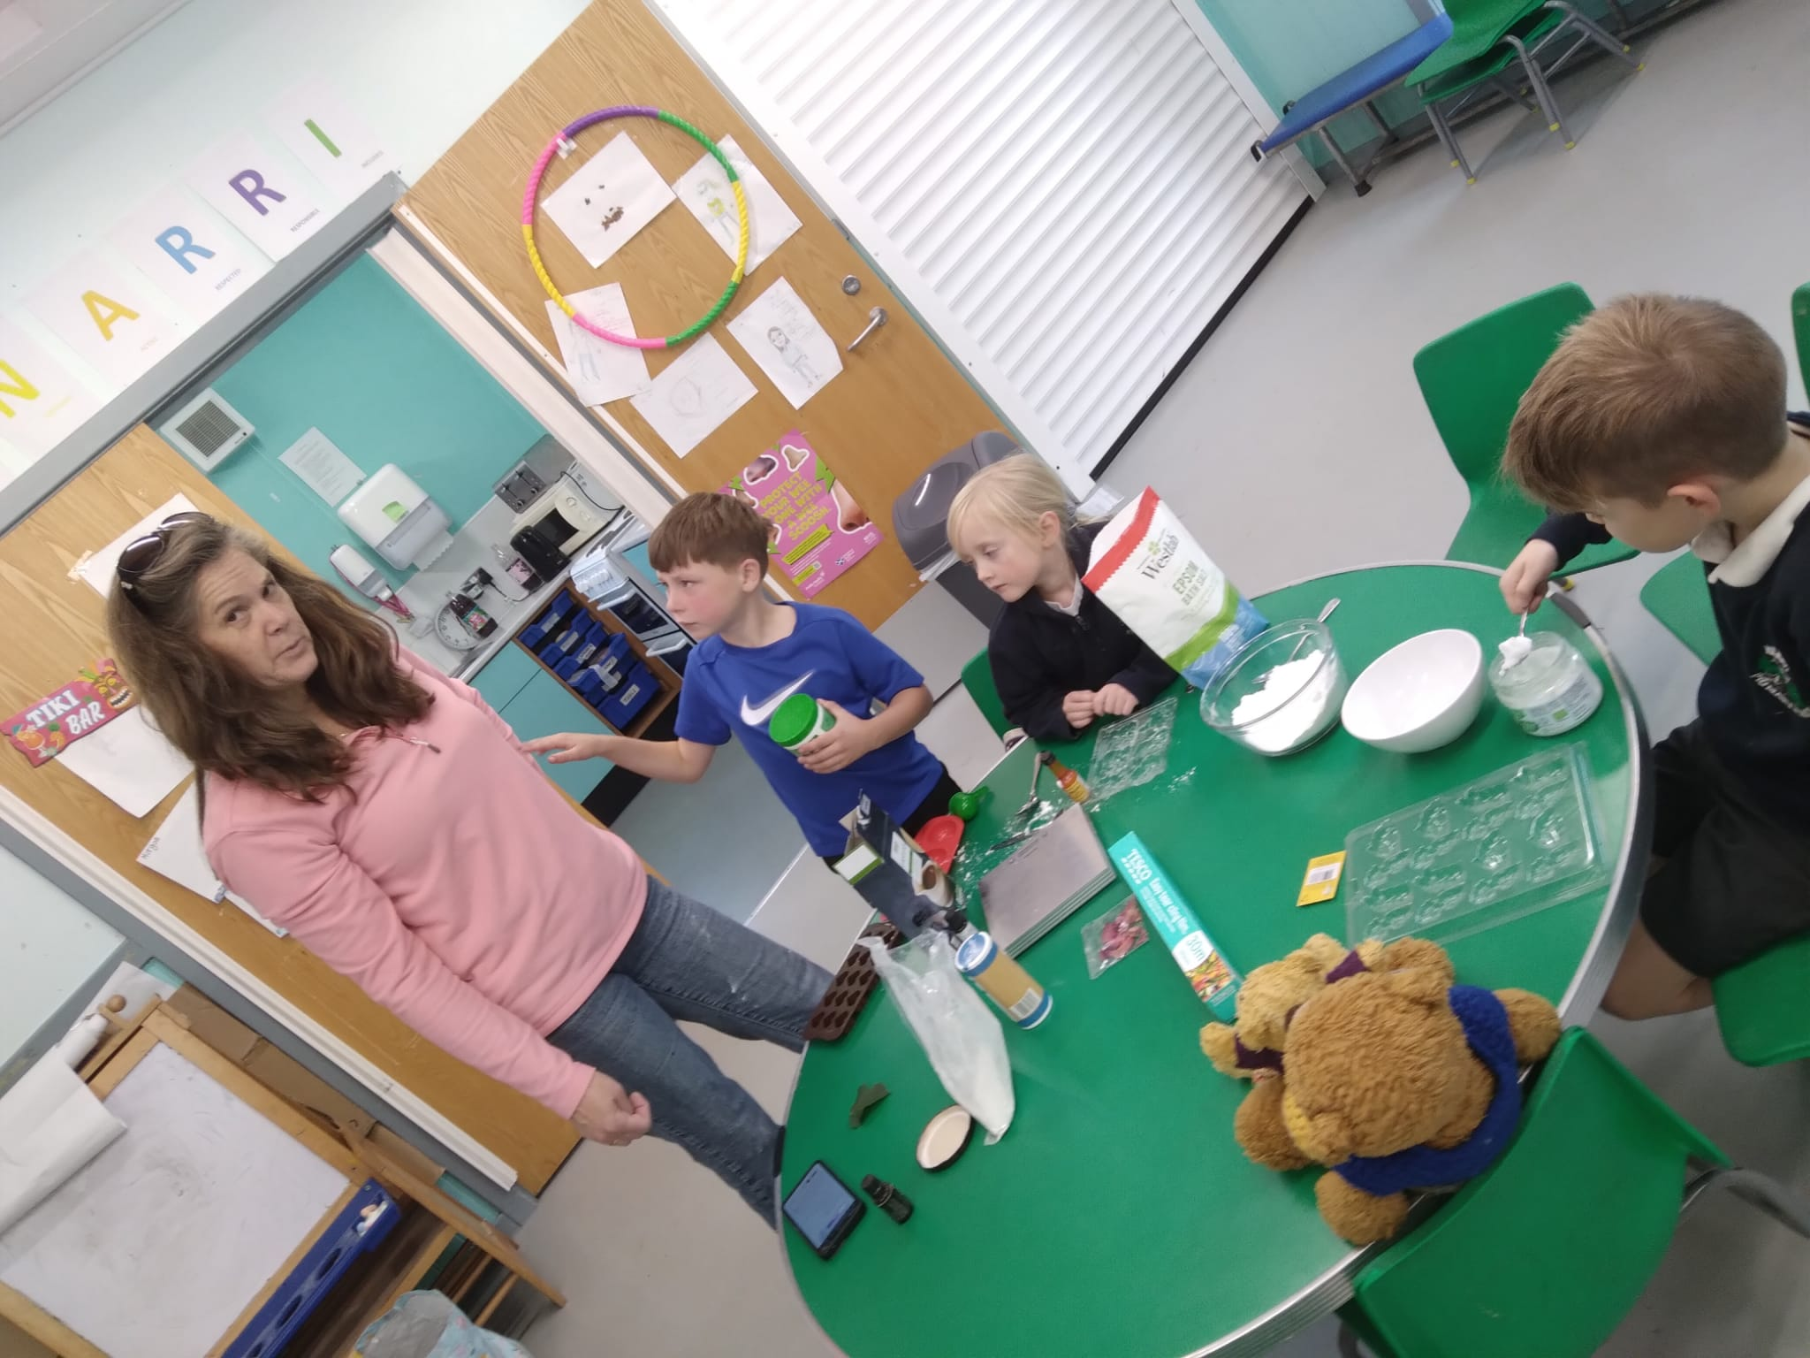

The difference we made
Our club is important to the children themselves - it’s a place where they spend time with friends and make new ones, have fun and have time to relax in a space where they feel safe and nurtured.

It’s crucial to families, in a location where there is no viable alternative wraparound care - and ever more so as we enter a cost-of-living crisis which means that families need to keep being able to do their jobs.

It contributes to the viability of Heriot Primary School, and the sustainability of the wider Heriot community.

Thank you for reading our Trustee Report for the year 2024-2025 and for your support of Heriot Country Kids.

pp.Jakub Kebisek

Jakub Kebisek (Chair) on behalf of the committee

Date 15.03.2026

