Cymera Festival
Treasurers Report 2024-25
Accounts 2024-25
The Annual Report and Financial Statements for Year End 30th November 2024 was submitted to OSCR on 10th July 2025
The final balance for 2023-24 was £1,913.
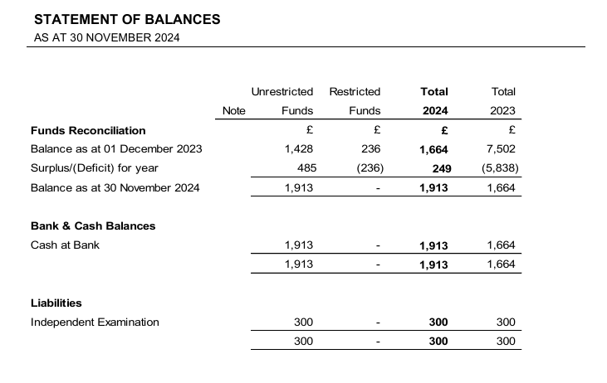

Accounts 2024-25
The final balance on 30th November 2025 is £6,650.32.
Income
In line with the charity’s business plan Cymera has been funded through a mix of self-generated income and external support in the form of grants, donations, and sponsorship.
The charity has received the following in grants, donations, and sponsorship:

Grants and Donations 2024-2025
Creative Scotland | 17597
Scottish Book Trust | 700
Donations | 500
Sponsorship | 800
Total | 19597

One fund was restricted for the delivery of specific projects:
£700 from the Scottish Book Trust towards Speaker Costs for the Cymera Writers Conference 2025
By 30th November 2025 total expenditure on Speaker Costs for the Cymera Writers Conference 2025 was £1,008.02.
Speaker Costs - Cymera Writers Conference 2025

Stripe/Sumup sales made up of sales income from tickets, merchandising and the Cymera auction. This income increased by 39.23% on 2023-24
Total Income 2024-25
Grants | 18297.00
Stripe/Sumup Sales | 57588.59
Booksale | 1032.00
Sponsorship | 800.00
Donations | 500.00
Total Income | 78217.59

Expenditure

Total Expenditure increased by 16% over 2023-24. This can be attributed to the overall increase in goods and services and the expansion of the project to include a Writers Retreat in November 2025.

Due to cashflow issues in July 2024 the Charity accepted a loan from its Chair of £2,500. This was repaid in April 2025. This has not been included in total expenditure.

Total Expenditure 2024-25
Marketing | 637.25
Speaker Costs | 27573.24
Venue Costs | 18163.49
Hospitality/Accommodation | 12138.56
Admin Costs | 620.75
Transport/Travel | 153
Staffing Costs | 6424.78
Merchandise | 1363.46
Digital Events | 3110.22
ICT Web & Social | 611.32
Total Expenditure | 70796.07

Cymera Income and Expenditure by Month 2024-25

