THE AITEAL TRUST
(Registered Charity SC060559)

The Aiteal Trust
Trustees’ Annual Report
12th January 2025 - 11th January 2026

Charity contact information


Your charity’s name
Scottish Charity Number: SC050669
Address Inglewood House, Comrie, Perthshire
Postcode PH6 2EA
Telephone number 01764 679011
Email address kating1@kating1.plus.com
Website www.theaitealtrust.com

Charity Trustees

- Kate Sainsbury, Chair - Inglewood House, Station Road, Comrie, Perthshire, PH6 2EA. Email: kating1@kating1.plus.com Telephone: 01764 679011DOB 3.06.1959 - Founding Trustee - 12.01.2021
- Charity Trustee Rachel McLeod, Secretary - Campfield, Dalginross, Comrie, PH6 2HG - Email: r_mcleod@hotmail.co.uk Tel: 01764 670996 - Founding Trustee 12.01.2021
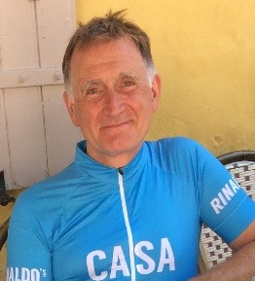
- Charity Trustee Nick Wharton, Treasurer – 37 Sedbergh Road, Kendal, Cumbria, LA9 6AH. Email: nickwharton95@gmail.com Telephone:07811 912161 DOB: 30.06.1963 – Founding Trustee – 12.01.2021
- Charity Trustee Jane Jackson - Maidenplain Farmhouse, Aberuthven, PH3 1HJ Email: mail@janejackson.co.uk Tel: 07779 788485. DOB 18th September 1965. Founding Trustee - 12.01.21
- Charity Trustee Helen Martin - 7 Rintoul Avenue, Crieff, Perthshire, PH7 3SJ - email strathview11@gmail.com. Telephone 07718 395442. D of B - 2nd October 1970. Founding Trustee - 12.01.21
- Charity Trustee Maureen Philip - 44a Gray Street, Perth, PH2 0JL -Email maureen.phillip116@gmail.com - Tel 07775028774 - DOB 28/09/1954 - Founding Trustee 12.01.21
- Charity Trustee Loren Kirk - Kirkton Cottage, Stirling Street, Black-ford, Perthshire, PH4 1QG. Telephone – 07701334570 DOB 18/08/1986 Trustee - since February 2024
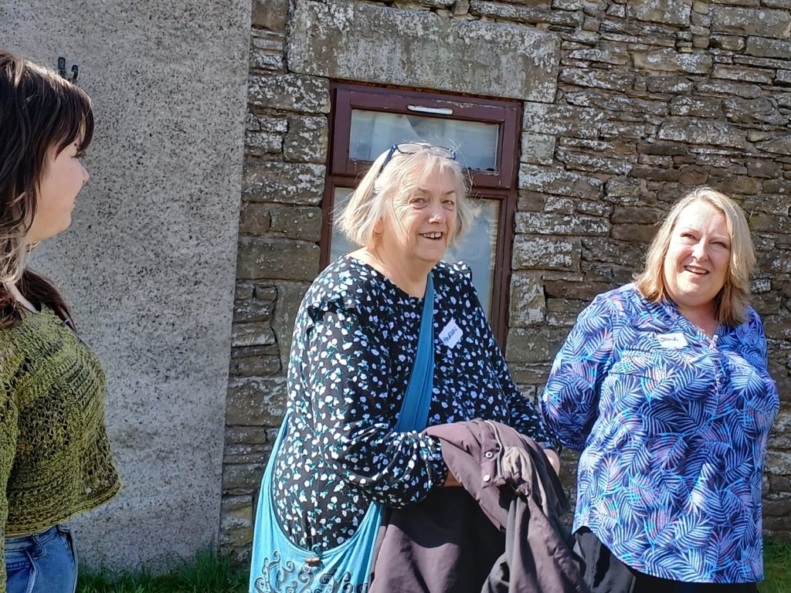
Trustees Maureen Phillip, (centre) and Jane Jackson (right) with volunteer Heather Souter (left)

Patrons
Laura Mcardle, contributes her life experience of living with PMLD, enriching our community gatherings with her presence. Laura also bring her family and carers into our network.

Rory Stewart, former Government Minister, broadcaster, affirms the value of our aims and the work of carers whose roles often go unnoticed in society.

The Bishop of St Andrews, Dunkeld and Dunblane was appointed 17th December 2025. This is an ex-officio appointment, thereby establishing formal continuity with the successor in his role.

The current Bishop, Ian Paton, visits Appletree for social events and acts of worship. He meet people connected with the charity, offers his support for our objectives and activities. As part of the College of Bishop, he shares the issues of justice we raise.

Objectives and activities

Our charity was set up to support people, predominantly adults, with profound and multiple learning disabilities, their families and carers.
Our purposes are:
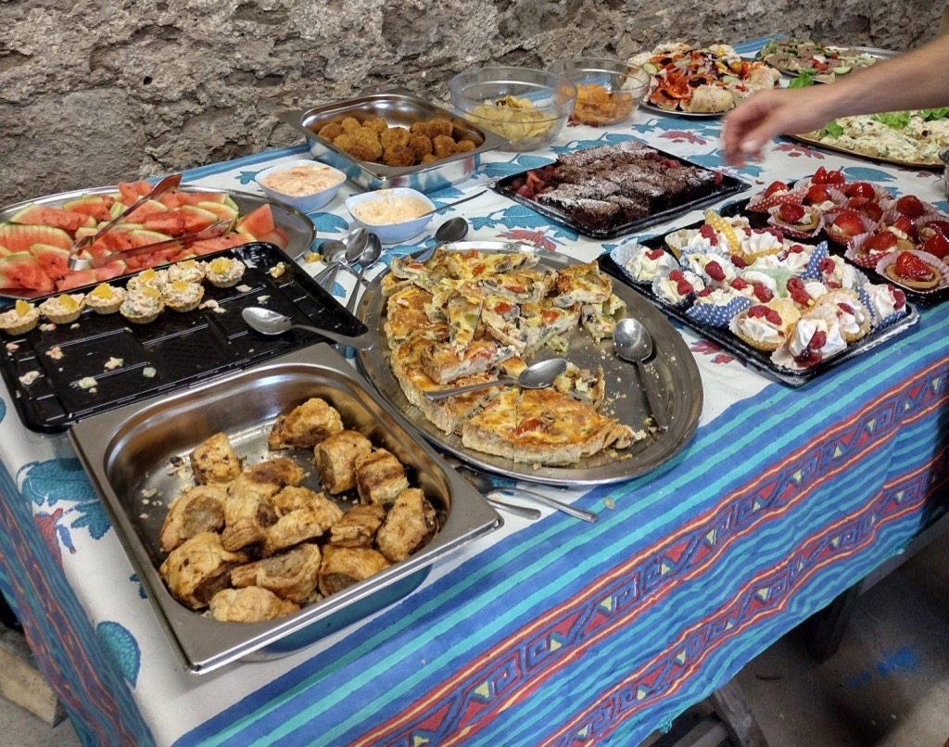
to advance health, community development, and provide relief primarily to adults in need by reason of severe, complex and profound multiple learning disabilities, autistic spectrum disorder and/or global developmental delay who are in need of support to lead fulfilling lives, and to those ends, to provide benefit and support to their families and those who care for them.
Our four working themes are:
- building community for mutual support for all the following: people with PMLD, their family members, their carers, supporters in community
- arranging appropriate activities in suitable surroundings
- raising the profile in a positive way of people with PMLD, who can be overlooked as a minority group, seeking to transform perceptions of people with PMLD, within a Human Rights approach
- advocating for people within this group, in the following ways: on behalf of the whole group, and groups within it, particular families and individuals
Additionally there is Housekeeping work for the charity.

Lived experience benefits

Collectively, we share a great deal of lived experience within the Trustee body, our Patrons and community networks. We have a great deal of experience of living with PMLD and autistic spectrum disorder. We know first-hand the challenges and shortcomings within the care system, from childhood into adulthood and onwards.
We know the harmful effects on individuals and families, particularly parents and siblings, of poor care. We seek to share our knowledge with:
- parents, families and their advocates, including the press, creating a body of experience with a collective voice
- the statutory sector, including Scottish Government, advisory bodies, health boards, HSCPs
- academics
- Human Rights groups and third sector organisations.
We know first-hand what is helpful. We seek to share good practice and positive effects of working collaboratively with other people with PMLD, with families, carers and with professionals.

Main activities across the year

Our main activities during the year 12th January 2025 - 11th January 2026 included:
- Research: disseminating the research we published in 2023, through an exhibition in Scottish Parliament 25th - 27th February 2025, sponsored by Jackie Baillie, MSP to an audience of
- A man with PMLD and his carers and family, Families, community supporters, Ministers of Scottish Parliament, Members of Scottish Parliament, their Researchers; Chair and Executive of the Scottish Human Rights Commission, Chair of the Human Rights Consortium Scotland, Academics, Senior Executives in national care organisations, in national regulatory organisations, COSLA.
- Our research colleagues, Edinburgh Napier university, created display boards highlighting key messages from the research, framing them within the Human Rights lens of the United Nations Convention on the Rights of Persons with Disabilities (UNCRPD).
- Hospitality: bringing people together, intentionally creating community, building trust and relationships. We did this, on six specific occasions throughout the year, in a variety of events, of different sizes, including the reception at Scottish Parliament described above. In doing this we shared support for one another as well as information, amongst people with PMLD, families, professionals.
- Advocating, based on the ‘proof of concept’ of quality care from our research and lived experience, we advocate for quality life in community, for people currently detained in hospital, backed by the UNCRPD. We advocate for ’low arousal’, trauma-informed care with a priority on good communication. We share this information with families and professionals. We do this backed by Scottish Government’s ‘Coming Home’ work, their own policies on care in community rather than detention in hospital.
- Profile-raising - seeking to show people with PMLD as people with capacity, with relationships, with interests, with human rights, status as citizens. We seek to start to change public perception of people with PMLD, to promote and to integrate within society.
- Housekeeping: development of trustee body, relationships, report writing for OSCR; development of website

[QUESTION FOR TRUSTEES:
Do any of you, the Charity’s trustees want to give YOUR perspective on the charity’s work throughout the year 2025? QUOTES?

Structure, governance and management
We are governed by a Constitution which we adopted in January 2021 after legal advice from a small firm of solicitors specialising in Charity law.
We are a SCIO, a Scottish Charitable Incorporated Organisation.
Trustee recruitment and appointment
Our Trustee body has remained stable throughout the year. In a year of consolidation, we have made new relationships with a widening network of community and family connections, giving us scope for future recruitment should we find it necessary to do so.

Achievements and performance
Research - Dissemination
- Exhibition at Scottish Parliament 25th- 27th February 2025
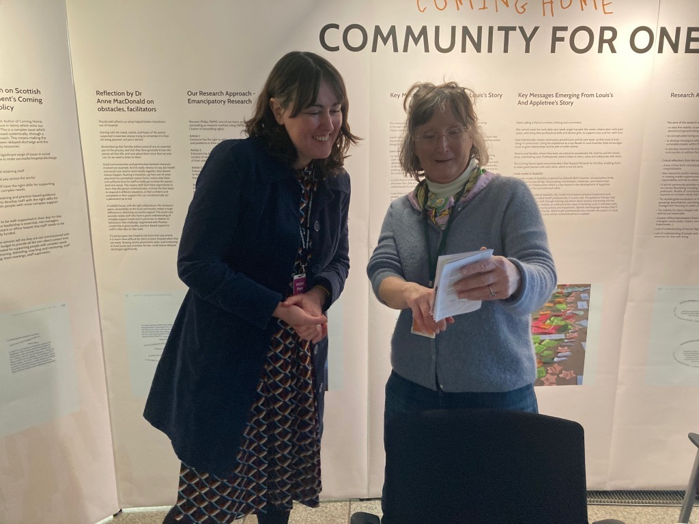
- Sharing link to our research via our website, through emails, by word of mouth and community networks, with families and professionals including organisations upholding Human Rights.
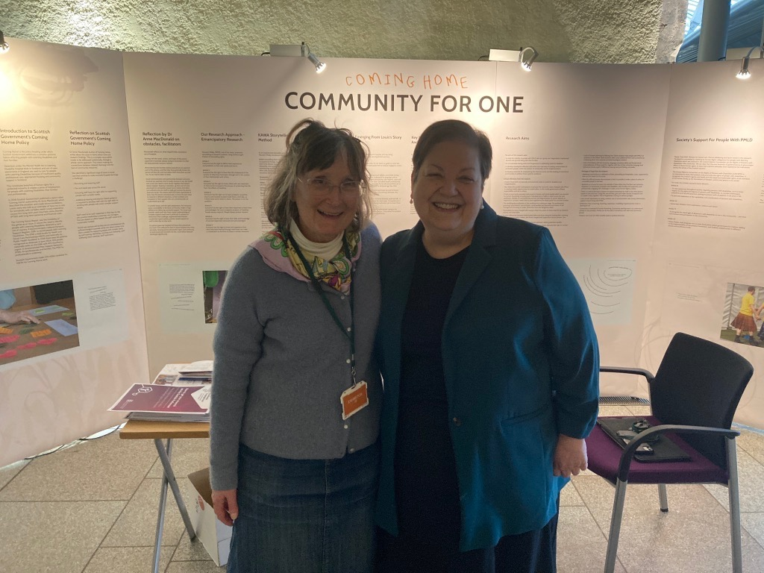
PHOTOGRAPH Above: Shelley Gray, Human Rights Commissioner, SCHR (Scottish Commission for Human Rights) visits the exhibition stand, with Kate Sainsbury

PHOTOGRAPH Above: Dame Jackie Baillie, MSP, sponsor of our Scottish Parliament Exhibition and Reception, with Kate Sainsbury

Hospitality
Reception at Scottish Parliament 27th February 2025
The Reception was sponsored by Dame Jackie Baillie, MSP, catering funded by the Aiteal Trust, hosted by Louis Sainsbury, whose story was told in the research, who has profound and multiple learning disabilities. Jackie Baillie addressed the invited guests. The Right Honourable Cabinet Minister for Social Care Maree Todd, MSP addressed them too. Both commended the work of Appletree, the stories we shared, citing them as examples to learn from.
The audience included a man with PMLD, formerly detained, parents of people currently or formerly detained, community supporters, carers, care managers, MSPs, Researchers, Chief Officers of 3rd and Public Sector organisations including the Care Commission, COSLA, academics and researchers, policy makers.
Spring Party in the Barn at Appletree 13th April 2025
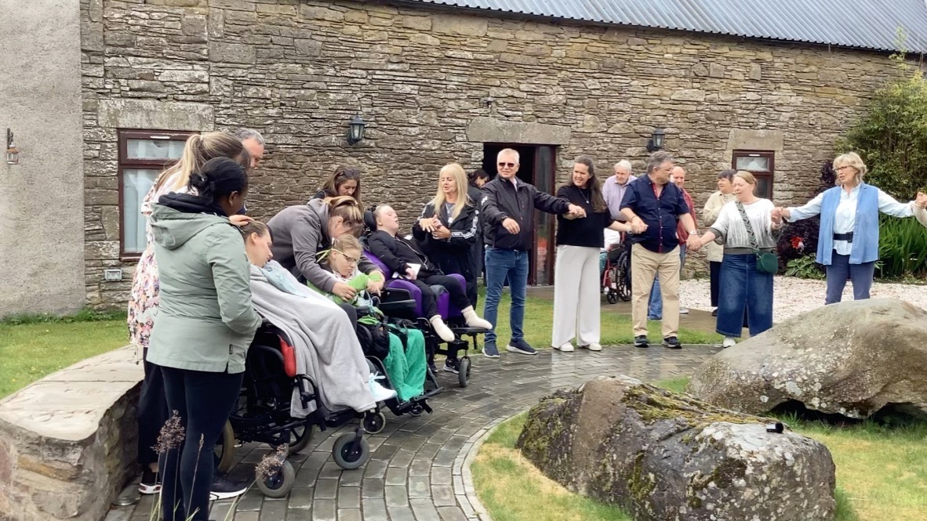
This was by invitation of Louis Sainsbury, whose home it is. We organised outside catering and an outside professional musician to provide music and community singing. Guests at the party included two sets of parents whose sons were still detained in hospital, who are planning for life in community for their sons. They were able to speak with each other and with Trustees, deriving support and information.
Above: Aiteal Trust Summer party Sunday June 22nd 2025
Summer Party 22nd June 2025
Louis invited us to use his home as our venue. Our Patron, Laura Mcardle came too, with other guests, some with PMLD and learning disabilities, carers, families, community supporters. We organised outside catering and musician and a visit from a pony. Derek Richardson, Musician, entertained us with his playing and singing. Everybody enjoyed the event, the singing, the company. Carried Day, film maker, working on a film for PAMIS, was present and recording.

ABOVE: Joey the pony comes to Appletree, meets Laura Mcardle, Patron
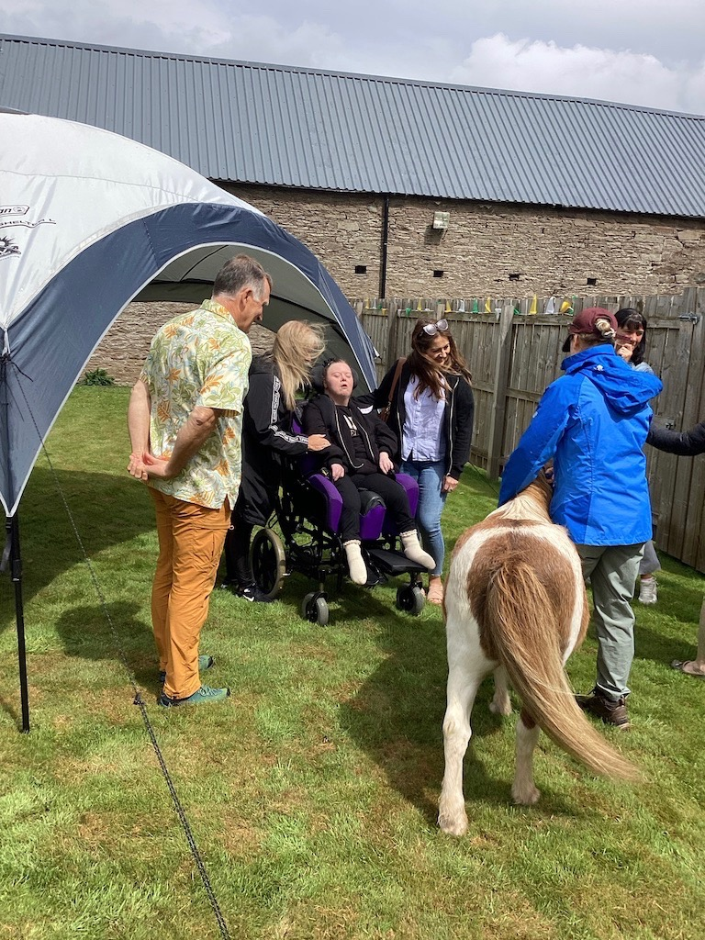
Summer party 2025
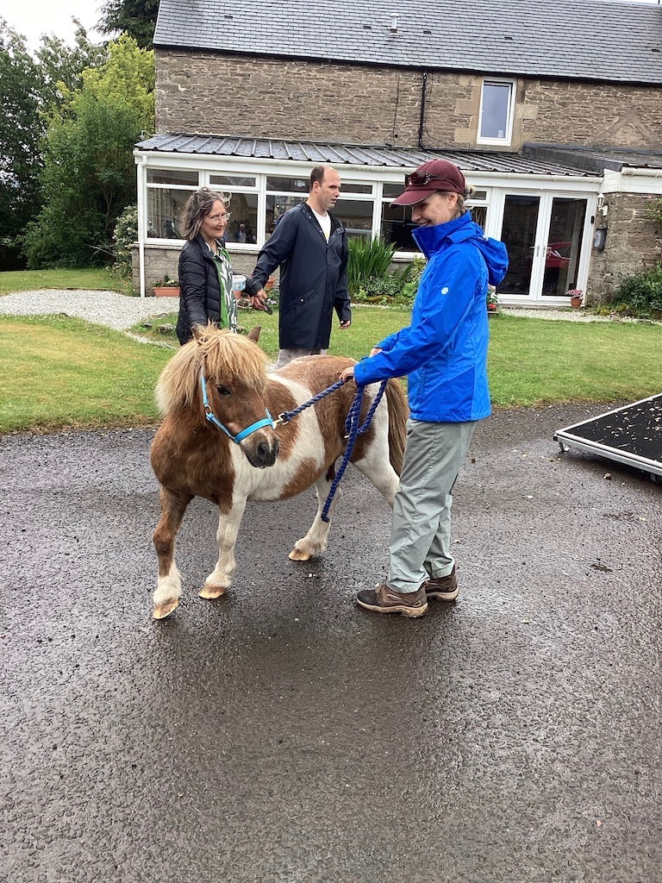
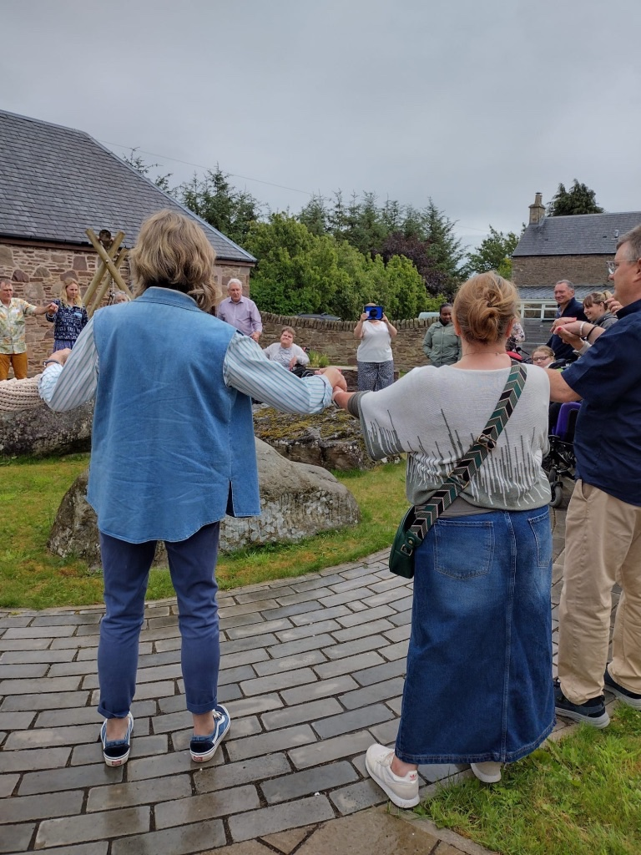
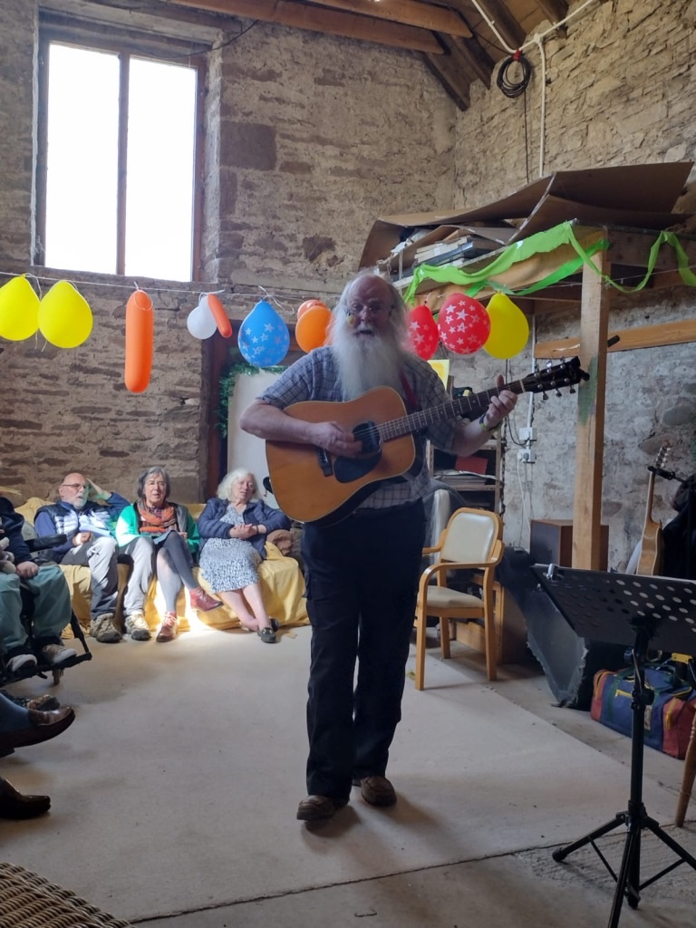
BELOW: Singing in the courtyard Derek Richardson, Musician

Harvest Thanksgiving party Saturday 4th October 2025
We held a Harvest Thanksgiving Party, at Appletree. There was fun and laughter with dancing to Robin Spearing and his band, catering by Andrew Scott, for guests with PMLD, their families and carers and community friends.
This gave an opportunity for networking by parents, especially some whose sons are detained in hospital.
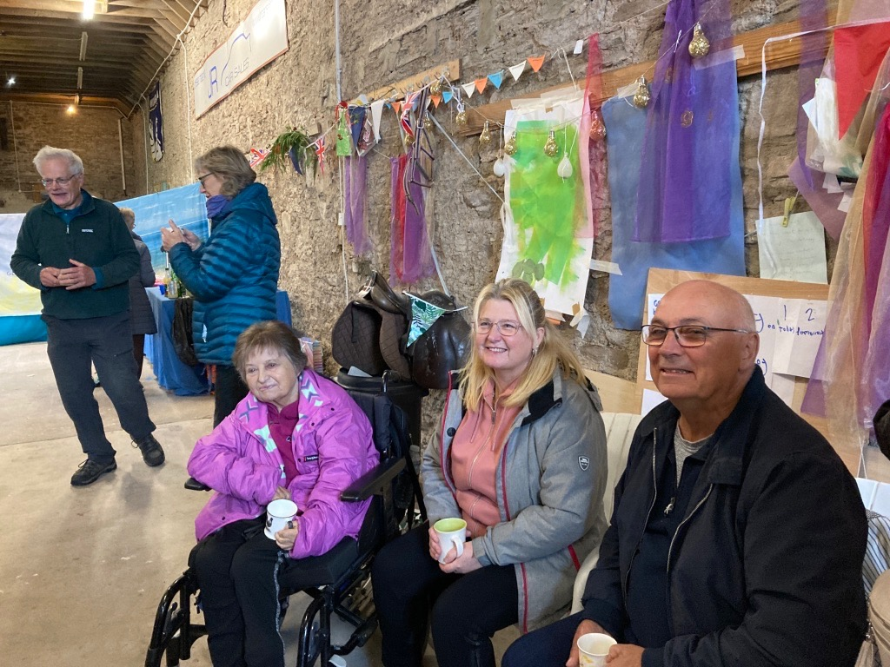
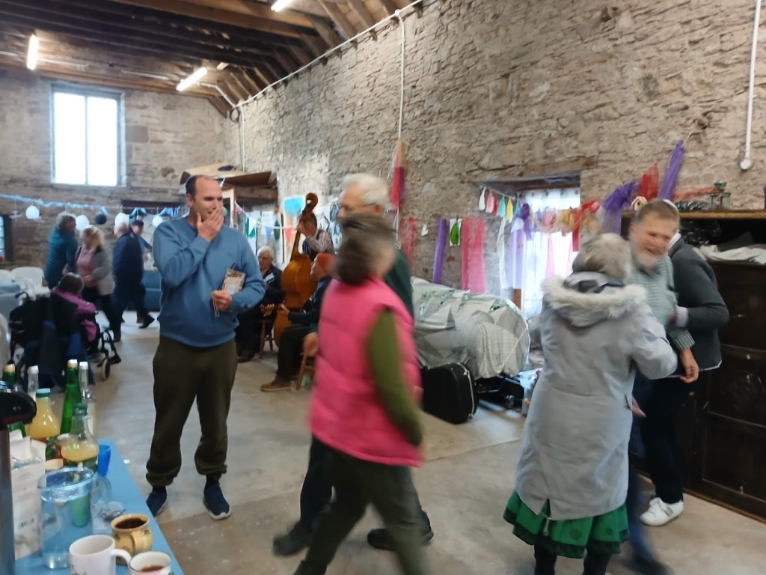

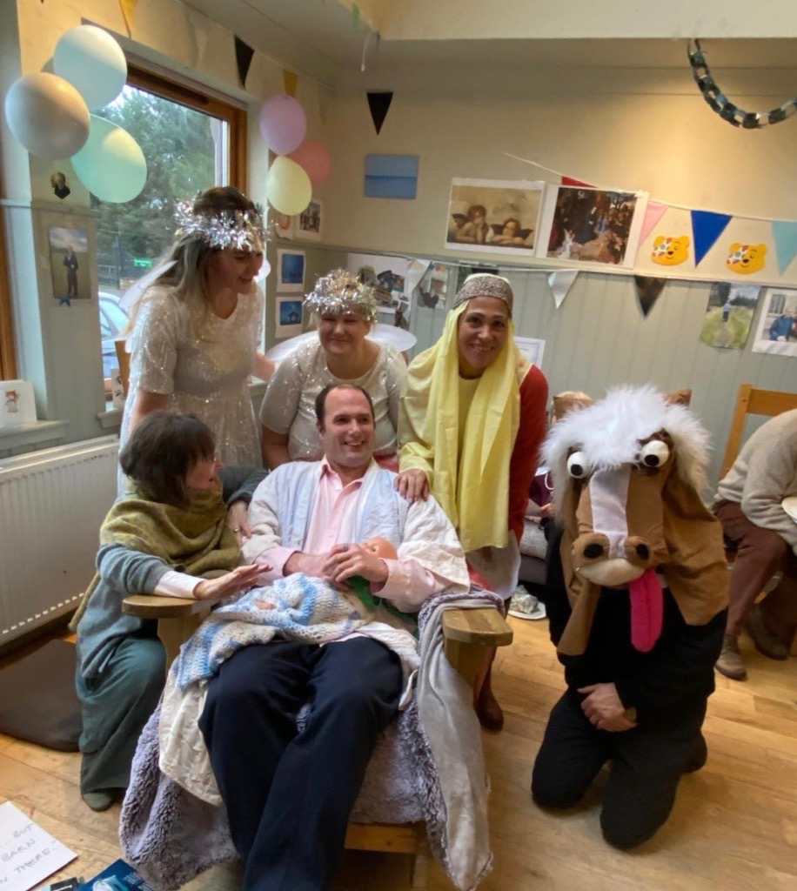
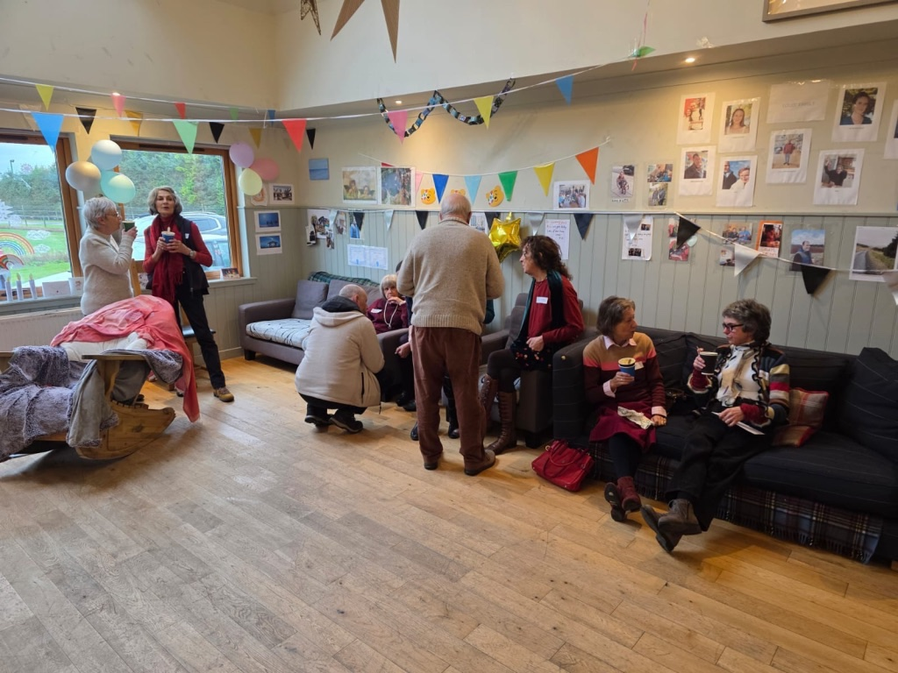
Christmas Party with Nativity Play and appointment of Bishop Ian as Patron of the Aiteal Trust - Weds 17 December 2025

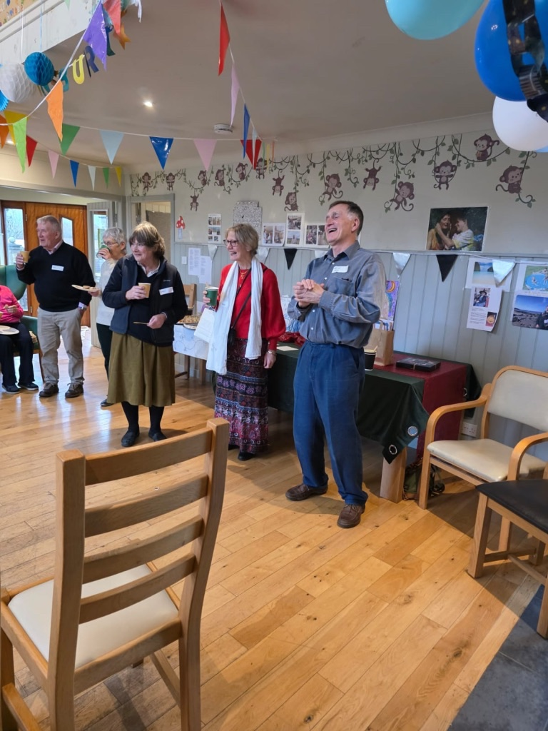
Guests enjoyed lunch and a get-together, with a Nativity play, parts performed by our host, Louis, a man with PMLD, his care team and his mother. The Bishop of St Andrews, Dunkeld and Dunblane accepted a Certificate appointing him Patron of the Aiteal Trust, from Louis. Dom Bush, the Aiteal Trust’s film maker, was present, filming.
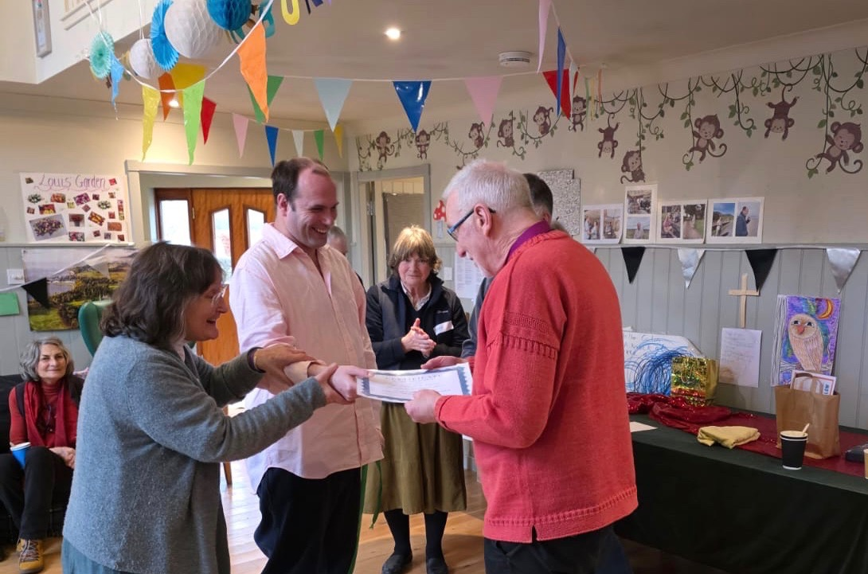
Visits to Appletree
On 7th November there was a visit from two Service Managers for Learning Disability Services: Margaret Mason, NHS Greater Glasgow and Clyde, and Lesley Kinloch, West Dunbartonshire HSCP. Both are members of Scottish Government’s Coming Home working groups. They wanted to see Appletree as an exemplar of care for somebody formerly detained in hospital, now living well in community. Louis welcomed them and Louis’s care team showed them round and explained the culture and operations.
Advocating
At a personal level, our events create opportunities for parents to encounter our Chair, Kate Sainsbury, and Maureen Phillip, Arts Manager for PAMIS, who offer help and support. Both have spent time accompanying people, signposting people towards other organisations.
At national level, Kate has been involved in Scottish Government’s Coming Home work stream since 2018. Coming Home is a programme to do with returning people with learning disabilities to community, out of detention in hospital or private sector Assessment and Treatment Units.
Kate speaks in her own voice, from her own and her son’s experience. She also represents the experiences of people with PMLD, their families and carers, who wish to have their stories told. She speaks as a voice of lived experience in forums where the majority are professionals and unfamiliar with the personal side of detainment. Kate focuses attention on the people with Learning Disabilities at the heart of the issue. She points to the ‘proof of concept’ that is Appletree Community, and its subsequent flourishing, as described in the Aiteal Trust’s research. She offers hospitality to professional colleagues to ‘come and see’. She offers ‘good news’ stories about people with PMLD fulfilling their human rights, as opposed to speaking about people with PMLD as ‘problems’.
Kate contributed as an Advisory Board member to the Scottish Human Rights Commission’s report entitled ‘Tik Tok’, launched end January 2025, drawing on Louis’s and her own experiences.
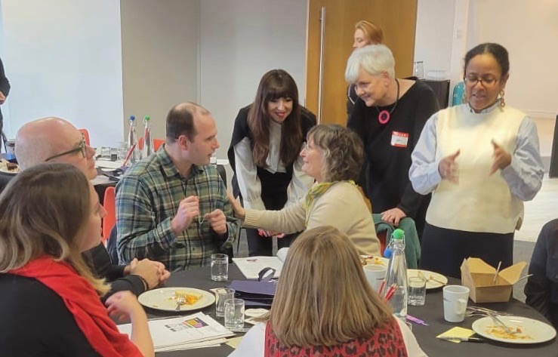
She accompanied Louis Sainsbury and two carers to the launch, in Glasgow, helping Louis to fulfil his role in society as somebody with lived experience, who had contributed to the report.
Louis Sainsbury with L-R: Charlie Macmillan, former Chief Executive of the Scottish Commission for people with Learning Disabilities (SCLD), Jan Savage, Executive Director, Scottish Human Rights Commission (SHRC), Kate Sainsbury, Angela O’Hagan, Chair SHRC, Cathy Asante, Lawyer, SHRC, Author of the Tick Tock report, at the launch of the report, 30th January 2025, Glasgow
Kate advocates, on behalf of people with Learning Disabilities and their families, improving Learning Disability Services in NHS Tayside. She does this as an individual and in association with the Stakeholder Participation Group SPG.
Profile-raising
Throughout 2025, the Trustees sought to raise a positive profile of people with PMLD. Three means of raising the profile of people with PMLD were agreed:
- To exhibit the research ‘Louis’s Story: the Story of Appletree’ in Scottish Parliament, with its associated Reception.
- To commission a film to take our story to a wider audience
- To plan a community outing to Iona Abbey for 2025, for people with PMLD, their families, carers and supporters

The exhibition of our research ‘Louis’s story: the story of Appletree’ and Reception at Scottish Parliament - described previously
To commission a film to take our story to a wider audience
Land and Sky media film ‘Appletree: Community for One’
The Trustees agreed to form a working group for this. A Film brief was created and sent to potential filmmakers. From this process, a Director was chosen, Dom Bush, of Land & Sky Media. Following discussions, he was commissioned to make a short film (between 12 - 20 mins) for a general audience.
Filming started in early 2025 at Appletree. It covered the Scottish Parliament event, the community pilgrimage to Iona, a party at Appletree and the Christmas party late 2025. We ended the year with much of the film completed, looking ahead to 2026 to finalise it, then to plan a marketing strategy for maximum impact and outcomes.
also PAMIS film, directed by Carrie Day, featuring quality care
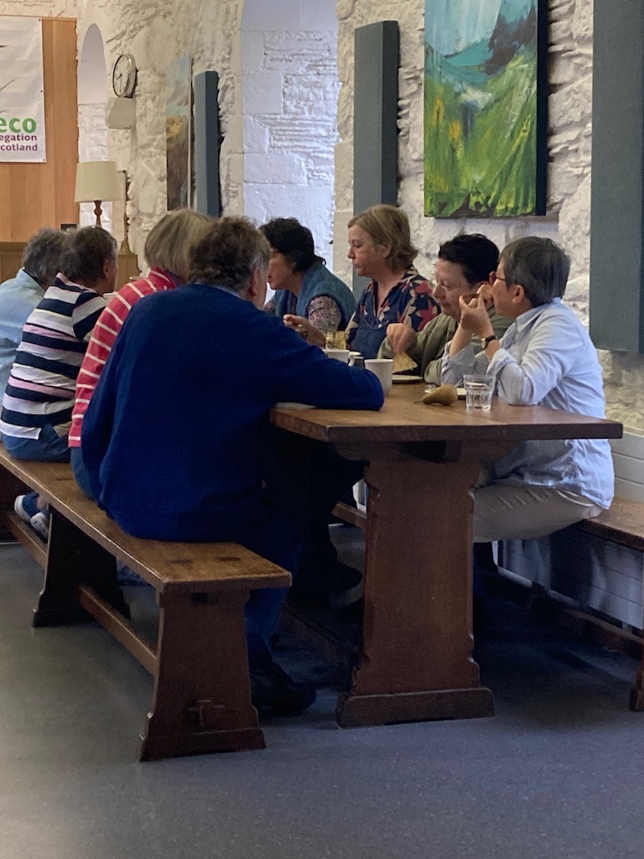
The Aiteal Trust was delighted to work with Carrie Day, film maker, commissioned by PAMIS, inviting her to their events, allowing her to capture a full range of care situations, and a range of community situations where people with PMLD get together and care is provided.

Community pilgrimage to Iona Abbey 2025
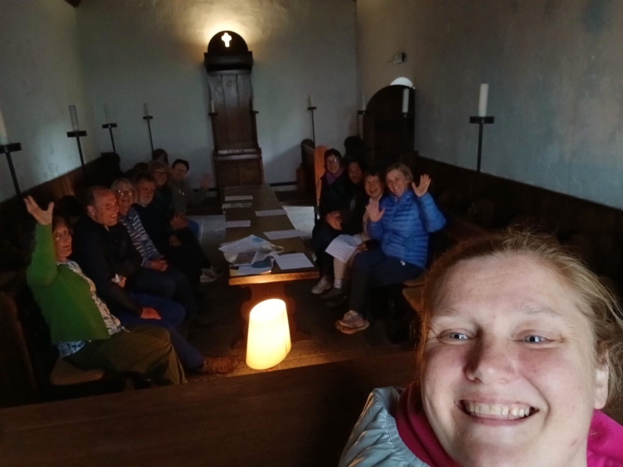
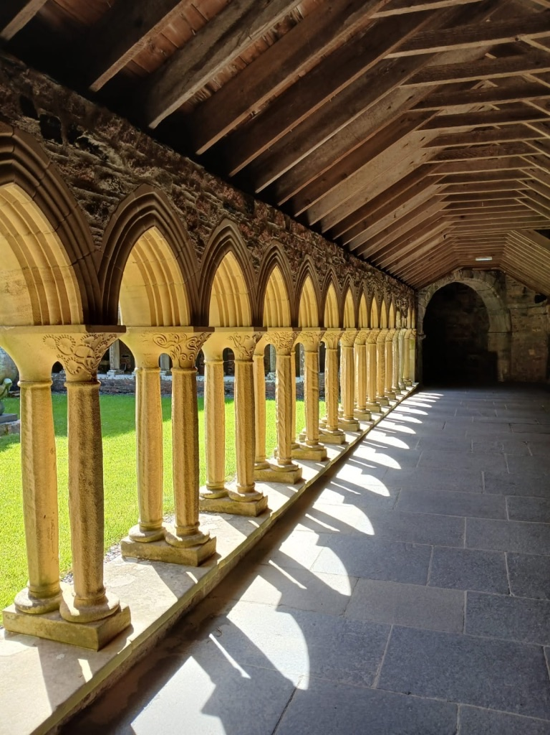
The Trustees agreed to support a public outing for a group of community supporters to the Iona Community on the island of Iona. This is the physical heart of a worldwide network of connections that uphold peace and justice issues. The Iona Community itself has charitable status and is intentionally inclusive towards people who are at risk of being marginalised.
The Community welcomed an opportunity to offer hospitality to Louis Sainsbury, with his carers and wider group. They altered their booking schedule to enable a visit of just two nights for this group of twelve. The Trustees decided to fund a proportion of the accommodation costs for people wishing to go to Iona in this group. There were a total of twelve booked, including Carrie Day, film maker. One person withdrew due to last-minute illness.
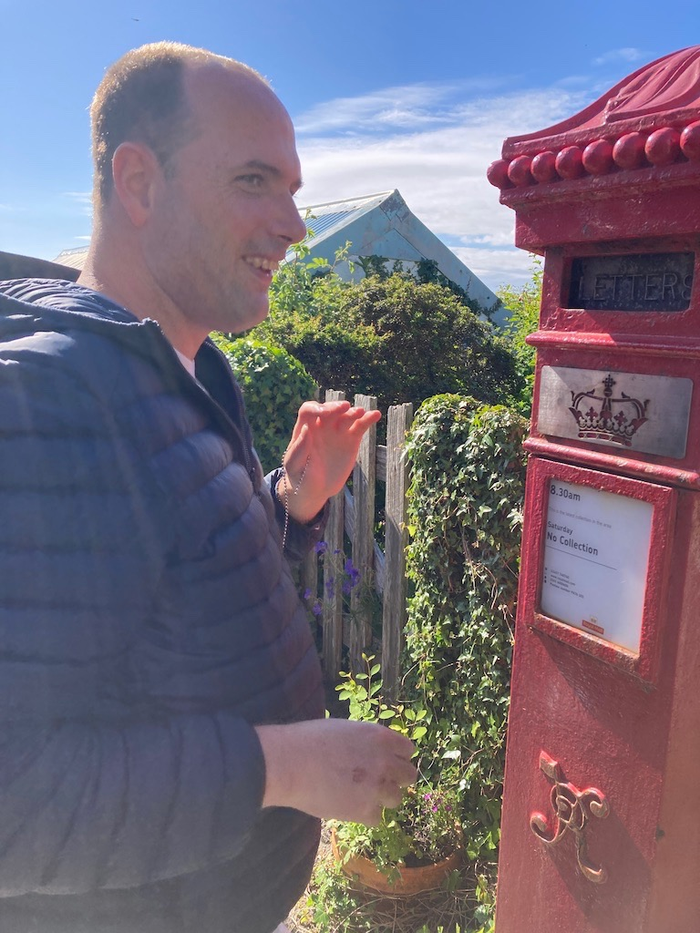
Travel was by public transport. Individuals within the group, familiar with PMLD through Louis, demonstrated inclusion to wider community.
Our film maker, Dom Bush, joined us, so that Iona is one of the places featured in our film, ‘Appletree: Community for One’.

Press
Article ‘Being Heard’ PMLD Link Spring 2025, describing public participation of man with PMLD in our Scottish Parliament Reception.

Outcomes
The Aiteal Trust has established a strong link with PAMIS, the national charity that supports people with PMLD. Maureen Phillip, Director of Creative Arts at PAMIS, is one of our trustees, a dynamic link between the two charities. She links us to opportunities, introduces families to us.
The Aiteal Trust has established a profile in national circles, including Scottish Government’s Coming Home workstream, and Scottish Government Learning Disabilities directorate. The Aiteal Trust is known for being a hub that gathers lived experience from people with PMLD, their families and carers. The Aiteal Trust is known for speaking up for Human Rights and a care model that is an alternatives to detention, .
We have links within third and public sectors, with families and community groups in a network of connections that extends across Scotland and into the UK. Through hospitality, we create connections, accompany people, help them feel safe.
The Community in Iona Abbey were delighted to welcome the Aiteal Trust group. They spontaneously adapted their own practices (eg doing ‘silent’ clapping, rearranging seating arrangements in the dining room) to offer meaningful welcome. Individuals came and spoke with us, new relationships were made.
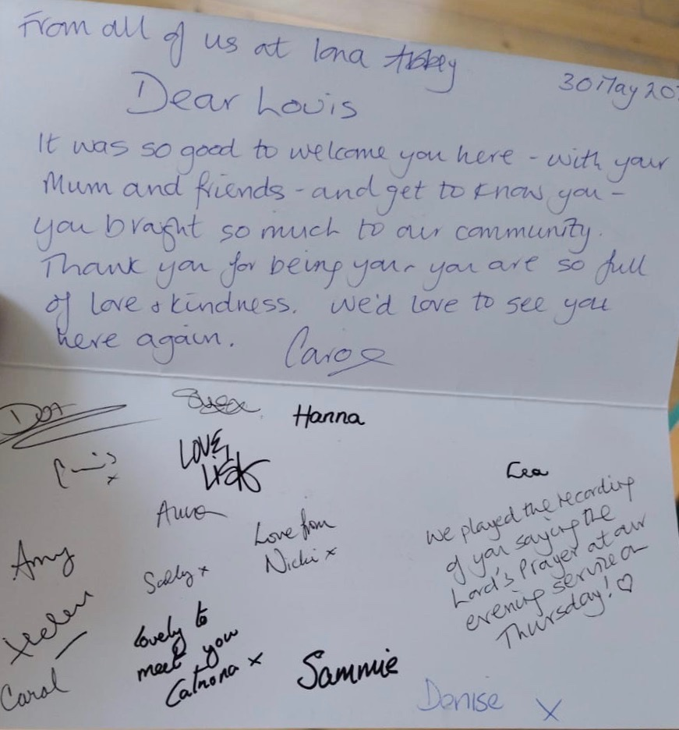
Bishop David Railton, Bishop of Argyll and the Isles, joined us for a day. He met Louis. He heard from us about the systemic care difficulties that lead to people being detained in hospitals, which he shared with the College of Bishops in the Scottish Episcopal Church. He made connections for us with other families.
The Community later wrote to Louis, acknowledging him as group leader, thanking him for bringing the party, inviting him back again.
Impacts
Our socialising events create a network of connections amongst people with PMLD, who get to know each other, to make relationships, leading them to meet on other occasions. We are shaping a public view about the need for visibility of people with PMLD, insisting on their Human Rights.
Parents enjoy opportunities to meet with others, to discuss what their hopes and concerns are. They are supported in a safe space where others understand the issues they face. Parents have few opportunities to come together in community in this way.
When parents are suffering stressful situations at the hands of the care system, they have sympathetic, knowledgeable support with us. This gives them support, when they are usually struggling in isolation.
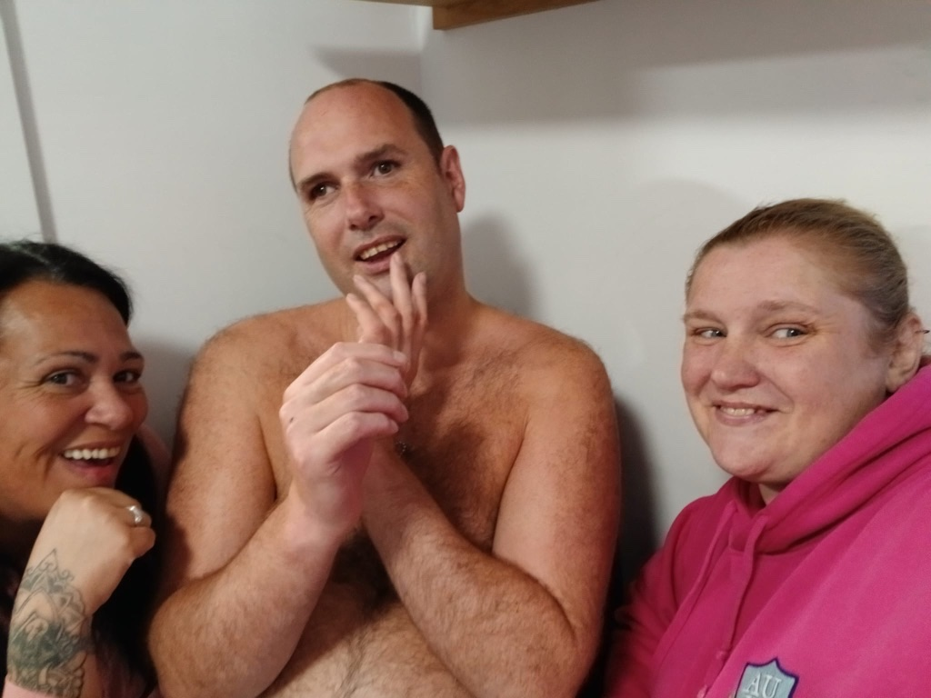
Carers benefit from what we do. Their skills and commitment are validated by people who are involved in our events. This helps them realise their own worth, feel recognised and valued.
By engaging with our community and neighbours we establish positive views of PMLD in wider society. This was manifest in our journey to Iona and the response of the Iona Community, recognising Louis as our Leader.

Volunteers
We are grateful to all who support the Aiteal Trust: our Patrons, Trustees, community friends, our Funders, our neighbours. We are also grateful to the volunteers from PAMIS who bring the mobile changing toilet to our events.

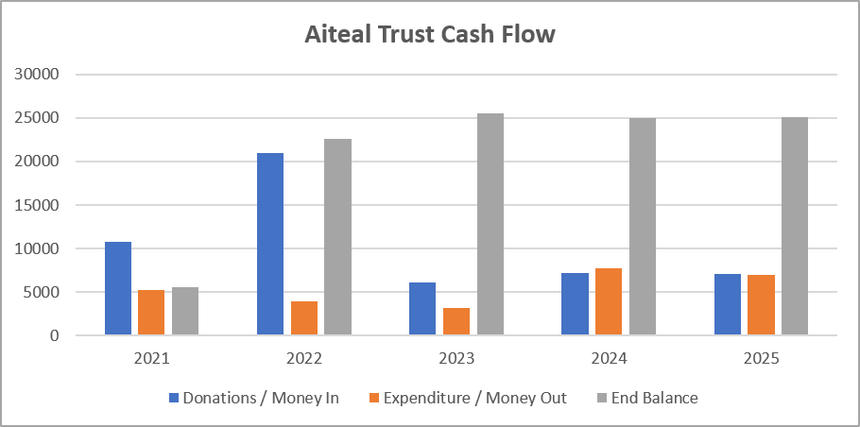
Financial review

Nick, this may require some input from you …

INSERT BOX
2021 2022 2023 2024 2025
DONATIONS/ MONEY IN 10800 21010 6096 7224 7068
EXPENDITURE/ MONEY OUT 5259 3938 3170 7750 6961
END BALANCE 5541 22612 25538 25013 25519

Income
The Aiteal Trust has benefited from generous donations since its inception with significant contributions from the Dinning Trust, Sheila Laxman and numerous other friends and supporters – both individuals and groups.
Expenditure
As described elsewhere in this report, the Aiteal Trust continues to spend money on various activities in pursuit of its aims. Expenditure has been higher this year with additional activities including the trip to Iona, which the Trust supported and the Scottish Parliament event at which the Trust provided catering and covered other minor expenses
Statement of the charity’s policy on reserves
Whilst The Aiteal Trust does not have a formal policy on reserves, the trustees aim to maintain sufficient funds to enable ongoing activities in pursuit of its aims. At the same time the trustees recognize that generous donations were provided on the assumption that they would be spent and not simply kept in a bank account, hence the willingness to increase our outgoings over the last period. The Aiteal Trust currently has a healthy balance.

Donated facilities and services
Our facilities for our community meetings are donated without charge by a man with PMLD, whose home has suitable, safe, indoor and outdoor community space alongside his own accommodation. His mother and Deputy is our Chair.
Our Chair works without payment on our advocacy services, research and profile-raising.
All our Trustees give their time by donation and we are grateful to them for this.

Future plans
Our plans for the year 12th January 2025 - 11th January 2026:
Research
Continuing our collaborative research with people with PMLD, their families and carers, the charity PAMIS, the University of Portsmouth and Edinburgh Napier based on the ‘proof of concept’ established in our research published in 2023 ‘Louis’s Story: the Story of Appletree’. We are in discussion with a second family, to tell their story through research.
Hospitality
Continuing to hold parties at Appletree Community, bringing people together.

Profile-raising
Continuing to work with film maker Land and Sky Media, to develop our film for release, showing positive images of a man with PMLD within his network of carers, family and community, living well, telling his story. This is the ‘proof of concept’ that emerged from our research.

Advocating
Continuing to work with NHS Tayside, BBC Scotland and Radio Scotland, speaking on behalf of people with PMLD, their families and carers. To advocate publicly on the benefits of ‘low-arousal’ care approaches, the promotion of a Human Rights approach, in order to promote well-being of people with PMLD, their families and carers.

Additional information
Got something else to say? Here is your chance!

Declaration
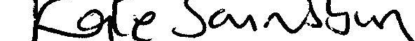
Signed on behalf of the charity trustees:

Kate Sainsbury
Print name

Chair
Designation

Date

