
Trustees’ Annual Report

Year ended 31 July 2025: Year 9
Finlay’s Friends SCO 46675
Comfort for families of seriously ill children
rushed to hospital in an emergency.
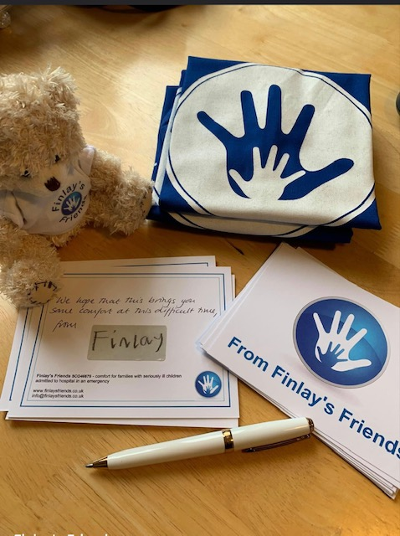

Supporting RHSC Edinburgh, the Royal Hospital for Children, Glasgow (RHCG), Victoria,
St John’s & Ninewells

Structure, governance and management
The trustees, who are also the directors for the purposes of company law, present their report and financial statements of the charity for the year ended 31 July 2024.

Reference and administrative details

Registered charity name Finlay’s Friends

Charity registration number SCO46675

Registered Office 3 The Forge
Dunfermline
Fife
KY129ED

The trustees Jennifer Bennett
David Bennett
Alison Campbell
Alan Richmond

Bankers Bank of Scotland
Business Banking
PO Box 1984
Andover
SP10 9GZ

Independent Examiner Mrs Paula Kemp (Insurance Underwriter)
12 The Forge
Dunfermline
KY129ED

Purposes and Activities

Our Purposes:

Finlay’s Friends has the charitable purposes of the relief of those in need by reason of age, ill-health, disability, financial hardship or other disadvantage. Finlay’s Friends is established for charitable purposes only, and in particular, the objects are for (4.1.1) the relief of those in need by reason of ill-health, in particular, to provide emergency support for families and those responsible for seriously ill children living in the Area of Benefit (Scotland) admitted to hospital in an emergency situation by providing Comfort Kits and other help of a non-financial nature. This is in the form of providing relief for families of children rushed to hospital in an emergency by way of supplying them with support in the form of, but not restricted to, a Comfort Kit designed to tide them over for the first 24-48 hours following the child’s emergency admission to hospital.
Erskine Stewart’s Melville Schools – extract from community impact report:
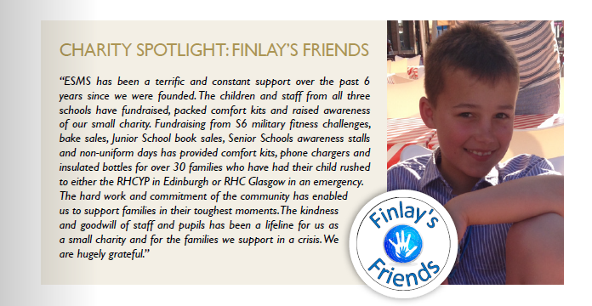

Previous Development Plan 1st August 2024-31st July 2025: Progress Made

 |  | Status | Overview
Review of Comfort Kit, Charger and Bottle content | With the cost of living crisis imminent (and feeling the bite at time of writing), we will need to re-evaluate our suppliers and costs. While endeavouring to keep costs low, we still want a quality comfort kit that meets the needs of the recipients while feeling like a ‘hug in a box’. | Ongoing | Each re-order required is leading to finding the cheapest supplier, often resulting in having to place a larger order and hold more stock to ensure we get a good price. Storage is therefore becoming an issue as we have limited space without having to pay for a storage unit. Many items have gone up in price significantly in spite of shopping around.
Investigate provision of more sustainable Comfort Kits | One of our Young Ambassadors has rightly raised concern regarding the amount of plastic used in the contents of the comfort kits and the potential of our chocolate bars used containing palm oil. To this end we will start exploring more sustainable alternatives in order to evaluate costs and potential impact on our provision. Impact on the planet as well as the integrity of our support provision will be assessed. | Postponed | Given the ongoing cost of living rises and pressures on our fundraising as a result, while we are laying the ground work and investigating what is available (some of our provisions are already sustainable), this would lead to too great a jump in the cost of comfort kits at this stage. Research will continue next year in the hope this is something we can fulfil in the medium term.
Investigate the extension of Finlay’s Friends Support | To liaise with our partner hospitals to investigate the possible extension of support provided beyond the Comfort Kits, insulated bottles and phone chargers. | Ongoing | The generosity of others, not least during tougher financial circumstances continues to amaze us and, if we can offer additional support to families then we would like that to be meaningful. If it can be done without negatively impacting our current provision.
Extension of social media presence and use | We still predominantly use Face Book which targets adults more than children. Given we receive much fundraising support from schools and youth groups, we need to learn to better utilise Twitter, Instagram and other social media aspects to update supporters and the public on what we are doing and showcase our supporter’s efforts while building our community links further. | Ongoing | We have dipped our toe in the Instagram world to add to our social media presence through Finlay’s Friends. Focus must now be on more regular updates of the website too.
Update Website | To refresh our stories to ensure information is kept up to date for those visiting the website. To make sure our ‘make a donation’ is clear to users. | Ongoing | This needs to be a regular process given ongoing events and should celebrate the commitment of our supporters. Work to be done in agreement with kit recipients to share their stories, with consent.

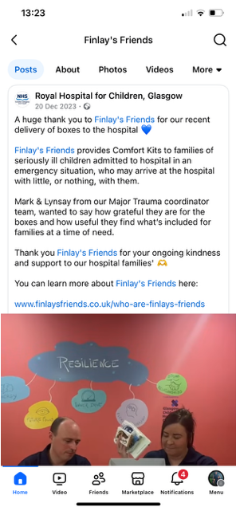

Activities Used to Achieve Purposes and Context of the Year: 1st August 2024-31st July 2025

Our 9th year of operation having received our charitable status in July 2016 has focussed on achieving our prime purpose of supporting families with children rushed to hospital in an emergency and extending our provision when we have reached a point when we have financially been able to do so. This point comes when we know we have funds to honour at least 6 months of provision to each of our partner hospitals should our fundraising dry up. We achieved a roll out to a 5th hospital in August 2021 for Ninewells in Dundee, Ward 29, the Children’s Ward. We continue to support our previous four partners in Edinburgh, Glasgow, Livingston and NHS Fife in Kirkcaldy with greatest demand for our services coming from Glasgow and Edinburgh. We have seen a significant rise in the demand for comfort kits, chargers and bottles from these for two main reason. Firstly, Glasgow is established in it’s role as a major trauma centre and also there is greater awareness amongst staff in the areas of the hospitals that benefit from our provision and can identify those in need of our support, therefore we are asked for supplies more readily. We have continued to supply kits, power bank phone chargers and insulated water bottles through our extended provision to all five hospitals when we are asked for a resupply by their teams. Demand has increased above what was original projected prior to our partnership with the first hospital. Hospitals have reported increased emergency admissions for children and the hospital teams are better informed about the existence of our comfort kits for families who need them meaning they are more inclined to be distributed. Our supply of c.80 comfort kits, chargers, and bottles to Edinburgh sick kids, 120 of each to Glasgow Children’s Hospital has been the bulk of our provision, and has been possible through a range of fundraising activities. Demand for provision fluctuates depending on several factors including admissions, size of hospital, wards supported, opening hours and provisions of existing Family Support Units.

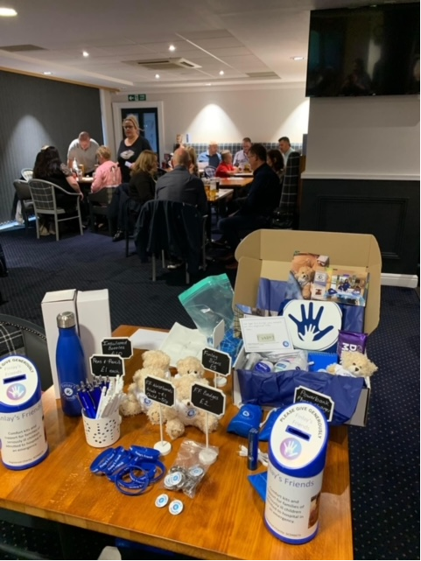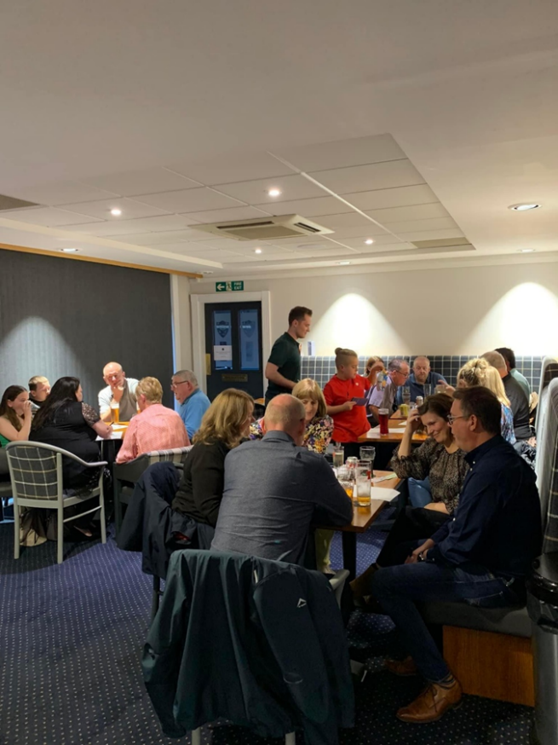
Finlay’s Friends Annual Quiz Night– Pitreavie Golf Club, Dunfermline

Evidence in support of Development Plan

- Review of Comfort Kit, Charger & Bottle content

Finlay’s Friends was established in memory of Jen and David Bennett’s (Chair and trustee) son Finlay who died suddenly aged 8 years from meningitis having been rushed by ambulance to the Yorkhill Children’s Hospital (now the Royal Hospital for Children, Glasgow) and cared for in the High Dependency Unit led by Dr Chris Kidston for 5 days. It was this experience of being in pyjamas with no basic toiletries, comforts, warmth or resources that generated the initial idea of supporting families during one of the most difficult times they might face. Since our initial Comfort Kits were developed through partnership with the RHCG, we have continued to receive feedback from a number of families who received the kits and, with their permission, have shared their stories on our social media.

We constantly compare costs of comfort kit contents to keep them as low as possible without sacrificing the quality of the kits. These are meant to be special ‘gifts’ to those who need them and must be unisex as much as possible. It is a balance between quality and cost. Costs have increased more markedly this year than previous years, but we still believe we are providing the right items at a fair cost while keeping in mind the status and potential of our fundraising capacity when the cost of living crisis is noticeably impacting our donations. Buying stock in larger quantities has reduced the unit numbers a little, but we have to be mindful of the limited storage we have. If we were to look at operating out of a larger and separate storage facility, this would have significant cost implications. Those below reflect average prices – often we are able to buy toiletries on 3 for 2 offers on toiletries. We have also improved the quality of our notebooks so they are more hardwearing, with hard and wipeable outer covers given their use in a hospital environment. This has increased the cost of the kits. So too has global pressures, ongoing cost of living and transportation costs in the delivery of orders, not least the Power Bank chargers which are shipped in from overseas prior to branding.

Category | Product | Notes | Actual cost per unit (previous average)
Toiletries | Toothbrush & 2 toothpastes | Travel set | £1.95 (£1.85)
 | Hand sanitizer | Travel size | £1.10 (£1)
 | Comb |  | 45p (40p)
 | deodorant | Travel size | £1.90 (£1.50)
 | Shower gel / soap | Travel size | £1.20 (£1)
 | Lip balm | Vaseline tub | £1.500 (£1.30)
 | Tissues | Travel pack | 15p (10p)
 | Handy wipes | Travel pack | 50p (30p)
 | Moisturiser | Travel size | £1.50 (£1)
 | Hair tie |  | 12p (10p)
 | (all in zip lock pouch) |  | 1.95p (£1.90)
Comfort | Blanket | Small & light (Ikea no longer doing the original one but have more compact version in its own drawstring bag which works better for recipient storing it between use.) | £4.50
 | Socks | Thick tote socks size 6-9 (to suit men / women) | £4.95 (£4.50)
 | Mints / boiled sweets | Packet(perishables in one pack with expiration label on front) | 45p (43p)
 | Chocolate bar |  | £1.50 (£1.20)
Practical | Notebook |  | £4.20 (45p)
 | Notebook sticker |  | 6p (4p)
 | propelling pencil | Finlay’s friends one | £2.80 (£2.20)
 | Canvas Bag – | FF logo to put Kit contents in | £4.05 (£2.32)
 | Sustainable drawstring bag | For dirty laundry etc. | £1.20
keepsake | Teddy with FF t-shirt | 12cm PAW from Total Merchandise | £4.94 (£4.75)
Storage | Cardboard box | White 305x240x100mm | £1.53 (£1.43)
 | Box labels |  | 7p
 | Postcard | For personal note | 41p
 | Finlay’s Signature sticker | For personalised note | 9p (7p)
 | Tissue Paper to wrap |  | 25p
Occasional | Donated by sticker |  | 38p
 | Jumbo storage bag | Holds 7 kits (£4.50 divided by 7) | 65p
 |  | Total | £44.35 (£43.45)

Comfort Kits are therefore set at a cost of £44.35 per kit, although we are often able to make savings with offers. The cost price since last year has risen by £1 per kit. It is clear to see the increased cost of living and impact of the war in Ukraine on products that are shipped into the UK, but we have also improved the quality and practicality of our notebooks and made the canvas bags more durable and environmentally friendly due to being more robust and less ‘throw-away’ with a thicker material in use and stronger handles. We know that increases to transportation costs will impact the cost of our Powerbank Chargers in the future and insulated water bottles too when we need to restock these. This is where our Reserves policy will be important and why we want to continue to minimise our overheads.

Local volunteers, trustees and our Young Ambassadors all continue to help with the ongoing commitment of ordering and maintaining stock for Comfort Kits, packing kits and resupplying our partner hospitals when they alert us through text and / or email that their stock levels are low.

- Investigate provision of more sustainable kits

It was the recommendation of one of our Young Ambassador’s, Frasier, to try to make the contents of our Comfort Kits more environmentally friendly and sustainable. We have done some initial research and been trialling the quality of some products, including drawstring reusable bags rather than plastic bags in the comfort kits. This has increased our costs but sits better with us knowing that these products have longevity. We continue to trail a selection of eco-products including toothbrushes and shampoo bars, at home with a view to being able to swap out many of our plastic contained products. In many cases the cost remains prohibitive at this stage unless we are buying in bulk and this directly impacts on our storage costs. We need to balance between financial cost of items, practicality in using these for recipient families in a hospital setting and supply / availability, all while keeping the ethos of Finlay’s Friends in terms of the kits being a supportive gift.

While we have made some inroads, this will be a longer term productive. At the moment, the increased cost of living is making this unviable given the uncertainty over fundraising and charity income in the shorter term. We will continue researching products and approaching companies for best prices as a charity into next year and beyond.

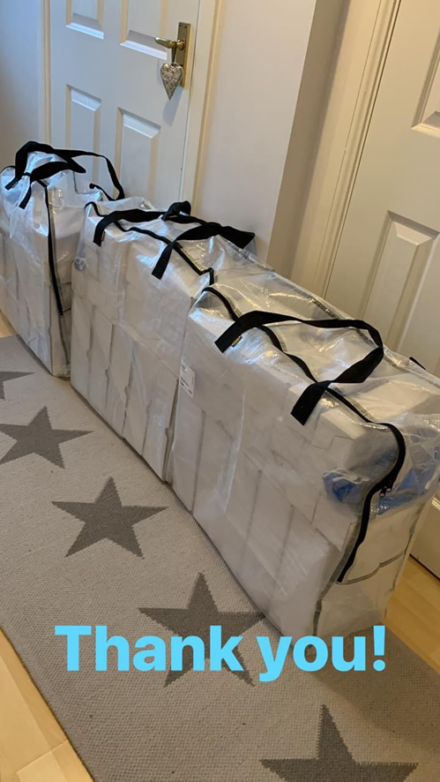
Comfort Kits, packed and ready for delivery to the Edinburgh Hospital with ‘donated by’ stickers on the boxes so we can show our supporters and fundraisers exactly where their donations are going with our insulated bottles and Power Bank phone chargers for parents.

- Investigate extension of Finlay’s Friends support

Fundraising and promoting the work of Finlay’s Friends has predominantly been led by the trustees and our ambassadors who all knew Finlay and his caring nature. Organisation of a number of events in Dunfermline and Edinburgh around friends, the local community and workplaces has resulted in most of our income. . This means that we will role over this development plan target as we need to consider the impact on our fundraising as people continue to (understandably) tighten their belts. We have had some feedback from recipients suggesting there is nothing ‘missing’ in the Comfort Kits they feel would help, but conversations with staff in Glasgow have suggested that additional support in the Family Rooms such as spare t-shirts, toiletries in the shower etc would be of benefit. To be explored over the coming years. Our longer term wish is to set up a local support group for bereaved parents associated with the charity but not strictly run by it given our stated purpose.

Other generous supporters of Finlay’s Friends, who know the family of Finlay, have also undertaken a number of sponsored events to help us raise funds to supply our first Comfort Kits, cover costs including public liability insurance, Just Giving subscription which has increased from £12 per month to £18 per month, stock storage boxes, pop up posters, maintain stock and honour our supply commitment. A particular thank you must go to the staff, pupils and extended community of the Erskine Stewart’s Melville Schools in Edinburgh who have fundraised thousands of pounds for us over our first nine years through a whole range of activities including non-uniform days, bake sales, plant sales, charity lecture evenings, staff versus pupils cricket matches, Maths Books sale and much more. Destination Judo also continue to be major fundraisers for us too – Finlay was so proud to have been a club and squad member.

- Increase use of social media & 5. Update website
This year we have worked hard to keep our supporters more informed about what we have been up to, not least due to the fact we are not hosting as many events ourselves, yet which also serve to raise awareness. This has primarily been done through changes to our website and through the use of Facebook where our page has over 700 followers. We have just started to navigate the use of Instagram too in order to extend this for our younger supporters. We met with the Marketing manager of RHCG to look at some mutual awareness spreading which resulted in them publicising Finlay’s Friends, as well as Finlay’s story, on their own media platforms both within and beyond the hospital.

We have taken small steps to extend our platform across different social media platforms by setting up both Instagram and Twitter accounts. This is partly due to the number of younger fundraisers and supporters we have who use Instagram and other social media platforms far more than Facebook. This is early days, and the plan moving forward is to undergo some more training in social media use to maximise the impact of our posts over the coming months to build on these foundations. A more regular commitment is also needed to update our website regularly so we are better placed to use this as our landing platform for enquiries. We would also like to see testimonials from our recipient families who are willing to provide one so supporters can see the impact of their kindness. Again, progress has been stymied by our day to day workloads. Our greatest hurdle is time – we all have full time day jobs as well as volunteering for Finlay’s Friends.

Achievements and Performance

Our main achievements in the last year include:

- Maintenance of provision to 5 hospitals
- Keeping overheads and costs as low as possible
- Positive and generous feedback from families / users
- Increasing awareness with others fundraising on our behalf

The greatest achievement of the year has been to see the increased demand for our support from both the Edinburgh and Glasgow hospitals again. This is a result of greater need now that Covid restrictions are lifted and society has opened up again, but also on account of greater awareness amongst hospital staff that the kits, bottles and chargers are there to be used in supportive of families with children rushed to hospital in an emergency. We are very proud of our ability to maintain and extend our provision, not least given Glasgow’s role as a major trauma centre for children now too. This has been managed at a time when financial pressures are understandably causing people to tighten their belts. We continue to be humbled by the generosity of others in supporting what we do.

Behind the scenes we have explored costs of our kits, continuing to seek out the best prices while not compromising the quality of the product. The kits are not just about practical support to those in need, they are also about providing emotional support. We aim to meet a supply request within a week and therefore are now able to pack kits to have a supply ready to ship on receipt of a request using couriers, thus meaning we continue to work hard to maintain cost effective stock. Exploring more sustainable products for the kits is an ongoing process as we balance the overall cost of the kits with our fundraising intake and demand from the hospitals. We have regular and open dialogue with our largest partner hospitals (Glasgow and Edinburgh) regards to the usage of the kits, what else would be useful to provide relief to those in need as identified in our charitable purposes and in terms of raising awareness for Finlay’s Friends’ support within the hospital itself. While we have a greater presence in Glasgow due to the size of the hospital, that this is where the greatest demand comes from and we started there after they cared for Finlay, this has developed further in Edinburgh.

We have continued to foster links in the community to ensure ongoing support of our fundraising and drive to support families in need in line with our charitable purposes. This has proved particularly important in keeping the public, donors, beneficiaries, members and the media up to date and informed on our events and actions. Initial training received by the Chair on effective use of Instagram will develop this over the coming years to spread awareness of the work of Finlay’s Friends to a broader audience.

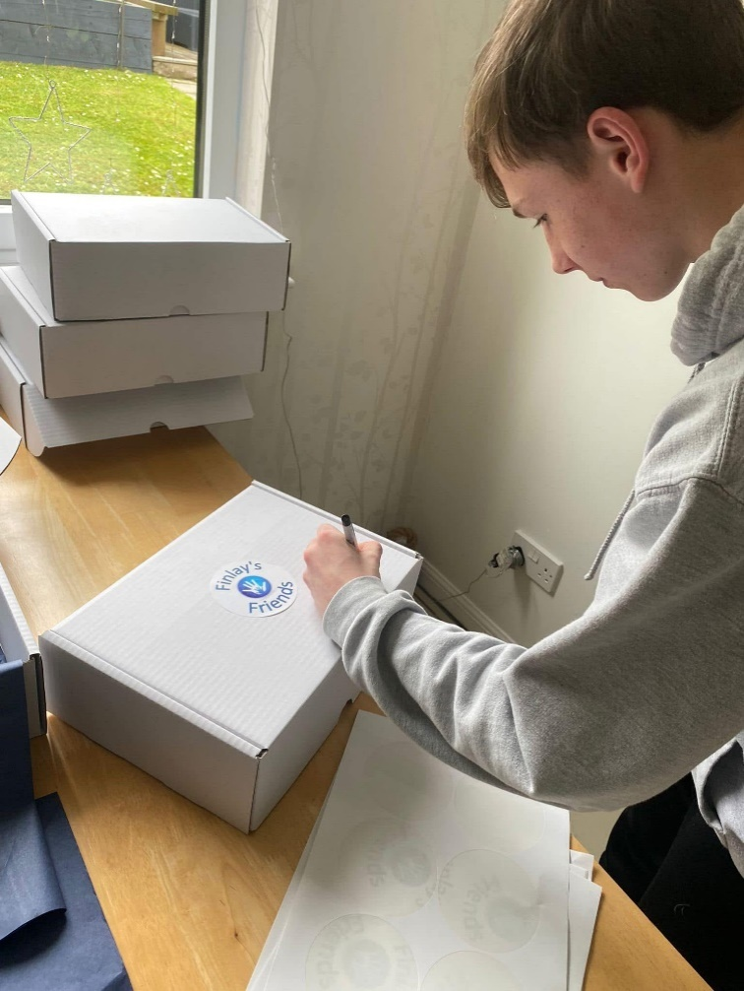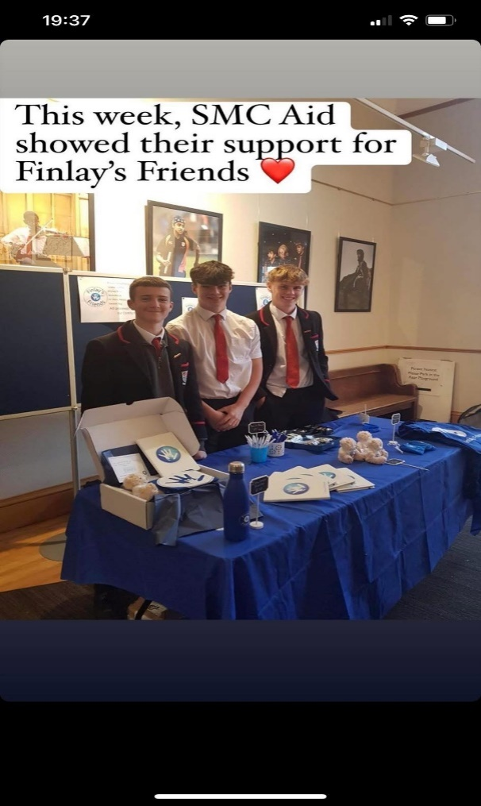
Young Ambassador Frasier hard at work! Stewart’s Melville College Superstars!

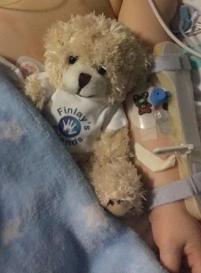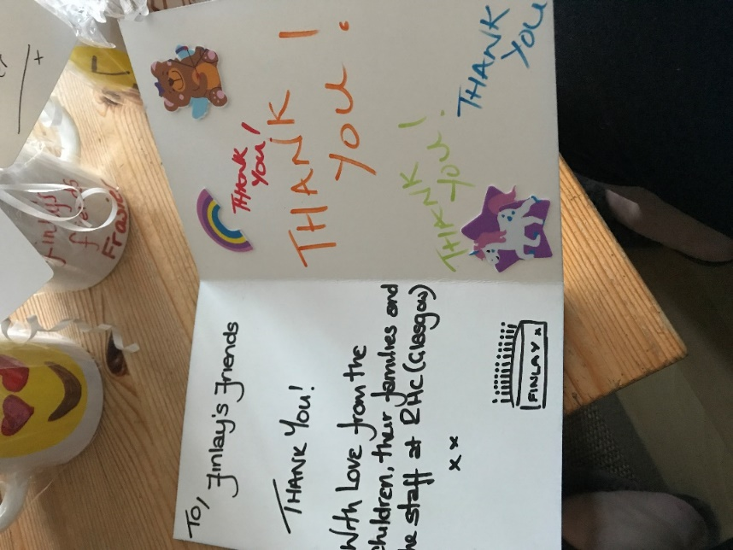

Locally, a key driver for us in our fundraising is to foster community spirit and relationships. In the last year we have met and made a host of new friends and gained tremendous support, not least because of Finlay’s emotive story. Most pleasing is the repeat support people offer (and continue to do so) in attending events, offering help to pack kits, fundraise and spread the word. We are regularly asked when the next fundraiser is as we are determined that, while some funds are raised to help us provide kits and support for the relief of those in need, we also want people to have a good time and remember Finlay positively rather than with sadness. We are very much looking forward to a wider return of these events as (hopefully) financial burdens lessen over time . We continue to update progress of kit packing, deliveries and logistics on our Facebook page. The increased demand for tickets to our events is a good indication that we are getting this right and we are likely to get a little more ambitious with the scale of our events in the coming years, though we do not wish to stretch people too thin are and acutely aware of the financial hardship many are facing. In time we will explore local celebrity support as we continue to grow.

Finlay’s Friends was set up in memory of mine and David Bennett’s son, Finlay. Above all else, Finlay thought of others and showed care for others in all he did. For a young boy, he was tremendously aware of the feelings of those around him and had a real drive to help others who were in difficulty. Finlay’s Friends is succeeding in Finlay’s name as we are seeing the positive impact of the relief we are able to provide to those in need during the hardship of having their children rushed to hospital in an emergency. This makes all our hard work worthwhile and, in some ways, the loss of Finlay a little easier to manage as he continues to inspire us all as we look to the future for Finlay’s Friends.

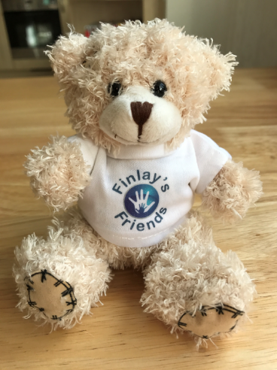
Finlay Bear

Development Plan 1st August 2025 -31st July 2026: Year 10 of operations

We are rolling over last year’s plan on account of the socio-economic climate.
Review of Comfort Kit, Charger and Bottle content | With the cost of living crisis imminent (and feeling the bite at time of writing), we will need to re-evaluate our suppliers and costs. While endeavouring to keep costs low, we still want a quality comfort kit that meets the needs of the recipients while feeling like a ‘hug in a box’.
Investigate provision of more sustainable Comfort Kits | One of our Young Ambassadors has rightly raised concern regarding the amount of plastic used in the contents of the comfort kits and the potential of our chocolate bars used containing palm oil. To this end we will start exploring more sustainable alternatives in order to evaluate costs and potential impact on our provision. Impact on the planet as well as the integrity of our support provision will be assessed.
10 year milestone | Investigate a small 10 year anniversary celebration to thank supporters.
Extension of social media presence and website | We still predominantly use Face Book which targets adults more than children. Given we receive much fundraising support from schools and youth groups, we need to learn to better utilise Twitter, Instagram and other social media aspects to update supporters and the public on what we are doing and showcase our supporter’s efforts while building our community links further.

Structure, governance and management

The charity is an SCIO, registered on 05 July 2016. The work of Finlay’s Friends is led by our Chair and the trustees in terms of charity law, in line with our constitution.

The trustees are responsible for ensuring that our charity purposes (the relief of those in need by reason of age, ill-health, disability, financial hardship or other disadvantage) are met. Specifically, that our work is consistent at all times with our charitable objectives. These, as approved by OSCR and set out in our constitution are that Finlay’s Friends is established for charitable purposes only, and in particular, the objects are for: 4.1.1. the relief of those in need by reason of ill-health, in particular to provide emergency support for families and those responsible for seriously ill children living in the Area of Benefit admitted to hospital in an emergency situation by providing Comfort Kits and other help of a non-financial nature.

Please see Appendix 1 – Constitution of Finlay’s Friends

Trustee recruitment and appointment
As a small and newly founded charity, the trustees of Finlay’s Friends consist of the individuals who signed the original charity trustee declaration forms trustees. These signatories are the Board. The maximum number of trustees, including the Board, is 12 with a minimum of 3.

The Board may at any time appoint any person (unless debarred from becoming a charity trustee under clause 9 of the constitution) to be a trustee if the majority of the charity trustees are in agreement. The Chair of the Board has the casting vote on account of there being no majority. The Board manages the organisation and any decisions made require a quorum. The Board holds one formal Annual General Meeting with 2 additional Board meetings a year. There is currently no formal training for trustees.

A secretary and treasurer are also appointed by the Board – these do not need to be Board members or trustees.
Induction and training of trustees

New trustees undergo an induction to brief them on their obligations under charity law. This includes information on the recent financial performance of Finlay’s Friends.

New trustees are provided when appointed with a copy of ‘Guidance for Charity Trustees’ issued by the office of the Scottish Charity Regulator (OSCR), Finlay’s Friends Constitution and our Vision and Outline Plan. The Chair will also provide a tour of our existing provisions and talk about the work being carried out and plans for the future.

Financial Review
2024/25
A stable financial year for Finlay’s Friends, which ran from the 1st August 2024-31st July 2025. Receipts totalled £14808, £190 received as donations and £14618 raised by fund raising activities. a significant increase in the receipts of the previous year (£5306).
Expenditure for the year was £11474 compared to £5271 in the previous year. £10122 (88%) of the spend was directly related to the provision of the comfort kits, an increase of 192% on the previous year (£5271). This reflects the steadily increasing demand for the kits but more so the increased unit costs for the kits. Whilst it is pleasing the demand for comfort kits signifies a strong awareness amongst the medical staff regarding the provision and distribution of the kits, inflationary pressure is a concern, especially as it appears unlikely to significantly ease in the near future. The kit contents remain under constant review to maintain the balance between providing the items required by those in need and delivering the economical prudence the charity acutely feels the responsibility to deliver. A notable example of this is the increased bulk buying of non-perishable items to reduce unit cost in addition to substituting items which no longer deliver value.
The remaining expenditure consisted of overheads £343 (53.0% of income), consisting of liability insurance (£127) and JustGiving fees (£216), and increase of £31 on the previous year solely due to the increase in liability insurance. Other costs were Stationary (£125, 1.1%), postage and packing costs (£593 5.2%) , Gratuity (£47,0.4%), Mileage and travel (£370.3%) , and events expenditure (£207, 1.8%). There is an increase across the board for all the figures compared to the previous year, £1685 compared to £1358 (24%), mostly due to inflation rather than increased activity or operational changes.
The charity realised a surplus for the year 2024/2025 of £3334. To achieve this against the background of rising costs and steadily increasing demand is a testament to the fantastic support the charity receives and is extremely grateful for. The focus remains on delivering the support to those in need whilst maximising the value achieved by the donation spend.

Management of Risks

Risks are assessed and monitored by the Board.

Health and Safety
Fire drills with full evacuation are carried out a minimum of once a year. The office and stockroom are risk assessed regularly particularly when new furniture, equipment and activities are planned, and time limits are set on the actions required to be taken.

The Board will continue to be responsible for ensuring regular risk assessments and procedures are carried out and followed. Trustees with any presence on a hospital ward unaccompanied by hospital staff as requested by our partner hospitals will be Disclosure Scotland checked.

Financial Risks
An annual projection of fundraising requirements is presented at the AGM which outlines how much we need to raise in order to fulfil our commitments to provide support for the hospital (s) we are in partnership with. Currently this is on the Royal Hospital for Children, Glasgow. An annual projection is approved by the Board for the start of each budget year with the aim of ensuring income and expenditure are within the budget forecast for the year.

Within our limitations to do so, we have built reserves to mitigate against financial risk. Given that we are a small charity, we judge that a minimum of 6 months ‘liquid’ reserves are sufficient to allow for operational costs and outgoings enabling a 6-month provision of Comfort Kits.

Reserves Policy
Total Reserves as at 31 July 2024 (end of operating year 8) were £5000 having reached our target by end of the operating year 2. Part of our development plan will be to review our level of reserves required having increased the number of hospitals we are supporting.

Responsibilities of the Board

Charity law requires the persons in control of a charity to prepare accounts that give a true and fair view of its state of affairs and of its income and expenditure for the budget year. In doing so the members of the Board are required to:
- Select suitable accounting policies and apply them consistently
- Make judgements and estimates that are reasonable and prudent

Members of the Board are responsible for maintaining proper accounting records that disclose with reasonable accuracy the financial position of the organisation, and to enable them to ensure that the accounts comply with relevant legislation. They are also responsible for safeguarding assets of the organisation and hence for taking reasonable steps for the prevention and detection of fraud and other irregularities.

Appointment of Independent Examiner

A resolution will be proposed at a Board of trustees meeting to appoint Mrs Paula Kemp, Insurance Underwriter (Standard Life) , as independent examiner of the organisations’ accounts for the forthcoming year.
The Trustees’ Annual Report and Receipt and Payment accounts were approved on 12th April 2026 and signed on behalf of the Board of Trustees by:

Jennifer Bennett
Chair
APPENDIX I



CONSTITUTION
of
Finlay’s Friends
~Scottish Charitable Incorporated Organisation~

  - Type of organisation
The organisation will, upon registration, be a Scottish Charitable Incorporated Organisation (SCIO).

  - Scottish principal office
  - The principal office of the organisation will be in Scotland.
  - For the avoidance of doubt ‘charitable organisation’ shall mean a body on the Scottish Charity Register which is also regarded as a charity in relation to the application of the Taxes Acts. The expression ‘charitable object’ shall mean a charitable purpose under section 7 of the Charities and Trustee Investment (Scotland) Act 2005 which is also regarded as a charitable purpose in relation to the application of the Taxes Acts.

  - Name
The name of the organisation is ‘Finlay’s Friends’.
  - Purposes, Area of Benefit & Beneficiaries
  - The organisation is established for charitable purposes only, and in particular, the objects are for:
  - the relief of those in need by reason of ill-health, in particular, to provide emergency support for families and those responsible for seriously ill children living in the Area of Benefit admitted to hospital in an emergency situation by providing comfort kits and other help of a non-financial nature.
  - The area within which the organisation shall operate (in this constitution referred to as the ‘Area of Benefit’) shall be Scotland.
  - Powers
  - The organisation shall have the power to do anything which is calculated to further its objects as set out in clause 4 or is conducive or incidental to doing so, in particular but without limitation, the organisation shall have the following powers:
  - to provide comfort kits and other help of a non-financial nature to those facing disadvantage related to present circumstances pursuant to clause 4;
  - to promote the organisation’s activities within the Area of Benefit;
  - to distribute and monitor the funds of the organisation in order to meet the objectives specified in clause 4 (including utilising the funds of the organisation in order to purchase and hold land, property and/or premises and/or to lease land, property and/or premises);
  - to invest any of the organisation’s funds which are not immediately required for the organisation’s activities as may be considered appropriate (and to dispose of and vary such investments);
  - to establish and/or support any other charitable body, by way of assistance and donations, that fall within the organisation’s objectives;
  - to take such steps as may be deemed appropriate for the purpose of raising funds for the organisation’s activities (including but not limited to fundraising generally);
  - to accept grants, donations and legacies of all kinds (and any reasonable conditions attached to them);
  - to engage such consultants, professionals, agencies and advisers as are considered appropriate for the proper conduct of the organisation’s activities; and
  - to remunerate a charity trustee or member of the organisation for services (e.g. in a contract for the provision of services by the charitable trustee or member to the organisation or a contract of employment with the organisation) provided that no remuneration will be paid for simply being a charity trustee or member of the organisation and any such remuneration shall be agreed by the Board so long as the paying of any such remuneration is in accordance with Section 67 of the Charities and Trustee Investment (Scotland) Act 2005.
  - No part of the income or property of the organisation may be paid or transferred (directly or indirectly) to the charity trustees (or any one of them) either in the course of the organisation’s existence or on dissolution except where this is done in direct furtherance of the organisation’s charitable purposes.
  - General structure
  - The structure of the organisation shall consist of a Board who holds regular meetings, and generally controls and supervises the strategy and the activities of the organisation; for example, the Board is responsible for monitoring and controlling the financial position of the organisation.
  - The people serving on the Board are referred to in this constitution as charity trustees.
  - Liability of trustees
  - The charity trustees of the organisation have no liability to pay any sums to help to meet the debts (or other liabilities) of the organisation if it is wound up; accordingly, if the organisation is unable to meet its debts, the charity trustees will not be held responsible.
  - The charity trustees have certain legal duties under the Charities and Trustee Investment (Scotland) Act 2005; and clause 7.1 does not exclude (or limit) any personal liabilities they might incur if they are in breach of those duties or in breach of other legal obligations or duties that apply to them personally.
BOARD
  - Number of charity trustees
  - The maximum number of charity trustees is 12.
  - The minimum number of charity trustees is 3.
  - Eligibility
  - Charity Trusteeship is open to:
  - any person aged 16 or over; and/or
  - any individual who has been nominated for membership by an unincorporated organisation; and/or
  - any corporate body,
who subscribes to the purposes of the organisation and wishes to see them fulfilled.
  - Any person, nominated individual or body who/which wishes to become a charity trustee must sign a written application for charity trusteeship; and for a corporate body, that application must be signed by an appropriately authorised officer of that body who will remain as the representative of that corporate body until such time as the corporate body informs the Board otherwise.
  - The application will then be considered by the Board at its next Board meeting.
  - The Board may, at its discretion, refuse to admit any person, nominated individual or corporate body, or veto the proposed authorised officer acting as a representative of a corporate body, to charity trusteeship.
  - The Board must notify each applicant promptly (in writing, which includes by e-mail) of its decision on whether or not to admit him/her/it to charity trusteeship.
  - A person will not be eligible for election or appointment to the board if he/she is disqualified from being a charity trustee under the Charities and Trustee Investment (Scotland) Act 2005.
  - Initial charity trustees
The individuals who signed the charity trustee declaration forms which accompanied the application for incorporation of the organisation shall be deemed to have been appointed as charity trustees with effect from the date of incorporation of the organisation.
  - Election, retiral, re-election
  - The Board may at any time appoint any person (unless he/she is debarred from becoming a charity trustee under clause 9) to be a charity trustee if the majority of the charity trustees are in agreement. The Chair of the Board will have the casting vote in the event of no majority agreement.
  - At each Annual General Meeting (AGM) all of the charity trustees (with the exception of the Chair as per clause 14.1) must retire from office - but may then be re-elected under clause 11.1.
  - A charity trustee retiring at an AGM will be deemed to have been re-elected unless: -
  - he/she advises the board prior to the conclusion of the AGM that he/she does not wish to be re-appointed as a charity trustee; or
  - an election process was held at the AGM and he/she was not among those elected/re-elected through that process; or
  - a resolution for the re-election of that charity trustee was put to the AGM and was not carried.
  - Termination of office
  - A charity trustee will automatically cease to hold office if: -
  - he/she becomes disqualified from being a charity trustee under the Charities and Trustee Investment (Scotland) Act 2005;
  - he/she becomes incapable for medical reasons of carrying out his/her duties as a charity trustee - but only if that has continued (or is expected to continue) for a period of more than six months;
  - he/she gives the organisation a notice of resignation, signed by him/her;
  - he/she is absent (without good reason, in the opinion of the board) from more than three consecutive meetings of the board - but only if the board resolves to remove him/her from office;
  - he/she is removed from office by resolution of the board on the grounds that he/she is considered to have committed a material breach of the code of conduct for charity trustees (as referred to in clause 17.1);
  - he/she is removed from office by resolution of the board on the grounds that he/she is considered to have been in serious or persistent breach of his/her duties under section 66(1) or (2) of the Charities and Trustee Investment (Scotland) Act 2005; or
  - he/she is removed from office by a resolution of the board passed at a board meeting provided that the Chair cannot be removed from the board in accordance with the provisions of clause 14.1.
  - A resolution under clauses 12.1.5, 12.1.6 or 12.1.7 shall be valid only if: -
  - the charity trustee who is the subject of the resolution is given reasonable prior written notice of the grounds upon which the resolution for his/her removal is to be proposed;
  - the charity trustee concerned is given the opportunity to address the meeting at which the resolution is proposed, prior to the resolution being put to the vote; and
  - (in the case of a resolution under clause 12.1.5 or 12.1.6) at least two thirds (to the nearest round number) of the charity trustees then in office vote in favour of the resolution.
  - Register of charity trustees
  - The Board must keep a register of charity trustees, setting out
  - for each current charity trustee:
  - his/her full name and address;
  - the date on which he/she was appointed as a charity trustee; and
  - any office held by him/her in the organisation;
  - for each former charity trustee - for at least 6 years from the date on which he/she ceased to be a charity trustee:
  - the name of the charity trustee;
  - any office held by him/her in the organisation; and
  - the date on which he/she ceased to be a charity trustee.
  - The Board must ensure that the register of charity trustees is updated within 28 days of any change:
  - which arises from a resolution of the Board or a resolution passed by the members of the organisation; or
  - which is notified to the organisation.
  - If any person requests a copy of the register of charity trustees, the Board must ensure that a copy is supplied to him/her within 28 days, providing the request is reasonable; if the request is made by a person who is not a charity trustee of the organisation, the Board may provide a copy which has the addresses blanked out - if the board is satisfied that including that information is likely to jeopardise the safety or security of any person or premises.
  - Office-bearers
  - Notwithstanding any other provision of this constitution, the Chair of the Board shall be Jennifer Bennett and she shall remain the Chair of the Board until such times as she elects to retire or resign from this office.
  - The charity trustees must elect (from among themselves) a treasurer and a secretary.
  - In addition to the office-bearers required under clause 14.2, the charity trustees may elect (from among themselves) further office-bearers if they consider that appropriate.
  - A person elected to any office will automatically cease to hold that office: -
  - if he/she ceases to be a charity trustee; or
  - if he/she gives to the organisation a notice of resignation from that office, signed by him/her.
  - Powers of board
  - Except where this constitution states otherwise, the organisation (and its assets and operations) will be managed by the board; and the board may exercise all the powers of the organisation.
  - A meeting of the board at which a quorum is present may exercise all powers exercisable by the board.
  - Charity trustees - general duties
  - Each of the charity trustees has a duty, in exercising functions as a charity trustee, to act in the interests of the organisation; and, in particular, must:-
  - seek, in good faith, to ensure that the organisation acts in a manner which is in accordance with its purposes;
  - act with the care and diligence which it is reasonable to expect of a person who is managing the affairs of another person;
  - in circumstances giving rise to the possibility of a conflict of interest between the organisation and any other party:
  - put the interests of the organisation before that of the other party;
  - where any other duty prevents him/her from doing so, disclose the conflicting interest to the organisation and refrain from participating in any deliberation or decision of the other charity trustees with regard to the matter in question;
  - ensure that the organisation complies with any direction, requirement, notice or duty imposed under or by virtue of the Charities and Trustee Investment (Scotland) Act 2005.
  - In addition to the duties outlined in clause 16.1, all of the charity trustees must take such steps as are reasonably practicable for the purpose of ensuring: -
  - that any breach of any of those duties by a charity trustee is corrected by the charity trustee concerned and not repeated; and
  - that any charity trustee who has been in serious and persistent breach of those duties is removed as a charity trustee.
  - Provided he/she has declared his/her interest - and has not voted on the question of whether or not the organisation should enter into the arrangement - a charity trustee will not be debarred from entering into an arrangement with the organisation in which he/she has a personal interest; and (subject to any exercise of the organisation’s power under clause 5.1.9 and to the provisions relating to remuneration for services contained in the Charities and Trustee Investment (Scotland) Act 2005), he/she may retain any personal benefit which arises from that arrangement.
  - Subject to any decision made in accordance with clause 5.1.9, no charity trustee may serve as an employee (full time or part time) of the organisation. No charity trustee may be given any remuneration by the organisation for carrying out his/her duties as a charity trustee.
  - The charity trustees may be paid all travelling and other expenses reasonably incurred by them in connection with carrying out their duties; this may include expenses relating to their attendance at meetings.
  - Code of conduct for charity trustees
  - Each of the charity trustees shall comply with the code of conduct (incorporating detailed rules on conflict of interest) prescribed by the Board from time to time.
  - The code of conduct referred to in clause 17.1 shall be supplemental to the provisions relating to the conduct of charity trustees contained in this constitution and the duties imposed on charity trustees under the Charities and Trustee Investment (Scotland) Act 2005; and all relevant provisions of this constitution shall be interpreted and applied in accordance with the provisions of the code of conduct in force from time to time.
DECISION-MAKING BY THE CHARITY TRUSTEES
  - Notice of board meetings
  - Any charity trustee may call a meeting of the board or ask the secretary to call a meeting of the board.
  - At least 7 days' notice must be given of each board meeting, unless (in the opinion of the person calling the meeting) there is a degree of urgency which makes that inappropriate.
  - Procedure at board meetings
  - No valid decisions can be taken at a board meeting unless a quorum is present; the quorum for board meetings shall be The Chair and two charity trustees charity trustees, being present in person or by conference call.
  - If at any time the number of charity trustees in office falls below three in number, the remaining charity trustee(s) will have power to fill the vacancies - but will not be able to take any other valid decisions.
  - The chair of the organisation should act as chairperson of each board meeting.
  - If the chair is not present within 15 minutes after the time at which the meeting was due to start (or is not willing to act as chairperson), the Chair will delegate her duties to a charity trustee present at the meeting who will act as chairperson of that meeting.
  - Every charity trustee has one vote, which must be given personally.
  - All decisions at board meetings will be made by majority vote.
  - If there is an equal number of votes for and against any resolution, the chairperson of the meeting will be entitled to a second (casting) vote.
  - The Board may, at its discretion, allow any person to attend and speak at a Board meeting notwithstanding that he/she is not a charity trustee - but on the basis that he/she must not participate in decision-making.
  - A charity trustee must not vote at a Board meeting (or at a meeting of a sub-committee) on any resolution which relates to a matter in which he/she has a personal interest or duty which conflicts (or may conflict) with the interests of the organisation; he/she must withdraw from the meeting while an item of that nature is being dealt with.
  - For the purposes of clause 19.9: -
  - an interest held by an individual who is “connected” with the charity trustee under section 68(2) of the Charities and Trustee Investment (Scotland) Act 2005 (husband/wife, partner, child, parent, brother/sister etc) shall be deemed to be held by that charity trustee;
  - a charity trustee will be deemed to have a personal interest in relation to a particular matter if a body in relation to which he/she is an employee, director, member of the management committee, officer or elected representative has an interest in that matter.
  - Annual General Meeting
  - The Board must arrange a meeting of the Charity Trustees (an annual general meeting or "AGM") in each calendar year, reporting on the immediately preceding financial year of the organisation.
  - The gap between one AGM and the next must not be longer than 15 months.
  - Notwithstanding clause 20.1, an AGM does not need to be held during the calendar year in which the organisation is formed; but the first AGM must still be held within 15 months of the date on which the organisation is incorporated with the Office of the Scottish Charity Regulator.
  - The business of each AGM must include:-
  - a report by the convenor on the activities of the organisation;
  - consideration of the annual statement of account of the organisation, as prepared under Section 44 of the Charities and Trustee Investment (Scotland) Act 2005;
  - the election/re-election of charity trustees, as referred to in clause 11.

  - Minutes
  - The Board must ensure that proper minutes are kept in relation to all board meetings and meetings of sub-committees.
  - The minutes to be kept under clause 21.1 must include the names of those present; and (so far as possible) should be signed by the chairperson of the meeting.
ADMINISTRATION
  - Delegation to sub-committees
  - The Board may delegate any of their powers to sub-committees; a sub-committee must include at least one charity trustee, but other members of a sub-committee need not be charity trustees.
  - The Board may also delegate to the chair of the organisation (or the holder of any other post) such of their powers as they may consider appropriate.
  - When delegating powers under clause 22.1 or 22.2, the Board must set out appropriate conditions (which must include an obligation to report regularly to the Board).
  - Any delegation of powers under clause 22.1 or 22.2 may be revoked or altered by the Board at any time.
  - The rules of procedure for each sub-committee, and the provisions relating to membership of each sub-committee, shall be set by the board.
  - Operation of accounts
  - Subject to clause 23.2, the signatures of two out of three signatories appointed by the Board will be required in relation to all operations (other than the lodging of funds) on the bank and building society accounts held by the organisation.
  - Where the organisation uses electronic facilities for the operation of any bank or building society account, the authorisations required for operations on that account must be consistent with the approach reflected in clause 23.1.
  - Accounting records and annual accounts
  - The Board must ensure that proper accounting records are kept, in accordance with all applicable statutory requirements.
  - The Board must prepare annual accounts, complying with all relevant statutory requirements; if an independent examination is required under any statutory provisions (or if the Board considers that an independent examination would be appropriate for some other reason), the Board should ensure that an independent examination of the accounts is carried out by a qualified accountant.
MISCELLANEOUS
  - Winding-up
  - If the organisation is to be wound up or dissolved, the winding-up or dissolution process will be carried out in accordance with the procedures set out under the Charities and Trustee Investment (Scotland) Act 2005.
  - Any surplus assets available to the organisation immediately preceding its winding up or dissolution must be used for purposes outlined at clause 4.1.
  - Alterations to the constitution
  - This constitution may (subject to clause 26.2) be altered by resolution of the Board passed at a board meeting (subject to achieving the majority referred to in clause 19.6) or by way of a written resolution of the Board.
  - The Charities and Trustee Investment (Scotland) Act 2005 prohibits taking certain steps (e.g. change of name, an alteration to the purposes, amalgamation, winding-up) without the consent of the Office of the Scottish Charity Regulator (OSCR).
  - Interpretation
  - References in this constitution to the Charities and Trustee Investment (Scotland) Act 2005 should be taken to include: -
  - any statutory provision which adds to, modifies or replaces that Act; and
  - any statutory instrument issued in pursuance of that Act or in pursuance of any statutory provision falling under clause 27.1 above.
  - In this constitution: -
  - “charity” means a body which is either a “Scottish charity” within the meaning of section 13 of the Charities and Trustee Investment (Scotland) Act 2005 or a “charity” within the meaning of section 1 of the Charities Act 2006, providing (in either case) that its objects are limited to charitable purposes;
  - “charitable purpose” means a charitable purpose under section 7 of the Charities and Trustee Investment (Scotland) Act 2005 which is also regarded as a charitable purpose in relation to the application of the Taxes Acts.

APPENDIX 2 – Reserves Policy
Reserves Policy
Finlay’s Friends SCO 46675
Comfort for families of seriously ill children
rushed to hospital in an emergency.

Purpose
The purpose of the Reserves Policy for Finlay’s Friends is to ensure the stability of the charitable purposes and ongoing operations of the charity. The Reserve is intended to provide an internal source of funds for situations such as sudden increase in expenses, unanticipated loss of income through fundraising and donations, or uninsured losses. The Reserve may also be used for one-time, nonrecurring expenses that will build long-term capacity, such as research and development or investment in infrastructure to further achieve our charitable purposes. Reserves are not intended to replace a permanent loss of funds or eliminate an ongoing budget gap. It is the intention of Finlay’s Friends for Reserves to be built, used and replenished within a reasonably short period of time. The Reserves Policy will be implemented in concert with the other governance and financial policies of Finlay’s Friends and is intended to support the charitable purposes contained in these related policies, our governance and constitution and in strategic and operational plans.

Definitions and Goals
The Reserve Fund is defined as a designated fund set aside by action of the Trustees. The minimum amount to be designated as Reserve will be established in an amount sufficient to maintain ongoing operations and commitments for a set period of time, measured in months. The Reserves serves a dynamic role and will be reviewed and adjusted in response to internal and external changes.

The target minimum operating Reserve Fund is equal to six months of average operating costs. The calculation of average monthly operating costs includes all recurring, predictable expenses such as public liability insurance, Just Giving fees and provision of 20 Comfort Kits per month to one hospital. Depreciation, in-kind and other non-cash expenses are not included in the calculation. The calculation of average monthly expenses also excludes some expenses such as one-time or unusual, capital purchases for reasons of fulfilling our charitable purposes. The amount of the Reserve Fund target minimum will be calculated each year during completion of the Trustees Annual Review (TAR) and Receipts and Payments Accounts and included in such.

Accounting for Reserves
The Reserve Fund will be recorded in the financial records as ‘Reserve’. The Fund will be funded and available in cash or cash equivalents. Reserves will be commingled with the general cash and investment accounts of the charity.

Funding of Reserves
The Reserves Fund will be funded with surplus unrestricted operating funds. The trustees may from time to time direct that a specific source of revenue be set aside for Reserves. Examples may include one-time gifts or bequests, special grants, or special appeals.

Use of Reserves
Use of the Reserves requires three steps:

- Identification of appropriate use of reserve funds.
The Chair and trustees will identify the need for access to reserve funds and confirm that the use is consistent with the charitable purposes of Finlay’s Friends and is consistent with the purpose of the reserves as described in this policy. This step requires analysis of the reasons for this shortfall, the availability of any other sources of funds before using the reserves, and evaluation of the time period that the funds will be required and replenished.

- Authority to use Reserves
Authority for the use of Reserves is delegated to the Chair in consultation with the trustees. The use of Reserves will be reported to the trustees, accompanied by a description of the analysis and determination of the use of funds and plans for replenishment to restore the Reserve Fund to the target minimum amount. The Chair must receive prior approval from a quorum of the trustees if the Reserves will take longer than 6 months to replenish.

- Reporting and Monitoring
The Chair and trustees are responsible for ensuring that the Reserve Fund is maintained and used only as described in this policy. Upon approval for the use of Reserve funds, the Chair will maintain records of the use of funds and plan for replenishment. He / she will provide regular reports to the Trustees of the progress to restore the Fund to the target minimum amount.

Review of Policy
This Policy will be reviewed every other year, at minimum, by the trustees, or sooner if warranted by internal or external events or changes. Changes to the Policy will be recommended by the Chair or any trustee to the Board of Trustees.

