Charity Name G61/G62 Community Response
Trustees’ Annual Report
Period From 1st August 2024 to Period End 31st July 2025

Charity contact information
Peter Ogg (Treasurer) 122 Ledi Drive Bearsden Glasgow G61 4JR
g61/g62communityresponse@gmail.com 07824 711209
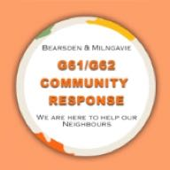

Your charity’s name G61/G62 Community Response
Scottish Charity Number: SC051962
Address 122 Ledi Drive Bearsden Glasgow
Postcode G61 4JR
Telephone number 07824 711209
Email address g61/g62communityresponse@gmail.com
Website g61g62communityresponse.org
Facebook & Instagram Social Media profile name g61g62communityresponse
Charity Trustees
Name all of your charity trustees for the period, and the date they left if they were not in post for the whole year

- Peter Ogg (Treasurer)
- Samina Hassan (Chairperson)
- Dr Sowbhagya Munishankar (Secretary)

Objectives and activities

During the first lockdown East Dunbartonshire Voluntary Action set up Groups in Post Code G66 Kirkintilloch, G64 Bishopbriggs & in our local area G61 / G62 Bearsden & Milngavie. Our Group began in 1st July 2020 & became a Charity on 30th August 2022.
- Our Aims are to assist as many elderly or vulnerable people in our catchment area as possible with various tasks.
- We do this by shopping for them, picking up prescriptions, picking up foodbank parcels, transport to hospitals and clubs, light gardening, hedge & grass cutting & basic DIY, dog walking and any other Ad hoc requests that are within our capabilities. We also have a few volunteers making befriending calls or befriending visits.
- We have increased our client base to 382 people a further 53 are no longer with us for various reasons. Some of these needed one off assistance during lockdown and some are regulars with weekly transport to clubs they attend or shopping they need.
We have 20 active volunteers who undertake the tasks. We do not take pictures of our clients getting into cars to go to hospital or out shopping, so have no images to share.
Structure, governance and management
Type of governing document
We have a constitution covering everything we do as our governing document. This has been reviewed and updated where appropriate.
Trustee recruitment and appointment
The trustees were appointed at the outset when we became a Charity. At the AGM the positions just like the committee positions are proposed for re election.
Achievements and performance
Since we began we have undertaken over 7,146 tasks. Just under 1,500 in the financial year to July 2025. At the beginning it was shopping for people who were shielding during covid & picking up their prescriptions. Now it is predominantly transport as none of the local hospitals are easy to get too often needing 2 modes of transport, 2 buses or bus and train, assuming you can physically get to a bus stop or train station.
We were covering 100% of requests, but with only a few of our volunteers willing to do transport, and the volume increasing, 24 regular transport request to clubs every week 4 fortnightly ones and 4 monthly ones, so 32 or more those weeks, double what we had the previous year, as social service come across lonely people and find clubs for them to go to or ask us to do shopping for them, tick a box to say they have organised this, but we then have to fulfil the actual requests. On top of that we get requests to get to hospitals, etc so we are on occasion not able to cover everything.

The Trustees : -
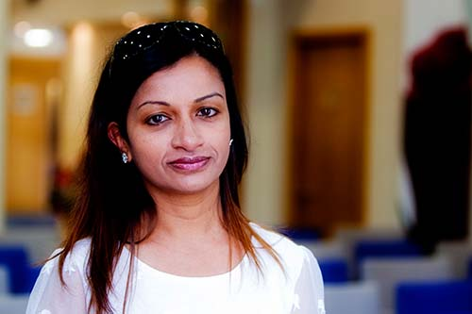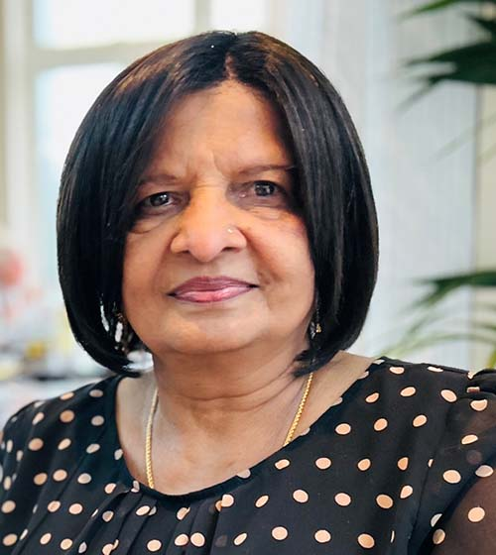
Peter Ogg (Treasurer) Samina Hassan (Chairperson) Dr Bhagya Munishankar (Secretary)

- We have made a big difference to numerous clients mental health, getting them away from isolation and loneliness by transporting them to clubs, making befriending calls and visits and outings for coffee & cake. We have helped them with cost of living issues by transporting them to hospitals. Some make voluntary donations. For example. the cost of a taxi to The Queen Elizabeth Hospital is £26. £52 for a return trip.
- Our volunteers are really dedicated. They get the satisfaction of helping people, while also getting out of the house. We took one client to The Beatson for cancer treatment daily for 6 weeks. Excluding weekends which his family were able to cover as off work.
Financial Review
Accounts have been presented in a Receipts and Payments Format. Inbound calls used to be answered by OPAL (Older Peoples Assistance Line). This was manned in rotation by CEARTAS, Citizens Advice & Carers Link). They received and shared a sizable grant for doing this. However in late 2024 this grant was withdrawn and they closed down the helpline. We felt we had sufficient funds to cover the expenditure that would be created to counter this. East Dunbartonshire Voluntary Action who original set up our group encouraged us to apply for grant funds that they control to cover the extraordinary expenditure incurred in purchasing a mobile phone, one years phone charges reprinting stationery and advertising material and sending cards to every client who had ever used our services. This amounted to £1,182 of restricted funds for that use only.
We do not at this time anticipate needing grants again in the future as are self funding and looking to become. Donations increased by £2,498. Transport Costs (volunteers expenses) were up by £1,640 both of these relating to an increase in transport request. We are doing much more local transport to clubs. Volunteers tend to not claim for these trips. We were shopping every week & paying bills for 3 client in 2024/25. We reimbursed our volunteers immediately, but had to wait on relatives refunding us or me visiting to collect cash. One had a change in Banks and stopped receiving funds as they were not being forwarded. Along with social services we eventually tracked down her benefits, but not before £800 was owed as we couldn’t leave her without food. This created just over £4,000 of contra entries. This contributed to income being £11,529 Overall though still had a surplus of Income over Expenditure of just £17.29.
We are in a good position financially with as at the financial year end £5,687 and £190 on an Asda Card.

Statement of the charity’s policy on reserves
In the early years we were dependant on Grant Funding, and while we applied for a Grant in November 2023, which was paid to us in February 2024, due to the amount of transport we were undertaking. Due to donations received from transport requests and gardening, we see ourselves being self sufficient ongoing. We have no reserves target and quite the opposite, work on the basis that should funds fall we will seek grants again. As mentioned the Grant received in December 2024 of £1,882 was for a specific purpose relating to helpline close down.
Donated facilities and services
We take some young autistic adults to a gardening group every week. Their project New Roots Initiative agreed to donate an amount equivalent to the 45p a mile that we would pay a volunteer. This amounted to £809. The clients have made donations amounting to £5,198. Local supermarket Waitrose has donated some bags of food the last 4 years. 6 last Christmas. We pass these on to any clients that we have provided packages from the foodbank, or for whom we have done shopping.
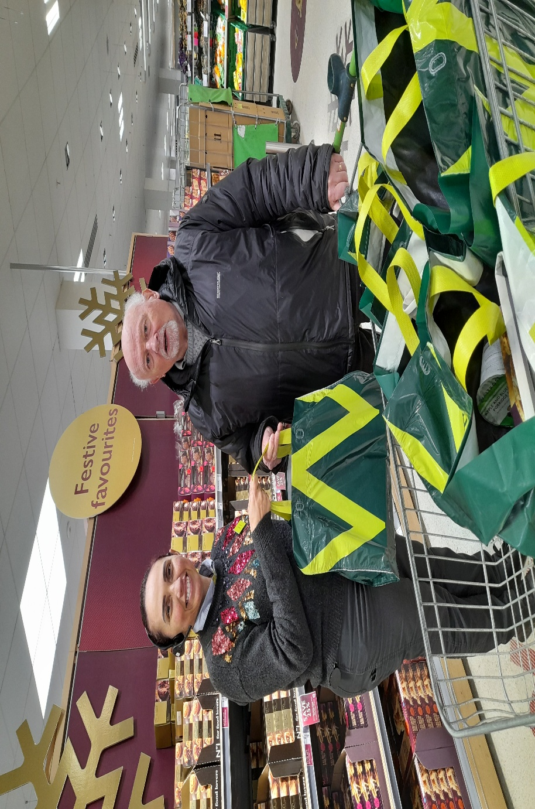
A member of staff from Waitrose and our Treasurer Peter Ogg get donations of food, which we gave to some of our clients who regularly use the foodbank.

Future plans
We need to get more volunteers to undertake transport. We actively advertise and get the occasional free advertorial from a local Community Magazine, which has in the past got us some volunteers. We aim to get back to 100% coverage of requests made.
We have been fielding our own calls from January 2025, which makes the role of Treasurer Peter Ogg more onorus. It would be good to get someone to do this or share this task due to his other roles. Treasurer, cutting grass & hedges, and 2 days on admin, sending out details of requests picked up to volunteers.
Declaration
Signed on behalf of the charity trustees: (see separate page as it isn’t allowing input in any of these boxes).
PER

PPPP
Print name
T
Designation

Date

