

Cardenden Community Development Forum
Trustees’ Annual Report
April 1st 2025 to March 31st 2026

Charity contact information

Cardenden Community Development Forum
Scottish Charity Number: SC045024 (until 3/02/26) SC054944( from 3/02/26)
Address – The Community Shop
129A Station Road
Cardenden
KY5 0BW

Email address - cardendenforum@outlook.com
Website – under development.
Twitter / Facebook / Social Media profile name
**Social Media presence is currently being developed as part of Community Action plan.**

Charity Trustees
Name all of your charity trustees for the period, and the date they left if they were not in post for the whole year

- Dave Roy
- Elaine Collins
- Rosemary Wallace
- Margaret Gillies ( became trustee April 25)
- Linda Stuart (became trustee Nov 25)
- Vi Penman ( left September 25)
- Nicola Wilson ( left September 25)
- Betty Moffat ( left September 25)
- Pete Borthwick (left November 25)
- David Taylor (Left November 25)

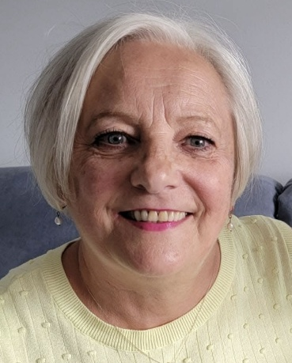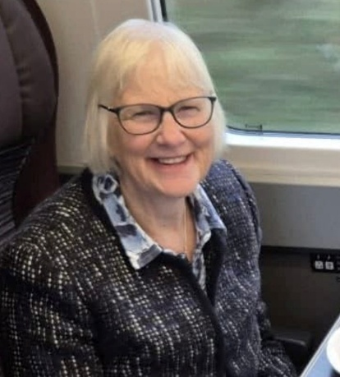

Objectives and activities
The Forum was established to support the advancement of citizenship and community development with the objective of improving the conditions of life for the Cardenden Community.
The Forum is the driving force behind the Cardenden local place plan /action plan. This plan is formulated by a variety of different means of consultation with the Cardenden community and is owned by all the organisations and individuals that participated in its subsequent preparation. It represents the needs and aspirations of the community and gives the community an active ‘voice’.
The plan consists of four general themes each with specific priorities to be addressed with the purpose of the improvement of Cardenden.
The forum brings together a variety of community groups and individuals who consider the main priorities within the place plan and set fluid targets by identifying projects to achieve the priorities within the plan.
The forum holds regular meetings to consider action plan progress, group reports and consider any further support required by groups/members.
Funding sources are identified to support the delivery of priorities and projects and this is an ongoing task. The Forum also holds money for raised these tasks and for groups who are members of the Forum
The Forum also runs a community shop where profits compliment the work of the community groups and projects

Structure, governance and management
Cardenden Community Development Forum governing document is a constitution the contents of which determine its functionality
Trustees for the year were recruited from most recent AGM and subsequent members meeting.
The Forums constitution and other necessary policies were revisited and produced throughout the latter part of 2025. This galvanised our system for membership and subsequent trustee appointment.
No external organisations are involved in the appointment of trustees.
When deemed necessary elected council members are invited to meetings in an ex-officio capacity.
.
Achievements and performance

Creation of a dog park in Wallsgreen park
This provided an area for park users to safely exercise their dogs. This also addressed ongoing problem of dog fouling in the park and previous misuse of play areas to exercise dogs .
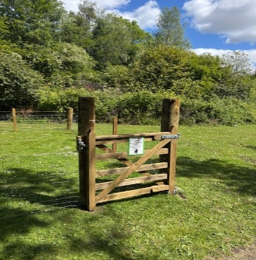

Extensive repair of several structures within Cardenden’s memorial to Lady Josephine /Bowhill Colliery
This was a tricky project as it required careful removal by crane of a large metal bogie to transport it to a local company for extensive welding work. The bogie had to be replaced by crane and associated structures (bogie base, wheel, seating areas, planters, commemorative cairn) repaired and repainted onsite.
This is a very significant memorial to the mining industry which is embedded in Cardenden heritage and a valued destination for the community to visit. It is included in a mining landscapes uk route.

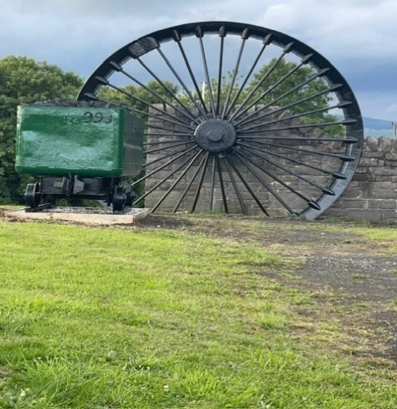

Restoration of Brigghills viaduct
This ancient viaduct is a beautiful structure left over from mining days.
It is a key link from two valuable well used green spaces with Cardenden however prior to forum involvement was very unsafe and a health and safety concern. The restoration was completed after negotiations with local company to undertake the tasks and what was achieved was an architectural triumph.
This not only preservation of important historical structure but also contributes to the health and well-being agenda as the community can now safely access beautiful woodland areas/paths
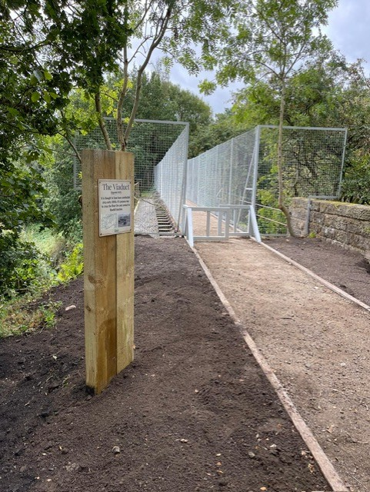

Upgrade to Core Path 517
This route was resurfaced path using local company to add a connectivity element to the existing path network and in addition provide a surface and route that improves and enables access for those users with mobility issues.
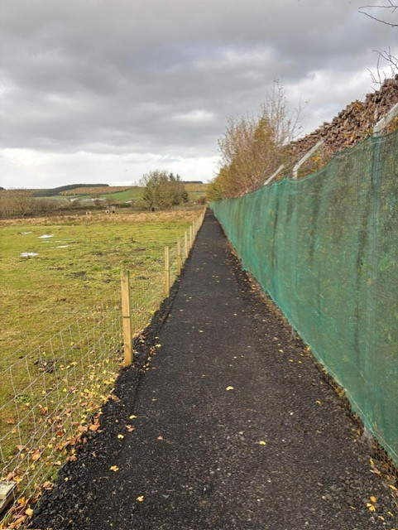
Upgrade to Bowhill Community Woodland access road
Access road to the woodland was upgraded to facilitate usage for those with mobility issues/buggies .
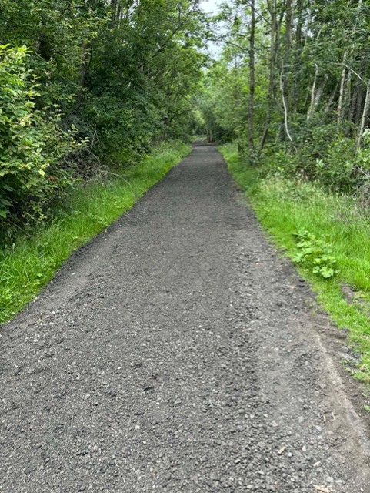
Completion of Youth Forum Mural
Following successful completion of mural on one side of the entrance wall to Wallsgreen park which celebrated key structures within the Cardenden area the youth forum completed the other side with focus being the activities that are undertaken within Cardenden area.
It creates an attractive focal piece when entering the park.
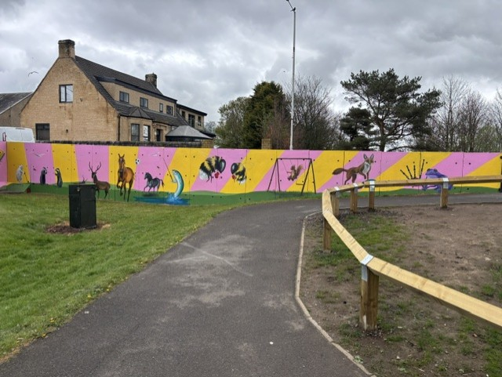

Planting of trees and bulbs in Bowhill Community Woodland
After planting 8000 daffodil bulbs and 150 trees in 2024 a further 3000 bulbs and 120 trees were planted in early autumn 2025.
These bulbs have all flowered in Spring 2026 and are spectacular. The trees continue to flourish
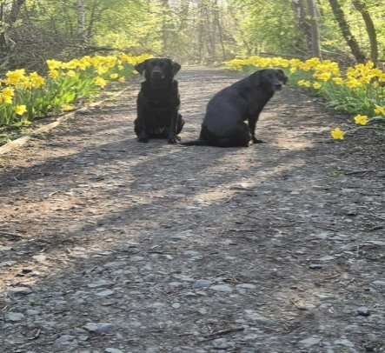
Memorial plaque for Dundonald /Lady Helen Colliery
In order to commemorate Lady Helen/Dundonald Colliery a plaque was mounted on a wooden structure depicting the history of the colliery.
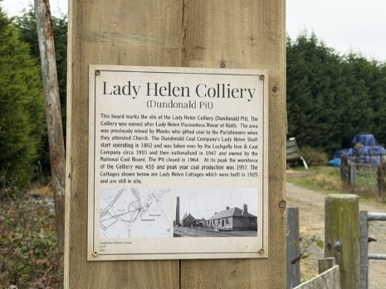

Rebuilding of Scout Hall
After losing previous scout hall due to a fire after many years of hard work a new scout hall was opened in late Spring 25.
This provides an invaluable asset not only to the scouts but to the population of Cardenden.

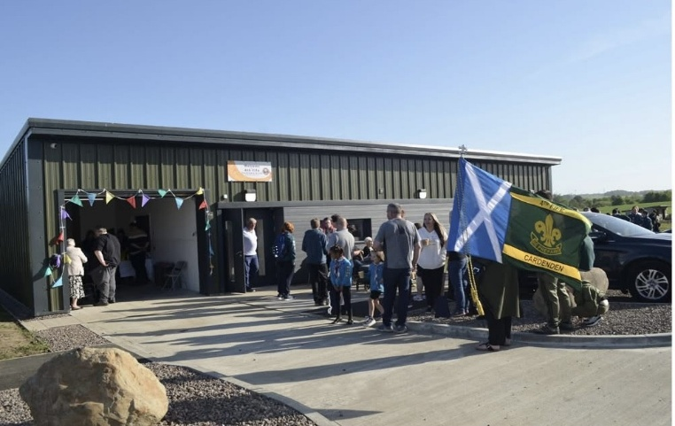

The above successful projects were undertaken by a variety of groups and individuals linked under the umbrella of the Forum. Different funders were sourced including Fife Council, Ore Valley, The Purvis Group, SPEnergy, Community Lotto, FRD, Kingdom Housing Nadra among a few.
Strong community links with local companies provided the Forum with a level of expertise and skill to compliment volunteer input.

Financial review
Statement of the charity’s policy on reserves
The charity maintains reserves within its account to cover shop running costs for the year of £10,000.
There are restricted funds allocated to the following groups –
Environment Group- £9,792.36
Woodland Paths - £2,007.00
Action Plan - £10,000.00

Details of any deficit
No deficit.

Donated facilities and services
Good quality items continue to be donated from members of the public to the Community Shop whose profits are used to help fund the community projects detailed under achievements and performance.

Future plans
The trustees and members intend to carry forward the actions detailed in our five year action plan.

Additional information
This year has been a challenging year. There has been a change in membership and trustees and a revisit to our constitution and related policies. The Forum has evolved as a stronger and more dynamic entity and the result is an exciting future in taking the Community action plan forward.

Declaration
Signed on behalf of the charity trustees:

Print name

Designation

Date

