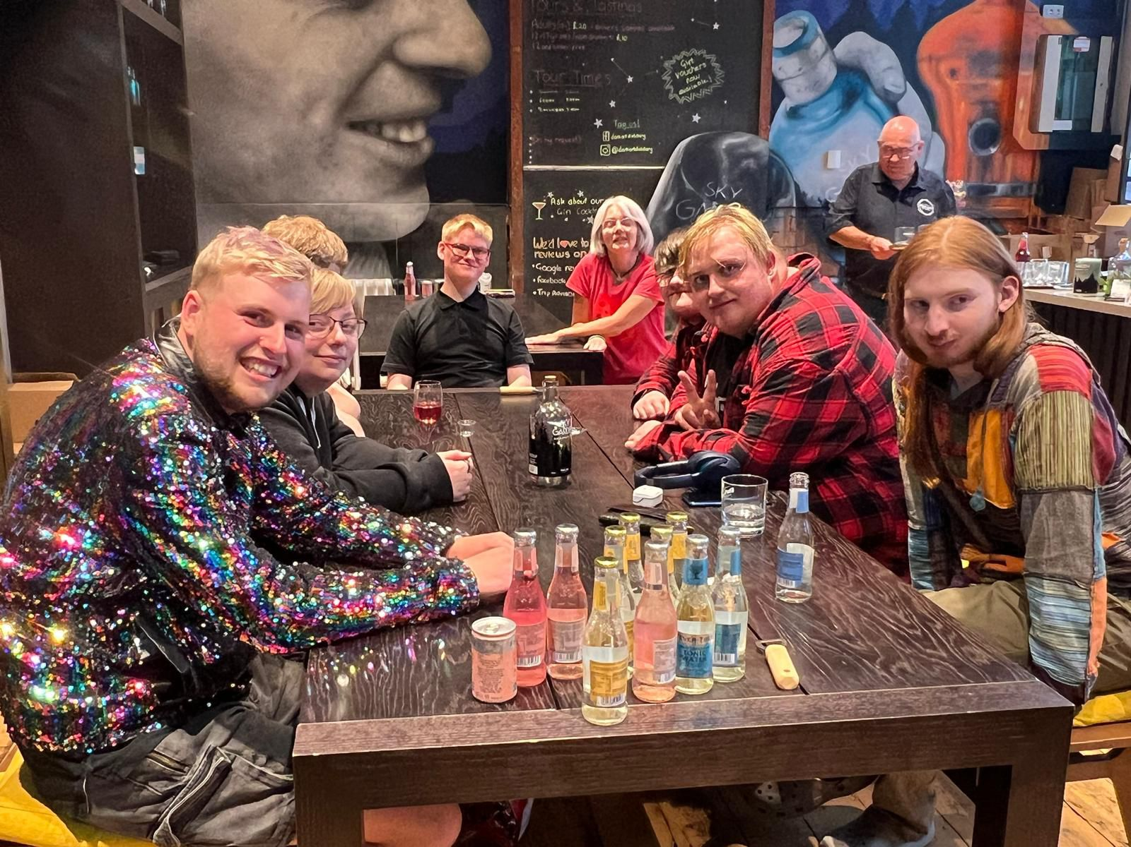

Trustees’ Annual Report

2025 - 2026

Resonate: Creating Communities

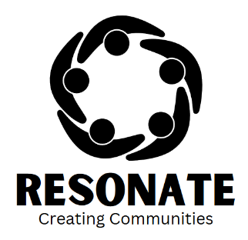
Contents
Chair’s Comments 3
Reference and administrative details 4
Charity Details 4
Charity Trustees 4
Objectives and activities 5
Vision 5
Objectives 5
Activities 5
Structure, governance & management 6
Constitution of Resonate: Creating Communities 6
Trustee recruitment and appointment 6
Achievements and performance 7
Summary of activities 7
Our impact 7
Computer Games Design Workshops and Club 9
Funding 10
Support from funders 10
Financial Review 11
Statement of financial activities 12
Future Plans 14
Next year 14
A new partnership 14
Summary 15

Chair’s Comments
Welcome to the second Resonate Annual Report! Our first year as an organisation was successful, but I think progress in the last year really takes things up a level, with the successful Community Asset Transfer of the former Kirkcudbright Police Station. Ahead of the proposed refurbishment, it is already being put to good use hosting some of our activities.
Our huge thanks again go to everyone who has supported us and helped us to continue our momentum in Year 2. Our progress is in no small part due to the efforts of our CEO, and the Board are increasingly conscious of the need for support, so she can focus on bidding and planning without also needing to be the main person who delivers everything we do.
Last year, I highlighted the challenges facing a young charity in securing funding. The situation hasn’t changed, but the challenge is now more acute, as we look to secure significant funds to transform the Police Station. However, we do now own the building, which will open doors to some new potential funding sources, and we are buoyed by our progress so far, to keep working hard. Our goal remains; to increase our impact and positively influence even more young people.
Please come with us to see things develop, and how we can make a difference.
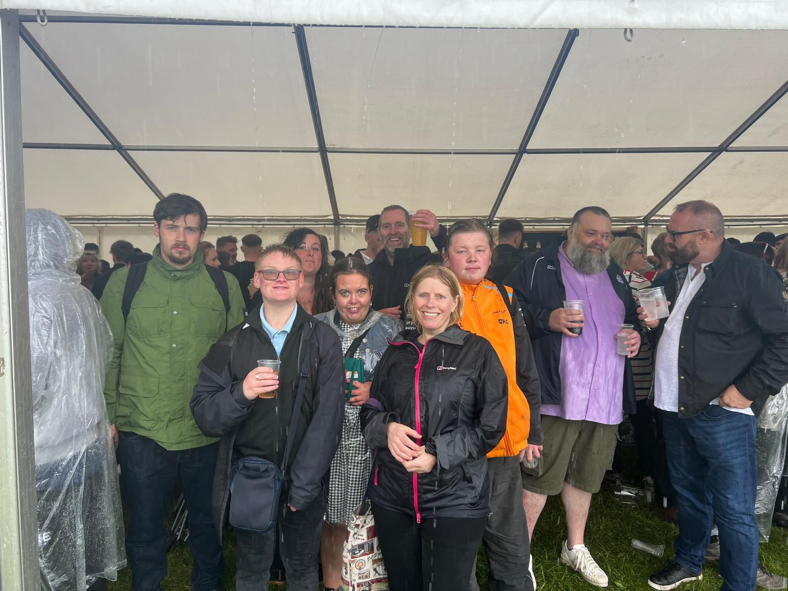

Reference and administrative details

Charity Details
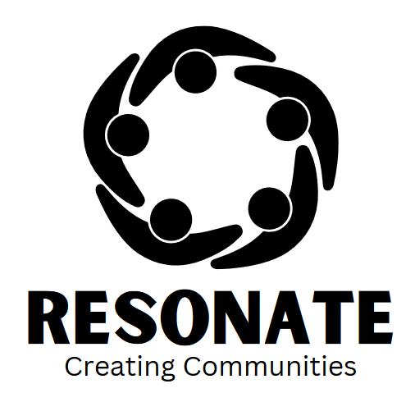

Resonate: Creating Communities
Scottish Charity Number: SC053544

Registered address:
Leamington House
High Street
New Galloway
Castle Douglas
Dumfries and Galloway
DG7 3RN

Telephone number: 07407 102796 / 07480 939869
Email address: info@resonatecreatingcommunities.co.uk
Website: https://resonatecreatingcommunities.co.uk/
Facebook: Resonate Creating Communities

Charity Trustees
- David Wright Chair
- Karen Wright Vice Chair
- Alexander Urquhart Treasurer
- Gillian Robinson Secretary & H&SC Lead
- Graeme Campbell Safeguarding & Education Lead

Objectives and activities

Vision

To create a more inclusive society for Autistic people where they can have more fulfilling, contributing and connected lives

Objectives
To transform the lives of people with autism and those affected by autism by providing information and support; housing; social and learning opportunities in specialist autism friendly environments, where autistic people can come together and thrive.

To support people newly diagnosed with understanding the positive sides of being Autistic and not see it as a limiting diagnosis.

To develop and build on peoples’ special interests and turn them into viable business opportunities that can lead to more financial stability and greater access to opportunities.

Activities
The charity was set up, to try to fill a gap in local services and provision for Autistic people.
In our first two years we have run social groups, computer games design workshops, regular weekly clubs, and have completed a Community Asset transfer application for the former police station In Kirkcudbright. We plan to re-open this as a Positive Minds hub for young people & the wider community, alongside out of school/ college activities for young people with ASD and upstairs open a shared independent living flat.
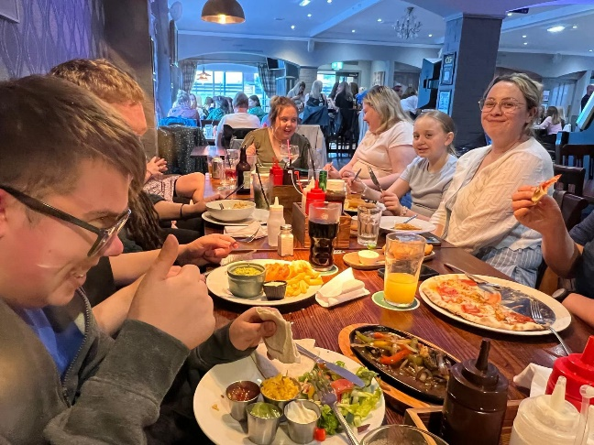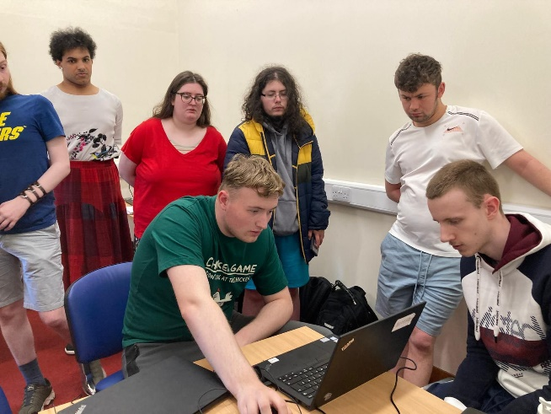

Structure, governance & management

Constitution of Resonate: Creating Communities
Resonate Creating Communities is a Scottish Charitable Incorporated Organisation and has a tier two model constitution.

Trustee recruitment and appointment
We initially held three information sessions about what Resonate: Creating Communities was wanting to achieve. Which was basically finding ways to fill identified gaps in local provision. It was at one of these meetings that our initial board members put themselves forward to be on the board. After filling in Board Member applications, they were allocated roles that best fit their skills and experience. These were seconded and approved.
Sadly, during the course of the year, changes in circumstances have meant that Tracy Campbell has stepped down from the Board, and her role as Secretary. The Board would like to extend their sincere thanks to Tracy for her contribution. To recruit a new board member/trustee, we advertised locally on Kirkcudbright Development Trust and Kirkcudbright Community Help Facebook pages. We were successful in recruiting a new board member: Local business owner Gillian Robinson Joined our board as Secretary
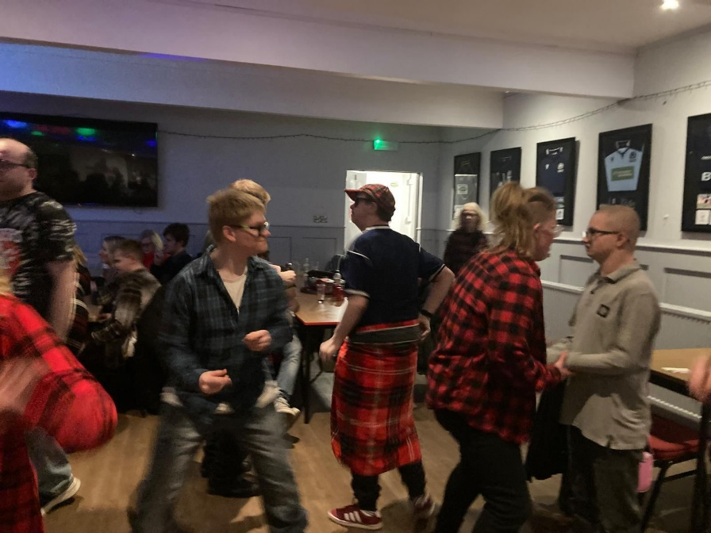

Achievements and performance

Summary of activities
During our second year as an organisation, we have:
- Successfully raised the funds required and purchased Kirkcudbright Police Station, which we plan to turn into a positive minds’ hub.
- Applied for and been granted planning permissions for the change of use and redevelopment of the police station.
- Our organisation/ board of Trustees and CEO have completed governance training and worked with several organisations to support this.
- Run a weeklong Games Jam workshop with graduates from Abertay University to further develop the skills of young people with ASD.
- We have run 2 social club sessions weekly (one in Dumfries and one in Stewartry) for young adults with ASD, with a rich and varied programme of activities.
- We have run 3 Dungeons and dragon groups for young autistic people in Dumfries, Kirkcudbright and New Galloway.
- Continued to run our 2 x weekly Computer Games Design Clubs, allowing young people to further develop their skills, confidence and support them with applications / transition to college and further study.
- We have continued to support parents of adult children with ASD, have more understanding of the barriers, their loved one’s face as well as supporting the young person to make their first steps towards engaging, which has successfully led to trying one of our activities.
- Facilitated parent/ carer meet ups and peer support networks.
- Our parents and young people took part as volunteers and helped run 6 days of community engagement and pop-up fundraising café, to raise awareness of the project and help raise unrestricted funds.
- Secured £226,000 of funding to help develop several projects from a variety of funders (please see Funders section).

Our impact
We are making a difference to the lives of young people. We have gained new members to our social groups and have offered some joint group activities to help widen the young people’s peer/ friendship groups. We have had some great activities this year, from attending music gigs, festivals, dance workshops, Bingo nights, to taking part in water sports activities, and two camping trips, alongside our regular social sessions.

We have offered three trips, Blackpool Pleasure Beach, Comic Con and also a Glasgow trip: The itinerary included The Barras Market, Purple Cat Café and Tutankhamun Immersive Experience- a fantastic trip.

We have seen young people come along, who rarely see anyone outside the family home due to stress and anxiety, come along and enjoy hanging out with their peers. We have seen:
- Confidence increase.
- Social skills improve.
- Developing Friendships.
Young people developing the confidence to make suggestions and contribute activity ideas to the group, some of which has led to a few spin-off activities, that young people have instigated and arranged themselves.

We have also seen evidence of young people developing flexibility and willingness to give things a try, not just at the social group but in other areas of life. Four young people from our computer games design group went on to study computing /creative industries courses at college and one young man started and completed his first year at university.
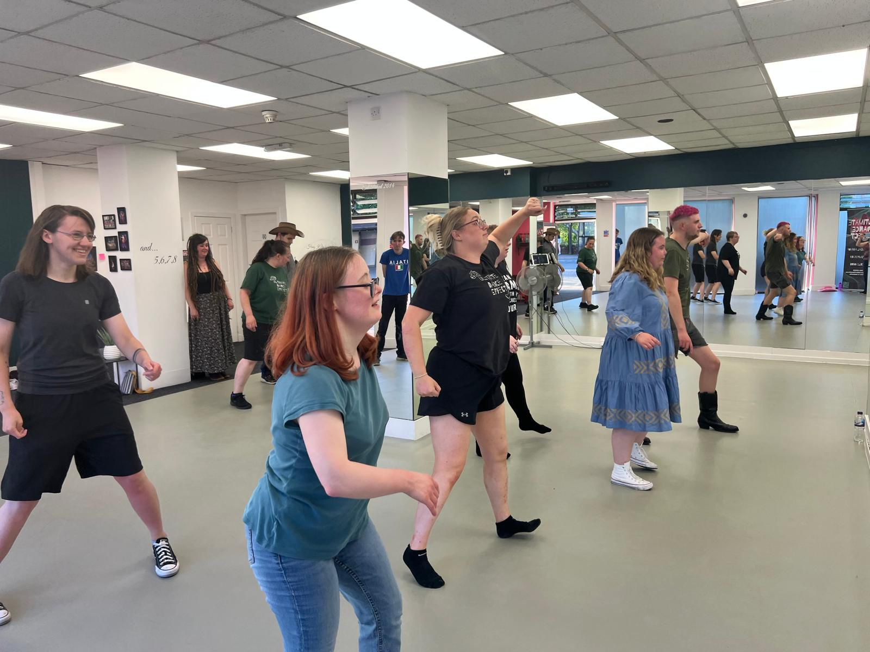

Computer Games Design Workshops and Club
The Computer Games Design workshops stemmed from a young person who wanted to become an independent games maker. To find out more, we went to the best and visited Abertay University, where we developed a link with some of the staff and graduates.

Over the last two years we have run three 4-day intense workshops with our Abertay Colleagues, which was a success. One young boy, who is home educated was not only motivated to come along because of the subject, however he surprised his family by enjoying it and wanting to come back!

For another young participant, although attending the workshop didn’t work out, the feedback and support he received from the graduates, boosted his confidence in his ideas and his ability and he has just completed his first year at college.
We have funding to run it again later this year, offering some new participants the chance to give it a try. This year we were joined by Duncan Curtis from Alive Radio, who ran some sound engineering / editing workshops to help our designers, incorporate sound into their games. Sessions were a great success. With one of our group members becoming a regular fortnightly fixture at Alive Radio.

Through involvement in the games design activities participants have:
• Learned how to use game engine software and developed their skills.
• Created a game to first level
• Met other neurodiverse young people and developed friendships,
• Gained confidence to pursue at college/ university
• Have positive & successful ASD role models

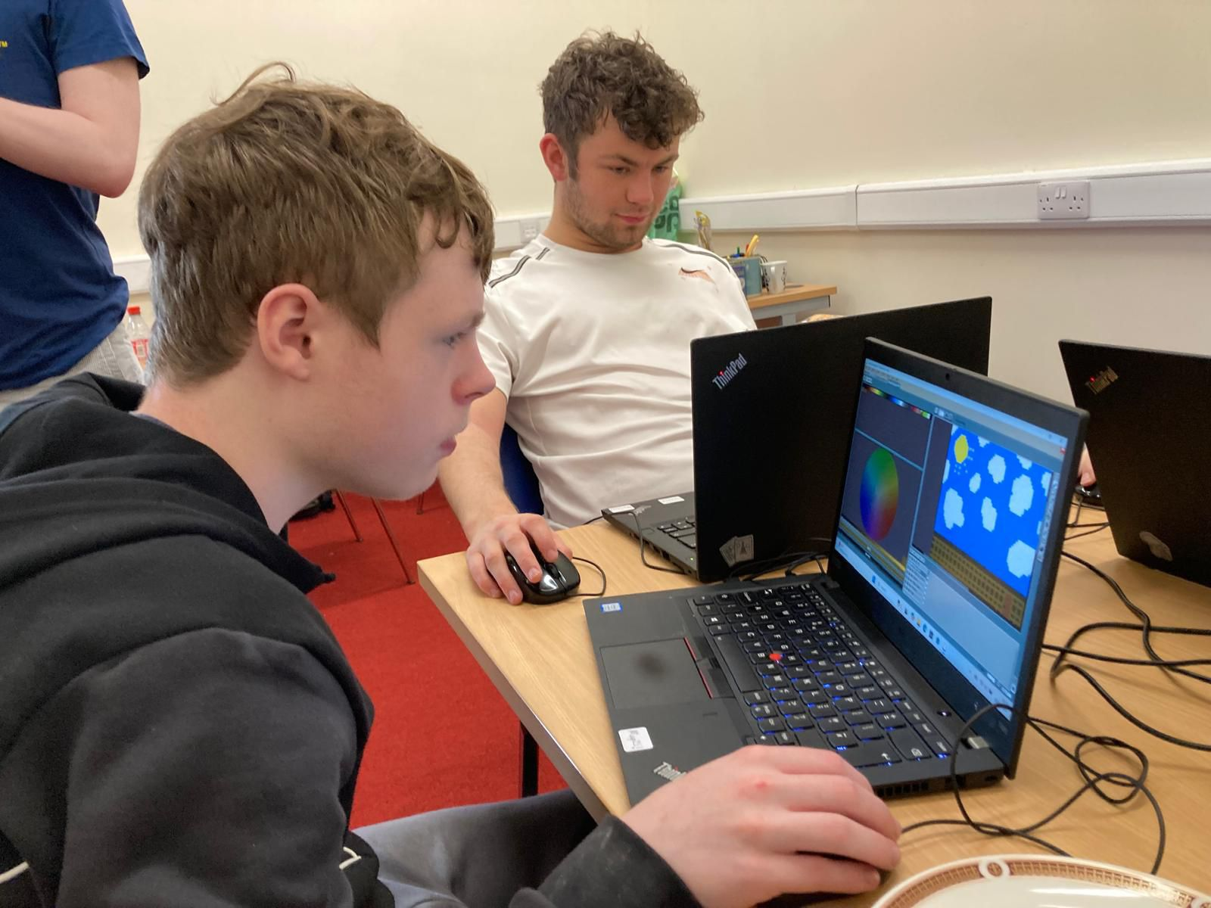

Funding

Support from funders
We would like to acknowledge our funders without them we would not be able to provide any activities or be able to reach our goals and vision. So, thank you to:
- Awards for All
- Children in Scotland
- Crown Estate
- Cunningham Housing
- Dumfries & Galloway Council
- Foundation Scotland Essential
- New Galloway & Kells Council
- Glenken’s District Trust
- Annan and Nithsdale Community Benefit Fund
- Robertson Trust
- Robin Rigg
- Firstport - Start It
- Tesco Groundwork
- Third Sector Dumfries & Galloway (TSDG) CLLD Fund
- D&G Council Kirkcudbright CGF
- R S MacDonald
- South Of Scotland Enterprise (SOSE)
- Albert Hunter Trust
- Trefoil

Financial Review

Statement of financial activities
Statement of Financial Activities for the Period 1st April 2025 to 31st March 2026

INCOME AND ENDOWMENTS FROM £ 224,613
Donations and legacies
EXPENDITURE ON £ 80,838
Other
NET INCOME £ 143,775
TOTAL FUNDS CARRIED FORWARD £ 207,056
Restricted fund £ 188,019

We would like to thank Gerald McGill from Farries, Kirk and McVean, Chartered Accountants for completing our accounts.

Statement of the charity’s policy on reserves
As a young charity, we do not currently have unrestricted/free funds to include in as part of our reserves policy. As all our funding to date has been restricted, to the activities we offer. Staff have been employed on a sessional basis, as it is project funded. We do aspire to have a reserves policy which has 6 months operating costs set aside for emergencies, such as a shortfall in funding. Operating costs are currently around between £5k-£8k a month, so we are aiming for a reserve between £30k and £48k.

As we are currently developing and plan to increase the activities we offer in the coming year, the figure will likely change, but this will be part of our financial planning and a matter for our finance board to review and set.

This continues to be an area of concern and one that the Trustees and CEO, will prioritise in the coming financial year, and look to find ways to secure funds for this purpose.

Details of any deficit
No deficit.
Donated facilities and services
We would like to thank Natural Power, for their continued support and a further donation of 10 used Lenovo laptops. A model, designed for mobile working, so are robust and sturdy. They have been invaluable, for our Computer Games Design Club, and being transported around.
We would also like to acknowledge The Castle Douglas IT Centre and their young trainees who refurbished all of them at cost, so for less than the price of one new laptop, we have had all 10 working models.

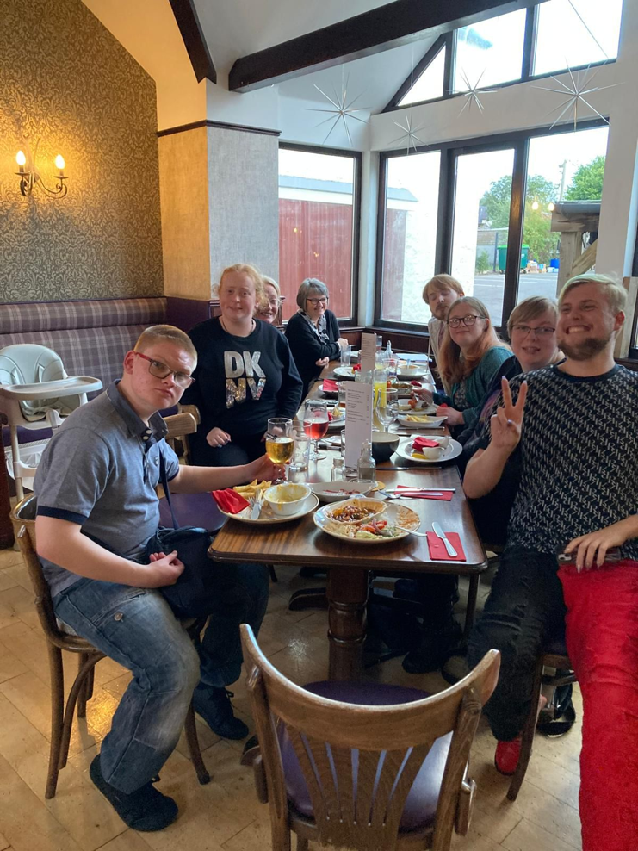
Future Plans

Next year
2026/27 is set to be an exciting year. We have just completed our Community Asset Transfer of the Kirkcudbright Police Station, and got the keys on the 27th March 2026. Now the hard work begins raising the funds to develop the site and make it fit for purpose and meet building regulations. In the meantime, we have started using the building and continue to run our regular groups.

The proposed Police Station development has been divided into three phases, and once we have raised enough funds building work will begin. We hope to have Phase 1, the Main building completed in this financial year.

The first phase includes creating a mental health/ positive minds hub for young people, which will provide informal mental health support and help fill the gap until they can access CAMHS or other statutory services. Upstairs we plan to create a supported transition flat, ASD flat, where young people will move out of the family home, live with similar peers and develop independence skills in a supported environment.

We plan to develop some new projects, to run within the Positive Minds hub, such as:
• Supporting individuals/ family locally with post ASD diagnosis support;
• Providing access to informal mental health support to individuals and supporting young people with accessing other services.
• Providing training/ workshops to parents on how to support the wellbeing of their children and loved ones.
• Increasing access to Computer Games Design training.
• Offer volunteering opportunities for young people within the positive minds’ hub, to help support younger peers through helping to run Lego clubs.
• Providing a safe lunchtime space for young people needing a place to recharge for the afternoon.

Summary
We hope that this brief summary of our last year’s worth of activities, together with an insight into our plans and vision, has painted a picture of the type of support that Resonate wish to provide young people within our area.

We are excited to continue this work, and to embark on the challenge to secure funding that will allow the Kirkcudbright Police Station project to become a reality over the next year.
Hopefully this facility can become a proof of concept for many more safe, multi-use spaces to help our young people develop, fulfil their potential and thrive.

