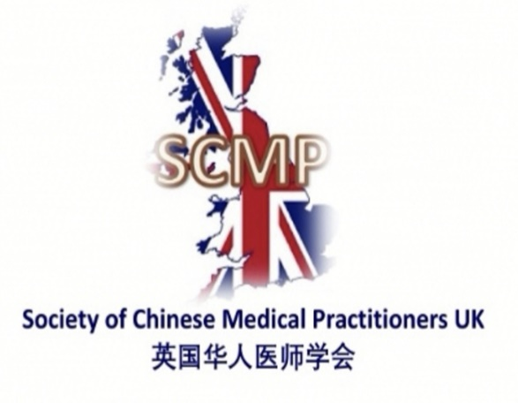

Society of Chinese Medical Practitioners UK
Trustees’ Annual Report
06/04/2024 to 05/04/2025

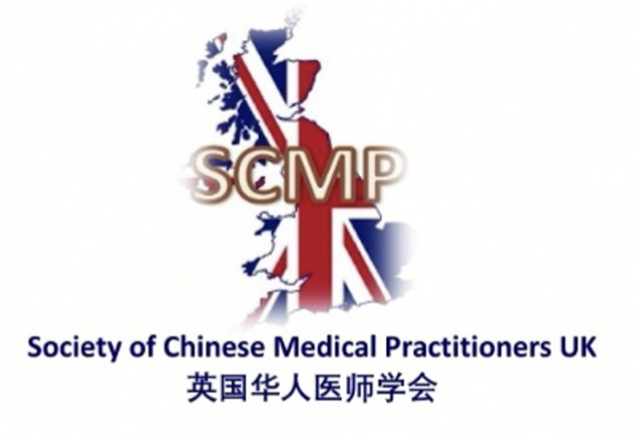
Charity contact information

Society of Chinese Medical Practitioners UK
Scottish Charity Number: SC051073
Company Number: 125338997

Suite L3, Fenton Way, Chatteris, England, PE16 6TT

Email: info@scmp-uk.org
Website: www.scmp-uk.org
Twitter: @scmp_uk

Charity Trustees

- Dr Xueli Jia
- Dr Hua Jiang
- Dr Li Li
- Dr Zhangjie Su
- Dr Luting Xu
- Dr Zichu Yang
- Dr Hongyi Zhang

Executive Committee

- Prof Jing Deng
- Dr Xueli Jia
- Dr Hua Jiang
- Dr Li Li
- Dr Zhangjie Su
- Dr Luting Xu
- Mr Zheng Xu
- Dr Zilin Xu
- Dr Zichu Yang
- Dr Hengjia Zhang
- Dr Hongyi Zhang

Objectives and activities

The Charty’s objects are:
(a) the advancement of education in the field of medical training and the healthcare system in China and the UK; and
(b) the promotion of culture through the understanding of cultural differences between China and the UK, in particular in relation to the healthcare sector.

In pursuance of the objects listed above (but not otherwise), the company shall have the following activities:
- To organise and run educational and cultural events, courses, seminars and other activities.
- To establish links between medical professionals within and out with the UK through visiting or exchange programmes.
- To provide advice, support and mentoring to medical professionals and students.
- To provide humanitarian support and advice to the public and to organisations in the UK and internationally.
- To carry on any other activities which further any of the above objects.
- To promote companies whose activities may further one or more of the above objects, or may generate income to support the activities of the company, acquire and hold shares in such companies and carry out, in relation to any such company which is a subsidiary of the company, all such functions as may be associated with a holding company.
- To acquire and take over the whole or any part of the undertaking and liabilities of any body holding property or rights which are suitable for the company’s activities.
- To purchase, take on lease, hire, or otherwise acquire, any property or rights which are suitable for the company’s activities.
- To improve, manage, develop, or otherwise deal with, all or any part of the property and rights of the company.
- To sell, let, hire out, license, or otherwise dispose of, all or any part of the property and rights of the company.
- To lend money and give credit (with or without security) and to grant guarantees and issue indemnities and to provide bursaries.
- To borrow money, and to give security in support of any such borrowings by the company, in support of any obligations undertaken by the company or in support of any guarantee issued by the company.
- To employ such staff as are considered appropriate for the proper conduct of the company’s activities, and to make reasonable provision for the payment of pension and/or other benefits for members of staff, ex-members of staff and their dependants.
- To engage such consultants and advisers as are considered appropriate from time to time.
- To effect insurance of all kinds (which may include officers’ liability insurance).
- To invest any funds which are not immediately required for the company’s activities in such investments as may be considered appropriate (and to dispose of, and vary, such investments).
- To liaise with other voluntary sector bodies, local authorities, UK or Scottish government departments and agencies, and other bodies, all with a view to furthering the company’s objects.
- To establish and/or support any other charity, and to make donations for any charitable purpose falling within the company’s objects.
- To take such steps as may be deemed appropriate for the purpose of raising funds for the company’s activities.
- To accept grants, donations and legacies of all kinds (and to accept any reasonable conditions attaching to them).
- To oppose, or object to, any application or proceedings which may prejudice the company’s interests.
- To enter into any arrangement with any organisation, government or authority which may be advantageous for the purposes of the activities of the company, and to enter into any arrangement for co-operation or mutual assistance with any charity.
- To do anything which may be incidental or conducive to the furtherance of any of the company’s objects.

Structure, governance and management
Type of governing document
As a company limited by guarantee and a Scottish Charity. The company’s activities are governed by Companies Act 2006 and Charities and Trustee Investment (Scotland) Act 2005.

The main governing document is the Articles of Association of Society of Chinese Medical Practitioners UK, adopted on 12 June 2021. This document is available to the public on the Companies House website.

Trustee recruitment and appointment
No change for trustees during this year

Executive Committee
In order to deliver the Charity’s objectives more effectively, the Board of Trustees agreed to establish an Executive Committee. This Committee will oversee the day-to-day running of the Charity, and to deliver the goals and tasks set up by the Board of Trustees. The committee was established in April 2024, current committee members is listed earlier in this report. The committee holds meetings regularly, normally once a month.

Registered office change
The Charity’s registered office has changed on 17 June 2024 to its current address.

Achievements and performance
This year has been both productive and rewarding for the Society of Chinese Medical Practitioners. Below are the highlights of our activities and accomplishments:
- PLAB 1 Preparation Courses
We have continued to run the established online PLAB part 1 exam preparation courses. Our second 8-week course was successfully delivered in April and May in 2024. PLAB is the exam for qualified doctors seeking UK GMC registration. Our PLAB courses continued to receive excellent feedback from attendees, indicating that our efforts in supporting candidates' readiness for the PLAB exam are highly effective.
- Clinical Attachment
We secured placements with two departments across two NHS hospitals to host international medical students and junior doctors for clinical attachments.
- Exchange Programme
For the exchange programme, we established partnerships with 19 departments across six NHS hospitals. During this financial year, two senior doctors from China participated in the programme. Dr Zhao spent three months in Neurosurgery at Addenbrooke’s Hospital from April to July 2024. Dr Xiao Yang undertook a six-month placement in Vascular Surgery at Bradford Royal Infirmary from September 2024 to February 2025.
- Annual conference
The 2024 SCMP Annual Conference was successfully held in Cambridge in June 2024. Attendees spoke highly of the seminar series and group discussions, highlighting their quality and relevance. The conference provided a valuable opportunity and an excellent platform for doctors of Chinese origin to share knowledge and exchange experiences of working within the NHS.

- Social activities
Doctors and dentists from the North region of the UK gathered in Manchester on 1st March 2025 to celebrate the Chinese Spring Festival.

- Scholarship programme
We began supporting SCMP existing members by offering scholarships to outstanding doctors working within the NHS. Dr. Heng Man Leong and Dr. Beili Shao were both successful in their applications for the 2025 Spring season, each receiving a grant of £500.

- Internation Collaborations and promotions
    - Dr. Xueli Jia was invited to Dezhou Hospital in Shandong Province in August 2024, where she shared her experience as a vascular surgeon in the UK. Her presentation and teaching inspired a group of vascular trainees and surgeons, who are now considering collaborations with UK universities and hospitals.
    - Dr. Hengjia Zhang led outreach visits to two prestigious dental hospitals in China in September 2024: the Chinese Medical University in Shenyang and Nanjing Medical University. During these visits, he delivered talks on the UK dental training pathways and highlighted SCMP's role in supporting Chinese medical professionals abroad.
Financial review

Dr Luting Xu continues to act as the Charity’s Honorary Treasurer during the period covered by this report and will continue to do so.

The Charity continues to appoint Eden Accounting Ltd to oversee the financial aspects on a regular basis. They also prepare Annual Returns/Confirmation statements for the relevant regulatory bodies, including the Companies House, HMRC and OSCR. Their contact details are as follows.

Please refer to the Annual Returns for details regarding the Charity’s financial position.

The contact details of the Accountants are as follows:
Eden Accounting Ltd Chartered Certified Accountants
Suite L3, South Fens Business Centre
Fenton Way
Chatteris
PE16 6TT
Email: info@edenaccounting.co.uk

Future plans
Biannual Conference
Our last biannual conference was held in June 2024, and the next one is scheduled for 2026 in Oxford.

Education Activities
We will continue to provide and expand clinical attachment and exchange programme.

Social Activities
Social and network activities will be organised throughout the years. These will be family-friendly events whenever possible to encourage the next generation into the medical profession. In addition, regional activities will also be planned in due course.

Scholarship Programme
We will continue the scholarship programme to support professional activity needs to our existing members.

International Collaboration
We have established contacts with sister organisations in the USA, France etc. And we will continue to play an important part in the family of the World Association of Chinese Doctors (WACD).

Other Charitable Activities
Depending on our resources and planning, we will continue to participate in all relevant charitable activities where we can contribute as a group with medical knowledge and background.
These insights will guide our efforts as we continue to expand our support for Chinese medical practitioners. By introducing new initiatives and enhancing existing ones, we aim to meet the evolving needs of our members and strengthen our impact in the medical community.

Declaration
Signed on behalf of the charity trustees:


Print name: Xueli jia

Designation: Trustee

Date: 4 May 2026

