ST. TERNAN’S SCOTTISH EPISCOPAL CHURCH
MUCHALLS

Registered Charity Number SC023264

Report and Accounts For the Year Ended
31st August 2025

OUR MISSION
At St. Ternan’s God calls us to use the Gifts we have been given, to grow as a Loving Church-Centred community of inclusivity in which we welcome The Stranger, Worship God and reach out to The World in which we live, always demonstrating Jesus’ Love.

SCOTTISH EPISCOPAL CHURCH – DIOCESE OF BRECHIN
ST. TERNAN’S CHURCH, MUCHALLS (CHARITY NO SC023264)
REPORT AND ACCOUNTS FOR THE YEAR ENDED 31ST AUGUST 2025

- The Trustees of the Charity who have served during the year, are as follows:-
Rev Canon Mary Jepp Chairperson
Mr Geoffrey Bell Treasurer
Mrs Irene Butler Secretary
Mr Andrew Herbert (Resigned 28/01/25) Property Convenor
(Resigned 28/01/25) Health & Safety Convenor
Mrs Jan Horn Minute Secretary
PVG Co-ordinator/
Mrs Dee Foulds
Mrs Sue Selway
Mrs Pamela Purkis
Mr Mike Jepp (Appointed 28/02/25) Health & Safety Convenor
(Appointed 28/02/25 Property Convenor

At least one Trustee retires from the Vestry at the Annual General Meeting and at least one Trustee falls to be elected.

- Bankers
The Bank of Scotland plc, PO Box 1000, BX2 1LB

- Independent Examiner
Mr Peter Nelson, 4 St Micharls Road, Newtonhill, Stonehaven, Aberdeenshire, AB39 3RW.

Page 1
SCOTTISH EPISCOPAL CHURCH – DIOCESE OF BRECHIN
ST. TERNAN’S CHURCH, MUCHALLS (CHARITY NO SC023264)
REPORT AND ACCOUNTS FOR THE YEAR ENDED 31ST AUGUST 2025

- Church Address
St Ternan’s Scottish Episcopal Church, Muchalls, Stonehaven, Aberdeenshire, AB39 3PP.

- Principal Office
C/O Treasurer – Mr Geoffrey Bell, 4 Eastsyde Lane, Portlethen, Aberdeen, AB12 4NU.

- Report of the Trustees
In terms of the Charities Accounts (Scotland) Regulations 1992 the Trustees report to the Congregation as follows:-
St. Ternan’s Church, Muchalls is a Church of the Scottish Episcopal Church, in full communion with the Anglican Church.
The superior authority is the Bishop of Brechin.
Our Charitable Purpose is the Advancement of Religion. We are part of the Scottish Episcopal Church. We offer regular public worship within the broad tradition of the Episcopal Church. We seek to live out the Christian Gospel in our local community in love and service.
The present Constitution of the Church dates from 2013. It is available for inspection if required.
The Trustees of the Charity present their annual report together with the financial statements for the year ended 31st August 2025.

Page 2
SCOTTISH EPISCOPAL CHURCH – DIOCESE OF BRECHIN
ST. TERNAN’S CHURCH, MUCHALLS (CHARITY NO SC023264)
REPORT AND ACCOUNTS FOR THE YEAR ENDED 31ST AUGUST 2025

- Review of the Accounts for the Year
The Accounts for the year show a deficit of £6,663 (2024 – a deficit of £8,026) which reflects
both a fall in income and a reduction in expenditure. Whilst we have again suffered a drop in
Congregational giving as numbers continue to decline we have lost our source of rental income
from our Rectory during the year as our long-time tenant moved to new premises. As the
Rectory is being prepared for imminent sale we have not sought to re-let the property.
Expenditure has been strictly controlled with a 50% reduction in heating related costs and a
near 50% reduction in property repairs and maintenance.

We are now well advanced on our plan to sell the Rectory to raise funds for our continuing work
within the Church. We have secured funding of £7,250 towards our Net Zero project to install
Electric Panel heating to replace our present wood pellet boiler which is located within the
Rectory and shared with it. As at the Balance Sheet date we had received £5,000 which is
included in our Bank of Scotland Funds but is reserved for Net Zero works and is not available
for general expenditure. We are working with an experienced Architect to finalise the design
and expect to imminently appoint Contractors. We have also appointed Contractors to provide
a separate water supply to the Church to replace the presently shared supply with the Rectory.
Once these works have been initiated we will put the Rectory on sale.

It has been agreed with the Diocese that we can call upon them for a Loan, secured against the
anticipated sale proceeds from the sale of the Rectory, to fund our works to provide a water
supply and electric heating which must be completed before such a sale can take place.

Page 3
SCOTTISH EPISCOPAL CHURCH – DIOCESE OF BRECHIN
ST. TERNAN’S CHURCH, MUCHALLS (CHARITY NO SC023264)
REPORT AND ACCOUNTS FOR THE YEAR ENDED 31ST AUGUST 2025

- Reserves Policy
The Trustees are mindful of the effect of continuing deficits on the remaining reserves of the
charity. If the charity continues to have a deficit at the current level of £6,600pa then our
reserves, (as at 31st August 2025 - £21,192 excluding our Net Zero grant of £5,000), would be
exhausted, assuming closure costs of no more than £7,500, within 1-2 years. Our Vestry has
accepted that our reserves must not fall below £7,500 so as to allow an orderly closure in the
event of cessation.

- Unit Trust Pool Investment
For many years the Vestry has held 165 Units in the UTP Fund established by the Scottish
Episcopal Church. Following the formal closure of the Sunday School in September 2024,
after many years of inactivity the Vestry decided in August 2025 to absorb the Funds which had
not been used for the Sunday School prior to it’s closure. These funds were valued at
£5,497 in September 2025 and have been included in the Balance Sheet for the current year.
They have been included in our unrestricted General Funds and are available to support our
general expenditure.

- Expenses paid to Trustees
The majority of payments to the Trustees are for the reimbursement of costs incurred
buying small items of stationery, altar supplies , catering and cleaning goods. In addition there
continue to be two exceptions:-
  - A member of Vestry, Mrs Sue Selway, is being paid the sum of £15.00 for a fortnightly cleaning of our various toilet and kitchen facilities. This was agreed upon in 2012 as being more cost effective than employing outside cleaners. Mrs Selway submits invoices for her work
Page 4
SCOTTISH EPISCOPAL CHURCH – DIOCESE OF BRECHIN
ST. TERNAN’S CHURCH MUCHALLS (CHARITY NO SC023264)
REPORT AND ACCOUNTS FOR THE YEAR ENDED 31ST AUGUST 2025

In addition to the above our Minister, Rev Canon Mary Jepp, who is also a Trustee by virtue of her position, receives a Stipend and associated housing provision from the Diocesan team. We, together with St James, Stonehaven and the Diocesan team share the costs of her Stipend and housing in a proportion agreed between the three parties before this arrangement commenced. During the year under review the costs borne by St. Ternan’s for our share of the Stipend, housing and sundry travel costs was £12,248, (2024 - £12,692) and are reported in the accounts under the heading Transitional Ministry.

- Budgetary Control
During the year under review a detailed budget assisted decision making within the Vestry.
However, due to the anticipated departure of our Minister, on her retirement in November 2025
we have been unable to prepare a financial forecast for 2025-2026 with any degree of
credibility. We anticipate a period of vacancy where we would not be charged a Stipend which
may last anything from three to nine months or indeed longer. In addition we anticipate major
expenditure on a water main and a heating system. In the event careful monitoring of our cash
position and anticipated expenditure has replaced our usual budgeting controls.

- Transactions between the Charity, Charity Trustees or Connected Persons
Apart from a moral obligation to pay Quota to the Diocese together with our agreed share of
Rev Canon Mary Jepp’s Stipend, housing costs and sundry travel costs referenced in Note 10
above, there are no material transactions with any other connected or associated body.

Page 5
SCOTTISH EPISCOPAL CHURCH – DIOCESE OF BRECHIN
ST. TERNAN’S CHURCH, MUCHALLS (CHARITY NO SC023264)
REPORT AND ACCOUNTS FOR THE YEAR ENDED 31ST AUGUST 2025

- Responsibility of the Trustees regarding the Accounts
It should be noted that it is the responsibility of the Trustees to prepare financial
statements, which give sufficient detail to enable an appreciation of the transactions of the
Church during the financial year. The Trustees are responsible for keeping proper accounting
records, which, on request, must reflect the current financial position of the Church at that
time. This must be done to ensure that the financial statements comply with the Charities and
Trustee Investment (Scotland) Act 2005 and the Charities Accounts (Scotland) regulations
2006. They are also responsible for safeguarding the assets of the Church and must take
reasonable steps for the prevention and/or detection of fraud or other irregularities.

Signed on behalf of the Trustees

Geoffrey Bell BSc, FCA, MIoD
Treasurer
St. Ternan’s Church, Muchalls
3rd December 2025

Page 6

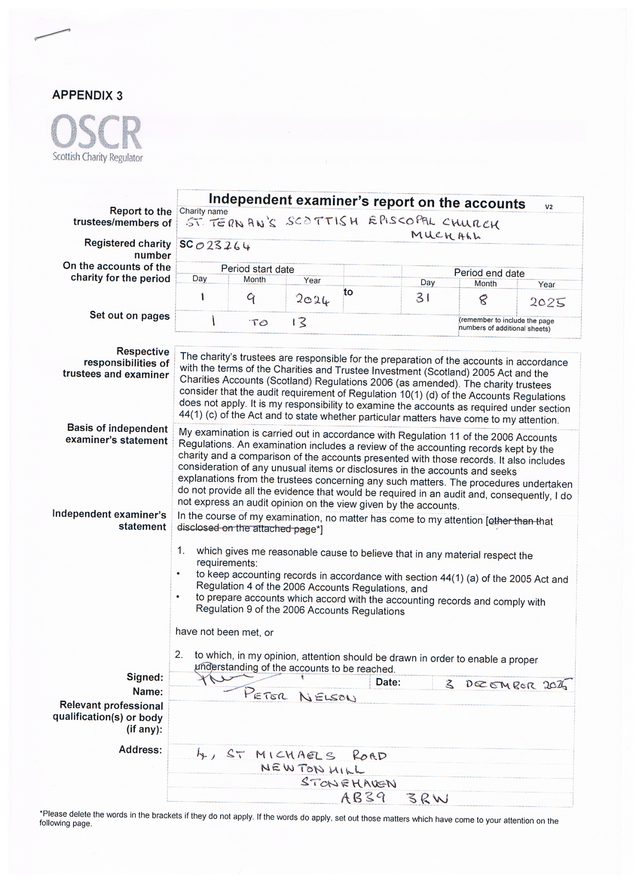SCOTTISH EPISCOPAL CHURCH – DIOCESE OF BRECHIN
ST. TERNAN’S MUCHALLS (CHARITY NO SC023264)
RECEIPTS & PAYMENTS FOR YEAR ENDED 31ST AUGUST 2025
RECEIPTS Notes 2025 2024
Congregational & Voluntary 2 14,983 16,306
Tax Reclaimed 2 3,959 4,297
Special Collections 3 0 408
Investment Income 4 163 355
Donations 2 895 514
Rental of Rectory 6 4,450 10,200
Rectory Heating Refunded 2 232 498
Sale of Register CD’S &Insurance Dividend 7 180 28
Fundraising Events 7 417 832
Total Income 25,279 33,438

PAYMENTS
Cost of Ministry, inc Quota 9 3,608 4,371
Church Expenses 11 210 14
Property Expenses 10 12,172 19,338
Organist/Organ Repairs 11 2,872 2,599
Transitional Ministry 11 12,248 12,692
Administrative Expenses 12 832 1,965
Charitable Expenditure 13 0 485
Total Expenses 31,942 41,464
DEFICIT FOR THE YEAR £6,663 £8,026

NET ZERO GRANT RECEIVED IN THE YEAR £5,000 £0
Page 7
SCOTTISH EPISCOPAL CHURCH – DIOCESE OF BRECHIN
ST. TERNAN’S MUCHALLS (CHARITY NO SC023264)
STATEMENT OF BALANCES AS AT 31ST AUGUST 2025
Notes 2025 2024
MOVEMENT ON RESERVES
Opening Balances 15 27,855 35,881
Deficit for the Year (6,663) (8,026)
Net Zero Grant 5,000 0
Closing Balances 15 £26,192 £27,855

RESERVES HELD BY THE CHARITY
Bank of Scotland Community Account 21,103 27,855
Petty Cash 89 0
Net Zero Grant 5,000 0

Bank and Cash in Hand 26,192 27,855
Unit Trust Pool – 165 Units 5,497 0

Closing Reserves £31,689 £27,855

Signed on behalf of the Trustees

Geoffrey M Bell BSc, FCA, MIod
Treasurer
St Ternan’s Church, Muchalls
3rd December 2025

Page 8
SCOTTISH EPISCOPAL CHURCH – DIOCESE OF BRECHIN
ST. TERNAN’S MUCHALLS (CHARITY NO SC023264)
Notes to the Accounts

- Accounting Policies

The Accounts are prepared on a Receipts and Payments basis without the recognition of any debtors or creditors.
Investments held beneficially are stated at latest valuation.
Unrestricted Funds are divided into general funds and designated funds and are controlled by the Vestry. Restricted funds are funds subject to specific conditions imposed by the donor or related trust.

2025 2024
- Congregational and Voluntary Income
Gift Aid Envelopes – net 11,716 13,306
Deeds of Covenant – net 3,267 3,000
Tax reclaimed - net 3,959 4,297
Donations 895 514
Refunded Rectory Heating 232 498
Totals £20,069 £21,615

- Special Collections
Vocal Moves Choir 0 190
Prayer Day 0 83
Eswatini Shoe Appeal 0 135
Totals £0 £408
In September 2025 there was a Special Collection for Microphthalmia, Anophthalmia & Coloboma Support (MACS) which raised £675. This had been delayed from earlier in the year and was attended by Lucas Butler who was born without an eye.

Page 9
SCOTTISH EPISCOPAL CHURCH – DIOCESE OF BRECHIN
ST. TERNANS MUCHALLS (CHARITY NO SC023264)
Notes to the Accounts (Cont’d)
2025 2024
- Investment Income
General Funds – SEC Unit Trust Pool 163 144
Virgin Money – Interest 0 211
Totals £163 £355
- Endowment Income
Not Applicable

- Property Income
Rental of Rectory £4,450 £10,200

7, Sundry Income
Sale of Register CD’s & Baptismal Prints & PC’s 50 28
Fund Raising 417 832
Ecclesiastical Insurance Dividend 130 0
Totals £597 £860

- Net Zero Funds
Receipt of Benefact Trust Grant £5,000 £0

- Cost of Ministry
Payment of Quota 3.591 4,121
Visiting Preachers & Ministry Team Expenses 17 250
Totals £3,608 £4,371

Page 10
SCOTTISH EPISCOPAL CHURCH – DIOCESE OF BRECHIN
ST. TERNAN’S, MUCHALLS (CHARITY NO SC023264)
Notes to the Accounts (Cont’d) 2025 2024
10, Property Expenses
Church & Grounds:-
Heating, Lighting & Related Repairs 4,491 9,004
Building Repairs & Maintenance 3,102 5,728
Insurances 1,872 1,631
Ground Maintenance 1,493 2,179
Rectory Costs:-
Insurance and Rates 813 435
Repairs & Maintenance 401 361
Totals £12,172 £19,338

11. Church Expenses
Transitional Ministry 12,248 12,692
Organ Repairs & Organists 2,872 2,599
Church Expenses 210 14
Totals £15,330 £15,305

12. Administrative Expenses
Church Telephone & WiFi (36) 826
Printing, Newsletters & Stationery 428 498
Scottish Churches Trust 230 50
Sundries – CCLI Licence, Facebook & Grapevine 210 591
£832 £1,965

Page 11
SCOTTISH EPISCOPAL CHURCH – DIOCESE OF BRECHIN
ST TERNAN’S MUCHALLS (CHARITY NO SC023264)
Notes to the Accounts (Cont’d)
2025 2024
13. Charitable Expenditure
Poppy Scotland 0 150
Bishop’s Lent appeal 0 100
Eswatini Shoe Appeal 0 135
MSF – Medecins Sans Frontieres 0 100
Totals £0 £485

14. Investments
Income was received from funds invested in the SEC Unit Trust Pool during the year of
£144, (2023 -£133). The Vestry are now satisfied that these investments can now be
included in our general Funds.

- Bank and Cash Account Balances
For ease of administration and minimisation of costs the Net Zero Grant was paid into our
existing Bank of Scotland Community Fund but is being separately accounted for as being
solely for our Net Zero project of Electric Heating.

Bank of Scotland Community Fund 21,103 27,855
Bank of Scotland Net Zero Grant Account 5,000 0
Petty Cash in Hand 89 0

Total Balances £26,192 £27,855

Page 12
SCOTTISH EPISCOPAL CHURCH – DIOCESE OF BRECHIN
ST. TERNAN’S MUCHALLS (CHARITY NO SC023264)
Notes to the Accounts (Cont’d)
2025 2024
16. Movement on Funds
Opening Funds at Start of Year 27,855 35,881
Deficit for the Year (6,663) (8,026)
Receipt of Net Zero Grant 5,000 0
Recognition of UTP Funds 5,497 0
Closing Funds at End of Year £31,689 £27,855

17. Outstanding Commitments
There were no capital commitments as at 31st August 2025, (2024 – nil).

Page 13

