ST. NINIAN’S
STAY AND PLAY FAMILY SUPPORT GROUP

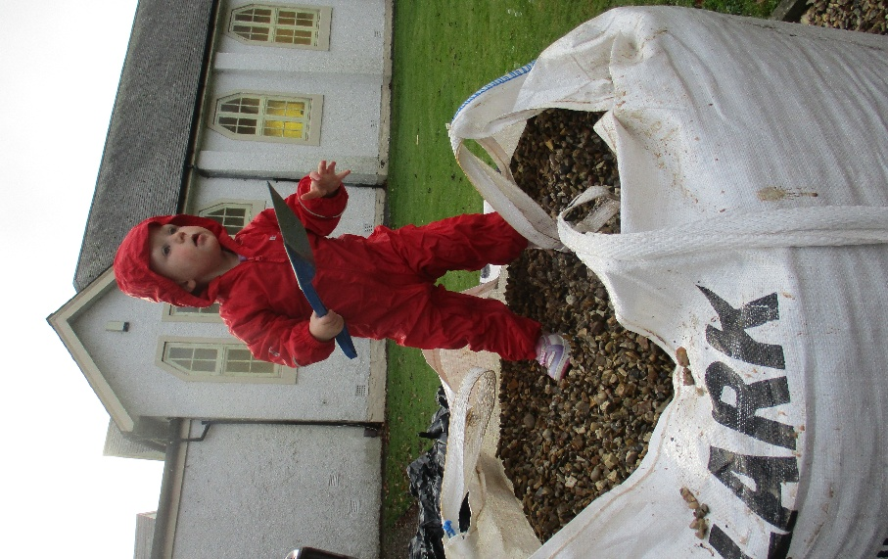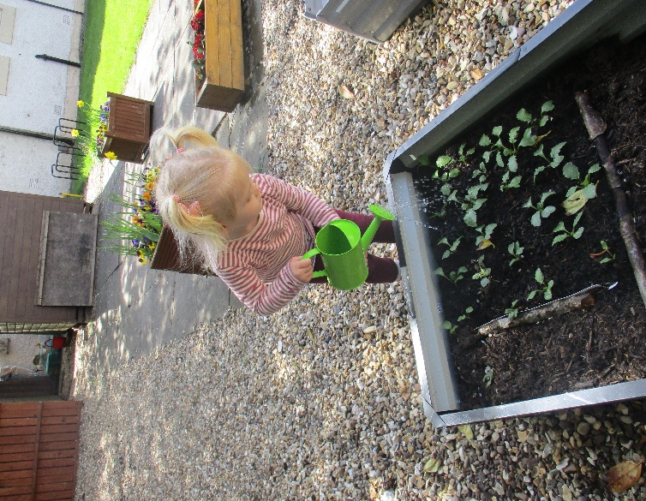
Nurturing!

Ready for Action!

ANNUAL REPORT and ACCOUNTS
Year Ending 28th February 2025
Charity Reference Number – SC043514

Introduction
Unfortunately, at the beginning of this year Rev. Liz Kay, our new chairperson, had to step down as she was unable to give the time required to the project and had also experienced a recent health scare. She thanked us for allowing us the short time she had with us, and we were able to thank her for doing what she could when she could.
Now begins the task of finding a new chairperson but we are as ever hopeful that someone will feel the call to help out the great work being done by this Group as a Trustee and Chairperson. Kathy Dunn also had to resign for family reasons, and we thank her for all the work she did in the Group. Previously as Family Support Worker and latterly in the fund-raising field.
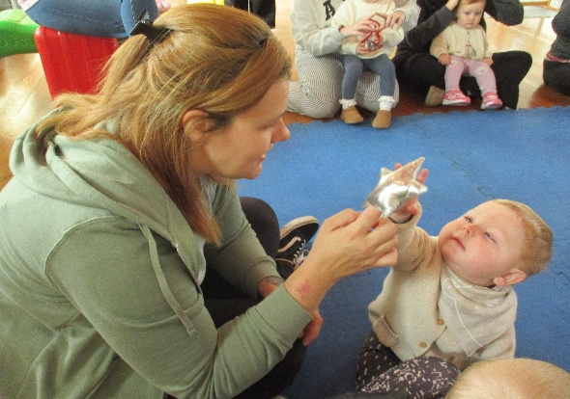
Hope is certainly the word required for this broken and fragmented world. The hope that this Group brings to parents, families, volunteers and to the community is tangible as you visit.
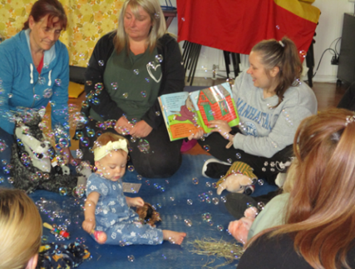
It is a place that helps them with the difficult job of parenting, a place where they can make friends and find a listening ear, practical support and encouragement for their own and their families well-being. Having tragically lost one of our parents this year the other parents responded by not only supporting each other but in fund-raising to provide a bench which has been dedicated and placed in a part of our beautiful outdoor space which they have turned into a well-being garden space and families have helped to plant flowers and we there are plans to grow some vegetables which can be used in our snacks and lunches.
We were also greatly encouraged this year by once again achieving the Volunteer Friendly Award from Volunteer Scotland. Our volunteers are a vital part of the Group and bring us great joy not only in what they bring to the group individually but as they increase in confidence and their own personal development.
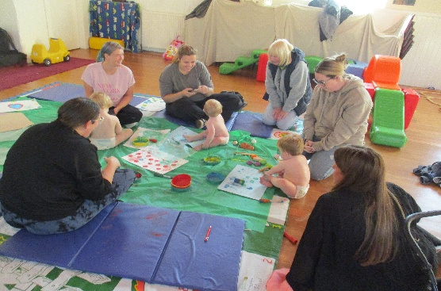
A new Volunteer Induction Pack has been produced for both the volunteers in the Group and new Trustees.
The Group continues to build on previous programmes and to introduce new activities as which are led by outside agencies but also by volunteers and parents who can share their skills. This allows all to grow and thrive and to have hope for themselves their families, their community and ultimately the world in which they are living and bringing up their children.
St. Ninian’s Stay and Play Family Project is delighted that it can be part of their experience to bring hope and offer opportunities to grow and to thrive both as families and as a community.
The members of the Board of Trustees present their Annual Report together with the financial statements for the year ended 28th February 2025.
Our Programme
Our programme has been designed with a focus on health and well-being this year to help families find the support they require to cope with the often difficult and trying times. To this end we have engaged the services of a recognised Counsellor who comes in and to whom people can talk when they need to and they can go on to other forms of support through this. The staff and indeed the volunteers support individual Parents at different ways and at different times.
Staff, volunteers and families have been working on the relaxation and reflection garden with the bench down on the patio and all have done a power of work clearing, preparing, planting and of course the ongoing nurture is vital.
Sports day today was great lots of fun and laughter. 15 families attended the Music Festival and despite the weather a good time was had by all. Music Tuition was offered but it was hard to fit sessions in. However regular exercise is recognised as being important and Armchair Yoga was tried with exercises on big screen. We try to provide exercises that can be continued with whole families at home. The staff are constantly amazed at how much our swimming sessions have encouraged a growth in confidence in parents and children.
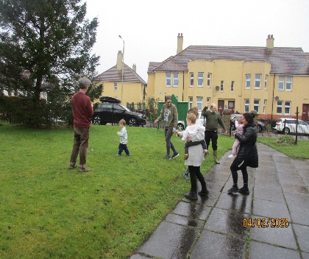
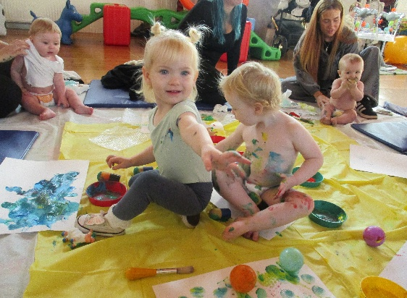
The group had a day at DCA and had a tour to see what was on offer to families.
Activities such as storytelling and reading, messy play, being outside in nature, playing games and visiting local attractions they might not otherwise have the opportunity to do, all promote the child’s development and sense of wonder.

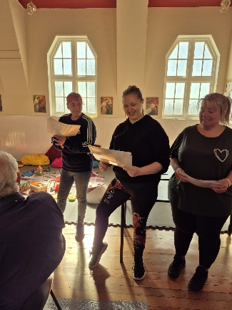
5 volunteers were trained by staff from The National Literacy Trust and excitedly delivered 6 sessions to the parents. The Volunteers presented Certificates to the children for their participation in the story telling sessions at a lunch where Anne Leslie, Community Development Worker from DVVA came along to a lunch to present the Volunteer Friendly Award.
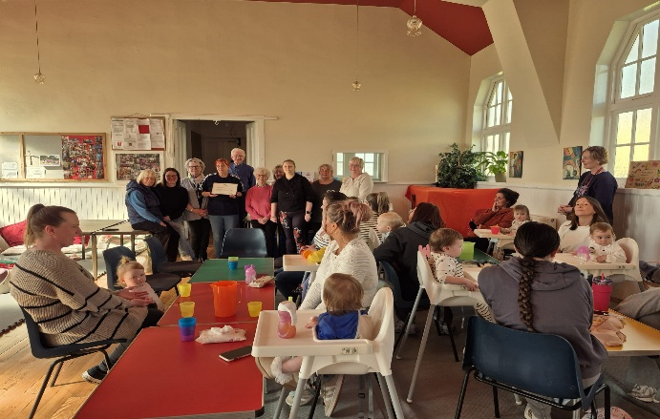
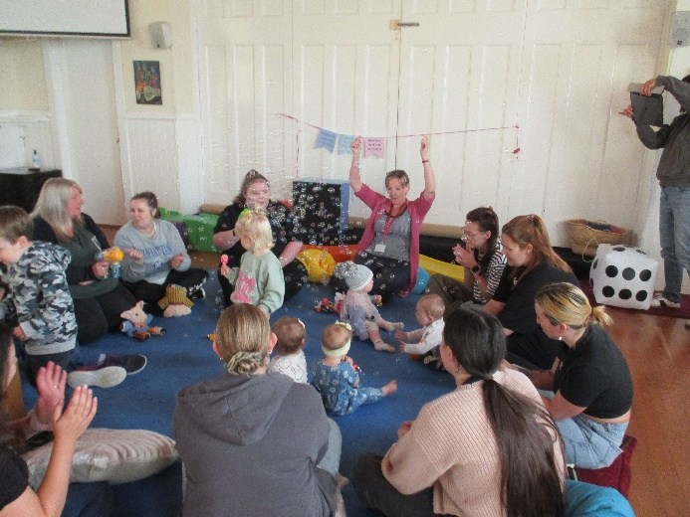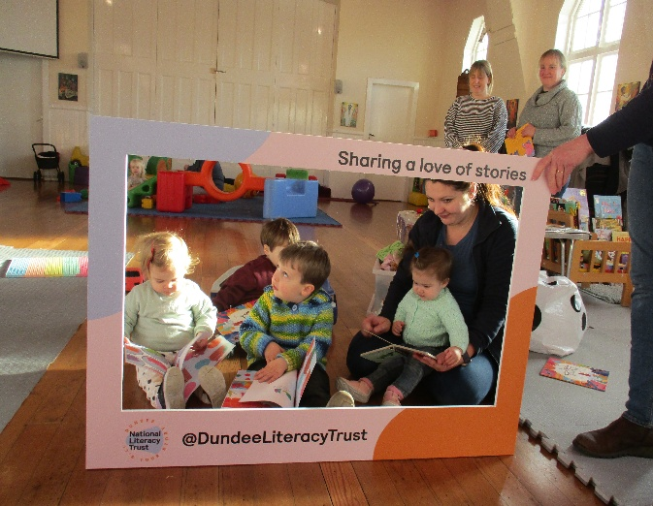
A Tribute to our Volunteers from The National Literacy Trust
It gives me a huge amount of pleasure to write this email about your wonderful volunteers.
National Literacy Trust Hubs do their best work when they work in partnership with community groups and families. Finding your group has been such a joy for us, as it has given us the opportunity to reach families with our messaging and resources, but even better than that, the chance to train, work alongside and more recently offer light-touch support to your volunteers. We also know that they are constantly learning from your leadership, and they’re supported to keep developing their confidence and skills.

Having initially spent two days training your volunteers as part of our Talk and Play Together programme, we were aware that each one came to the training sessions a little reserved and nervous. The second day of training offered them the chance to do what they know best – put together lovely, fun, engaging sessions for the families who access your group. This they did with care and expertise, choosing a weekly book and theming songs, rhymes and activities around it. During the first six-week delivery, modelled by National Literacy Trust staff and supported by your volunteers, they were such a great support.

I am absolutely thrilled that we have now begun a ‘second round’ of delivery to a new cohort of families, which doesn’t require our input other than to lend support and cheer from the sidelines. I am so proud of the girls when I watch them delivering the weekly tip, leading the singing and reading the story. This is what place-based working is all about, communities doing it for themselves and affecting change in the best and most positive way.
Thank you so much for giving us the opportunity to work with you and for the privilege of getting to know your volunteers and your families.
Very best wishes as always,
Jenni and Haillie
(National Literacy Trust Dundee Staff)

We have 25 families registered with the project who come along Monday and Tuesday as their schedules fit in. When they leave the Group some stay in touch, in person and on the Facebook page, and the opportunity to access the project later in their journey when necessary is much appreciated by families.

Links with other agencies are important both within and outwith the Group. Having been introduced families feel confident enough to access these agencies when needed for more targeted support.
Such agencies are: Family Support and Early Years Education, Brooksbank, National Literacy Trust, the NHS – Health Visitors, Keep Well Nurse, Child Nutrition, formal and informal Education services, Adult Learning Team, Home Start, Action for Children, Barnardo’s, Faith in the Community Dundee, Hope Project and Save the Children. Other support services include Dundee Foodbank, Dundee Bairns, Togs for Tots and Teens, Welfare Reform Service, Employment Support Service, School Family Development Worker and Angus Housing Association.
Future Plans
We have sufficient funding for another two years and are about to seek further funding to secure the ongoing work with our families, staff, volunteers, trustees and the wider partners and funders who support our work.
1 It will be essential therefore, that we consult with them to ensure that our ongoing development as a project links to the developing priorities both locally and nationally for working with families particularly in the areas of wellbeing and mental health.
The trustees will look at how best this can happen over the coming months.
2 In addition, a priority for the coming year will be to look at our online presence in terms of website and social media and to develop a strategy for this that assists our families to access support and put forward ideas; that clearly shows our partners and funders how the project is developing and demonstrates our commitment to meaningful engagement.
3 Identify additional resources to enhance our programme and further enhance the opportunities for people development within the project.
4 Project monitoring will be reviewed to ensure we are able to provide funders and partners with the information they require but also to enable us to more easily populate our reports and social media.
Real Life Comments!
Coming here has helped me grow in confidence.
To keep getting more confident and to keep improving my skills.
Volunteers
I hope that it continues thriving the way it is, to continue bonding within the volunteers, the parents and the children.

Hoping that our friendly, welcoming and family-like environment continues to thrive.
Hoping that the Group stays, grows and continues to be a community asset.
Staff

Agencies
I hope to engage with more families and build relationships to get a better insight into family life in this community.
It was good to get advice in the beginning about how to engage families in groups, asking families from further afield or meeting the family first. I hope to continue to develop this work.

Meaningful words from all
St Ninian’s Stay and Play Family Support Group

Governance
Charity Trustees
Rev Liz Kay Chair (Retired 24th February 2025)
Mrs Vina Strachan Member
Mrs Brenda Ivey Treasurer
Mrs Rhona Armitage Fundraiser
Mr Keith Florence Financial Adviser
Dr Sheila Gibb Database Manager
Mr Gerard Munro Professional Adviser
Mrs Heather Stewart Professional Adviser
Ms Kathy Dunn Fundraiser (retired 30th April 2024)
Very Rev Kenneth Gibson Member (Appointed 24th February 2025)
Very Rev Fay Lamont Member (Appointed 24th February 2025)

The Trustees meet five times per year and some of these meetings are held via Zoom.

Charity Address
St Ninian’s Stay and Play Family Support Group
St Ninian’s Scottish Episcopal Church
Longtown Road
Dundee DD4 7RW
Tel: Tel: 077123311245

Contact Details
Mrs Joan McKenna
Tel: 077123311245
Email: joanstniniansstayandplay@gmail.com
Group Email: stniniansstayandplay@gmail.com
Web: https://stayandplaydundee24.wixsite.com/st-ninians

Independent Examiner
Bird Simpson and Co.
144 Nethergate
Dundee
DD1 4EB
01382 227841

Structure and Governance

The charity is a Scottish Charitable Incorporated Organisation. In terms of the Charities and Trustee Investment (Scotland) Act 2005 and the Charities Accounts (Scotland) Regulations 2006 (as amended), the Board of Trustees report to the members as:
1. St. Ninian's Stay and Play Family Support Group - Dundee is a registered Scottish Charity (SC043514).
2. All its affairs are governed by the Board of Trustees.
Appointment of Trustees
The Board of Trustees are elected or appointed by Annual General Meeting established by constitution. There is no formal induction programme, but we do provide a pack of information including guidance on being a Charity Trustee and ongoing guidance is given to ensure that all Board members are familiar with the Group's values, aims and their responsibilities as the designated trustees of a charity. All Board members have signed the Charity Trustee Declaration, the Fit and Proper Persons Declaration and a GDPR Declaration.
Administrative Structure
It is the duty of the Board of Trustees to manage the affairs of the Group. Day to day running of the Group is delegated to the staff appointed by the Board.
Statement of Risk
The Trustees keep under review the major strategic business and operational risks to which the Charity is exposed and has established procedures to mitigate any risks identified.
Charitable Objectives and Activities
Our Aim is - To provide a non-judgemental support group for families.
Our Outcomes—what changes we want to see.
For adults:
1. Improved interaction with their children.
2. Increased self confidence in dealing with themselves, others, and external agencies.
3. Increased awareness of their child’s development.
4. Reduced isolation.
5. Reduced anxiety/stress.
6. Increased ability to access opportunities for personal development.

For children:
7. Improved overall development of each child.
8. Improved resilience of each child.

For Volunteers
Stay and Play values and holistically supports and seeks to develop all volunteers.

Financial Review

The charity received income of £17,392.00 with an expenditure of £41,389 during the year.
Balance in the Bank at 28th February 2025 was £87,194.00
We moved bulk of money to our Reserve Account to enable us to gain some interest and for anti-scam reasons. This can be transferred when we need it.
Funds carried forward in reserves shall be used to fund ongoing projects supporting families.
Our main funders this year 2024 - 2025 have been:

Trusthouse CF Grant
Scottish Episcopal Church Social Responsibility Committee
DVVA Well Being Fund

The support of the above and many other groups and individuals who support us financially sustain this important community facility for families. We have a few regular donors who have
Reserves The Trustees’ policy is to retain reserves of 3 months operating costs.
Statement of the Responsibilities of the Board of Trustees
The Trustees have accepted the responsibility to:
- prepare financial statements giving sufficient detail to enable an appreciation of the transactions of the Group during the financial year.
- keep proper accounting records reflecting the current financial position of the Group at this time. The financial statements comply with the Charities and Trustee Investment (Scotland) Act 2005 and the Charities Accounts (Scotland) Regulations 2006 (as amended).
- put procedures in place for the Protection of Vulnerable Groups.
- safeguard the assets of the Group and taken steps towards the prevention and/or detection of fraud and other irregularities.

On behalf of the Board of Trustees
 (Trustee) 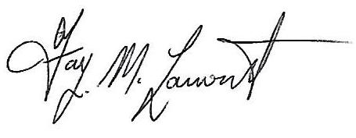(Trustee)
12th May 2025 12th May 2025

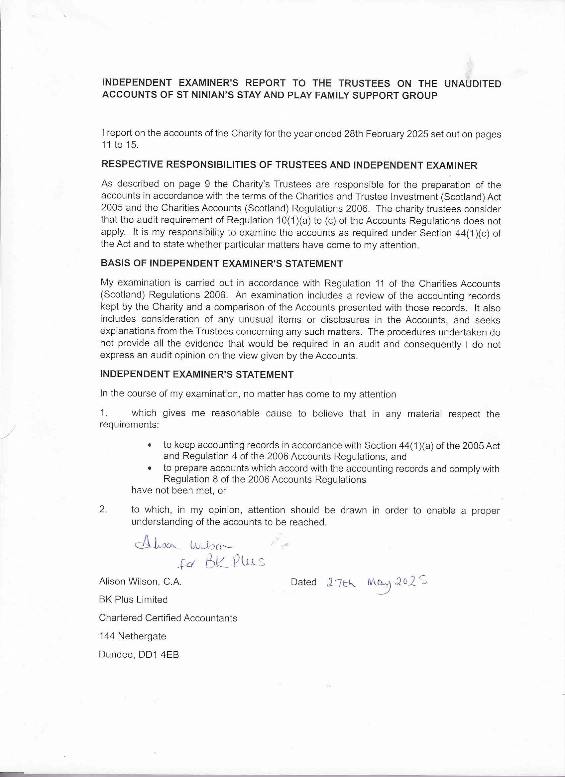
 |  |  | St Ninian's Stay and Play
 |  |  | Family Support Group
 |  |  | Charity No SCO43514
 | Statement of Financial Activities
 |  | For the year ended 28th February 2025
 |  |  |  | Unrestricted | Restricted | Total | Total
 |  |  |  | Funds | Funds | Funds | Funds
 |  |  |  | 2025 | 2025 | 2025 | 2024
 |  |  |  | £ | £ | £ | £
Income generated from charitable activities:
Voluntary Income |  |  |  | 298 | - | 298 | 2,172
Grants |  |  | 4 | 1,500 | 15,000 | 16,500 | 48,216
Other Income |  |  |  | 401 | - | 401 | 244
Bank Interest |  |  |  | 193 | - | 193 | 108
Total Incoming Resources |  |  |  | 2,392 | 15,000 | 17,392 | 50,740
Resources Expended
Charitable Activities |  |  |  | 11,389 | 30,000 | 41,389 | 38,673
Governance Costs |  |  |  | - | - | - | -
Total Resources Expended |  |  | 5 | 11,389 | 30,000 | 41,389 | 38,673
Net Movement in Funds |  |  |  | (8,997) | (15,000) | (23,997) | 12,067
Transfer between funds |  |  |  | - | - | - | -
Balance at 1 March 2024 |  |  |  | 76,156 | 35,035 | 111,191 | 99,124
Balance at 28 February 2025 |  |  |  | 67,159 | 20,035 | 87,194 | 111,191
10

St Ninian's Stay and Play
Family Support Group
Statement of Balances at 28th February 2025
Fixed Assets |  |  | Notes |  | 2025 |  | 2024
 |  |  |  |  | £ |  | £
Tangible Fixed Assets |  |  |  |  | - |  | -
Current Assets
Cash at Bank and in Hand |  |  | 7 |  | 87,194 |  | 111,191
Creditors Due within one year |  |  |  |  | - |  | -
Net Current Assets |  |  |  |  | 87,194 |  | 111,191
Total Assets less Current Liabilities |  |  |  |  | 87,194 |  | 111,191
Represented By:
Unrestricted Funds |  |  |  |  | 67,159 |  | 76,156
Restricted Funds |  |  | 8 |  | 20,035 |  | 35,035
 |  |  |  |  | 87,194 |  | 111,191

 | St Ninian's Stay and Play
 | Family Support Group
 | Year to 28th February 2025
1 | Basis of Accounting
 | These accounts have been prepared on the receipts and payments basis in accordance with the Charities & Trustee Investment (Scotland) Act 2005 and the Charities Accounts (Scotland) Regulations 2006 (as amended).
2 | Nature and Purpose of Funds
 | Unrestricted funds are those that may be used at the discretion of the trustees in furtherance of the objects of the charity.
 | Restricted funds may only be used for specific purposes. Restrictions arise when specified by the donor or when funds are raised for specific purposes. The charity currently has six restricted funds which are to be used as follows:
 | Groundworks – to fund an activity-based trip
 | National Lottery – to fund training, IT equipment etc
 | Trusthouse – funds 50% of salaries and running costs
 | The Robertson Trust – funds salary costs
 | Scottish Episcopal Church SR Fund -music/activities
 | DVVA -family support and training
3 | Related Party Transactions
 | No remuneration was paid to the trustees or connected persons during the year (2024- Nil)
4 | Grants Received | 2025 | 2025 | 2025 | 2024
 |  | Unrestricted | Restricted | Total | Total
 |  | Funds | Funds | Funds | Funds
 |  | £ | £ | £ | £
 | Northwood Charitable Trust | - | - | - | 5,000
 | Trusthouse CF Grant | - | 15,000 | 15,000 | 15,000
 | The Robertson Trust | 1,500 | - | 1,500 | 15,000
 | General Synod | - | - | - | 5,000
 | DVVA | - | - | - | 8,216
 |  | 1,500 | 15,000 | 16,500 | 48,216

St Ninian's Stay and Play
Family Support Group
Year to 28th February 2025
5 | Total Resources Expended |  |  | 2025 | 2025 | 2025 | 2024
 |  |  |  | Unrestricted | Restricted | Total | Total
 |  |  |  | Funds | Funds | Funds | Funds
 |  |  |  | £ | £ | £
 | Staff Salaries (incl Pensions ) |  |  | 484 | 30,000 | 30,484 | 29,996
 | Printing & Stationery |  |  |  | - | 211 | 400
 | Equipment & Activities |  |  |  | - | 3,256 | 1,079
 | Cleaning & laundry |  |  |  | - | 1,694 | 1,549
 | Venue Costs |  |  |  | - | 2,400 | 2,400
 | Insurance |  |  |  | - | 726 | 653
 | Telephone |  |  |  | - | 336 | 319
 | Lunches/healthy |  |  |  | - | 980 | 910
 | Training |  |  |  | - | - | -
 | Other |  |  |  | - | 414 | 647
 | Accountancy, payroll & IE |  |  |  | - | 888 | 720
 |  |  |  |  | 30,000 | 41,389 | 38,673
6 | Staff Salaries
 |  |  |  |  |  | 2025 | 2024
 |  |  |  |  |  | £ | £
 | Staff costs were as follows
 | Salaries |  |  |  |  | 29,449 | 28,591
 | Pension Contributions (ER) |  |  |  |  | 883 | 855
 | Social Security (ER NIC) |  |  |  |  | (88) | 430
 | Payroll Costs |  |  |  |  | 240 | 120
 |  |  |  |  |  | 30,484 | 29,996
 | St Ninian's Stay and Play
 | Family Support Group
 | Year to 28th February 2025
7 | Cash at Bank and in Hand
 |  |  |  |  |  | 2025 | 2024
 |  |  |  |  |  | £ | £
 | Main Account |  |  |  |  | 14,658 | 101,080
 | Reserve Account |  |  |  |  | 72,327 | 9,983
 | Cash |  |  |  |  | 209 | 128
 |  |  |  |  |  | 87,194 | 111,191
8 | Restricted Funds
 |  | Opening | Income | Expenditure | Transfer | Closing
 |  | £ | £ | £ | £
 | Groundworks (Tesco) | 2,000 | - | - | - | 2,000
 | National Lottery -Community Fund | 4,819 | - | - | - | 4,819
 | The Robertson Trust | 15,000 | - | (15,000) | - | -
 | Trusthouse | - | 15,000 | (15,000)
 | Scottish Episcopal Church SR | 5,000 | - | - | - | 5,000
 | DVVA | 8,216 | - | - | - | 8,216
 |  | 35,035 | 15,000 | (30,000) | - | 20,035

