 | 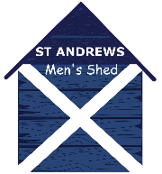
 | St Andrews Men’s Shed  Trustees’ Annual Report  1 May 2025 to 30 Apr 2026 | 

St Andrews Men’s Shed
Scottish Charity Number: SC0048346
Address Craigtoun Park, Mount Melville, St Andrews, Fife KY16 8NX
Website: www.standrewsmensshed.org.uk
Twitter / Facebook / Social Media profile name; St Andrews Men’s Shed
Charity Trustees
- Eric Box
- John Henderson
- Bill Horn
- John Keogh – Vice Chair
- Henry Paul- Secretary from December 2025
- Stephen Ritchie – Chair
- Antony Thorley – Treasurer
- Keith Haynes – Served as Chair until AGM in August 2025
- John Meek – Served as Treasurer until AGM in August 2025
- Andrew Peel – Served as Secretary until December 2025
- Gordon Shepherd – Served as trustee until February 2026
- Adrian Snowball – served as trustee until AGM in August 2025

The SHED in this report will refer to the St Andrews Men’s Shed.
Objectives and activities
The purpose of the organisation is to provide recreational facilities and advance the social needs, health, and wellbeing of men of all ages and backgrounds living in St Andrews and surrounding areas. These objectives will be achieved by
- creating, developing, and maintaining a facility, namely a Men’s Shed.
- offering opportunities for men in St Andrews area to meet and undertake creative, physical, purposeful, and recreational activities of their choice.
- reducing isolation of men in the area thus contributing to their physical and mental wellbeing.
- developing the capacity of men in the St Andrews area to share their skills and knowledge with others in the community.
Structure, governance, and management
The charity is a voluntary association governed by its constitution which was adopted on 7 November 2017 and registered with the Office of the Scottish Charity Regulator (OSCR) as a Scottish Charitable Incorporated Organisation (SCIO). The constitution was amended at the AGM on 29 March 2021 to ensure it was compliant with Community Asset Transfer rules i.e., the minimum membership number is now 20 and if the membership falls below 20 the SHED must take all efforts to increase the membership to 20 or above. The constitution was also amended to allow future meetings to be held in person or virtually.
The management and the administration of the charity is the responsibility of the charity trustees. New trustees are recruited from membership, proposed by the trustees, and appointed by the members at an AGM. The SHED is a member of the Scottish Men’s Shed Association (SMSA) and attends regular SMSA hosted meetings of all sheds in Fife to share information on good ideas and issues affecting the sheds.
Achievements and performance
The primary activities over the period were to complete the fitting out of the new SHED at Craigtoun Park, particularly:
- The electrical and lighting within the workshop area of the SHED;
- Arranging space for stores of materials, hand power tools and hand tools;
- Building a room for wood turning and equipping it with lathes;
- Clearing the workshop area and permanently placing the main machines;
- Providing dust extraction;
- Clearing and developing the garden area;
- Starting welding and 3D printing capabilities;
- Installation of Air Sourced Heat Pumps in the common area, entrance and hobby room; and
- Continue to raise funds to support the work.

This year the members of the SHED rose from 58 in August 2025 to 76 in April 2026 of which 51 are active members every month. Over the course of the last five years the sheds monthly attendance has risen from around 100 visits per month to nearly 300 in March 2026.
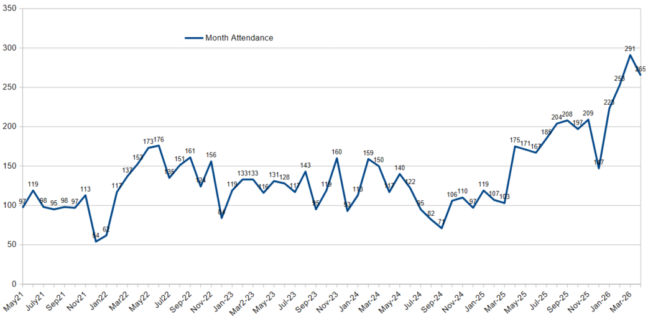
With completion of the build and good progress in outfitting SHED members have been able to return to working on their own projects as well as preparing items for sale.

During the last year the SHED members attended 7 events: Hidden Gardens; Craigtoun Summer Fair; Big Hoolie; St Leonards Easter; Craigtoun Easter Fayre; Open Day; and Bowhouse. These events are used to sell products made by the members, promote work of the members and canvass for new members. This year’s events takings were 17% higher than last year’s. Funds from these events are used improving our facilities and to secure our finances.
During the course of the year we were successful in applying for grants totalling £41,545 of which £24,000 remains to be spent on improving access in and around the shed and refreshing our IT capability.
Since starting fundraising for our new SHED we have raised over £196,000.

Our SHED was voted runner up at the Scottish Men’s Shed Association annual meeting.

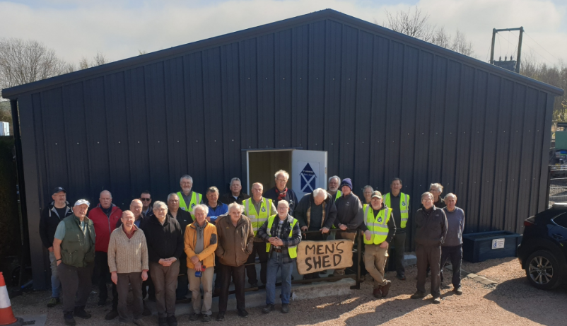
SHED members in front of the completed SHED.
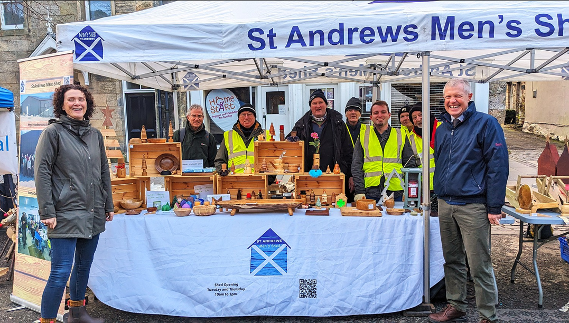
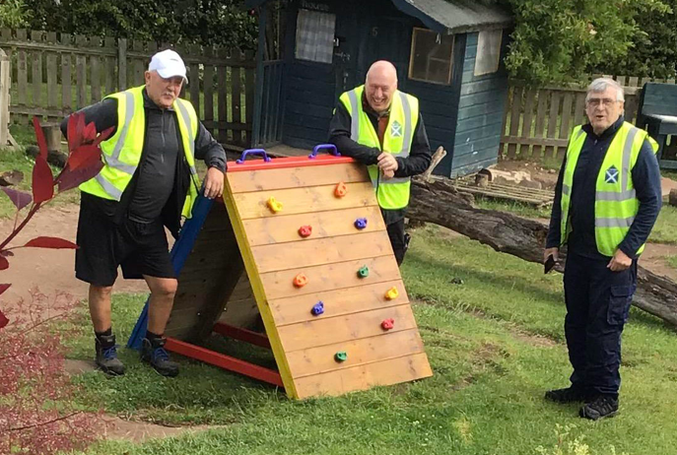
SHED stall at Big Hoolie with MP and MSP Climbing frame for local primary school
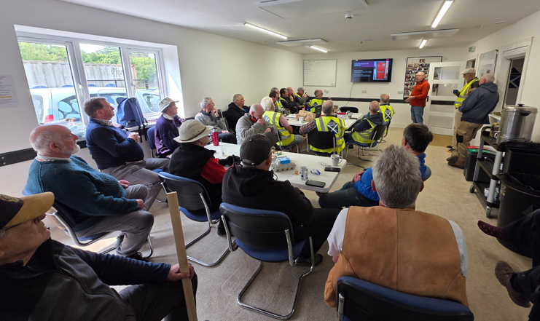
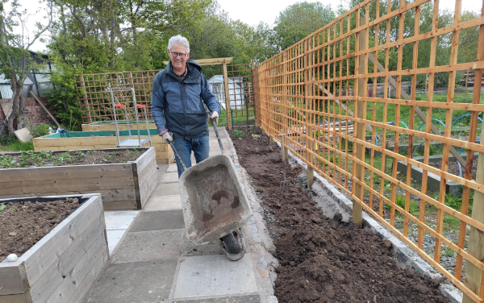

Fire safety briefing in common room Garden raised beds and paved area

Progress continues to be made in the garden area. Eight raised beds with three surrounded by paving making them assessable. Fruit trees planted. Seven 1.83m x 1.83m lattice screens erected. Large areas cleared making space for a planned poly tunnel, greenhouse and seating area.

SHED members also undertook a number of activities during the year which contribute to our local communities. These included providing a climbing frame for a local nursery, planters for local individuals and businesses. Helping clear areas of slabs and timber, some to be recycled for the SHED.

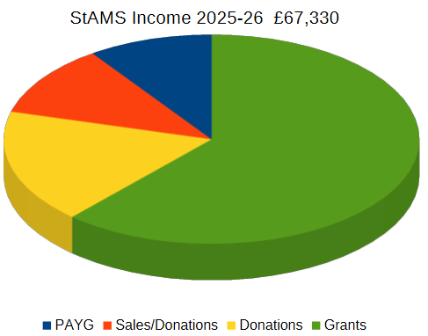
Financial review
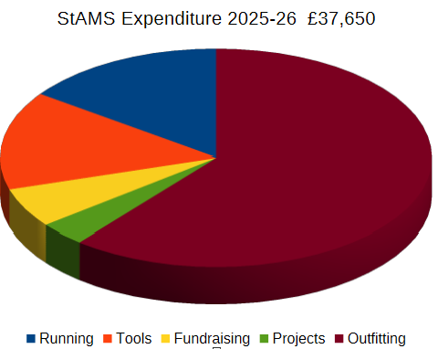
Full financial breakdown is contained in the examined accounts.
Statement of the charity’s policy on reserves
The SHED has increased its reserves, inline with other Men’s Sheds, to £5,000. Effectively one years running costs including annual insurance.
Future Plans
The members aim to improve accessibility around the SHED site, refresh our IT infrastructure and capabilities and continue to develop the garden area.
Now our new SHED construction and outfitting is nearly complete the SHED members can become more active in the community.

Declaration
Signed on behalf of the charity trustees:
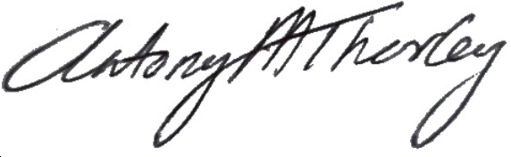

Print name
Dr Antony M Thorley

Designation
Treasurer St Andrews Men’s Shed

Date
22nd July 2026

