Company registration number SC512314 (Scotland)
Charity registration number SC046448 (Scotland)
FAIR ISLE DEVELOPMENT COMPANY
ANNUAL REPORT AND UNAUDITED FINANCIAL STATEMENTS
FOR THE YEAR ENDED 31 AUGUST 2025

LEGAL AND ADMINISTRATIVE INFORMATION

Trustees | - Mitchell  - Rotolo  - Shaw  M Bruhat
 | E Thomson  A Stout | (Appointed 25 March 2025)
 | S Wilson | (Appointed 17 March 2025)
 | E Thomson | (Appointed 25 March 2025)
Country of incorporation | United Kingdom  (Scotland) | SC512314
Charity registration | Scotland | SC046448
Registered office | Stackhoull  Fair Isle  Shetland  United Kingdom  ZE2 9JU
Independent examiner | Thyme Tax & Accountancy Ltd  36 Angusfield Avenue  Aberdeen  AB15 6AQ

CONTENTS

Page
Trustees' report 1 - 3
Independent examiner's report 4
Statement of financial activities 5
Balance sheet 6
Notes to the financial statements 7 - 14

TRUSTEES' REPORT (INCLUDING DIRECTOR'S REPORT)

FOR THE YEAR ENDED 31 AUGUST 2025

The trustees present their annual report and financial statements for the year ended 31 August 2025.
The financial statements have been prepared in accordance with the accounting policies set out in note 1 to the financial statements and comply with the charity's governing document, the Charities and Trustee Investment (Scotland) Act 2005, the Charities Accounts (Scotland) Regulations 2006 (as amended) and "Accounting and Reporting by Charities: Statement of Recommended Practice applicable to charities preparing their accounts in accordance with the Financial Reporting Standard applicable in the UK and Republic of Ireland (FRS 102)" (effective 1 January 2019).

Objectives and activities
Fair Isle faced severe structural vulnerabilities. Historically, the island suffered a steep population decline (dropping to just 55 residents in the mid-2010s), which threatened the viability of essential services like our primary school, shop, post office, and emergency response teams. FIDC was established as a Development Trust to:
· Promote community development and reverse population decline.
· Advance local heritage, culture, traditional arts (such as Fair Isle knitting), and science.
· Improve environmental protection and infrastructure, ensuring self-sufficiency for an off-grid island.
FIDC exists for the benefit of the entire community of Fair Isle (currently home to approximately 50–60 residents),made up of new residents, multi-generational families, crofters, and local business owners. By safeguarding the island’s future, we also serve scientists, conservationists, and tourists who travel to Fair Isle annually.
The trustees have paid due regard to guidance issued by the Charity Commission in deciding what activities the charity should undertake.

Achievements and performance
Throughout the 2024-2025 operating period, FIDC directed its efforts toward infrastructure advocacy, economic diversification, and housing partnerships. Our key outputs include:
· Infrastructure & Transport Liaison: Actively collaborated with the Shetland Islands Council (SIC) and Transport Scotland regarding the massive Shetland Ferry Replacement project. We successfully advocated for the ongoing construction of the new Fair Isle terminal at Grutness (scheduled for completion in mid-2026) and the development of the new custom-built Fair Isle vessel, scheduled for delivery in October 2026.
· Housing & Population Retention Initiatives: Partnered with the National Trust for Scotland (NTS) to review local housing stock and formulate targeted community-led development plans aimed at welcoming new families to the island.
· Heritage & Enterprise Support: Provided critical local development support to creative cottage industries. Notably, we collaborated to support Fair Isle Knitting and its producers, FIDC began the process of funding and planning the creation of a resource book safeguarding our world-renowned cultural heritage.
· Tourism & Scientific Rebuilding Support: Supported community integration and planning alongside Highlands and Islands Enterprise (HIE) and the FIBOT Charity for the multi-million-pound reconstruction of the Fair Isle Bird Observatory, following its devastating fire.
· Green Energy & Connectivity Advocacy: Maintained active consultations and resource sharing to future-proof our unique, off-grid community wind/solar energy grid and ongoing improved digital and broadband connectivity.

TRUSTEES' REPORT (INCLUDING DIRECTOR'S REPORT) (CONTINUED)

FOR THE YEAR ENDED 31 AUGUST 2025

The outputs achieved this year have triggered profound strategic outcomes for our remote community:
· Secured Transport Continuity: Our island-led support ensured that the Scottish Government’s £45 million capital allocation for a new resilience/relief ferry vessel moved smoothly into delivery phase.This partnership working guarantees that Fair Isle will not suffer crippling isolation as build stages are completed and island pressure from increased resource allocation to 30 construction staff on island during the project. .
· Cultural & Economic Preservation: By backing local cottage commerce, allowing young islanders to establish viable, high-value careers without needing to migrate to the mainland.
· Sustained Public Services: By focusing on housing availability and economic opportunities, we are trying to stabilise the island's population and possibly give opportunity to grow the numbers of residents. This stability is designed to protect the school roll at the Fair Isle Primary School and ensure the continuation of the local nurse and fire-fighting provisions.
The true measure of FIDC's success is that life on Fair Isle remains not just possible, but deeply desirable, sustainable, and progressive.
Focus Area - Community Confidence
Before Fair Isle Development Company (FIDC) Interventions - Anxiety over isolation, aging vessels, and terminal delays Impact made: High Optimism: Clear timelines for the new ferry and upgraded terminals have restored confidence in our physical link to the mainland.
Focus Area - Economic Resilience
Before FIDC - Over-reliance on single seasonal sectors (eg, cod-tourism).
Impact made: Diversified Economy: A thriving creative sector (knitting and crafts) and the imminent return of a world-class Bird Observatory provide stable year-round incomes. Connectivity with new fibre cable has supported high value on island remote working.
Focus Area - Demographic Health
Before FIDC - Threat of becoming an over stretched population with an aging demographic.
Impact made: Active Population Retention: Younger generations are actively choosing to stay, relocate with young families and step into leadership roles, and build modern, digitally connected lives on crofts.

Financial review
Financially, FIDC has successfully managed its resources, utilising community funding and external grants to maintain support for services while continuing capital project development. In accordance with the UK and Scottish Government legislative requirements, we are reviewing our Articles of Association and Fair Work policies criteria as an ongoing best practice approach, the Charity has a fully compliant board of active trustees that are focused on delivering what is best for Fair Isle.
Reserves policy
It is the policy of the charity that unrestricted funds which have not been designated for a specific use should be maintained at a level equivalent to between three and six month’s expenditure. The trustees consider that reserves at this level will ensure that, in the event of a significant drop in funding, they will be able to continue the charity’s current activities while consideration is given to ways in which additional funds may be raised. This level of reserves has been maintained throughout the year.

TRUSTEES' REPORT (INCLUDING DIRECTOR'S REPORT) (CONTINUED)

FOR THE YEAR ENDED 31 AUGUST 2025

The balance held as unrestricted funds at 31 August 2025 was £13,744 after deductions for fixed assets the funds available to spent at year rend are £13,330 .

Plans for future periods
As we look toward the remainder of 2025 and into 2026, our primary objectives will be the continued support of key infrastructure projects, namely the new ferry vessel and two upgraded piers and completion of the new Bird Observatory and its first season of operation and integration into life on the island and launching a fresh round of community consultations to update our multi-year Community-led Action Plan.
I extend my heartfelt thanks to my fellow Directors, our volunteers, National Trust of Scotland, Highlands and Islands Enterprise, the Shetland Islands Council, and, most importantly, the resilient people of Fair Isle.

Structure, governance and management
The charity is controlled by its governing document, a deed of trust, and constitutes a limited company, limited by guarantee, as defined by the Companies Act 2006.
The trustees, who are also the directors for the purpose of company law, and who served during the year and up to the date of signature of the financial statements were:
- Mitchell
- Rotolo
- Shaw
M Bruhat
E Thomson  A Stout | (Appointed 25 March 2025)
S Wilson | (Appointed 17 March 2025)
E Thomson | (Appointed 25 March 2025)
The trustees' report was approved by the Board of Trustees.
F Mitchell Trustee
27 May 2026
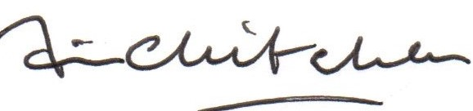

INDEPENDENT EXAMINER'S REPORT
TO THE TRUSTEES OF FAIR ISLE DEVELOPMENT COMPANY
I report on the financial statements of the charity for the year ended 31 August 2025, which are set out on pages 5 to 14.

Respective responsibilities of trustees and examiner
The charity’s trustees, who are also the directors of Fair Isle Development Company for the purposes of company law, are responsible for the preparation of the financial statements in accordance with the terms of the Charities and Trustee Investments (Scotland) Act 2005 and the Charities Accounts (Scotland) Regulations 2006. The trustees consider that the audit requirement of Regulation 10(1)(a) to (c) of the 2006 Accounts Regulations does not apply. It is my responsibility to examine the financial statements as required under section 44(1)(c) of the Act and to state whether particular matters have come to my attention.

Basis of independent examiner's statement
My examination is carried out in accordance with Regulation 11 of the Charities Accounts (Scotland) Regulations 2006. An examination includes a review of the accounting records kept by the charity and a comparison of the financial statements presented with those records. It also includes consideration of any unusual items or disclosures in the financial statements, and seeking explanations from the trustees concerning any such matters. The procedures undertaken do not provide all the evidence that would be required in an audit and consequently I do not express an audit opinion on the view given by the financial statements.

Independent examiner's statement
In connection with my examination, no matter has come to my attention:
- which gives me reasonable cause to believe that in any material respect the requirements:
  - to keep accounting records in accordance with section 44(1) (a) of the 2005 Act and Regulation 4 of the 2006 Accounts Regulations; and
  - to prepare financial statements which accord with the accounting records and comply with Regulation 8 of the
2006 Accounts Regulations; have not been met or
- to which, in my opinion, attention should be drawn in order to enable a proper understanding of the financial statements to be reached.
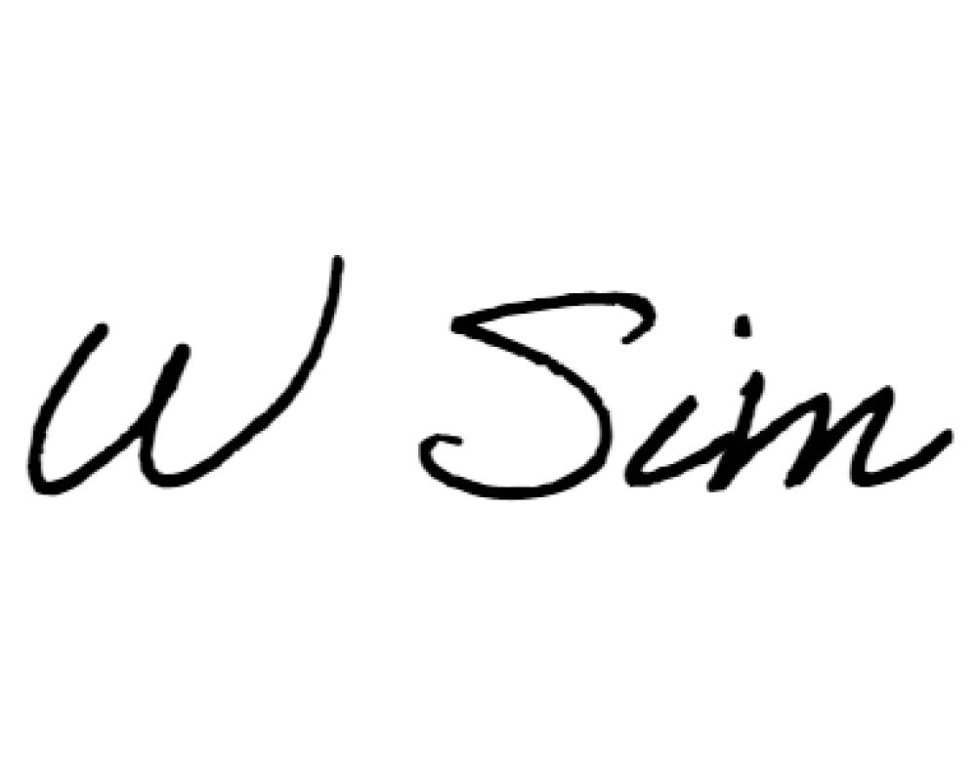
Wilma A Sim FCCA (non-practicing)
Thyme Tax & Accountancy Ltd
36 Angusfield Avenue
Aberdeen
Aberdeenshire
AB15 6AQ
United Kingdom
Dated: 27 May 2027

STATEMENT OF FINANCIAL ACTIVITIES
INCLUDING INCOME AND EXPENDITURE ACCOUNT

 | Unrestricted | Restricted | Total | Unrestricted | Restricted | Total
 | funds | funds |  | funds | funds
 | 2025 | 2025 | 2025 | 2024 | 2024 | 2024
Notes  Income from: | £ | £ | £ | £ | £ | £
Donations and legacies 3 | 48,490 | 80,239 | 128,729 | - | 45,389 | 45,389
Charitable activities 4 | 225 | - | 225 | - | - | -
Total income  Expenditure on: | 48,715 | 80,239 | 128,954 | - | 45,389 | 45,389
Charitable activities 5 | 19,382 | 91,705 | 111,087 | 23,449 | 46,967 | 70,416

FOR THE YEAR ENDED 31 AUGUST 2025

Net income/(expenditure) | 29,333 | (11,466) | 17,867 | (23,449) | (1,578) | (25,027)
Transfers between funds | (9,888) | 9,888 | - | - | - | -
Net movement in funds  Reconciliation of funds:  Fund balances at 1 September | 19,445 | (1,578) | 17,867 | (23,449) | (1,578) | (25,027)
2024 | (5,701) | 2,078 | (3,623) | 17,748 | 3,656 | 21,404

Total expenditure
19,382
91,705
111,087
23,449
46,967
70,416

Fund balances at 31 August 2025
13,744
500
14,244
(5,701)
2,078
(3,623)
The statement of financial activities includes all gains and losses recognised in the year. All income and expenditure derive from continuing activities.

BALANCE SHEET
 |  | 2025 |  | 2024
Fixed assets | Notes | £ | £ | £ | £
Tangible assets  Current assets | 10 |  | 414 |  | 1,808
Cash at bank and in hand |  | 21,028 |  | 6,766
Creditors: amounts falling due within one year | 12 | (198) |  | (197)
Net current assets |  |  | 20,830 |  | 6,569
Total assets less current liabilities  Creditors: amounts falling due after more than |  |  | 21,244 |  | 8,377
one year | 13 |  | (7,000) |  | (12,000)

AS AT 31 AUGUST 2025

Net assets/(liabilities) 14,244 (3,623)
The funds of the charity
Restricted income funds | 14 | 500 | 2,078
Unrestricted funds | 15 | 13,744 | (5,701)
14,244 (3,623)
The company is entitled to the exemption from the audit requirement contained in section 477 of the Companies Act 2006, for the year ended 31 August 2025.
The director acknowledges her responsibilities for complying with the requirements of the Companies Act 2006 with respect to accounting records and the preparation of financial statements.
The members have not required the company to obtain an audit of its financial statements for the year in question in accordance with section 476.
These financial statements have been prepared in accordance with the provisions applicable to companies subject to the small companies regime.
The financial statements were approved by the trustees on 27 May 2026
G Rotolo
Trustee

NOTES TO THE FINANCIAL STATEMENTS

FOR THE YEAR ENDED 31 AUGUST 2025
1 Accounting policies

Charity information
Fair Isle Development Company is a private company limited by guarantee incorporated in Scotland. The registered office is Stackhoull, Fair Isle, Shetland, ZE2 9JU, United Kingdom.

1.1 Basis of preparation
The financial statements have been prepared in accordance with the charity's governing document, the Charities and
Trustee Investment (Scotland) Act 2005, the Charities Accounts (Scotland) Regulations 2006 (as amended), FRS 102 “The Financial Reporting Standard applicable in the UK and Republic of Ireland” (“FRS 102”) and the Charities SORP "Accounting and Reporting by Charities: Statement of Recommended Practice applicable to charities preparing their accounts in accordance with the Financial Reporting Standard applicable in the UK and Republic of Ireland (FRS 102)" (effective 1 January 2019). The charity is a Public Benefit Entity as defined by FRS 102.
The charity has taken advantage of the provisions in the SORP for charities not to prepare a Statement of Cash Flows.
The financial statements are prepared in sterling, which is the functional currency of the charity. Monetary amounts in these financial statements are rounded to the nearest £.
The financial statements have been prepared under the historical cost convention, [modified to include the revaluation of freehold properties and to include investment properties and certain financial instruments at fair value]. The principal accounting policies adopted are set out below.

1.2 Going concern
At the time of approving the financial statements, the trustees have a reasonable expectation that the charity has adequate resources to continue in operational existence for the foreseeable future. Thus the trustees continue to adopt the going concern basis of accounting in preparing the financial statements.

1.3 Charitable funds
Unrestricted funds are available for use at the discretion of the trustees in furtherance of their charitable objectives.
Restricted funds are subject to specific conditions by donors or grantors as to how they may be used. The purposes and uses of the restricted funds are set out in the notes to the financial statements.
Endowment funds are subject to specific conditions by donors that the capital must be maintained by the charity.

1.4 Income
Income is recognised when the charity is legally entitled to it after any performance conditions have been met, the amounts can be measured reliably, and it is probable that income will be received.
Cash donations are recognised on receipt. Other donations are recognised once the charity has been notified of the donation, unless performance conditions require deferral of the amount. Income tax recoverable in relation to donations received under Gift Aid or deeds of covenant is recognised at the time of the donation.
Legacies are recognised on receipt or otherwise if the charity has been notified of an impending distribution, the amount is known, and receipt is expected. If the amount is not known, the legacy is treated as a contingent asset.

1 Accounting policies (Continued)

1.5 Expenditure
Expenditure is recognised once there is a legal or constructive obligation to transfer economic benefit to a third party, it is probable that a transfer of economic benefits will be required in settlement, and the amount of the obligation can be measured reliably.
Expenditure is classified by activity. The costs of each activity are made up of the total of direct costs and shared costs, including support costs involved in undertaking each activity. Direct costs attributable to a single activity are allocated directly to that activity. Shared costs which contribute to more than one activity and support costs which are not attributable to a single activity are apportioned between those activities on a basis consistent with the use of resources. Central staff costs are allocated on the basis of time spent, and depreciation charges are allocated on the portion of the asset’s use.

1.6 Tangible fixed assets
Tangible fixed assets are initially measured at cost and subsequently measured at cost or valuation, net of depreciation and any impairment losses.
Depreciation is recognised so as to write off the cost or valuation of assets less their residual values over their useful lives on the following bases:
Plant and equipment | 25% on reducing balance
Computers | 33% on reducing balance
The gain or loss arising on the disposal of an asset is determined as the difference between the sale proceeds and the carrying value of the asset, and is recognised in the statement of financial activities.

1.7 Impairment of fixed assets
At each reporting end date, the charity reviews the carrying amounts of its tangible assets to determine whether there is any indication that those assets have suffered an impairment loss. If any such indication exists, the recoverable amount of the asset is estimated in order to determine the extent of the impairment loss (if any).

1.8 Cash and cash equivalents
Cash and cash equivalents include cash in hand, deposits held at call with banks, other short-term liquid investments with original maturities of three months or less, and bank overdrafts. Bank overdrafts are shown within borrowings in current liabilities.

Basic financial assets
Basic financial assets, which include debtors and cash and bank balances, are initially measured at transaction price including transaction costs and are subsequently carried at amortised cost using the effective interest method unless the arrangement constitutes a financing transaction, where the transaction is measured at the present value of the future receipts discounted at a market rate of interest. Financial assets classified as receivable within one year are not amortised.
1 Accounting policies (Continued)

Basic financial liabilities
Basic financial liabilities, including creditors and bank loans are initially recognised at transaction price unless the arrangement constitutes a financing transaction, where the debt instrument is measured at the present value of the future payments discounted at a market rate of interest. Financial liabilities classified as payable within one year are not amortised.
Debt instruments are subsequently carried at amortised cost, using the effective interest rate method.
Trade creditors are obligations to pay for goods or services that have been acquired in the ordinary course of operations from suppliers. Amounts payable are classified as current liabilities if payment is due within one year or less. If not, they are presented as non-current liabilities. Trade creditors are recognised initially at transaction price and subsequently measured at amortised cost using the effective interest method.

Derecognition of financial liabilities
Financial liabilities are derecognised when the charity’s contractual obligations expire or are discharged or cancelled.

1.9 Employee benefits
The cost of any unused holiday entitlement is recognised in the period in which the employee’s services are received.
Termination benefits are recognised immediately as an expense when the charity is demonstrably committed to terminate the employment of an employee or to provide termination benefits.

2 Critical accounting estimates and judgements
In the application of the charity’s accounting policies, the trustees are required to make judgements, estimates and assumptions about the carrying amount of assets and liabilities that are not readily apparent from other sources. The estimates and associated assumptions are based on historical experience and other factors that are considered to be relevant. Actual results may differ from these estimates.
The estimates and underlying assumptions are reviewed on an ongoing basis. Revisions to accounting estimates are recognised in the period in which the estimate is revised where the revision affects only that period, or in the period of the revision and future periods where the revision affects both current and future periods.

3 Income from donations and legacies
 | Unrestricted | Restricted | Total | Unrestricted | Restricted | Total
 | funds | funds |  | funds | funds
 | 2025 | 2025 | 2025 | 2024 | 2024 | 2024
 | £ | £ | £ | £ | £ | £
Grants | 48,490 | 80,239 | 128,729 | - | 45,389 | 45,389

4 Income from charitable activities

Unrestricted Unrestricted funds funds
2025 2024
£ £
5 | Expenditure on charitable activities
 |  | 2025 | 2024
 | Direct costs | £ | £
 | Depreciation and impairment | 1,783 | 1,655
 | Office costs | (1) | -
 | Insurance | 56 | 316
 | Project exepnses | 94,485 | 68,068
 | Subscriptions | 193 | 72
 | Repairs | 2,700 | -
 | Purchases | 11,448 | -
 | Share of support and governance costs (see note 6) | 110,664 | 70,111
 | Support | - | 123
 | Governance | 423 | 182
Sale of goods 225 -

111,087
70,416
Analysis by fund
Unrestricted funds | 19,382 | 23,449
Restricted funds | 91,705 | 46,967
111,087
70,416

6 Support costs allocated to activities
2025 2024
£ £
Governance costs 423 305

Analysed between:
Indpendent examination | 342 | 244
Bank charges | 81 | 61
423
305

7 Trustees
None of the trustees (or any persons connected with them) received any remuneration or benefits from the charity during the year.

8 Employees
The average monthly number of employees during the year was:
2025 2024
Number Number
Total - -

There were no employees whose annual remuneration was more than £60,000.
9 Taxation
The charity is exempt from taxation on its activities because all its income is applied for charitable purposes.

10 Tangible fixed assets
 | Plant and equipment | Computers | Total
Cost | £ | £ | £
At 1 September 2024 | 6,311 | 782 | 7,093
Additions | - | 388 | 388
At 31 August 2025 6,311 1,170 7,481
Depreciation and impairment
At 1 September 2024 | 4,733 | 551 | 5,284
Depreciation charged in the year | 1,578 | 205 | 1,783
At 31 August 2025 6,311 7,067
756
Carrying amount
At 31 August 2025 | - | 414 | 414
At 31 August 2024
1,577
231
1,808

11 Loans and overdrafts
2025 2024
£ £
Other loans 7,000 12,000

Payable after one year | 7,000 | 12,000

12 | Creditors: amounts falling due within one year
 |  | 2025 | 2024
 |  | £ | £
 | Accruals and deferred income | 198 | 197

13 | Creditors: amounts falling due after more than one year
 |  | 2025 | 2024
 |  | £ | £
 | Borrowings | 7,000 | 12,000

14 Restricted funds
The restricted funds of the charity comprise the unexpended balances of donations and grants held on trust subject to specific conditions by donors as to how they may be used.
 | At 1 September 2024 | Incoming resources | Resources expended | Transfers | At 31 August 2025
 | £ | £ | £ | £ | £
Fuel bowser fund | 1,578 | - | (1,578) | - | -
British Science Association Fund | 500 | - | - | - | 500
SIC Fund | - | 11,458 | (11,458) | - | -
HIE Fund | - | 20,242 | (20,242) | - | -
South Light Fund | - | 27,100 | (35,220) | 8,120 | -
Kirk Fund | - | 8,356 | (8,670) | 314 | -
Electrical Grid Resiliance Fund | - | 13,083 | (14,537) | 1,454 | -
Previous year: | At 1 September 2023 | Incoming resources | Resources expended | Transfers | At 31 August 2024
 | £ | £ | £ | £ | £
General funds | 17,748 | - | (23,449) | - | (5,701)
80,239 (91,705)
2,078
9,888
500
Previous year: | At 1 September 2023 | Incoming resources | Resources expended | Transfers | At 31 August 2024
 | £ | £ | £ | £ | £
Fuel bowser fund | 3,156 | - | (1,578) | - | 1,578
British Science Association Fund | 500 | - | - | - | 500
SIC Fund | - | 26,200 | (26,200) | - | -
HIE Fund | - | 19,189 | (19,189) | - | -
45,389 (46,967)
3,656
-
2,078

15 Unrestricted funds
The unrestricted funds of the charity comprise the unexpended balances of donations and grants which are not subject to specific conditions by donors and grantors as to how they may be used. These include designated funds which have been set aside out of unrestricted funds by the trustees for specific purposes.
At 1 September Incoming Resources Transfers At 31 August
2024 resources expended 2025
£ £ £ £ £
General funds (5,701) 48,715 (19,382) (9,888) 13,744

16 Analysis of net assets between funds
 | Unrestricted | Restricted | Total
 | funds | funds
 | 2025 | 2025 | 2025
At 31 August 2025: | £ | £ | £
Tangible assets | 414 | - | 414
Current assets/(liabilities) | 20,330 | 500 | 20,830
Long term liabilities | (7,000) | - | (7,000)
13,744 14,244
500
 | Unrestricted | Restricted | Total
 | funds | funds
 | 2024 | 2024 | 2024
At 31 August 2024: | £ | £ | £
Tangible assets | 230 | 1,578 | 1,808
Current assets/(liabilities) | 6,069 | 500 | 6,569
Long term liabilities | (12,000) | - | (12,000)
(5,701) (3,623)
2,078

17 Related party transactions
There were no disclosable related party transactions during the year (2024 - none).

