SCOTTISH ETHNIC MINORITY SPORTS ASSOCIATION

Sporting diversity
A YEAR OF PARTICIPATION • 2026
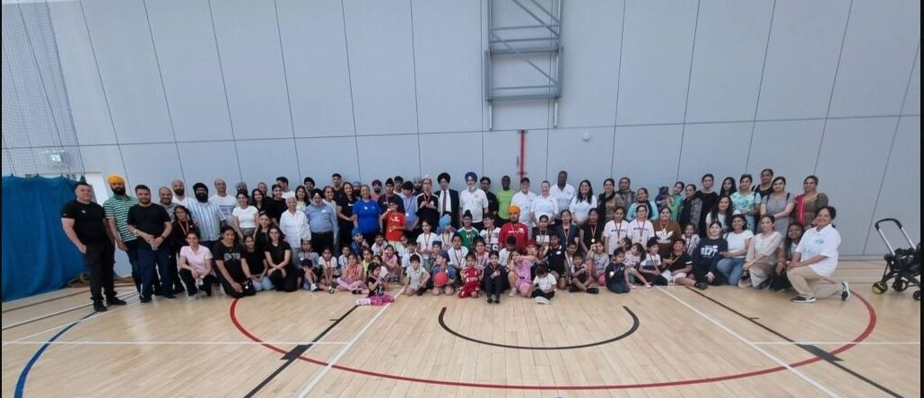
Community, movement and connection at the June 2026 Sports Day at Kelvin Hall.
About SEMSA  The Scottish Ethnic Minority Sports Association was established in Glasgow in 1990 to address the lack of culturally sensitive sporting provision for Black and Minority Ethnic communities. Today, SEMSA brings new and established communities together through accessible sport, physical activity, and community programmes.  Its work challenges inequality, racism and discrimination in sport while creating practical opportunities to participate, volunteer, coach and lead. Programmes include football, badminton, summer academies, competitions, capacity building and partnerships across Scotland. | Our focus  Inclusive activity  Culturally responsive programmes  Confidence and connection  Fairer access to sport

36 years of opening doors through sport

RECOGNITION AND REPRESENTATION

Celebrating people who move communities
SEMSA began in 2026 by recognising the volunteers, coaches, organisations, athletes and advocates whose commitment widens participation. International Women’s Day followed in March, bringing the community together through stories, culture, wellbeing, and celebration.
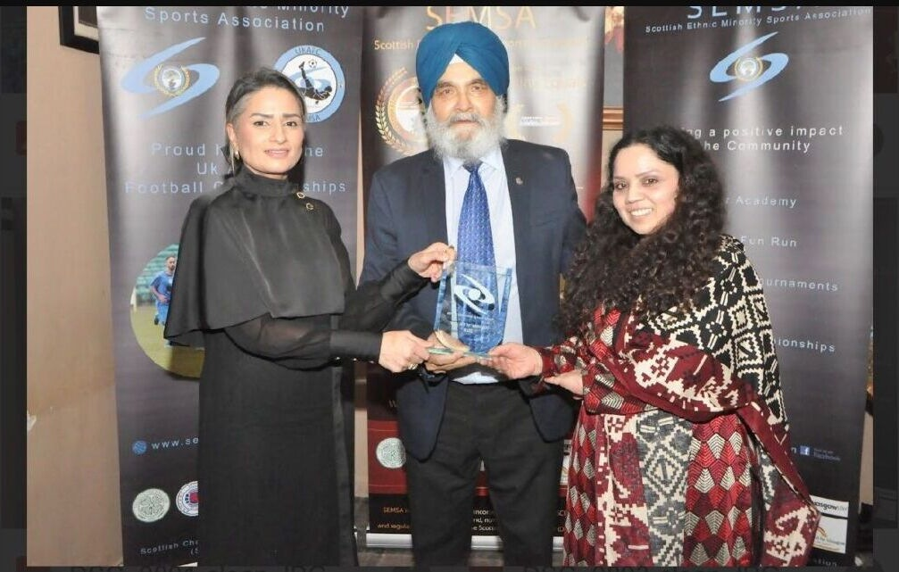  Annual Sport and Community Awards • 1 February 2026 | 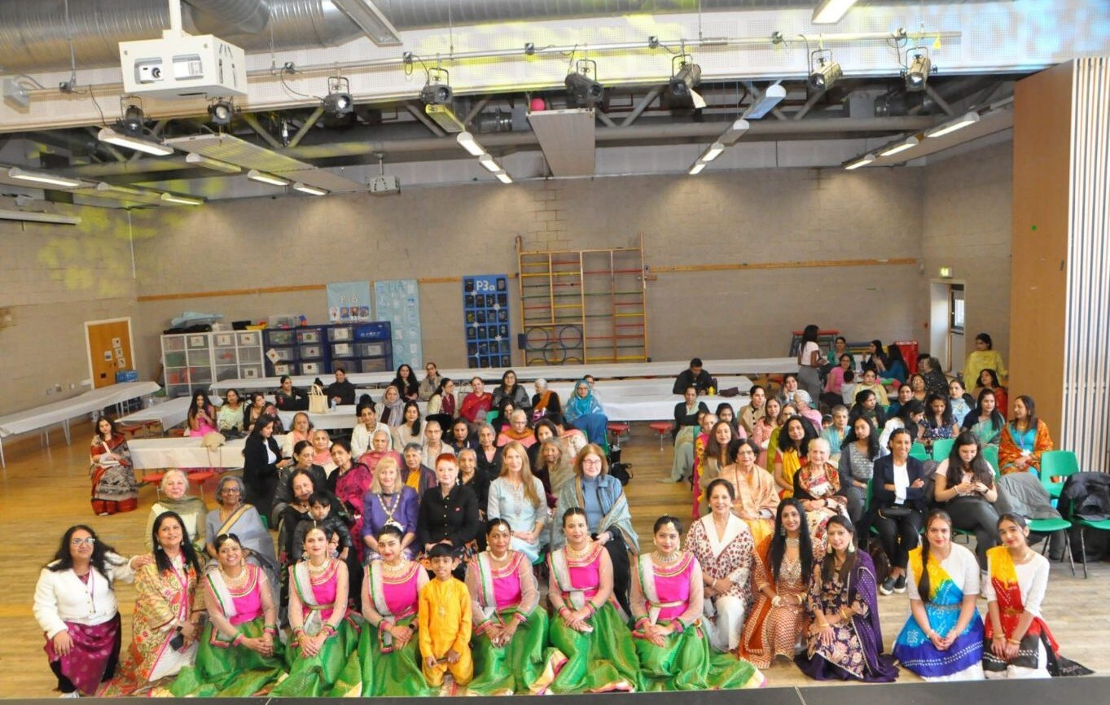  International Women’s Day • 8 March 2026

SEMSA Awards 2026
Held at Mr. Singh’s India in Glasgow, the annual ceremony honored achievement, service and the often-unseen work that helps people take part in sport and community life.
- Volunteer of the Year — Adrishta Gautam and Manira Ahmad  - Project of the Year — TAWAS  - Community Coach of the Year — Divya Manickavalu  - Female Entrepreneur of the Year — Tehseen Anwar  - Male Entrepreneur of the Year — Sanjay Majhu  - Unsung Hero of the Year — Farkhanda Choudhury | - Services to the Community — Athena Football Club  - Disability Achievement Award — James Pert  - Community Young Sports Person — Ekvira Singh  - Community Sport Person — Lila Sallis  - Special Recognition — Ronier Duemeni, African Challenge Scotland  - Lifetime Achievement — Mr Surjeet Chaudhry

International Women’s Day
Music, dance, food, conversation, and personal stories created a high-energy celebration of women’s leadership and collaboration. The strong turnout reflected a shared appetite for welcoming spaces where women can connect, participate and be heard.

2026 IN ACTION

Competition with community at its heart
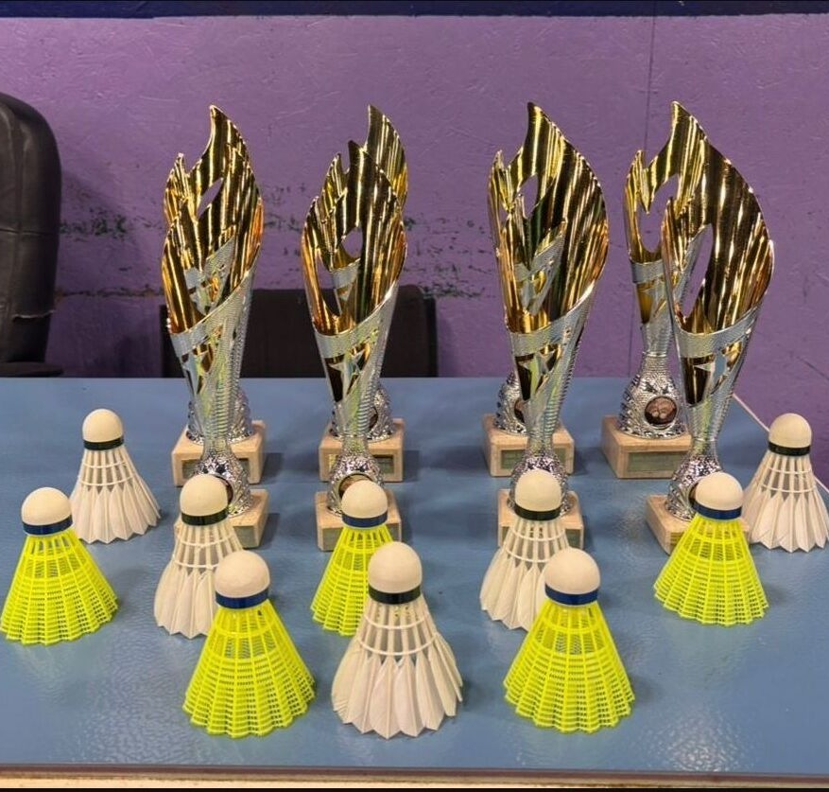  Mixed Doubles Tournament • 22 March | Mixed doubles badminton  Players competed in Social and Advanced categories at the Sir Craig Reedie Badminton Centre. Strong participation, skilled play, and good sportsmanship made the tournament lively for competitors and spectators alike.  The day captured SEMSA’s distinctive balance: serious competition, a welcoming atmosphere, and an emphasis on shared enthusiasm for the game.

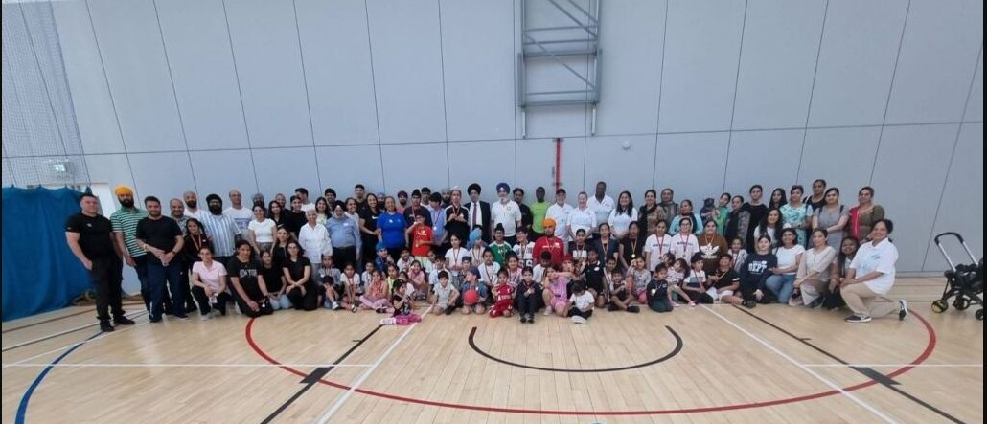  June Sports Day at Kelvin Hall | Summer sport  On 21 June, Punjabi Academy Glasgow joined SEMSA, Central Gurdwara Glasgow and Glasgow Life for an energetic, well-attended family sports day.

Women’s badminton • 27 June 2026
The women’s tournament at the Sir Craig Reedie Badminton Centre brought players together for an enjoyable day of badminton and community. The warm response and competitive spirit strengthened the platform for future women-centred events.
July sports event  The programme continued on 19 July, extending SEMSA’s summer calendar and creating another opportunity for families and participants to be active together. | THE 2026 THREAD  Play  Belong  Progress

TAKE PART

There is a place for you
SEMSA’s regular sessions are designed to make joining straightforward. Whether you are new to a sport, returning after a break, or looking for a welcoming activity for your child, you can begin at a level that feels right.
Weekly badminton
Session | When | Venue | Cost
Children aged 8–18 | Sun 2–4pm | Glasgow Club Springburn | £5
Mixed adults | Sun 5–7pm | Scotstoun Sports Centre | £6
Women | Wed 8–10pm | Glasgow Club Bellahouston | £6 / 2h
Women | Sat 9–11am | Glasgow Club Kelvinhall | £4 / 1h  £6 / 2h
Session details published by SEMSA in 2026. Please check the current arrangements before traveling.
More ways to move  SEMSA also promotes hill walking and develops activities through community partnerships. Contact the organisation to hear about upcoming outings, competitions, volunteering and programme opportunities.  Also, SEMSA has started a Healthy Habits Hub (HHH) to promote health and well-being amongst BAME community members.  For children’s sessions, registration and consent forms can be completed at the venue. Women’s sessions provide racquets, shuttles and coaching; participants should wear comfortable clothes and non-marking trainers. | Contacts  Mixed badminton  Greg • 07866 190137  Women’s badminton  Rajani • 07795 057092  General and hill walking  info@semsascotland.com

Keep moving with SEMSA
Visit semsascotland.com for current programmes, photographs and updates.
SEMSA is a Scottish Charitable Incorporated Organisation • Scottish charity number SC046642

