South Angus Parents of Adults with Learning Disabilities
(SAPALD)

Registered Charity SCO46702

Annual Report and Financial Statements
For the year ended 30th June 2025

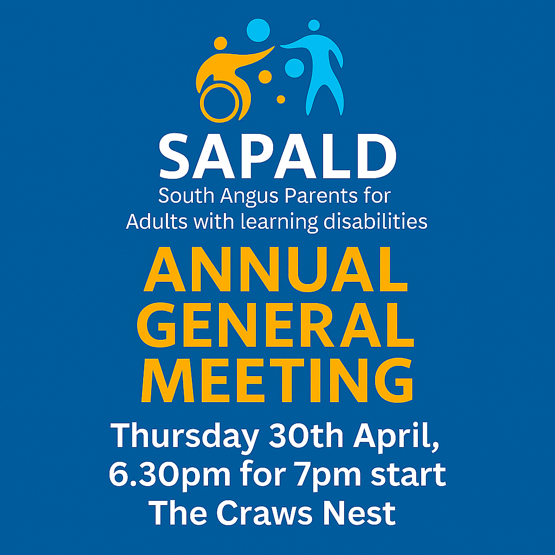

Table of Contents

- Overview
- Mission Statement
- Governance, Management and Leadership
- Activities and Achievements
- Financial Review
- Risk Management
- Future Plans

‘I can do anything you can do, just differently.’
— Chris Nikic (first person with Down syndrome to complete an Ironman triathlon)

Overview

Charity Name: South Angus Parents of Adults with learning disabilities
Registered Charity No: SCO46702
Trustees:
- Elizabeth McGillivray
- Ian Cummins
- Caroline Petrie
- Sandra Taylor
- Eric Macintosh
- Maureen Crawford
- Kevin Taylor

Contact information: Sapald2016@outlook.com

The South Angus Parents of Adults with Learning Disabilities (SAPALD) is a dedicated organization committed to supporting families and individuals navigating the unique challenges associated with learning disabilities. Over the years, SAPALD has tirelessly worked to provide a platform for advocacy, resources, and community engagement. Their unwavering dedication has made a significant impact in promoting inclusivity and understanding within the community.

The trustees of SAPALD play an essential role in guiding and overseeing the charity's mission and activities. Here's a general description of their roles and responsibilities:

1. Strategic Oversight:
- Set the long-term vision and objectives for the charity, ensuring alignment with its mission to support adults with learning disabilities.
- Make key decisions on the focus and direction of SAPALD's activities, such as the recent shift toward advocacy and lobbying.

2. Governance:
- Ensure the charity operates within legal and regulatory frameworks, including compliance with OSCR (Office of the Scottish Charity Regulator).
- Maintain transparency and accountability in financial and operational matters.

3. Fundraising and Financial Management:
- Oversee the financial health of the charity by monitoring budgets, approving expenditures, and exploring fundraising opportunities.
- Help develop strategies for sustainable funding, particularly as SAPALD adapts to its evolving role.

4. Advocacy and Representation:
- Represent SAPALD in external forums, such as local and national care service discussions, to advocate for the needs of adults with learning disabilities and their families.
- Engage with stakeholders, including members, associates, local authorities, and other organizations, to build partnerships and support.

5. Support and Volunteer Engagement:
- Work closely with the volunteer team to ensure the effective delivery of SAPALD’s initiatives.
- Encourage active participation from members and associates to strengthen the charity's impact.

“Just because my child doesn’t use words doesn’t mean they don’t have something to say.”
— Parent of a child with Angelman syndrome

Our purpose and mission.

‘We are dedicated to improving the quality of life for individuals by supporting adults with learning and life-long disabilities to live independently, in an appropriate housing, with the correct health and social care the right to Our mission is to enrich lives and foster well-being. Through our efforts, we aim to build a supportive and vibrant community where everyone can thrive.’

Governance and Leadership
The charity is governed by its Board of Trustees, who are responsible for the overall leadership, strategic direction, and governance of SAPALD, ensuring that the organisation continues to operate in accordance with its charitable purposes and regulatory obligations.
During the reporting period, the trustees met regularly to oversee the charity’s activities, monitor performance, and ensure appropriate financial and governance controls were maintained. The Board worked collectively to support the delivery of the charity’s objectives and to act in the best interests of its beneficiaries.
The trustees wish to record their sincere thanks to Elizabeth, who has provided leadership as Chair throughout the year. Elizabeth has chaired meetings effectively, ensuring that the Board operated in a well-managed, inclusive, and transparent manner. Her leadership has supported robust discussion, informed decision-making, and the effective discharge of trustee responsibilities.
The Board also extends its appreciation to all trustees for their continued commitment, time, and expertise. Their ongoing support and assistance have been vital to the effective governance of the charity and to ensuring that SAPALD remains well-managed and sustainable.

Activities and Achievements

Meetings and Decision making
The trustees held regular meetings to discuss the charity's operational business and future direction. These gatherings provided an opportunity for thoughtful discussion, including about how best to continue serving the community. After careful consideration, the trustees unanimously decided to reaffirm the charity's commitment to its core objectives, ensuring all activities remain aligned with its founding principles.
Overview of Activities
During the year, SAPALD continued to support adults with learning disabilities and their families across the South Angus area through advocacy, peer support, information sharing, and community engagement activities.
These activities furthered the charity’s purposes by promoting independence, reducing social isolation, and supporting families to navigate services and access appropriate support.
Over the reporting period, the charity supported families and engaged with adults with learning disabilities through regular meetings, events, and one-to-one support.

Chair’s Report

It is a privilege to present this year’s Chair’s Report and reflect on another positive and productive year for SAPALD. Over the past year, the organisation has continued to grow in both reach and impact, while staying true to its core purpose: supporting individuals with additional learning disabilities and their families, and ensuring their voices are heard.
One of the most encouraging developments has been our increasing visibility within the community. Our Facebook page continues to grow steadily, helping more families find us and connect with our work. However, SAPALD’s impact extends well beyond social media. Throughout the year, we have provided direct, practical support to parents and carers through letter writing, information sharing, and attending meetings with public and third sector professionals, including working with care managers. Acting as advocates, we have helped families navigate complex systems and ensured that their concerns and priorities are clearly understood.
Our commitment to inclusion and social connection remains central to everything we do. Our discos continue to be a highlight of the year, offering safe, welcoming, and joyful spaces for individuals and families to come together. Attendance remains strong, and the positive feedback we receive reinforces just how important these events are for building confidence, friendships, and a sense of belonging. I would like to sincerely thank everyone who has attended, supported, and helped make these events such a success.
We are also pleased to see continued improvements in our communication and working relationships with public and third sector organisations. Engagement with local services, care providers, and decision-makers has strengthened year on year, supporting a more collaborative approach to meeting the needs of our community. We are grateful for the ongoing support and engagement of local councillors and MSPs, whose involvement has helped raise awareness of the challenges faced by families and supported positive dialogue around inclusion and support.
None of this work would be possible without the dedication and commitment of our committee members. I would like to extend my sincere thanks to each member of the committee for their time, energy, and expertise over the past year. Their willingness to go above and beyond—often behind the scenes—has been vital to SAPALD’s continued success.
Finally, I would like to thank the parents, carers, volunteers, supporters, and partner organisations who place their trust in SAPALD. Your involvement, feedback, and encouragement continue to shape our work and drive us forward. As we look ahead, we remain committed to strengthening advocacy, expanding opportunities for connection, and ensuring that individuals with additional learning disabilities and their families feel supported, valued, and heard.
I look forward to another year of progress and collaboration.
Elizabeth McGillivray
Chair, SAPALD

Key achievements and Outcomes
Key achievements during the year included increased engagement from families, strengthened peer support networks, and improved communication with local service providers, enabling members to better access information and support.
The Trustees acknowledge that the year presented challenges, including capacity and resource limitations; however, these were managed through continued trustee involvement and partnership working.
Communications and Advocacy
Our Facebook page continues to grow steadily, contributing to increased visibility within the community and helping more families become aware of our work. However, our communications and impact extend well beyond social media. We provide practical, one-to-one support to parents and carers through letter writing, information sharing, and by attending meetings with public and third sector professionals, including care managers, where we act as advocates to ensure families’ voices are heard. This direct engagement has strengthened our relationships with public and third sector organisations and led to more effective communication and collaboration year on year.

Public Benefit
The activities delivered provided clear public benefit by supporting a vulnerable group, reducing isolation, and enabling families to better advocate for themselves. The Trustees consider that any barriers to participation were minimal and mitigated through accessible venues and informal support.

Financial Review

The Receipts and Payments Accounts are set out on the following pages. These accounts provide a detailed overview of the charity's financial transactions for the year ended 30th June 2025. They include all the money received (receipts) and all the money spent (payments) during the reporting period. This type of accounting is straightforward and helps to maintain transparency in financial management, ensuring that all funds are accounted for and used effectively to support the charity's mission.
“In learning about disability, we learn about humanity.”
— Judith Heumann (disability rights activist)
Reserves Policy
Our charity currently does not have a formal reserves policy. As a volunteer-led organisation with an income below £10,000, we focus our resources on delivering our mission and supporting our beneficiaries directly. Given our size and structure, our financial management practices prioritize maintaining flexibility and transparency in the use of funds, ensuring we can adapt to the needs of our community.

Risk Management

Best practices for risk management in SAPALD include:

1.Risk Identification: Proactively identify risks across all operational areas, including compliance, data security, and system performance.
2. Risk Assessment: Use tools like risk matrices to evaluate the likelihood and impact of each risk, prioritising those with the highest potential impact.
3. Mitigation Strategies: Develop clear plans to address risks, such as implementing robust controls, contingency plans, and regular audits.
4. Continuous Monitoring: Establish processes to track risks and the effectiveness of mitigation measures, ensuring timely updates and adjustments.
6. Stakeholder Engagement: Maintain open communication with stakeholders to ensure alignment and support for risk management initiatives.

These practices help create a resilient and adaptive risk management framework for SAPALD.

Future Plans

For the upcoming year, here are SAPALD’s considerations:

Here are some key considerations for your charity as you plan for the upcoming year:

1. Funding and Grants
- Explore funding opportunities tailored to disability support, such as small grants for charities with limited income.
- Build relationships with local businesses or larger charities for sponsorships or partnerships.

2. Advocacy and Awareness
- Raise awareness about the challenges faced by parents of adults with disabilities, particularly in housing, health, and social care.
- Collaborate with other organizations to amplify your voice and influence policy changes.

3. Tailored Support Services
- Offer workshops or support groups for parents to share experiences and gain practical advice.
- Provide resources to help parents navigate housing options, healthcare systems, and social care services.

4. Community Engagement
- Foster a sense of community among parents and caregivers through events, online forums, or local meetups.
- Partner with local authorities to ensure SAPALD is included in their "Local Offer" of services.

‘Disability is not inability.’ – Helen Keller (deafblind author and activist)

5. Sustainability and Growth
- Develop a strategic plan to ensure the long-term sustainability of your charity.
- Invest in training for your team to stay updated on best practices in disability support.

6. Technology and Accessibility
- Leverage technology to improve communication and service delivery, such as creating an accessible website or app.
- Ensure all materials and events are inclusive and accessible to people with varying needs.

Your disability does not define you; how you deal with the challenges it presents does.”
— David Hall (Paralympic swimmer)
