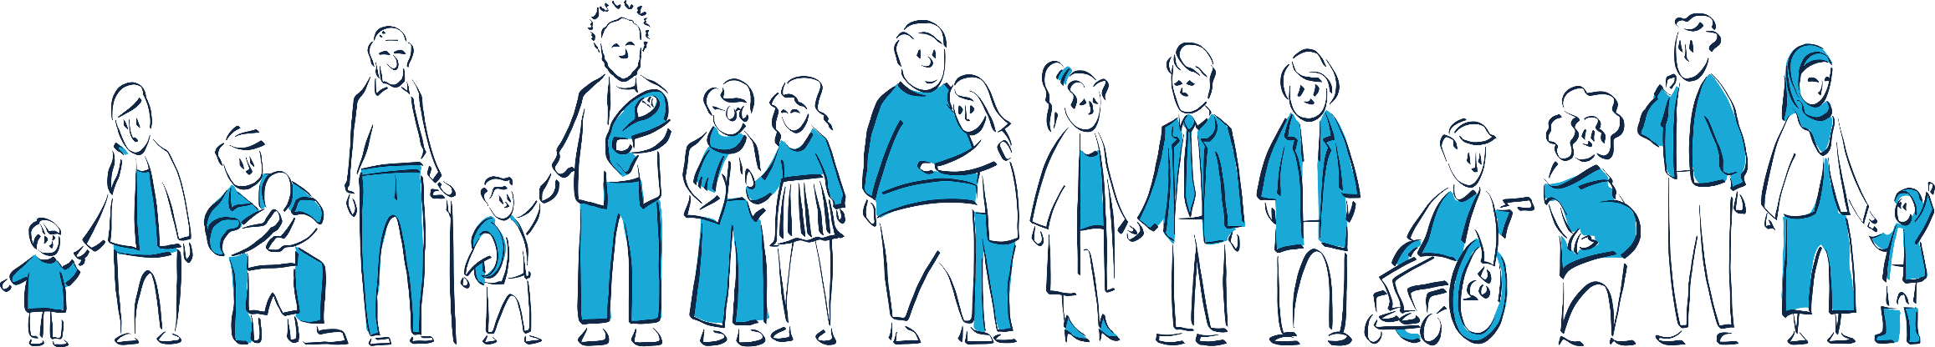
Who we are
The difference we made
2025-26
We are an independent charity operating since 1994 in the Orkney Islands, providing specialist support for adults, children, couples and families affected by relationship difficulties, family breakdown and associated challenges.
As a Relationships Scotland (RS) member, we are part of a Scotland-wide network of locally run services, are Organisational Members of COSCA (the Professional Body for Counselling and Psychotherapy in Scotland) and the College of Mediators. RS are also a Signatory of The Scottish Mediation Charter.

Our aims
Children and their families, couples and individuals, are
- supported to have better, stronger relationships.
- People in Orkney make the best possible transitions through relationship difficulties, separation and divorce.
- Relationship and family support is fully integrated within national and local policy and practice.

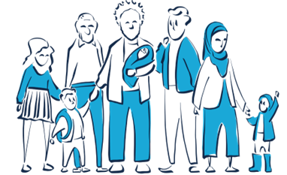

Our approach
- We work to the highest possible standards in accordance with the requirements of professional bodies.
- We respect and value diversity in our clients, practitioners, staff members and volunteers.
- We work in partnership with other organisations and individuals who share our aspirations for the people of Orkney.
- We are transparent and accountable, acting with openness and integrity at all times.

Our vision is for positive and respectful relationships to be at the heart of our community.

What we do
We offer a range of services tailored to the needs of individuals and families, who often access multiple services simultaneously or over time, as their needs change.

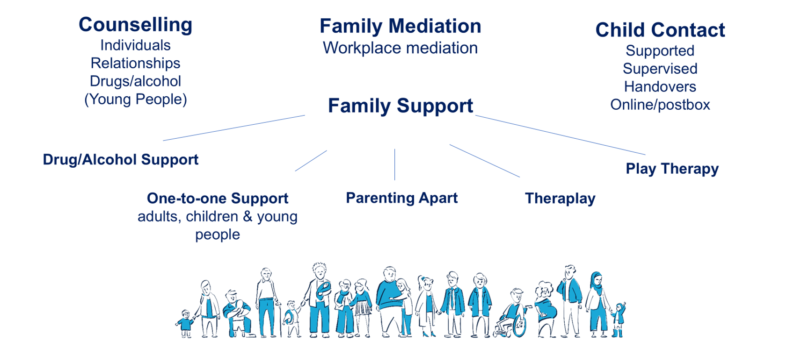
What we did in 2025-26

In the year 1 April 2025 to 31 March 2026 we supported 380 adults and 253 children/young people in the local community (including children of adults we worked with). This increases to 477 adults and
305 children if all those who attended an intake appointment, but did not go on to access a service within the year, are included.
A growing number of clients access to or more of our services (see pie chart), reflecting increasingly challenging circumstances and the multiple support needs of families.
KEY | SERVICE DESCRIPTION
FSW | Family Support Work
IC | Individual Counselling
D&A | Drug & Alcohol Support/Counselling
FM | Family Mediation
PT/PTG | Play Therapy (including group)
CFW/ThP | Children & Family Support/Theraplay
YPS | Young Person’s Support
RC | Relationship Counselling
CCC | Child Contact Centre
RSM | Relationship Support Mediation
WPM | Workplace Mediation
CYP | Children/Young Person’s Counselling
PA | Parenting Apart programme
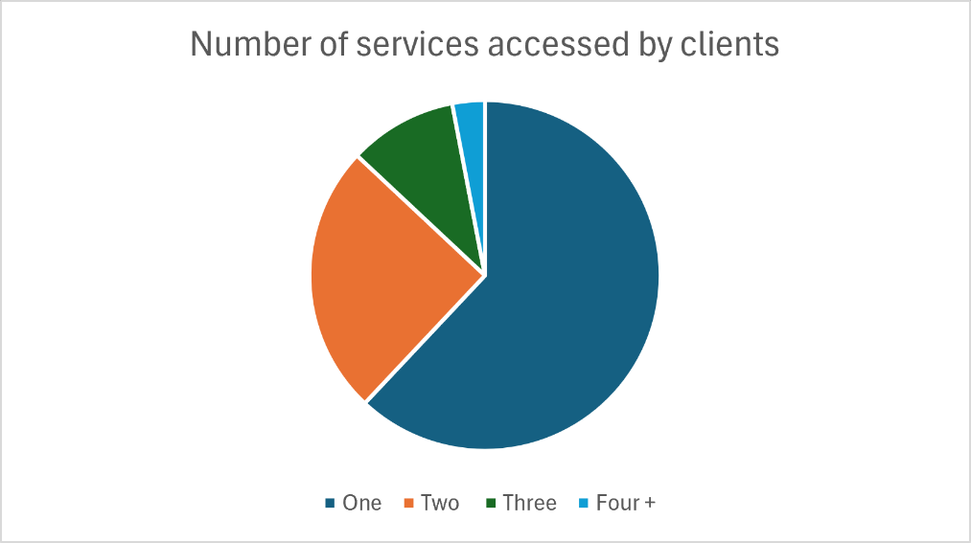
We launched a new Relationships Support Mediation service, enabling those waiting for Relationship Counselling to meet with a Mediator right away, to help with communication difficulties.

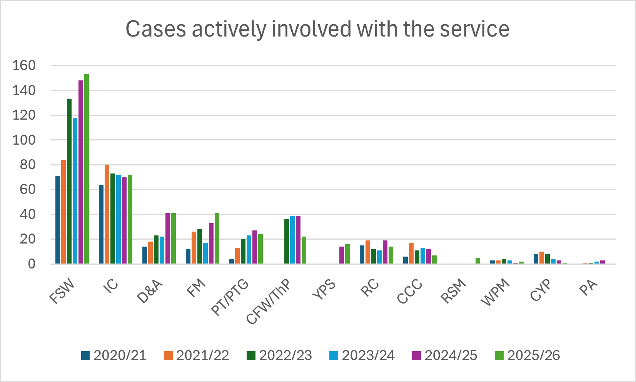
The Client Journey
We offer a non-judgmental welcome, and respond to people quickly when they reach out for help. We aim to get in touch within one working day of receiving a referral or someone getting in touch.
An intake appointment is arranged so we can discuss the client’s situation, and how we might be able to help. If they would benefit from more than one of the services we offer, onward referrals are made.
Due to high demand, there is a wait for some services. We offer interim support where appropriate, which clients tell us they value: “There was quite a long wait to see a counsellor but it was immensely helpful to have sessions with a support worker in the meantime.”
We respond to the needs of clients as they change over time, and offer flexibility around appointment times, including evenings and some weekend appointments.
We build positive and respectful relationships with the adults, young people and children we work with. Many clients work with us over a number of years, and may return for further help in the future if the need arises.

“The service was very approachable and easy to use. The space is comfortable and comforting and everyone that I interacted with was highly professional, considerate and helpful.”

Referral/Enquiry
We make contact by email/phone within 1 working day.

We offer intake appointment and make onwards referral(s) as appropriate.

Signposting to other services, where appropriate
Counselling
Support
Play Therapy
Theraplay
Family Mediation
Child Contact
Parenting Apart

Ask client about their experience.

Client returns if need arises in future.

Who we work with

Most of those we work with live on the Orkney mainland and linked South Isles (95%), 4% of clients live on ferry-linked islands and 1% elsewhere in Scotland (usually as part of a family where other family members are based in Orkney).

We work with people of all ages: the graph below shows the full age range and the growth of work with children and young people age 5 to 16 over the last 5 years; and a sharp increase more recently in our work with adults in their 30s.
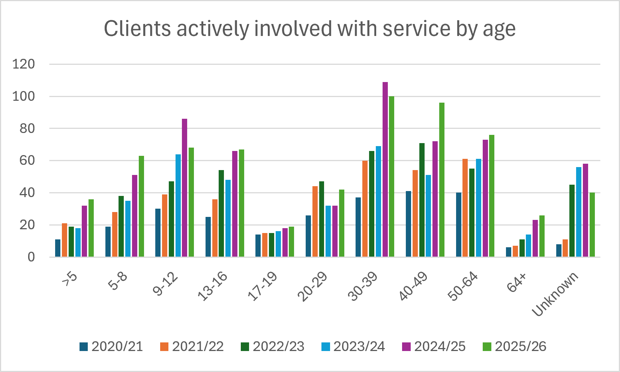

Clients present with a complex range of needs: 51% identify a disability or difficulty, including 38% with a mental health condition, 17% with a long-term illness, disease or condition, 11% with a physical disability and 10% with a learning disability or difficulty. 10% of those we work with described themselves as care-experienced.

Over 81% of clients present with one or more risk factors at their initial assessment meeting including mental health concerns, suicide, domestic abuse, alcohol/drugs.

Of these, mental health concerns are the most prevalent risk factor, present in over 70% of cases, with suicide and/or domestic abuse in around 20% of cases.

In addition to these issues, many clients face financial challenges, often exacerbated by relationship breakdown. 32% earn less than £12,000 per year and half earn less than £20,000. It is therefore vital that we continue to offer services free of charge, which we are able to do only thanks to the generous funding we receive from a range of sources (see page 14).
Referrals

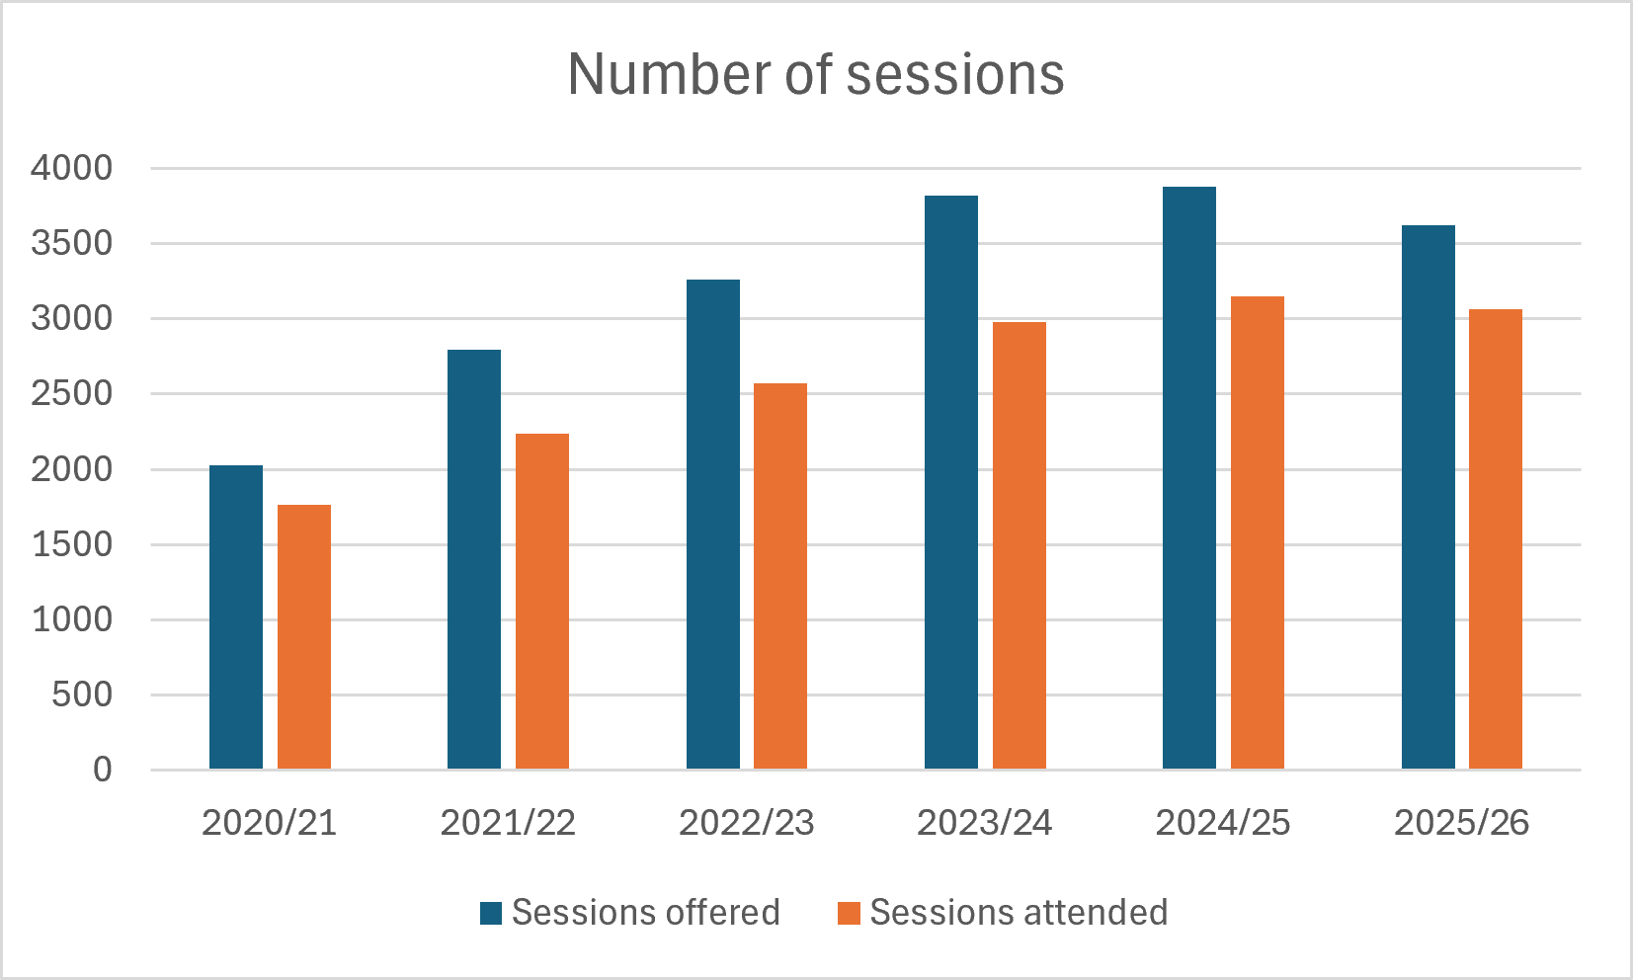
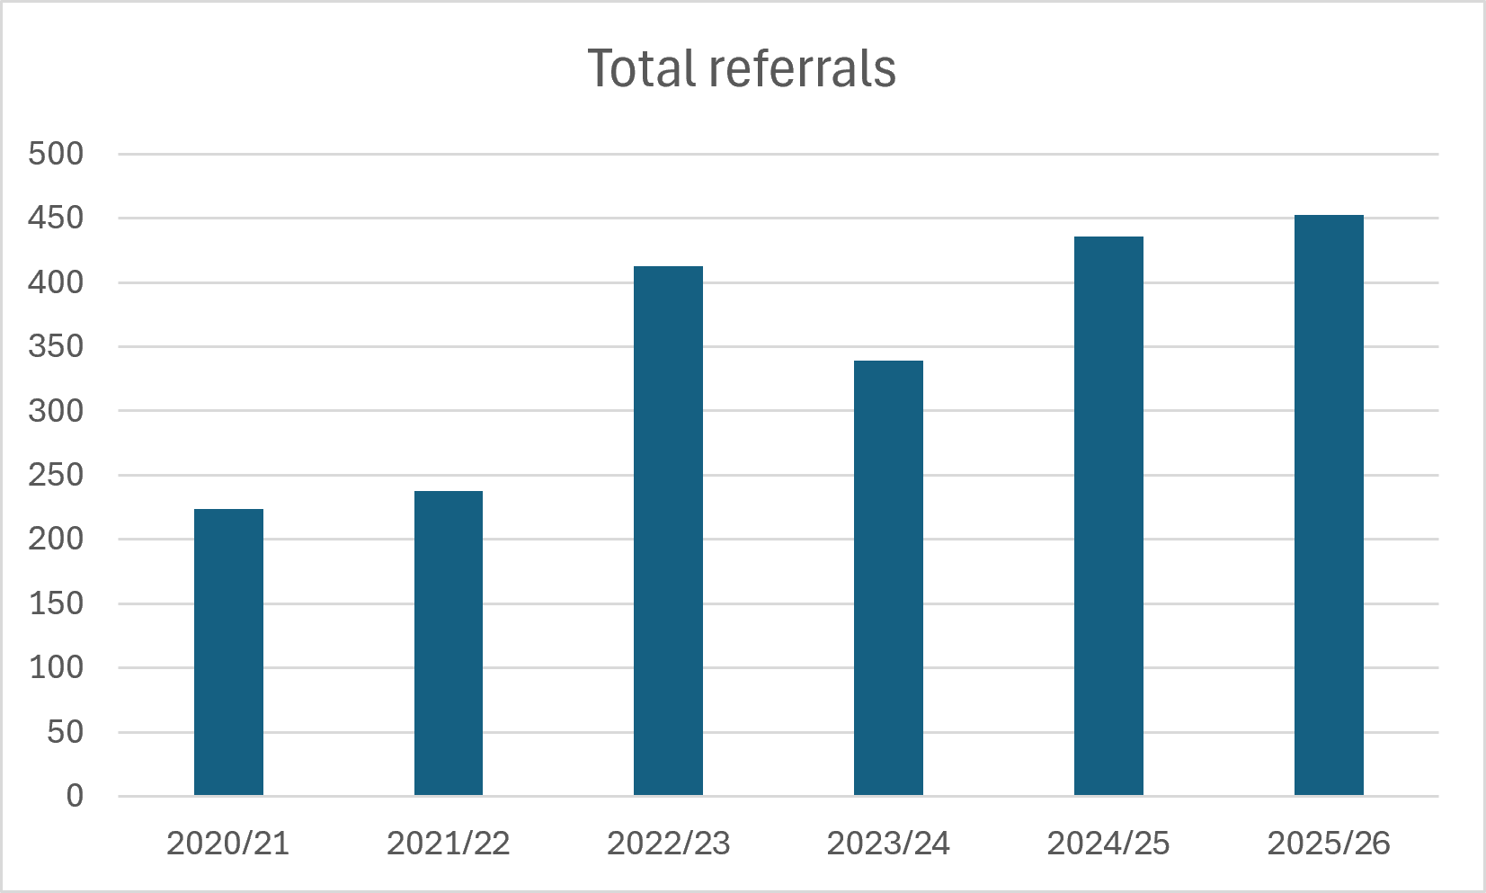
Demand for our services continues to rise. In the year April 2025 to March 2026, 398 cases attended 3,062 sessions, and we opened 453 new cases. The number of people needing our services has grown significantly since 2020, as shown below:

Referrals come from a range of sources: 38% of clients self-refer; 40% of cases are internal referrals; 7% are referred by a health professional (e.g. GP); 2% by School; 3% Social Work; 1% Criminal Justice and the rest from other sources including third sector partners. Internal referrals are where, for example, parents come for Family Mediation and one or both parent/s then accesses individual Support; they may also use the Child Contact Centre and/or be referred for Counselling.

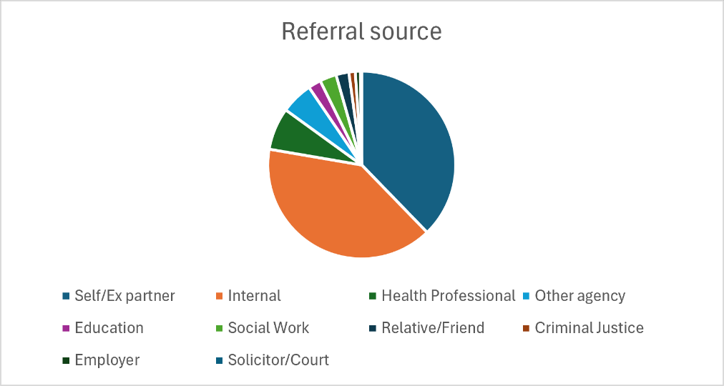

Individual and Relationship Counselling
During the year 2025-26, a total of 87 cases attended for counselling (including 14 couples and 1 young person). A total of 694 counselling sessions were attended.

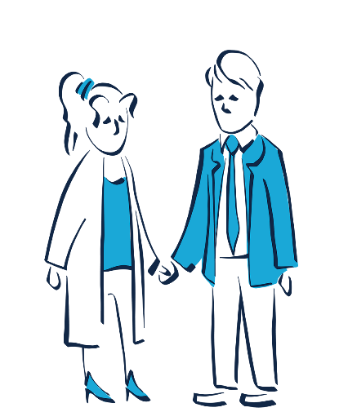
We provide a safe, confidential place for individuals and couples to talk to a professional counsellor about problems of any kind such as relationship difficulties, anxiety, depression, anger, bereavement/ loss to explore feelings and find ways to move forward.

87% of clients reported that they felt able deal with their difficulties and to move forward after counselling.

“Our Counsellor listened to us and helped us to understand the unhelpful patterns that we had been using in our relationship over decades. Then we learnt new ways of dealing with our emotions. We learnt ways to communicate effectively. The couples therapy we received has been very beneficial and has enabled us to stay together.”

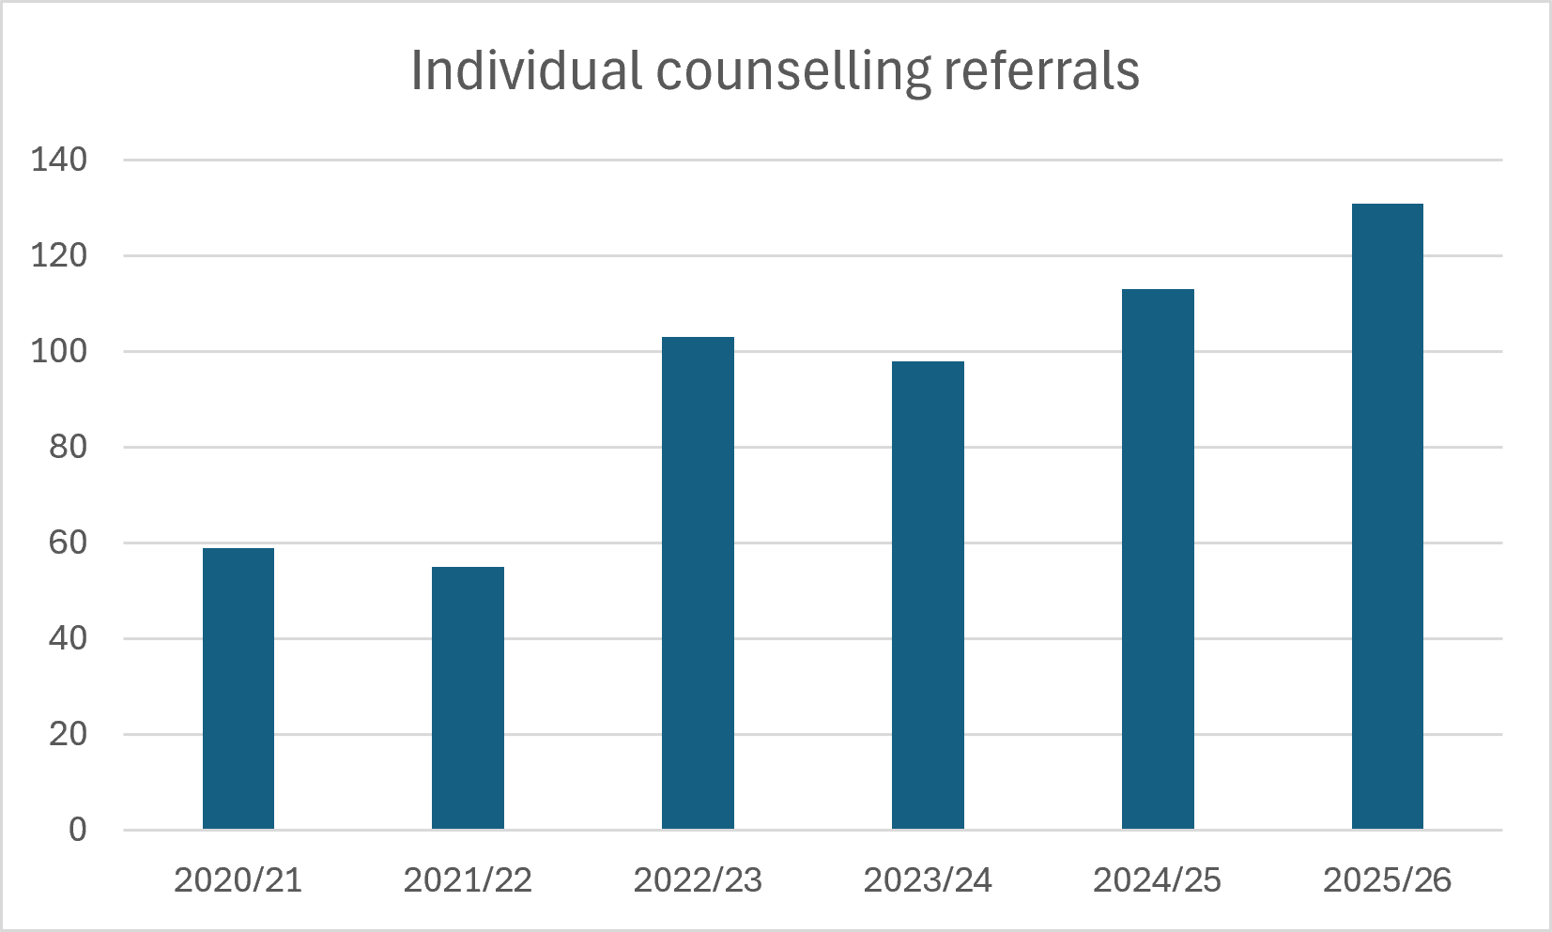
As the graph shows, the number of referrals for Individual Counselling continues to increase. This year we received 131 new Individual Counselling referrals. Unfortunately this means there is currently a wait to start Counselling, but we offer Support to all clients who are waiting.
“I was very impressed by the service I received - the fact that I was able to see a support worker regularly while I waited to see a trained counsellor… the skill and patience of the counsellor and the way [the Counsellor] listened, asked perceptive and appropriate questions, and that there was no sense of being judged.”

Family Mediation
Family Mediation is a voluntary process which can help separated parents and family members when communication becomes difficult or has broken down. With the help of a trained and impartial mediator, long, painful and expensive legal battles can be avoided. 41 families attended 143 mediation sessions in 2025-26.
“Without our family mediation sessions, my daughter would not have the relationship she now does with the other parent, as communication had broken down to such an extent that it was impossible to make plans for the other parent to see her.
We all wouldn’t be where we are today without mediation, and I feel this is a vital service for all families facing difficulties during a separation.”

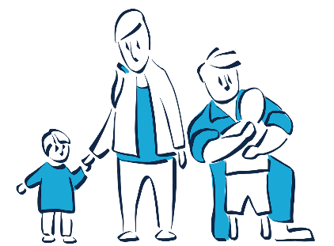
“This service was extremely beneficial to our situation and allowed us to make arrangements that suited our child. Our mediator was extremely professional, but also kind and caring. It gave us a space to talk about things without anyone ‘holding the power’ as such.”

87% of clients reported mediation had helped improve their family situation.
47% said they were dealing with conflict well compared to 5% before mediation.

Child Contact
We provide a safe, friendly, neutral and child-centred environment where children affected by family breakdown can meet and maintain their relationship with the parent they no longer live with or with other family members.
“I think everyone working there is very professional and keep the child as the focus of all that they do in relation to child contact which is reassuring.”

Family Support
“I feel this is a valuable service that has helped me through the hardest times of my life. Simply having a listening ear from someone impartial has helped to ease the burden during life's most challenging moments. It has offered a sense of hope, helping me to regain stability and confidence when faced with adversity. The service has empowered me to navigate through struggles, reminding me that I am not alone in my journey and has given me coping strategies to help support me for the future. The impact has been immeasurable, as the service has helped restore my dignity and bring light to the darkest of times.”

Our Family Support Workers help individuals and families to identify their strengths and build capacity, so they become better able to cope with relationship issues, mental health, parenting and other life challenges. One-to-one support is offered for adults, young people and children: 191 people attended 1,425 support sessions.

In all the work we do with families, we seek to ensure that the voice of the child is heard when decisions are being made or actions taken which affect a child’s future.
“I originally was going to Relationships Scotland for mediation. After not going ahead with the mediation, I was offered support sessions. This all happened so quickly and was offered support sessions within a couple of weeks. I felt very comfortable straight away with my support worker. Great service and would recommend.”

“The support that I received has been without question the most influential aspect of me being able to continue forward with a new life, I have advanced in both my mental wellbeing and life aspects . Thank you for providing such a wonderful caring service.”

76% of clients reported improvements in their relationships with family and friends after accessing support;

83% told us they felt more able to cope as a result of the help received; and

67% reported feeling more confident in themselves and their abilities.

Play Therapy
This creative and arts therapy can help children to express themselves, particularly where they are struggling to understand their feelings or find it hard to put their feelings into words. This approach can help children to work through a traumatic experience, such as abuse, loss of a parent, parental separation and associated challenges.

Last year 24 children attended 230 sessions of Play Therapy, and we continue to see strong demand for this service.
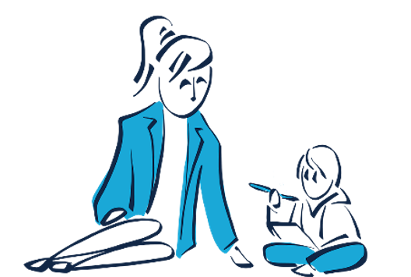

In all our work with children

- We support The Promise that Scotland has made, to ensure that all children and young people grow up loved, safe and respected so that they realise their full potential.

- We adhere to the principles of Getting it Right for Every Child

- We recognise rights of children and young people, in particular the right not to be discriminated against, a right to play, a right to have a say in matters that affect them, and that decisions made about children should be in their best interests.

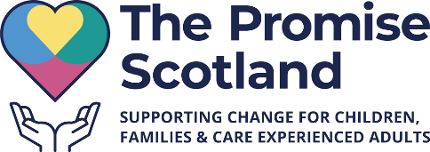

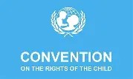

Alcohol/Drug Counselling & Support
This service helps individuals and families impacted by their own or someone else’s alcohol/drug use to reduce harm and, where appropriate, to explore the underlying causes through counselling. 17 adults attended 203 sessions of drug/alcohol counselling to explore the underlying issues; 17 adults attended 140 session of recovery support.
“[The Drug & Alcohol Counsellor] is fantastic, this was the second time I required use of Relationship Scotland Orkney’s services. My support through the Drug and Alcohol support service was exemplary. From the girls on reception, to my counsellor. Thank you once again for everything, I truly appreciate it xx.”

Our Alcohol and Drug Support and Counselling Service is commissioned by the Orkney Alcohol & Drugs Partnership.
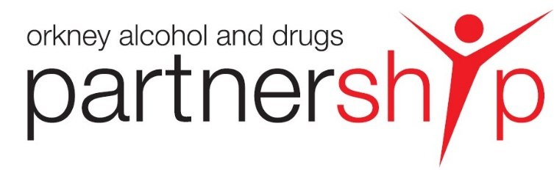

Feedback from professionals we work with

We receive a growing number of referrals from General Practitioners. GPs told us this about their experience of our service:

“I find referring patients to relationship Scotland easy when I do it, the fact they can self refer is very beneficial as well. Patient feedback is good.”
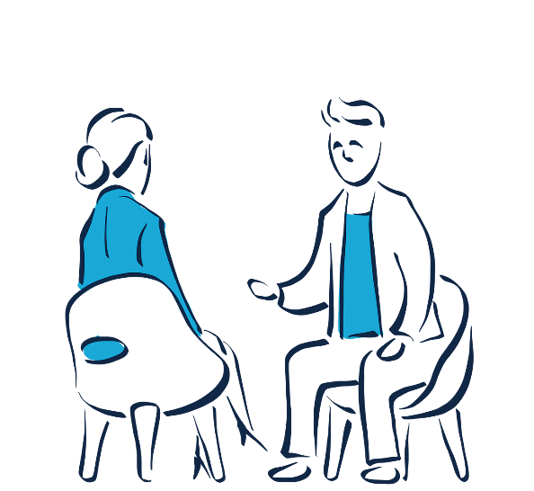

“My experience of referring patients to Relationships Scotland Orkney has overall been very positive. Initial intake and assessment appointments are offered in a timely manner, and I consistently receive good feedback from patients both during their counselling and after completion, particularly regarding the quality and impact of the support provided.”

Our people
To enable us to respond to a growing and varied caseload, we have expanded our capacity, and continue to invest in training.
We employ 11 full/part-time staff including 4 Family Support Workers, 2 Counsellors and 8 sessional Child Contact workers.
In addition, we have a team of skilled self-employed practitioners: 4 Counsellors, 3 Mediators and 3 Play Therapists.
In all the work we do with families, we seek to ensure that the voice of the child is heard when decisions are being made or actions taken which affect a child’s future.

Staff training and development
We are committed to developing our staff and to building Orkney’s specialist workforce for the future.
This year, we supported one Counsellor and one Family Mediator through practice placements, and offered work placements to 7 Counselling Certificate students.
Our practitioners are all qualified to postgraduate Diploma level, requiring significant commitment from the trainees, support and funding from the organisation. Qualified practitioners are required to undertake at least 12 hours of Continuing Professional Development every year to hone their skills.
Staff participate in mandatory training in Child Protection, Fire Safety, Health and Safety and Data Protection; as well as additional training

relevant to their role e.g. in Suicide Intervention Skills, Motivational Interviewing, Drug Awareness and Trauma-Informed Practice.
The Play Therapists and Children/Young People Support Worker this year did Beacon House training in Developmental Trauma.
Our Child Contact Centre Workers are skilled in working with children and families and, like all our staff, their approach is tailored to the individual needs of each child and family. The staff are trained to Relationships Scotland national standards, and this year undertook additional training in areas such as Paediatric First Aid, Supporting children’s Rights, Voice of the Baby, Introduction to de-escalation techniques.

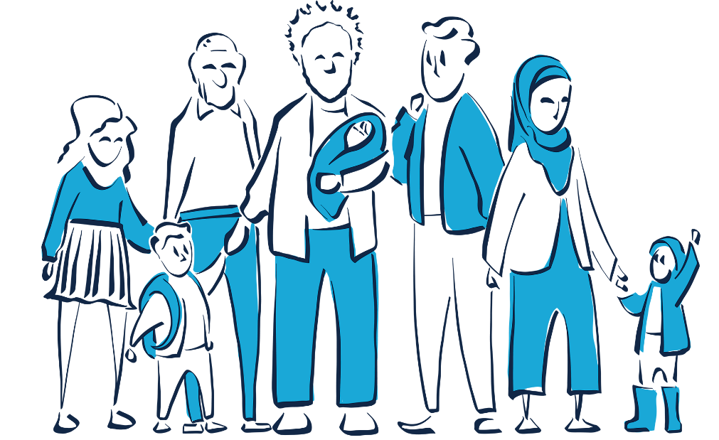
Our funders
As our work has expanded in recent years to meet needs within the local community, we constantly need to find additional sources of funding.
We are grateful to the Scottish Government for grants awarded to the Relationships Scotland Network through the CYPFEIF and CORRA Foundation, which contribute to the core costs of providing Counselling, Family Mediation and Child Contact services.
We have received generous grants from The Henry Smith Foundation, The National Lottery Community Fund and The Robertson Trust to enable us to deliver an integrated package of Intensive Family Support.
The Orkney Alcohol and Drugs Partnership (OADP) commissions services to support those in the community impacted by their own or someone else’s alcohol or drug use. We have been commissioned to provide counselling and harm reduction support; and also support for families and friends impacted by a loved one’s alcohol/drug use.

Orkney Islands Council (OIC) contributes towards the funding of our core services, and the management of the Orkney Counselling Centre, as well as providing a small grant enabling us to support those at risk of homelessness.
Our remaining income comes from a range of sources including client donations, local fundraising and other small grants including from Mind On and Orkney Renewable Energy Ltd.
Without the support of these individuals and organisations, we could not continue to support the individuals and families we work with across Orkney’s 19 inhabited islands.


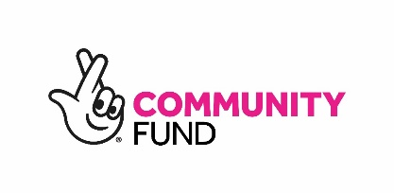
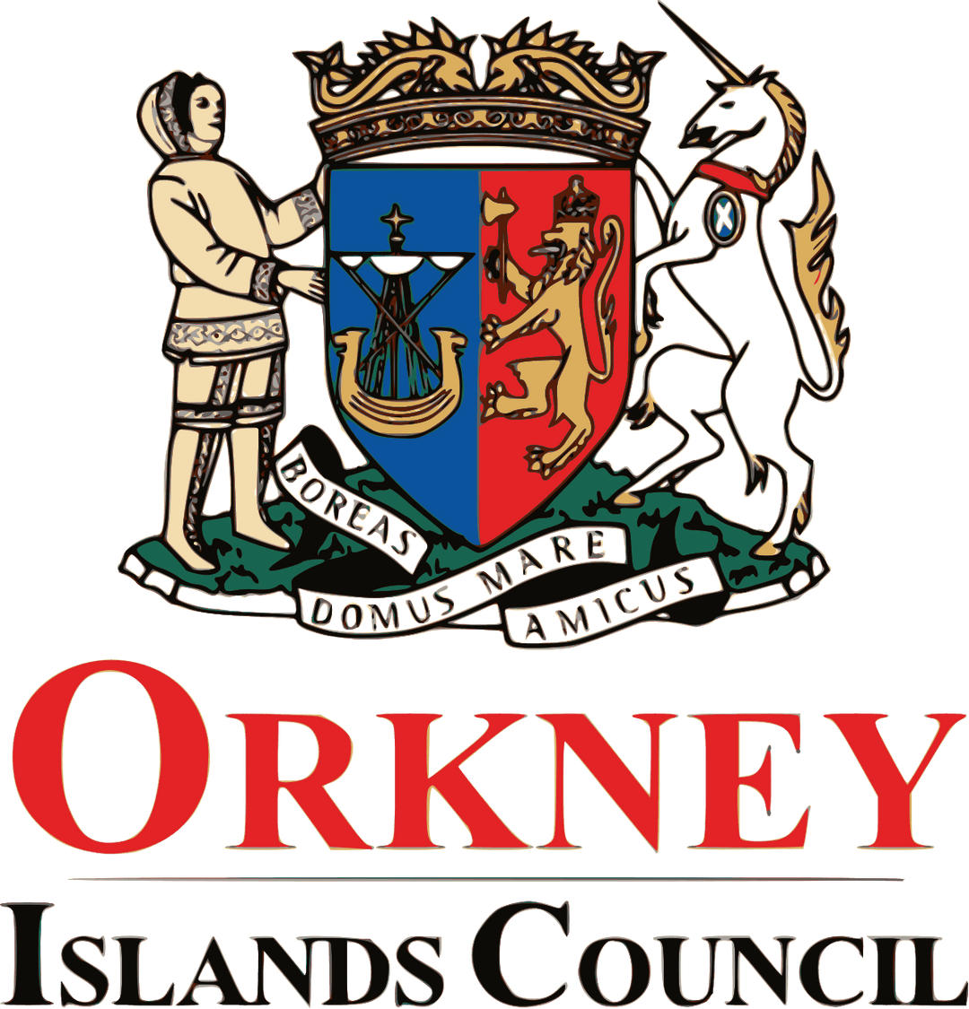
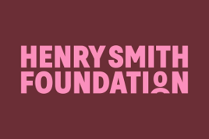

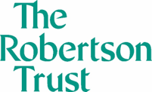
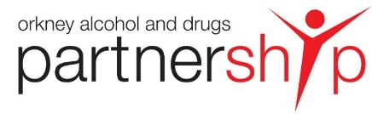

Strategic Aims 2022-27 : progress in 2025-26
Improve & extend our services to meet client needs
- Demand for Individual Counselling continues to grow, with 131 new referrals this year, so we offer everyone who is waiting one-to-one sessions with a Support Worker meantime.
- We have developed our Play Therapy service, hiring a dedicated space so we can provide a suitable and consistent therapeutic environment for children.
- We are working with local partners to develop integrated referral pathways for our children’s services.
- Work is ongoing locally and across the Relationships Scotland Network to prepare for regulation of Child Contact Centre services, anticipated in 2027.

Build capacity and develop the workforce
We continue to invest in staff training and development. In the past year:
- 1 trainee Family Mediator has done a practice placement, working towards becoming a Registered Family Mediator.
- 1 Counsellor has worked towards their Diploma in Relationship Counselling and is doing their practice placement.
- 1 Counsellor has completed their Diploma in Individual Counselling following their practice placement.

Raise awareness of our services and influence local service development
- We participate in a range of local partnerships including: Suicide Prevention Task Force, Orkney Alcohol & Drugs Partnership, The Promise Board, Orkney Community Justice Partnership, Third Sector Working Group, Orkney MARAC.
- We work closely and constructively with colleagues in NHS Mental Health Services, Social Work, Housing and Police Scotland as well as third sector partners to support clients and ensure a holistic approach to meeting their needs.
- We promote our work through posters and leaflets, our website and social media, to raise awareness of the help available and how people can access our services.

Fund our ambitions
- The funding climate continues to be challenging, and we grateful for the support of all our funding partners.
- A Priority for the Strategy was to secure ongoing funding for our Family Support Work. This is in place until 2026, and we are working hard applying for new grants to ensure this important work can continue from 2027 onwards.
- We receive donations from clients who are in a position to donate, and are doing more local fundraising to raise awareness and build local support for our work.

How to access our services
Individuals can self-refer or someone (e.g. a GP, Link Practitioner or Teacher) can contact us on their behalf.
The client is contacted within 1 working day, and an initial appointment is usually offered within 10 working days. There may be a wait for some services, but support is available meantime.
We will work with the individual to find out which of our services best suit their circumstances, and may also offer support to other family members. If appropriate, we refer on to other services who can better meet a client’s needs, and we will support them through the transition from one service to another.

If you are concerned about a family member or someone else you know, you can contact us to discuss confidentially whether we may be able to help.
“I think all the staff are very friendly and respectful of everyone’s individual needs, they provide a very high level of service which I have in the past and still do recommend to others as it’s definitely been a great help to my mental health.”
Former client

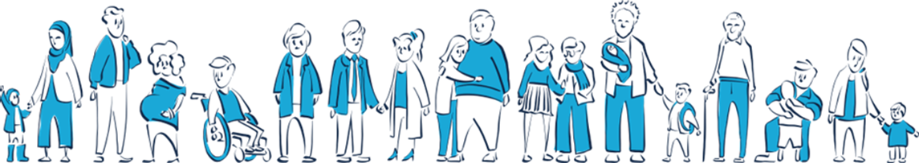

Relationships Scotland Orkney
First Floor Right
Kirkwall Travel Centre
West Castle Street
Kirkwall
Orkney KW15 1GU
01856 877750
enquiries@rsorkney.org.uk
www.rsorkney.org.uk

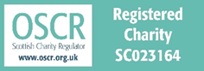

Scottish Company Number SC380628

Our services are free and confidential.

