HAPPINESS COMES FIRST
Trustees’ Annual Report
Scottish Charity Number: SC054387
Reporting period: 8/7/2025-2026

Charity Overview

Happiness Comes First is a Scottish charity established to support people experiencing disadvantage, financial hardship, social isolation and barriers to wellbeing. The charity seeks to improve physical, mental and social wellbeing through accessible community activities, practical support and opportunities for people to connect.

2. Activities During the Reporting Period

Free Fitness and Wellbeing Sessions

After securing premises, Happiness Comes First began providing free weekly fitness and wellbeing sessions for members of the community. During the most recent two months from May 2026 sessions were delivered approximately once a week. The sessions were designed to provide an accessible opportunity for residents, adults and families to become physically active, improve wellbeing and connect with other people.

3.Volunteer Support

Volunteers supported the delivery of the charity’s activities. Their contribution included helping to prepare the activity space, welcoming participants, supporting the running of fitness sessions and assisting with wider community activities.

Clothing, bags, shoes Collection and Redistribution

The charity also collected items donated by residents and redistributed these items free of charge to people who needed them. This provided practical support to members of the community while encouraging the reuse of good-quality clothing.

4.Community Premises

The charity’s premises provided a dedicated base for community activity. The space was used for fitness, wellbeing and community engagement activities and enabled adults, children and families from different backgrounds to participate in an inclusive environment.

5.Achievements and Public Benefit

Through its free activities and practical community support, Happiness Comes First worked to reduce barriers to participation, encourage healthier lifestyles, strengthen social connections and provide support to people who may otherwise experience financial or social disadvantage. The contribution of volunteers helped the charity deliver these activities and build community involvement.

6.Plans for the Next Period

The charity intends to continue developing its community fitness and wellbeing activities, strengthen volunteer involvement, build partnerships and use available funding responsibly to increase the number of people who can benefit from its charitable work.

7. Trustee Approval

This report is to be reviewed and approved by the charity trustees before submission to OSCR.
Approved by the charity trustees on: 10/8/2026_______________
Name: Sandra Linda Nshangalume________________________
Role: Chairperson/Charity Trustee__________________________
Signature: Sandra Linda Nshangalumeo___________________________

Appendix 1 Activity Photographs (Supporting Evidence)

The following photographs illustrate community fitness and wellbeing activity at the charity’s premises.
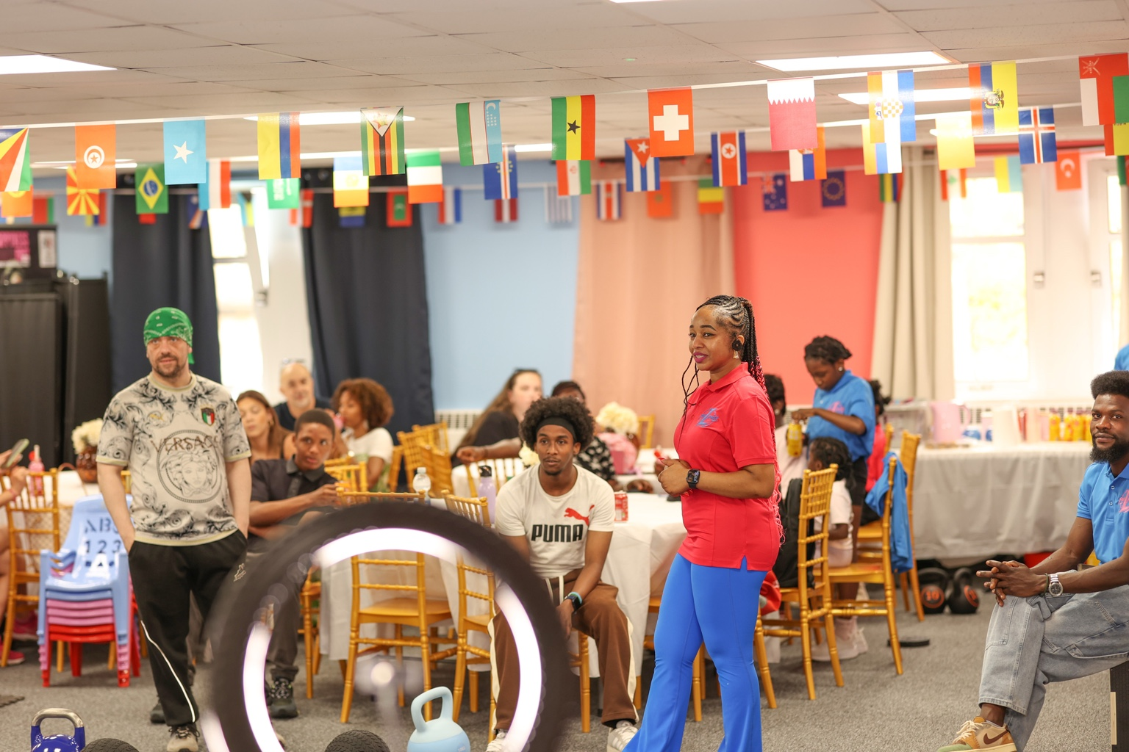
Community gathering and fitness/wellbeing activity.
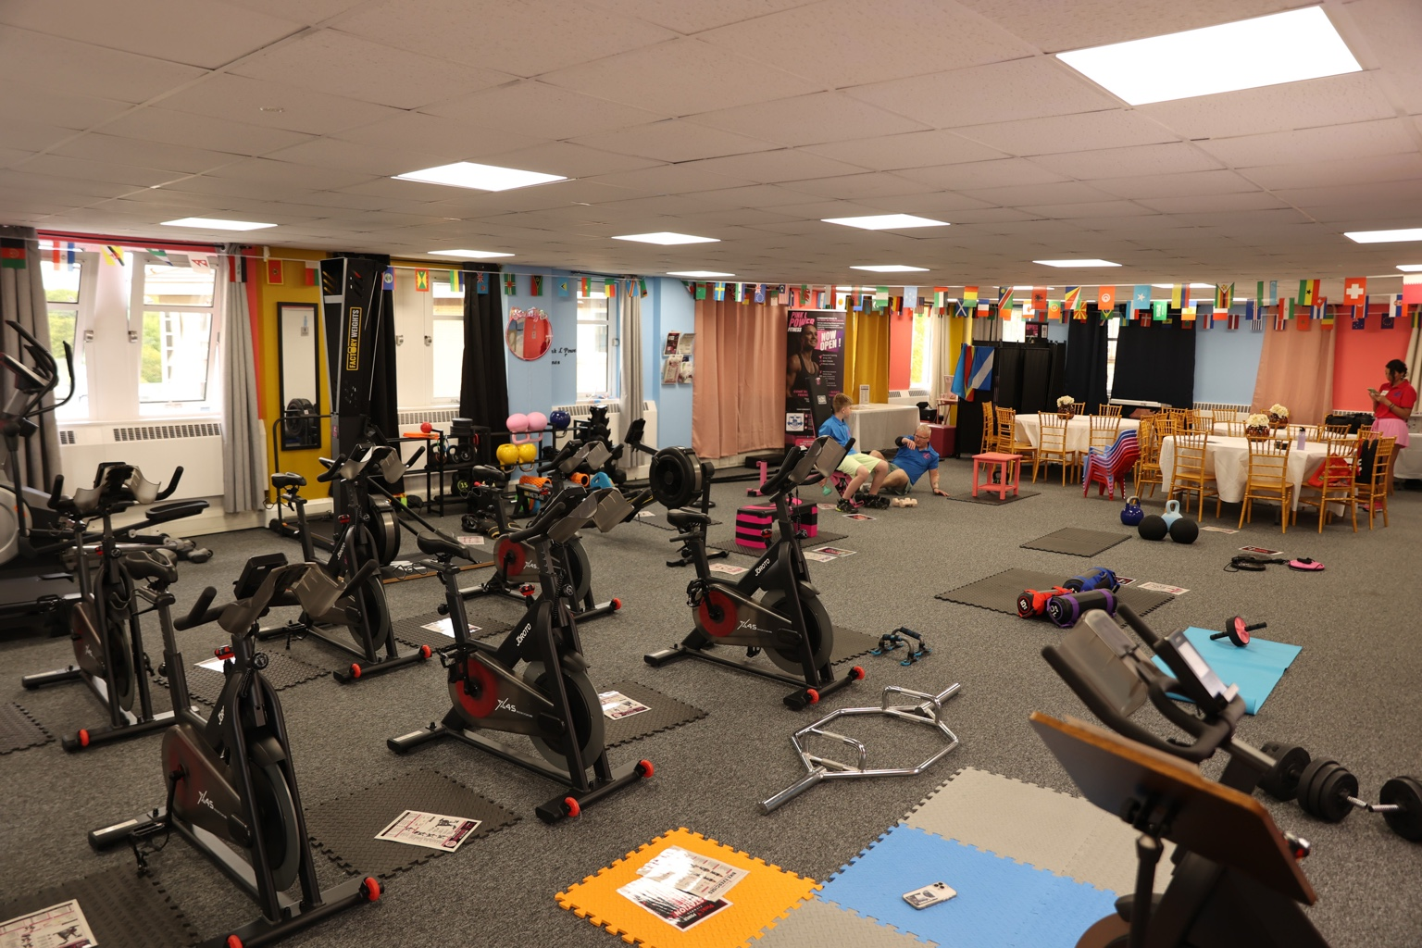
Fitness and wellbeing activity space at the premises.
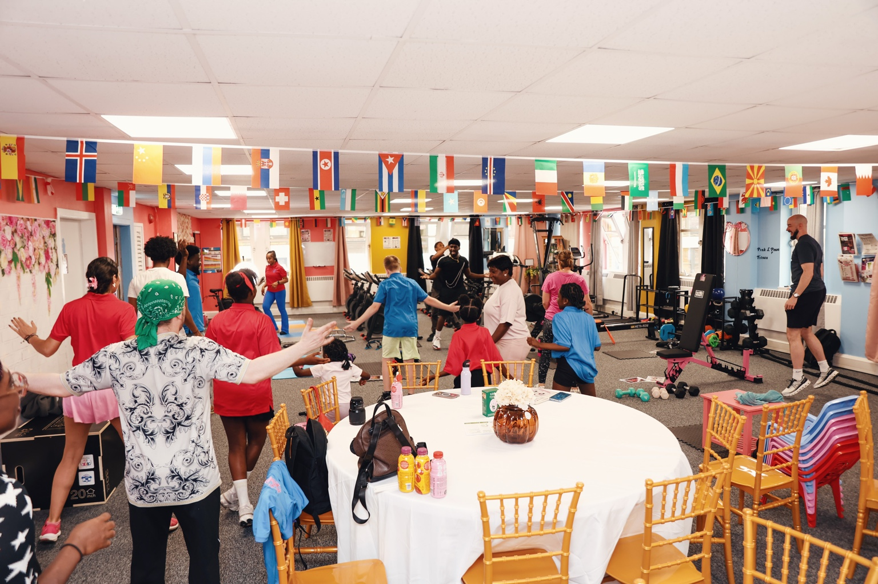
Community participation in a group fitness session.
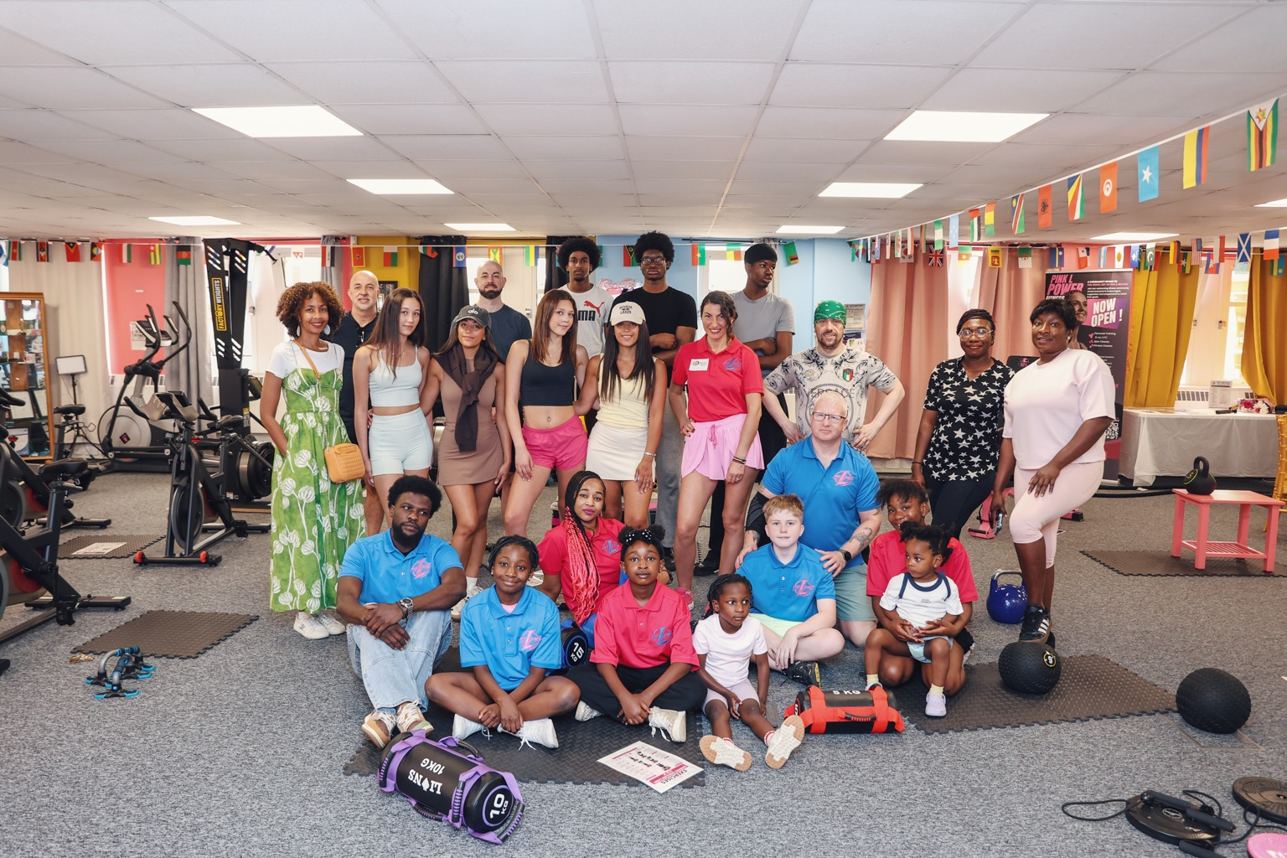
Participants, volunteers and community members at the premises.

