Riding for the Disabled Aberdeen Group
SC010604

Accounts for the year ended 31 March 2026

Name of Charity: | Riding for the Disabled Aberdeen Group
Scottish Charity Number: | SC010604
Address of the principal office: | Ashbrook House  Maryculter  ABERDEEN  AB12 5GR
Names of charity trustees: | Catherine Stott
 | Elizabeth Gammie
Laura Freeland - resigned 29 January 2026
Muriel Simpson - resigned 29 January 2026
Claire Perras
Sandra Thomson
Karyn Stewart
Jane Eddie – appointed 6 March 2026
Catriona Livock – appointed 29 March 2026

The organisation is a Scottish Charitable Incorporated Organisation, the purpose of which is to promote the objects of the Riding for the Disabled Association by providing disabled people with the opportunity to ride to benefit their health and wellbeing in the Aberdeen area.

The structure of the organisation consists of members who have the right to attend members’ meetings (including any annual general meeting) and have important powers under the constitution; in particular, the members appoint people to serve on the board and take decisions on changes to the constitution itself. The Board who are known as charity trustees hold regular meetings and generally control the activities of the organisation.

The main activities of the charity has been the provision of riding opportunities for around 20 individuals per week, engaging in fund raising activities and raising the profile of the charity with a view to encouraging donations.

The policy of the charity trustees in terms of reserves is to generate sufficient funds, through fund raising, donations and interest to cover the running expenses of the charity without spending any of the capital base. This was achieved during the year to 31 March 2026 as the reserves increased by £3,388.

Approved …………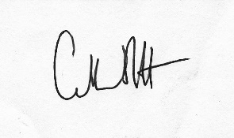……………………….  Catherine Stott  Chairperson | Date 12 October 2026

Receipts and Payments
For the year ended 31 March 2026

Receipts | Year to  31/3/26  £ | Year to  31/3/25  £
Interest received | 13,662 | 9,687
Donations | 1,490 | 1,000
Fundraising activities | 3,214 | 3,720
Donation – Valero Energy | 3,333 | -
Donation – K Philip | 1,707 | -
Donation – N Dalgarno | 3,401 | -
Donation – Student Show  Donation – Robert Stephen estate | 500  - | 1,545  89,834
Hire of ponies | 1,467 | 2,351
Sale of Merchandise | 585 | -
 | 29,359 | 108,137
Payments

Tillyoch hire | 5,176 | 8,195
Running costs of ponies | 12,055 | 15,944
Coaching | 5,107 | 4,486
RDA national | 522 | 477
Meeting and AGM expenses | 67 | 44
First Aid courses and training | 795 | -
Website costs | - | 217
Fundraising costs | 216 | 216
Miscellaneous | 579 | 718
Purchase of Merchandise  Purchase of equipment | 460  994 | -  -
 | 25,971 | 30,297
Surplus for year | £3,388 | £77,840

Statement of Balances as at 31 March 2026

 | 31/3/2026  £ | 31/3/2025  £
Virgin Money Charity Term Deposit | 78,427 | 75,040
Hampshire Trust Bank Term Deposit | 65,539 | 84,812
Cambridge and Counties Bank Term | 81,923 | 78,420
Shawbrook Bank | 83,431 | 80,000
Virgin Current Account | 19,141 | 6,801
Total funds | £328, 461 | £325, 073
Reconciliation of balances
Total funds at 31/3/2025 | 325,073 | 247,233
Surplus for the year | 3,388 | 77,840
Total funds at 31/3/2026 | £328,461 | £325,073

The liabilities outstanding at 31/3/2026 amounted to £1,365 and relates to coaching costs, hire of pony, web hosting and venue fees.  Approved ………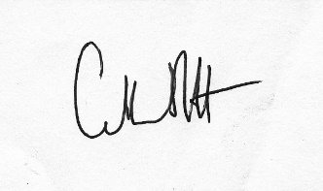…………….  Catherine Stott  Chairperson | Date 12 October 2026

Notes to the Accounts

- The funds have been distributed around the various accounts and banks to ensure that the Financial Services Compensation limit of £120,000 is not exceeded.
- No remuneration has been paid to a charity trustee or a person connected to a charity trustee.
- No expenses were paid to any of the charity trustees.

Independent Examiner’s Report to the Trustees of Riding for the Disabled Aberdeen Group

I report on the accounts of the charity for the year ended 31 March 2026 which are set out on pages 1 to 5.

Respective responsibilities of trustees and examiner
The charity’s trustees are responsible for the preparation of the accounts in accordance with the terms of the Charities and Trustee Investment (Scotland) Act 2005 and the Charities Accounts (Scotland) Regulations 2006. The charity trustees consider that the audit requirement of Regulation 10(1) (d) of the 2006 Accounts Regulations does not apply. It is my responsibility to examine the accounts as required under section 44(1) (c) of the Act and to state whether particular matters have come to my attention.

Basis of independent examiner’s statement
My examination is carried out in accordance with Regulation 11 of the 2006 Accounts Regulations. An examination includes a review of the accounting records kept by the charity and a comparison of the accounts presented with those records. It also includes consideration of any unusual items or disclosures in the accounts and seeks explanations from the trustees concerning any such matters. The procedures undertaken do not provide all the evidence that would be required in an audit, and consequently I do not express an audit opinion on the view given by the accounts.

Independent examiner’s statement
In the course of my examination, no matter has come to my attention
- which gives me reasonable cause to believe that in any material respect the requirements:
- to keep accounting records in accordance with Section 44(1) (a) of the 2005 Act and Regulation 4 of the 2006 Accounts Regulation
- to prepare accounts which accord with the accounting records and comply with Regulation 9 of the 2006 Accounts Regulations
have not been met, or
- to which, in my opinion, attention should be drawn in order to enable a proper understanding of the accounts to be reached.

Name: Mhairi Miller MA (Hons) CA
Relevant Professional qualification/professional body: ICAS
Address: 127 Desswood Place, Aberdeen AB15 4DP

Signed
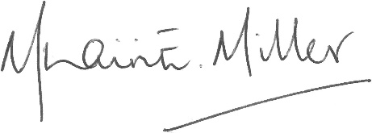
Date 12 October 2026

