Urban Uprising
SC 044205
Accounts for year ending 31 December 2025

Contents

OSCR Receipts and payments accounts 3
OSCR Statement of balances 4
OSCR Notes to the Accounts 5
Funds 2025 6
Reserves Policy 7
Independent Examiner Report 8

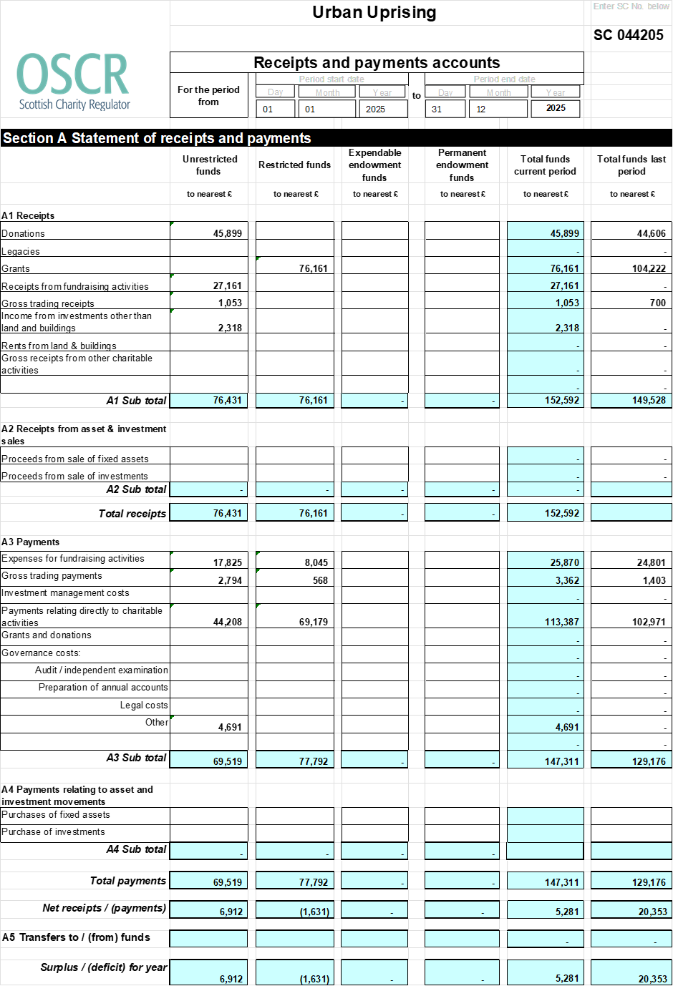
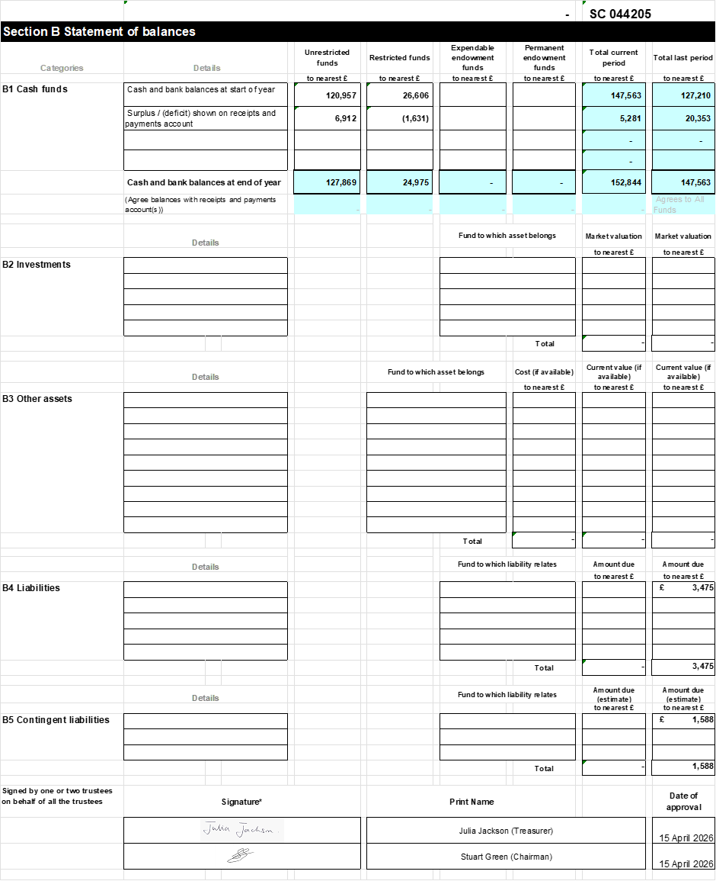

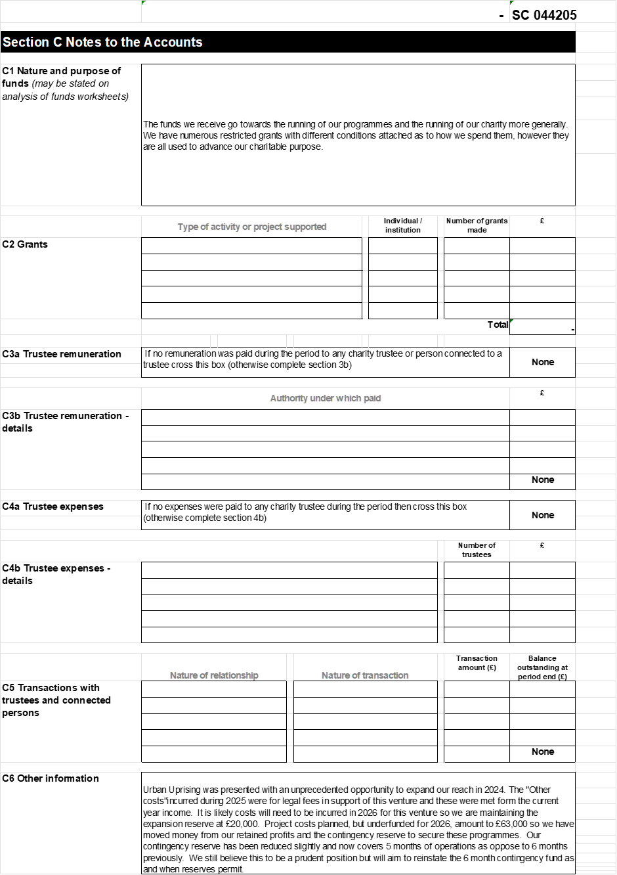
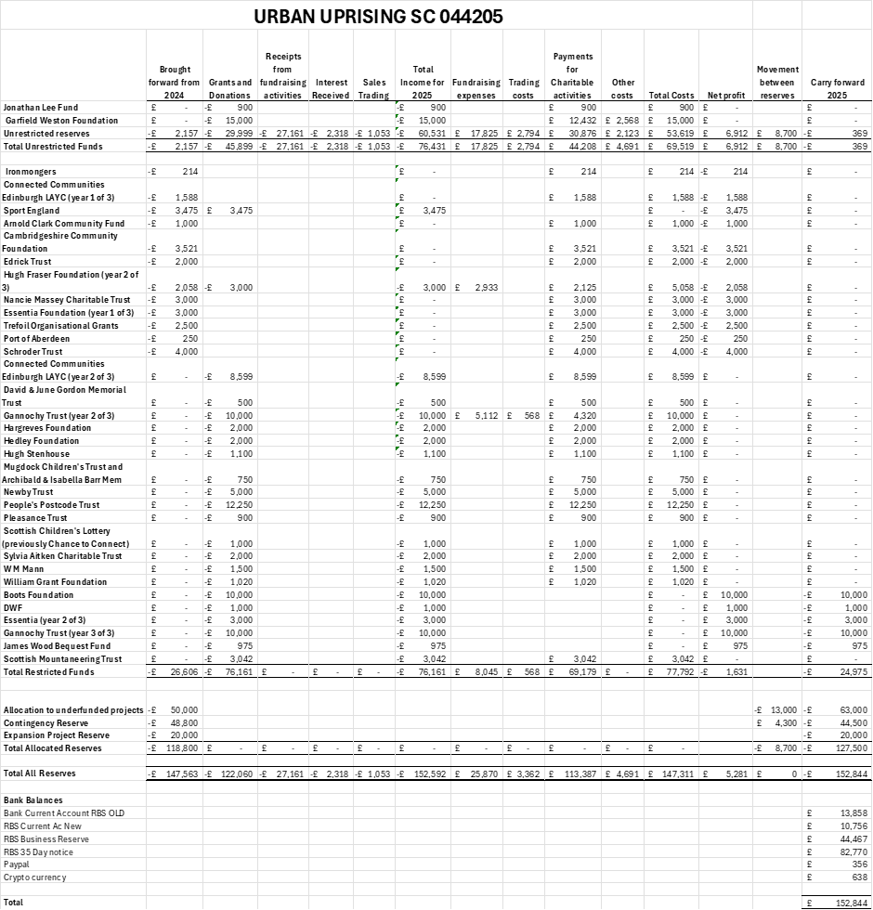
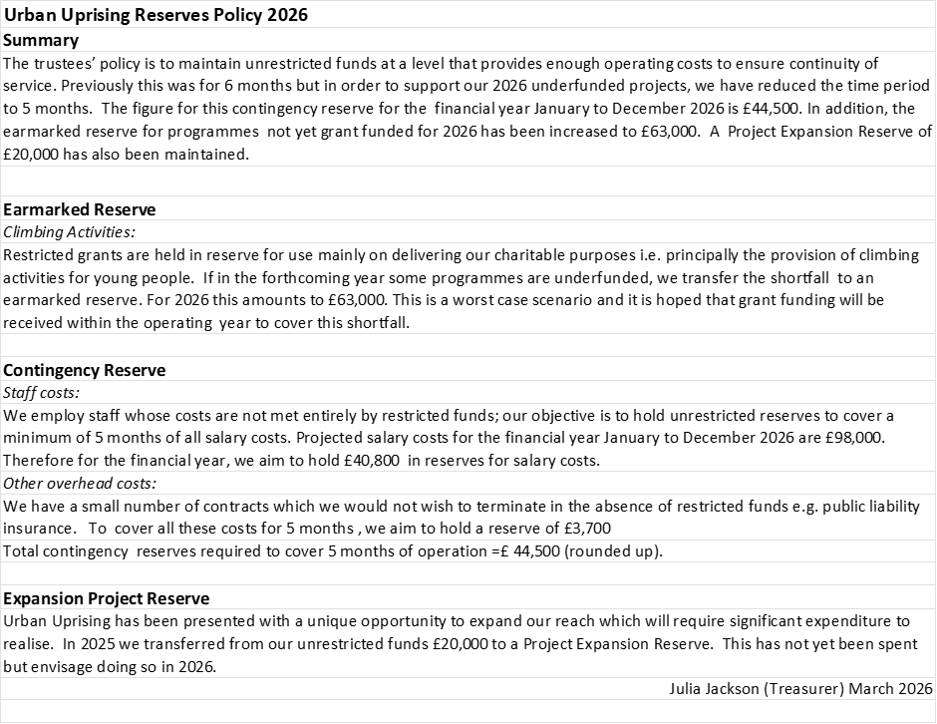
Independent Examiner’s Report to the Trustees of Urban Uprising
I report on the accounts of the charity for the year ended 31 December 2025.
Respective responsibilities of trustees and examiner
The charity’s trustees are responsible for the preparation of the accounts in accordance with the terms of the Charities and Trustee Investment (Scotland) Act 2005 and the Charities
Accounts (Scotland) Regulations 2006 (as amended). The charity trustees consider that the audit requirement of Regulation 10(1) (d) of the 2006 Accounts Regulations does not apply. It is my responsibility to examine the accounts as required under section 44(1) (c) of the Act and to state whether particular matters have come to my attention.
Basis of independent examiner’s statement
My examination is carried out in accordance with Regulation 11 of the 2006 Accounts Regulations. An examination includes a review of the accounting records kept by the charity and a comparison of the accounts presented with those records. It also includes consideration of any unusual items or disclosures in the accounts, and seeks explanations from the trustees concerning any such matters. The procedures undertaken do not provide all the evidence that would be required in an audit, and consequently I do not express an audit opinion on the view given by the accounts.
Independent examiner’s statement
In the course of my examination, no matter has come to my attention which gives me reasonable cause to believe that in any material respect the requirements:
- to keep accounting records in accordance with Section 44(1) (a) of the 2005 Act and Regulation 4 of the 2006 Accounts Regulations
- to prepare accounts which accord with the accounting records and comply with Regulation 9 of the 2006 Accounts Regulations
have not been met, or
- to which, in my opinion, attention should be drawn in order to enable a proper understanding of the accounts to be reached.

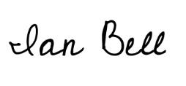

Ian Bell ACA
Member Institute of Chartered Accountants in England and Wales
18/05/2026

