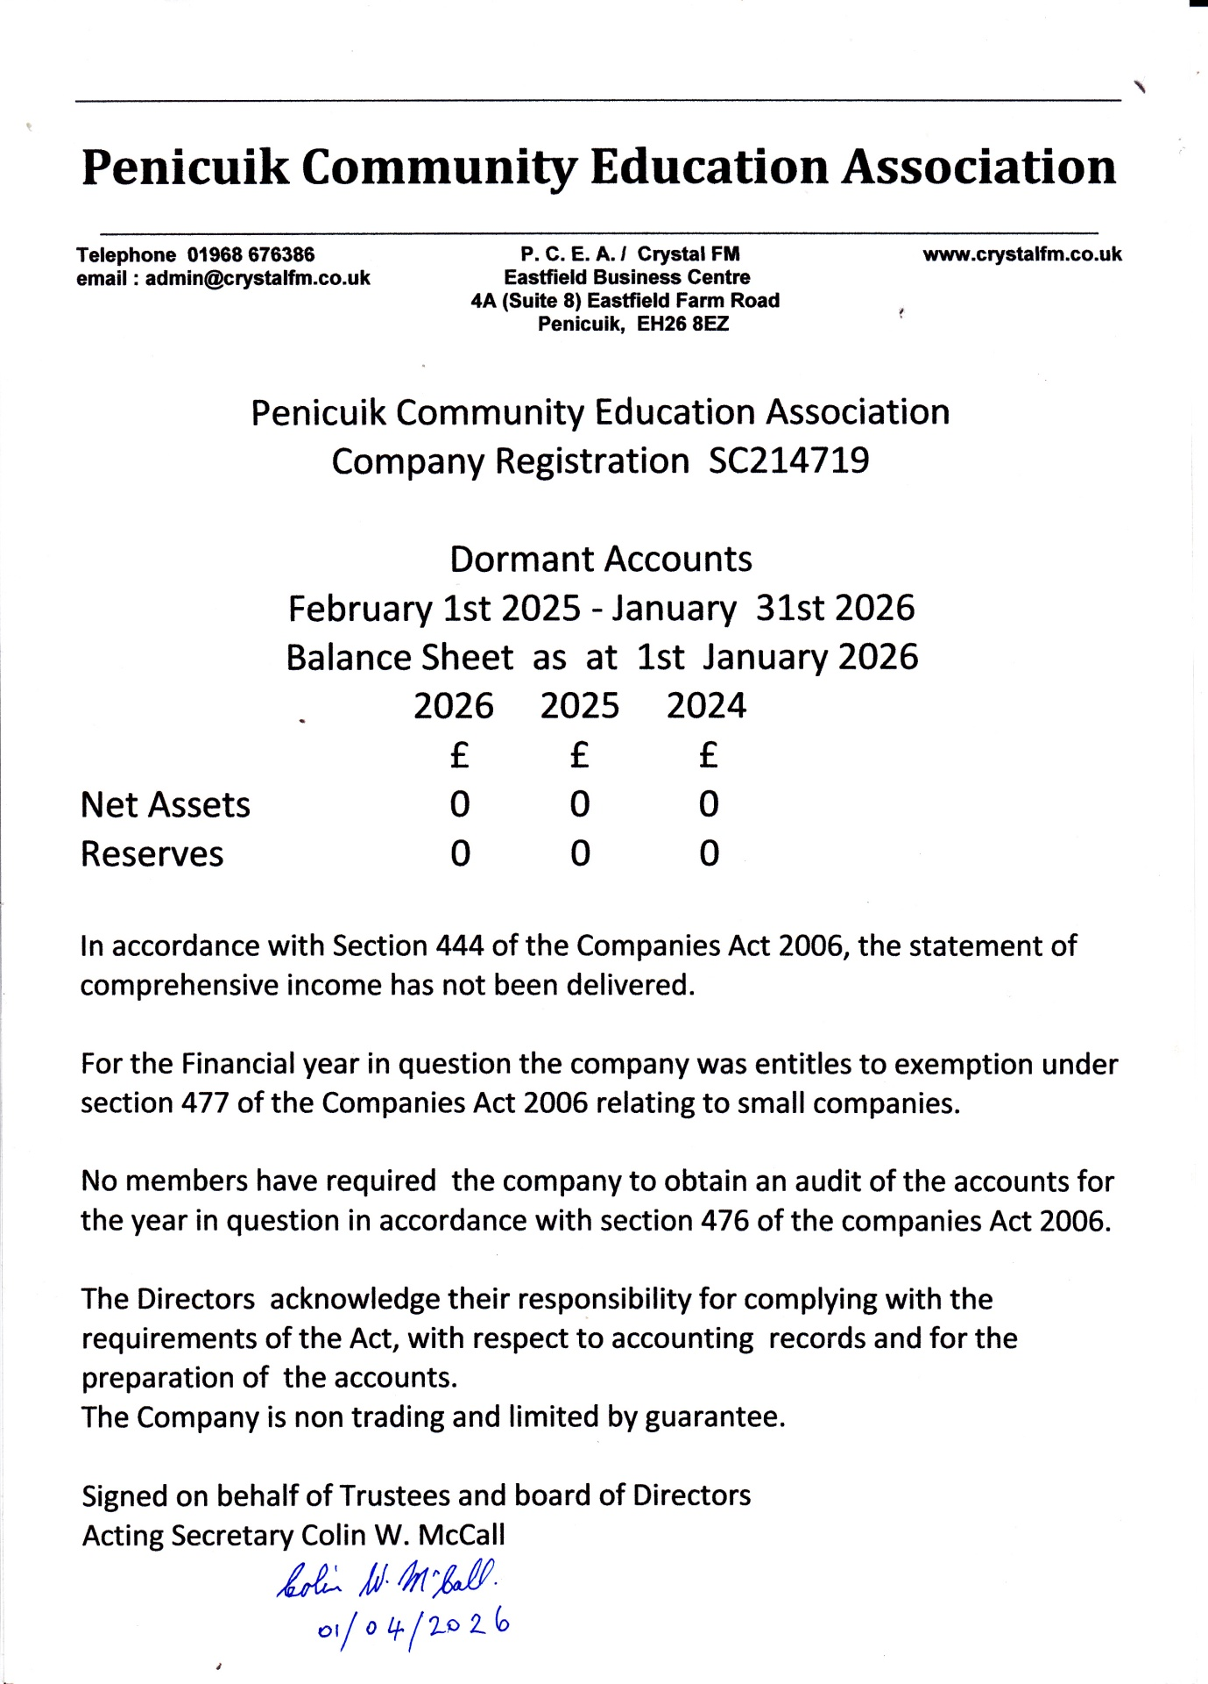

Annual Report 2026
First and foremost P. C. E. A. acts as licence holder for the Community Radio Station Crystal FM. Crystal FM is a facility allowing local residents to participate in community broadcasting and the promotion of community engagement. Volunteering opportunities are provided for local residents as well as in kind training support. Individuals have autonomy in producing their own radio shows and community events , activities, businesses and local organisations are promoted without charge.

