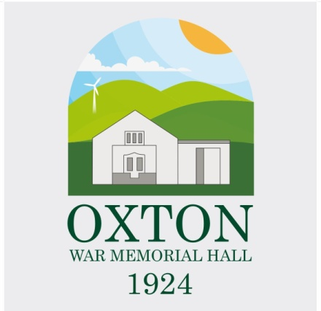

Oxton War Memorial Hall
Trustees’ Annual Report
August 01 2024 to July 31 2025

Charity contact information
Oxton War Memorial Hall
Scottish Charity Number: SC038442
Address: Station Road, Oxton TD2 6PW

Telephone number: +44 7818 263291
Email address oxtonwarmemorialhall@gmail.com
Facebook : Oxton War Memorial Hall https://www.facebook.com/OxtonHall/

Charity Trustees

- David Plain (Chair)
- Margaret Smith (Treasurer/Secretary
- Dr Ian Alexander Sutherland
- Frances Dickman
- Geordie Dun
- Darren Borthwick
- Angus Glennie
- Jill Young
- Lindsay Stuart William Montgomery
- Pamela Anderson (resigned 20/02/2025)
- George Keith (resigned 02/07/2025)

Objectives and activities
Through maintaining Oxton War Memorial Hall for the benefit of the community the Trustees will enable:
- The advancement of education.
- The advancement of arts, heritage, culture and science.
- The advancement of citizenship or community development (including rural regeneration), the promotion of civic responsibility, volunteering, the voluntary sector or the effectiveness of efficiency of charities.
- The promotion of equality and diversity.
This Trustees Annual Report starts a new chapter for the Hall after a significant refurbishment of the main hall and the extension to the memorial Hall building that includes an excellent kitchen, new toilet facilities, a wonderful new meeting room with stunning views and of course an excellent new home for the Oxton Community Shop. The main body of the Hall has benefitted from a new heating system, new lighting, under floor insulation, sound dampening, Guest WiFi and a new wooden floor. All of which positions our cherished hall to continue to support the community for many years to come.

Structure, governance and management
Type of governing document
The Oxton War Memorial Hall Charity is governed through the document: CONSTITUTION of Oxton War Memorial Hall adopted on 21 August 2006.
Trustee recruitment and appointment
This recent period (2024-2025) has see the resignation of two of our Trustees; Pam Anderson and George Keith, both of whom have provided excellent support and skills during their time as Trustees. In particular George’s drive, determination and his keen eye for detail were invaluable in keeping the Hall refurbishment/extension on track.
Three new Trustees have joined our ranks this year: Margaret Smith, Lindsay Montgomery and Jill Young.
Margaret has been integral to everything that goes on at the Hall for many years. From acting as the main point of contact for queries, bookings etc. ensuring the hall is presented in tip top condition for all bookings to looking after the accounts and arranging for the various maintenance tasks that get carried out. Margaret will continue to do everything that she does for the hall, but now as part of the group of Trustees.
Lindsay brings invaluable experience, skills and knowledge to the Trustees. His previous roles with various charities, public bodies and the Scottish Charity Regulator (OSCR) are essential in helping us bringing our governing documents in line with current guidelines and regulations, guiding us in best governance practices and key input to the many activities of the Trustees. Lindsay plays a key role with the Oxton Community Shop//Oxton Community Development Ltd.
Jill has taken on responsibility for publicity/communications as well as championing our efforts on Participation and Environmental Sustainability. Jill currently organises and manages the community After Dinner Club and her passion, enthusiasm and experience has been a valuable addition to the Trustees.
As we move forward with the OWMH we continue to look for other members of the community that can bring new skills, experience and ideas to further improve the services that the Hall provides to the community of Oxton and Channelkirk.
Achievements and performance
In what was the centenary of the Oxton War Memorial Hall, the Hall has remained closed due to the rebuild and refurbishment activities. This project has been the main focus of the Trustees over the past year to ensure the project delivered an excellent, modern space that will continue to serve the community over many more years.
The highlight and culmination of over 13 months of activities, was the formal opening of the redeveloped and enhanced Oxton War Memorial Hall on July 17 2025. Scottish Borders Council supported a Civic Reception to mark this occasion. SBC Convenor Watson McAteer and Councillor David Parker joined us for this landmark event.
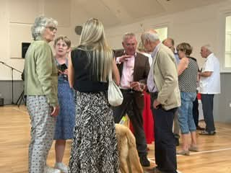
To mark this special occasion for the village, Oxton residents John Gilchrist and Alice Telford who have lived all their lives in the parish, cut the ribbon to formally open the hall.
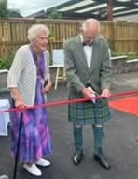
The redevelopment would have been possible without the efforts and support of local organisations and the local community.
The Trustees would like to thank the following groups and people:
- our many funders large and small – it would never have been possible without you and your valued funding.
- Scottish Borders Council for their support throughout the project and for sponsoring the opening ceremony.
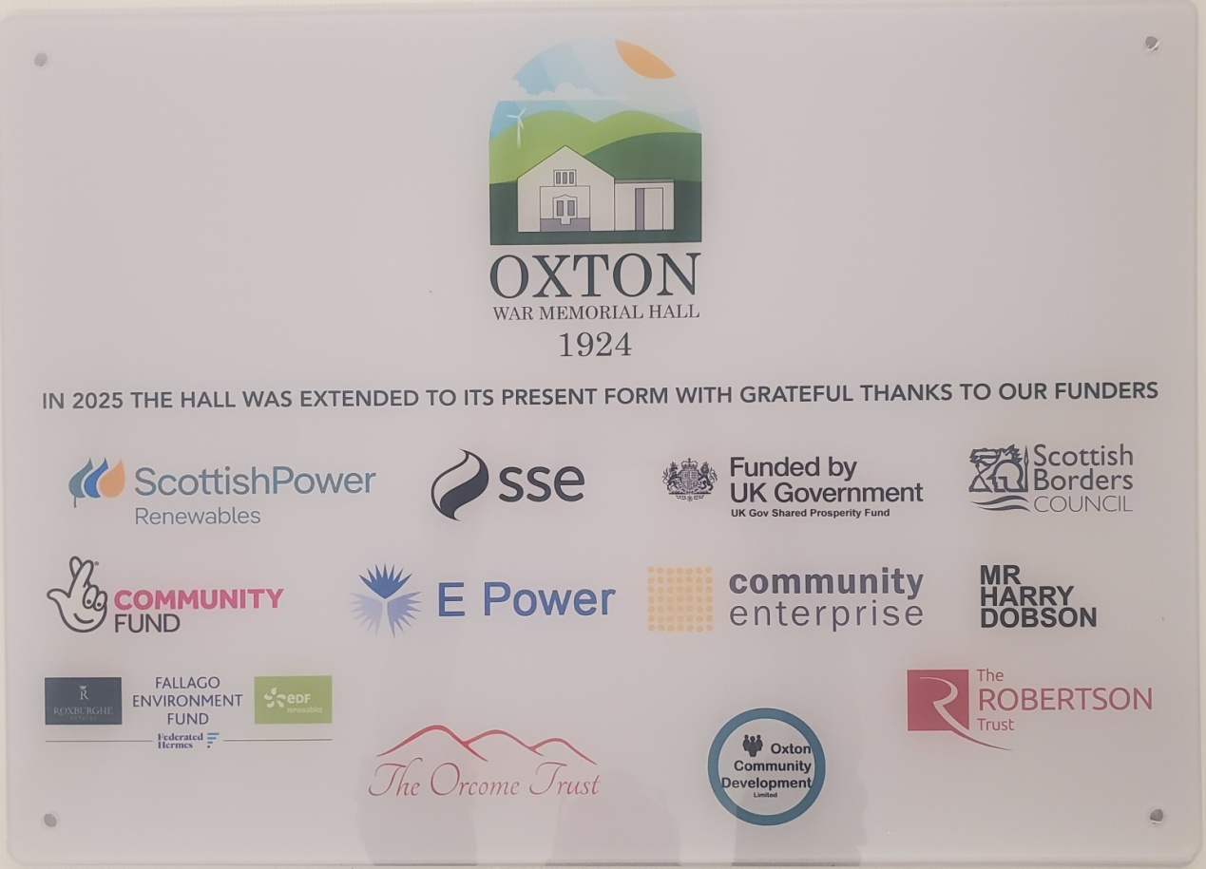
- the architects Lee Boyd who have been involved with the project throughout the past 12 years.
- the builders Campbell and Smith and all the other professional advisers that have been involved.
- last but not least the many residents and businesses that gave of their time and expertise to help us deliver this excellent facility for the community.
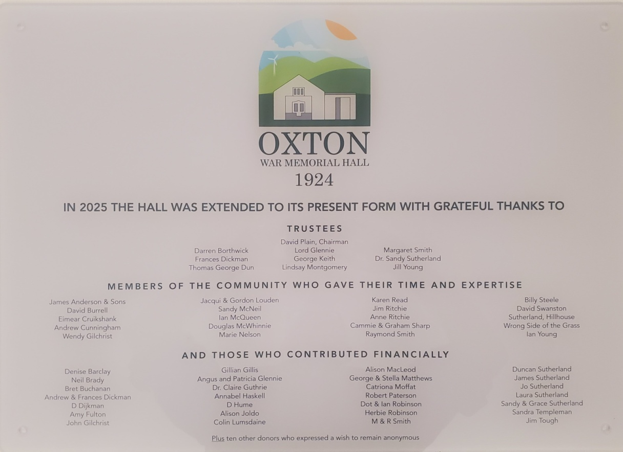

Oxton Community Shop
The move into the new bespoke shop premises has been a significant success. The new premises clearly has made the shop more attractive to shoppers and more comfortable for our vital team of volunteers. There has been an immediate and sustained increase in turnover and footfall, both in the region of 25%. This will contribute to the shop’s aim of sustaining this vital community resource.
Jim Tough – Chair OCDL/Oxton Community Shop
The re-opening of the hall has seen almost all of our previous groups and organisations return to the Hall for this year, with the welcome addition of some new regular classes and activities.
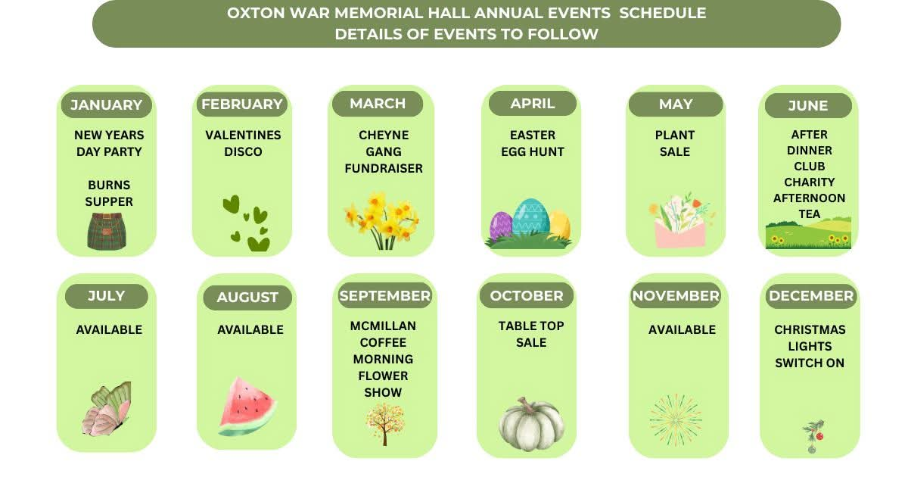
At present 7 fitness classes take place in the hall each week” and that 3 Community Groups (Wednesday Club, Coffee & Chat & Oxton After Dinner Club) use the hall on a regular basis. Since refurbishment it is also being used by others from outside the parish.
The Trustees have been conducting surveys on awareness and participation of the Hall and have setup a Suggestions Box in the hall in order to better address the wants and needs of the community.
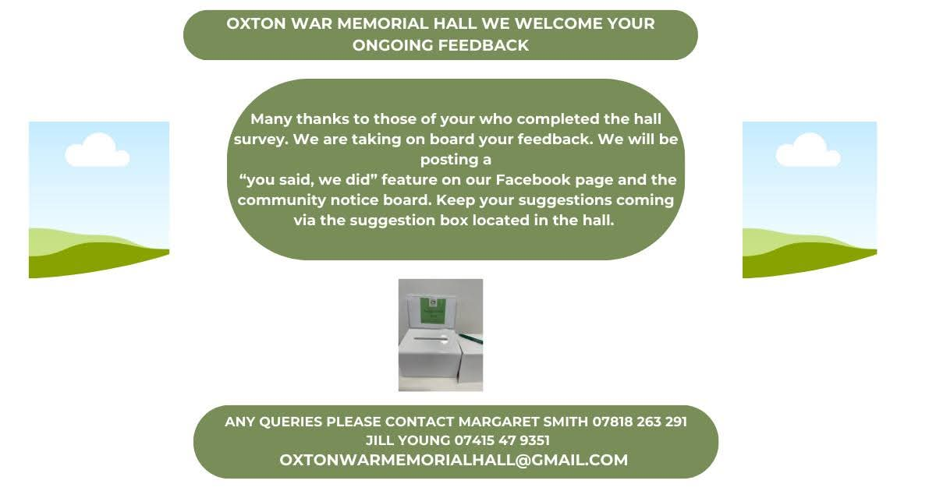
We have received excellent feedback and suggestions from the community and have already put some of these in place. The Trustees will look to continue and expand on the surveys for the coming year.
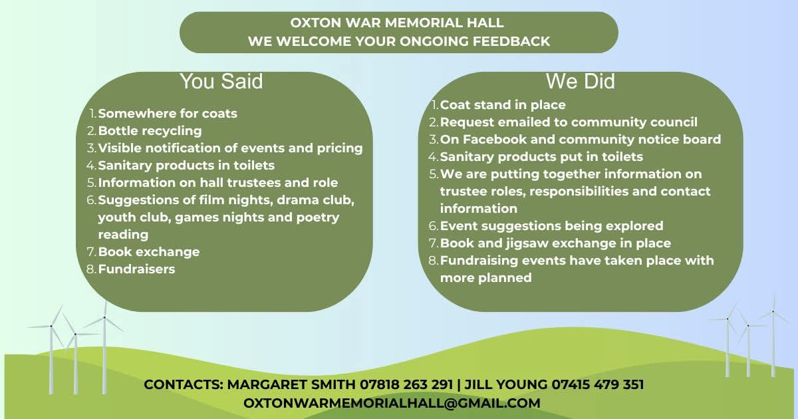
Financial review
This has been a very busy year for the Hall Trustees with our focus being on the rebuild and refurbishment activities that have been ongoing throughout this period. The Hall’s finances are dominated by the influx of grant funding received from a wide range of funders and benefactors and the subsequent management of invoices and payments from our construction partners and specialists. There has been almost no community activity throughout this period but that is now starting to pick up as the Hall has returned to regular use.
The Hall’s finances continue to be generally healthy and the trustees are continually monitoring the general income and expenditure to ensure the hall remains on a good financial footing.
Due to the income levels from grants received, this years accounts are prepared on fully accrued basis instead of the usual receipts and payments model.
Further details of the Hall’s accounts can be seen on the OSCR website: https://www.oscr.org.uk/about-charities/search-the-register/charity-details?number=SC038442
2024 Account Summary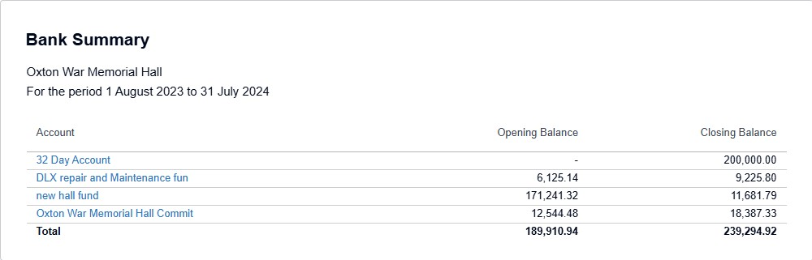
2025 Account Summary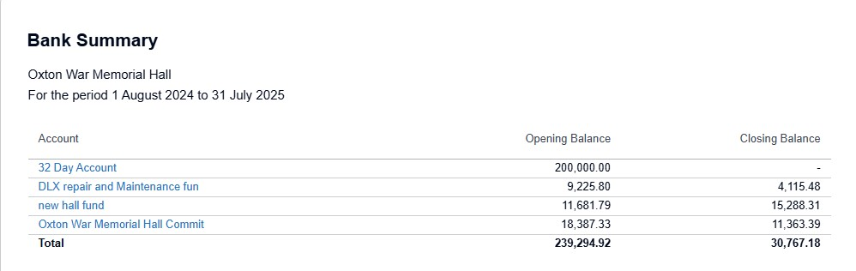

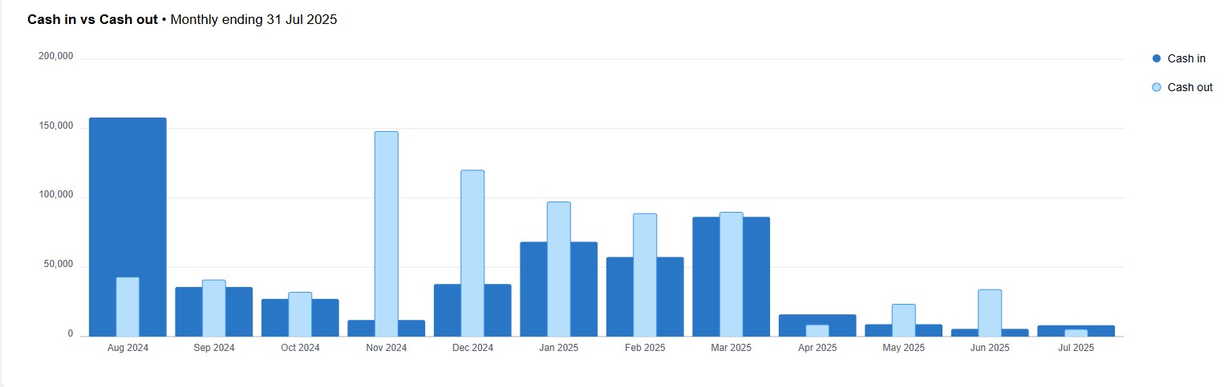
Future plans
The Trustee’s event planning group is planning a number of events throughout the next year and also looking at ways to increase the use of the hall through new regular classes and bookings as well as increased one off hall hire/events.
In terms of Hall infrastructure, the Trustees continue to look at appropriate maintenance activities as well as seeking out hall operational efficiencies.
The Trustee’s are anticipating and increase in electricity usage and costs and will be investigating opportunities to reduce our carbon footprint through additional solar panels and smart controls.
Additional information
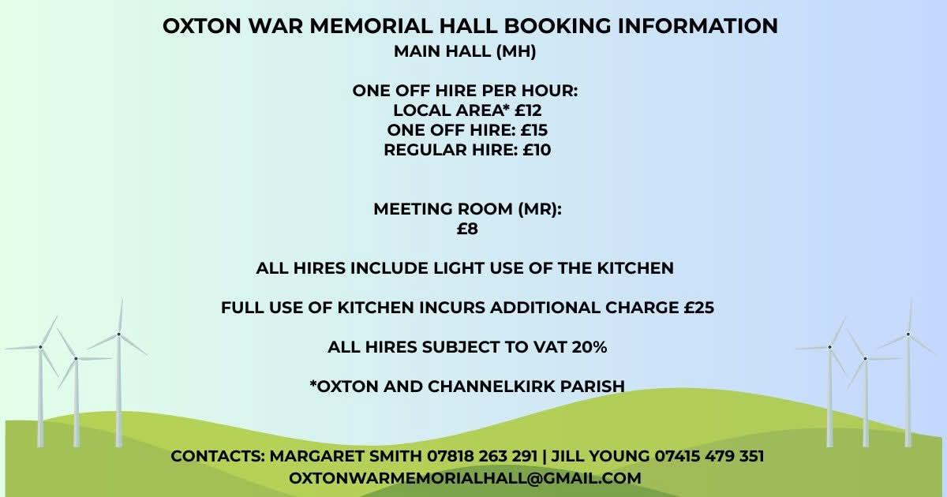
Declaration
Signed on behalf of the charity trustees:
David Plain

David Plain
Print name
Chairperson
Designation
XX April 2026
Date

