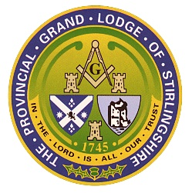
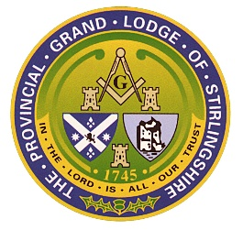
PROVINCIAL GRAND LODGE

OF

STIRLINGSHIRE
(www.pgls.co.uk)

Provincial Grand Master Provincial Grand Treasurer Provincial Grand Secretary
Brother Gordon W.S Sewell Brother Robert G. Stewart Brother Ronald Hay
54 Old Redding Road Davaar 13 Airthrey Road 20 Pearson View
Laurieston Stirling Sauchie
FK3 9EE FK9 5JP FK10 3LW
Mobile 07758597707 Mobile 07919211768 Mobile 07549944479
Gordon.sewell@blueyonder.co.uk davaar13@aol.com ronnie.hay391@gmail.com
__________________________________________________________________________________________
2024 Trustees Report on Benevolent
Charity Details
Name: Provincial Grand Lodge of Stirlingshire Benevolent Fund SC013658
Correspondence address: Davaar 13 Airthrey Road Stirling FK9 5JP
Charity Trustees and Addresses
Provincial Grand Master Provincial Grand Treasurer Provincial Grand Secretary
Brother Stuart Stirling Brother John Gwynne Brother Robert Hunter
24 Berryhill Crescent 14 Randolph Gardens 186 Carseview
Grangemouth Denny Tullibody
FK3 0DJ FK6 5DB FK10 2ST
Mobile 07888855162 Mobile 7884080725 Mobile 07752 440552
stirling.stuart61@gmail.com gwynne@blueyonder.co.uk robertfhunter1303@gmail.com

Operations
Charity status: Active
Constitutional Form: Unincorporated association
Main Operating Location: Stirlingshire
Purposes: The prevention or relief of property, the relief of those in need by reason of age, ill health, disability, financial hardship, or other hardship.
Beneficiaries: Older people, People with disabilities or health problems, no specific group or for the community, other charities/voluntary bodies
Activities: It makes grants, donations, loans, gifts or pensions to individuals, it makes grants, donations or gifts to organisations

Financial Report
Total Income: £390
Donations Received: £150
Total Expenditure: £175.50 in respect of almoner’s expenses and bank charges
Total Funds: The closing balance of the Fund at the 31st December 2025 was £19096.15

Robert G. Stewart FCMA
Independent Examiner

