Trustees Annual Report and Accounts for the Year ending 30th September 2024

Scottish Charity No SC 044926

Current Trustees:-
Andrew Knowles-Brown
Jacqueline Knowles-Brown
Jemma Knowles-Brown

Contact Address:-
Andrew Knowles-Brown, Crookedstane, Elvanfoot, Biggar, Lanarkshire, ML12 6RL.

Status:-
The Talon Trust is a Charitable Unincorporated Association

Objects:-
The advancement through science and education, the knowledge, culture, conservation, welfare and environmental protection of birds of prey and related subjects.

Activities:-
In the report year the activities were in setting up financial and administration structures.

Trustees remunerations and expenses:-
The Trustees did not receive any remuneration or expenses during the year.

Reserves:-
The Talon Trust has £1260.01 in reserves at the end of this financial year.

Approved by the Trustees and signed on their behalf.

Andrew Knowles-Brown

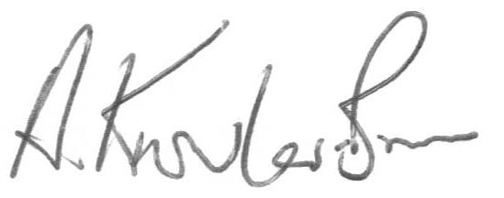

Date 27th June 2025

