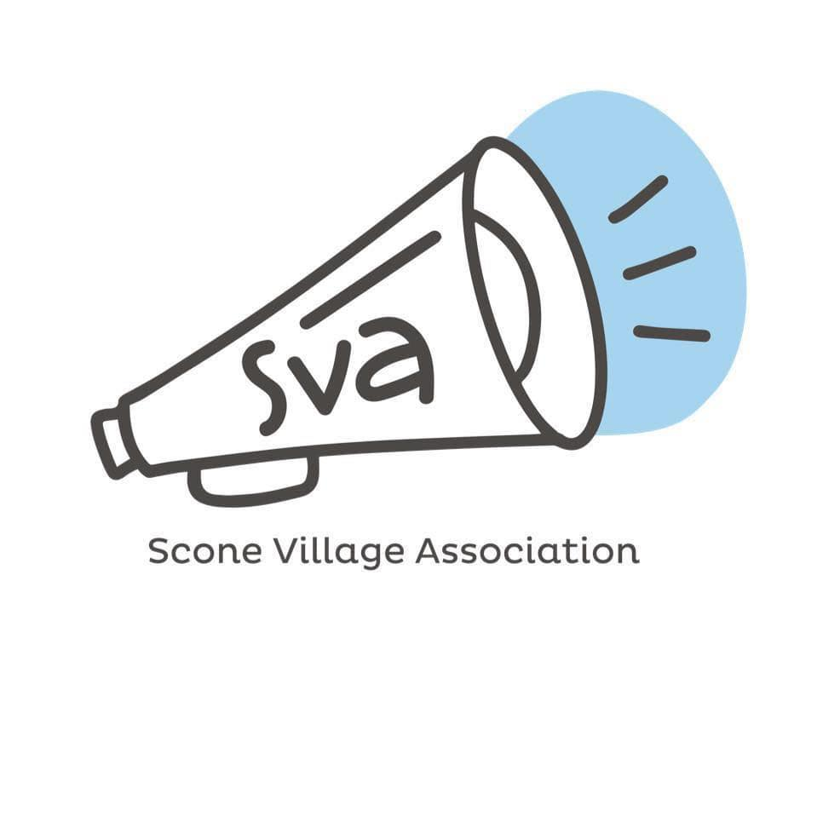
Annual Report and Financial Statements
for
Year Ended 31st March 2026
Scottish Charity Number SC 036081

SCONE VILLAGE ASSOCIATION
TRUSTEES’ ANNUAL REPORT YEAR ENDED 31st MARCH 2026
Scottish Charity Number SC 036081

The trustees present the annual report and accounts for Scone Village Association for the year ended 31st March 2026

Reference and Administrative Information

Current Trustees
Julie Livingstone (Chair)
Suzanne Westwood (Vice-Chair & Secretary)
Kevin Gates (Treasurer)
Margaret McMillan
Lewis Simpson
John Flood
Gaynor Hood

Contact address
Julie Livingstone
10 Queens Road
Scone,
PH2 6QJ

Independent Examiner
Marian C. Forgan Dip Com.,
7 Kenworthy Avenue,
Scone

Bankers
Royal Bank of Scotland,
12 Dunkeld Road,
Perth,
PH1 5RB

Bank of Scotland,
38 St Andrew Square,
Edinburgh
EH2 2YR

SCONE VILLAGE ASSOCIATION
TRUSTEES’ ANNUAL REPORT: YEAR ENDED 31st MARCH 2026

Governing Document
The Association is a charitable unincorporated organisation, and its purposes and administration are set out in our Constitution, which was adopted on 3rd November 2004 and last amended at the AGM on 24th May 2022.

Recruitment and appointment of Trustees
All the Association’s trustees are appointed or reappointed by the members at our annual general meeting, which is held in May each year.

Organisational Structure
Membership of the Association is open to all persons living in Scone and District.
The trustees meet five times in a year or more frequently if required. Certain responsibilities are delegated to Committees (e.g., day to day running of Destiny Newsletter and Ball Court).

Charitable purposes
The objects of the Association are to promote the benefit of the inhabitants of Scone and its environs, by advancing education, and to help provide facilities in the interest of social welfare for recreation and other leisure time activities. In furtherance of its objects, the Association seeks to provide opportunities for people of all ages to share experiences and develop community identity.

Activities and Achievements
Scone Ball Court
The Scone Ball Court continues to be our primary source of income. We are especially grateful to John Flood for managing bookings and keeping us updated on any maintenance needs. Our strong partnership with Scone Thistle Community Club remains central to the court’s regular use, particularly throughout the winter months. We also continue to work closely with Perth and Kinross Council to address infrastructure matters, including fencing and floodlighting. When not booked for group activities, the court is open daily for community use.

Destiny Magazine
Our bi-monthly village magazine, Destiny, remains a cherished part of local life, with around 500 copies sold per issue across five outlets. We were delighted to welcome new advertisers this year, and Mike is always keen to involve fresh contributors. Warm thanks go to Mike Moir and Maggie Ewens for their continued dedication to producing and distributing the magazine.

Defibrillator at the RDM Institute
We continue to oversee the defibrillator located at the RDM Institute, ensuring it remains fully accessible at all times in the event of an emergency.

Table Tennis
Table tennis returned to the Institute in late September. We extend our sincere thanks to Paulo Pinto for his commitment to running the group, especially following his recent operation. We continue to offer free places for under-18s and full-time students, and in January we purchased a new table tennis table, which has been warmly welcomed by players.

Singing for Fun
This popular group resumed in September at Scone New Church Hall on Balformo Road. New participants are always welcome. Our thanks go to Julia Robertson, whose enthusiasm and leadership make the sessions such a pleasure.

Facebook and Community Engagement
Our Facebook page remains a key platform for sharing updates and promoting local events. We are pleased to have grown our following to 1,400, and we greatly appreciate the continued engagement from the community.

Christmas Lights
We were delighted to expand our Christmas light display in 2025, adding two new motifs designed by pupils at RDM Primary School: Santa Got stuck down the Chimney and Rudolph the Red-Nosed Reindeer. This brings our total to 21 motifs and 66 braids. Our Christmas Lights Coffee Morning on 16 November was a wonderful community occasion. We extend heartfelt thanks to all volunteers, local businesses, and residents who contributed to its success. Funds raised support the maintenance and future growth of the festive display. We are also grateful for generous donations from Persimmon Homes, The Hub Café Committee, Premier Properties Perth, and Pankhurst Decorators Ltd.

Supporting Local Activities
We were proud to once again support Scone Thistle Community Club with a donation to help establish new groups under the Scone Thistle banner. We also contributed £500 to help establish the new and much-welcomed Scone Community Orchard Association. We remain committed to supporting worthwhile local initiatives and welcome suggestions for future projects.

We are very sad to report the death of one of the group’s founders, Doug Sutherland in August 2025. He will be very much missed by us all.

Financial Review

The Scone Village Association showed a surplus of £731 for the year.
Funds came from ball court income and a successful coffee morning. The ball court continues to be a popular venue for the community and external hirers. In the summer months the surface is open to all in the village.
Local good causes benefitted from donations of £1550. Main recipients were Scone Thistle Community Club and Scone Orchard Association
Destiny magazine continues to be a popular newsletter for the village, carrying local articles written by volunteers. Each issue achieves an average circulation of 500 copies. Total income from advertising and sales was £5915, and the cost of printing was £7195. The team continue to attract local advertisers to boost revenue.
Table tennis and the singing group are increasingly popular. Both continue to be subsidised
The annual coffee morning held to raise funds for the Christmas lights raised £1352 net. Thanks to all organisers and donors.

Reserves Policy
The Association’s total Unrestricted Funds on 31st March, 2026 stood at £33740, split between the Ball Court Maintenance Fund of £15,000, the General Fund of £13740 and the Christmas Lights Reserve £5,000.
As the Association does not have any employees, our unrestricted funds are considered by the trustees to be adequate, and in accordance with their policy of having approximately 12 months’ expenditure in reserve.
The Association’s assets are listed in the Statement of Balances. SCONE VILLAGE ASSOCIATION

Charity Number SC 036081
REPORT OF THE INDEPENDENT EXAMINER, YEAR ENDED 31st MARCH, 2026

I report on the accounts of the charity for the year ended 31st March, 2026, which are set out on pages 6 to 8.

Respective responsibilities of trustees and examiner

The charity’s trustees are responsible for the preparation of the accounts in accordance with the terms of the Charities and Trustee Investment ( Scotland ) Act 2005 and the Charities Accounts ( Scotland ) Regulations 2006.

The charity trustees consider that the audit requirement of Regulation 10(1) (d) of the Accounts Regulations does not apply. It is my responsibility to examine the accounts as required under section 44(1) (c ) of the Act and to state whether particular matters have come to my attention.

Basis of independent examiner’s statement

My examination is carried out in accordance with Regulation 11 of the Charities Accounts ( Scotland ) Regulations 2006. An examination includes a review of the accounting records kept by the charity and a comparison of the accounts presented with those records. It also includes consideration of any unusual items or disclosures in the accounts and seeks explanations from the trustees concerning any such matters. The procedures undertaken do not provide all the evidence that would be required in an audit, and consequently I do not express an audit opinion on the view given by the accounts.

Independent examiner’s statement

In the course of my examination, no matter has come to my attention

- which gives me reasonable cause to believe that in any material respect the requirements :

to keep accounting records in accordance with Section 44 (1 ) (a ) of the 2005 Act and Regulation 4 of the 2006 Accounts Regulations, and

to prepare accounts which accord with the accounting records and comply with Regulation 9 of the 2006 Accounts Regulations have not been met, or

- to which, in my opinion, attention should be drawn in order to enable a proper understanding of the accounts to be reached.

Date :
Marian C. Forgan Dip Com
7 Kenworthy Avenue,
Scone

