Charity No. SC015021

4th BRAID SCOUT GROUP

REPORT AND ACCOUNTS

For the 12 months ended 31 March 2026

4th BRAID SCOUT GROUP

ANNUAL REPORT AND ACCOUNTS

For the 12 months ended 31 March 2026

Contents Pages

Trustees’ report 3 - 5

Independent examiner’s report to the Trustees 6

Receipts and payments account 7

Statement of balances 8

Notes to the accounts 9

4th BRAID SCOUT GROUP

TRUSTEES’ REPORT

Introduction

The Trustees present their annual report with the accounts of the charity for the twelve months ended 31 March 2026. These have been prepared in accordance with the Trust Deed, the Charities and Trustee Investment (Scotland) Act 2005 and the Charities Accounts (Scotland) Regulations 2006.

Charity Information

TRUSTEES
Duncan Macniven – Chairman
James McTernan - Treasurer
Stuart Sanders
Stuart Aitken
Steve Stewart (resigned June 2025)
Emily Hargreaves
Steven Brocklehurst
Duncan Dalzel-Job
Alex Keightley (wef 2.2.2026)

PRINCIPAL ADDRESS
c/o James McTernan
4th Braid Scout Group
Greenbank Parish Church
Braidburn Terrace
Edinburgh
EH10 6ES

REGISTERED CHARITY NUMBER
SC015021

INDEPENDENT EXAMINER
Steven Corbett (Retired CA)
22 Greenbank Loan
Edinburgh
EH10 5SJ

BANKERS
Bank of Scotland
426 Morningside Road
Edinburgh
EH10 5QF

and

Santander Bank
31 Hanover Street
Edinburgh
EH2 2EB

4th BRAID SCOUT GROUP

TRUSTEES’ REPORT (cont’d)

FOR THE 12 MONTHS ENDED 31 MARCH 2026

Structure, governance and management

Constitution
The Group’s governing documents are those of the Scout Association. They consist of a Royal Charter, which in turn gives authority to the Bye Laws of the Association and The Policy, Organisation and Rules of The Scout Association. The Group is a trust established under its rules common to all Scouts.

Trustees
The Trustees are appointed in accordance with the Policy, Organisation and Rules of The Scout Association. Details of the Trustees who served during the year are listed on page 3.

Risk and Internal Control
The Group has in place systems of internal controls which are designed to provide reasonable assurance against material mismanagement or loss. These include the requirement for the signatures of two of the Trustees on all payments from the Treasurer’s account(s), monitoring of expenses and comprehensive insurance policies covering normal insurable risks.

Objectives and Activities
The objectives are set out in its governing document and are as a unit of The Scout Association. The Aim of The Scout Association is to promote the development of young people in achieving their full physical, intellectual, social and spiritual potentials, as individuals, as responsible citizens and as members of the local, national and international communities. The method of achieving this Aim is by providing an enjoyable and attractive scheme of progressive training and fun events based on the Scout Promise and Law and guided by adult leadership.
Details of significant activities for achieving objectives:
- Weekly meetings of Beavers, Cubs and Scouts throughout school terms including games, crafts and skills and indoor and outdoor skills to achieve merit badges. Participation in competitions involving other Groups at District level.
- Regular outings locally, ski week-ends, winter camps, week-end camps, indoor rock climbing, canoeing and hiking for the Scouts, winter and weekend camps for both Cubs and Scouts at district level. Annual week-long summer camp for Scouts. Occasional expeditions for Scouts at national and international level.

Achievements and Performance
Our main achievements during the year were:
- Group numbers were circa 120 and leaders, some of the leaders on rota. All Leaders have updated and / or completed extensive training and safety modules and most of the Leaders hold a Certification for first aid including covering outdoor activities.
- While there is some use of the Internet, activities are principally indoor activities, completion of skills and crafts for merit badges and outings including hikes, hill walking, sports, indoor climbing walls and a range of fun events during the year.
- Successful organisation for the Scouts of ski week-ends, several week-end camps, hikes and the annual summer camp. Outings and other activities and participation in District competitions. Use of the Bonaly Scout centre for all sections and overnight camps for Cubs and Beavers. Badge work for Cubs and Beavers. An award of King’s Scout for a former Scout, now an Explorer with our partnership Explorer Unit.
- Participation with other groups in activities and also representing Scouting in the Youth Service in the local Church and organising a carol party in the Church. Successful fundraising during the year from the Jumble Sale and the sale of Christmas Trees.
- These activities and fund raisers will all continue for the next year. In addition, 33 members and Leaders will also attend a Jamboree in Denmark along with our Explorer partner Unit.
4th BRAID SCOUT GROUP

TRUSTEES’ REPORT (cont’d)

Financial Review

Financial Information

Full details of the activities of the Group during the year can be found within the accounts as detailed on pages 7 to 9.

Membership and subscription payments remained strong although costs across the board continue to rise including, vehicle rental costs, insurance and rent and now Bank charges. The key fund-raising activity, the annual Jumble Sale, was again highly successful and the Group also undertook a very successful sale of Christmas trees. The Fund raising and many activities, in particular summer, winter and week-end camps were very well supported and we were able to sponsor a number of members, who have financial issues, for these outings

There was a surplus for the year of £27,259. Total funds held increased from £19,103 to £46,362 as at 31 March 2026. Of this £12,650 are restricted funds representing payment by members for the Scout Group Jamboree trip to Denmark in the Summer of 2026. This is considered an excellent outcome. Additionally, as the principal fund raiser, the 2026 Jumble Sale followed just after the financial year end the Group are in receipt of substantial funds from that event. A Legacy of £10,000 was also received and with substantial reserves and the Legacy the opportunity will be taken to upgrade and replace equipment.

Procedures continue to be monitored and worked on to ensure the Treasurer receives receipts in a timely manner. The Group now have a financial management system (Online Scout Manger) so improving controls and administration.

Reserves Policy

The Group’s policy on reserves is to hold sufficient resources to continue the charitable activities of the Group should future income from fundraising activities fall short.

The Group has a highly active programme and is therefore, in addition to subscriptions, reliant on the fund raising to support its many activities. That said activities can be adjusted if fund raising falls short.

The Trustees consider that the Group should hold a minimum sum equivalent to the committed annual operating costs which largely comprises the rent for the use of the Halls, Training and Insurance costs and a contingency budget for emergency expenditure. This is estimated at £7,000 and the Group held reserves of £33,712 at the year end. Central Scouting levies are largely covered by subscription income.

Signed on behalf of the charity’s Trustees

James McTernan
Treasurer

May 2026

INDEPENDENT EXAMINER’S REPORT TO THE TRUSTEES ON THE ACCOUNTS OF
4th BRAID SCOUT GROUP

I report on the accounts of the charity for the 12 months ended 31 March 2026 which comprise the Receipts and Payments Account, the Statement of Balances and the associated Notes to the Accounts.

This report is made to the Trustees, as a body, in accordance with the terms of my engagement. My work has been undertaken to enable me to report my opinion as set out below and for no other purpose. To the fullest extent permitted by law, I do not accept or assume responsibility to anyone other than the Charity and the Trustees, as a body, for my work or for this report.

Respective responsibilities of Trustees and independent examiners
The charity’s trustees are responsible for the preparation of the accounts in accordance with the terms of the Charities and Trustee Investment (Scotland) Act 2005 (the Act) and the Charities Accounts (Scotland) Regulations 2006 (the Regulations). The charity trustees consider that the audit requirement of Regulation 10(1)(d) of the Regulations does not apply. It is my responsibility to examine the accounts as required under section 44(1)(c) of the Act and to state whether particular matters have come to my attention.

Basis of examiner’s statement
My examination is carried out in accordance with Regulation 11 of the Regulations. An examination includes a review of the accounting records kept by the charity and a comparison of the accounts presented with those records. It also includes consideration of any unusual items or disclosures in the accounts and seeks explanations from the trustees concerning any such matters. The procedures undertaken do not provide all the evidence that would be required in an audit, and consequently I do not express an audit opinion on the view given by the accounts.

Independent examiner’s statement
In the course of my examination, no matter has come to my attention:

- which gives me reasonable cause to believe that in any material respect the requirements:
• to keep accounting records in accordance with Section 44(1)(a) of the Act and Regulation 4 of the Regulations, and
• to prepare accounts which accord with the accounting records and comply with Regulation 9 of the Regulations have not been met.

In my opinion attention needs to be drawn to the following matter in order to enable a proper understanding of the accounts to be reached:

- In the Santander bank statements, there were eleven payments to Amazon with a total value of £238 which have been allocated as Scout expenditure for which there were no receipts. Well over half of all items of expenditure in the Santander bank statements did not have receipts.

Steven Corbett (Retired CA)
22 Greenbank Loan
Edinburgh EH10 5SJ

May 2026

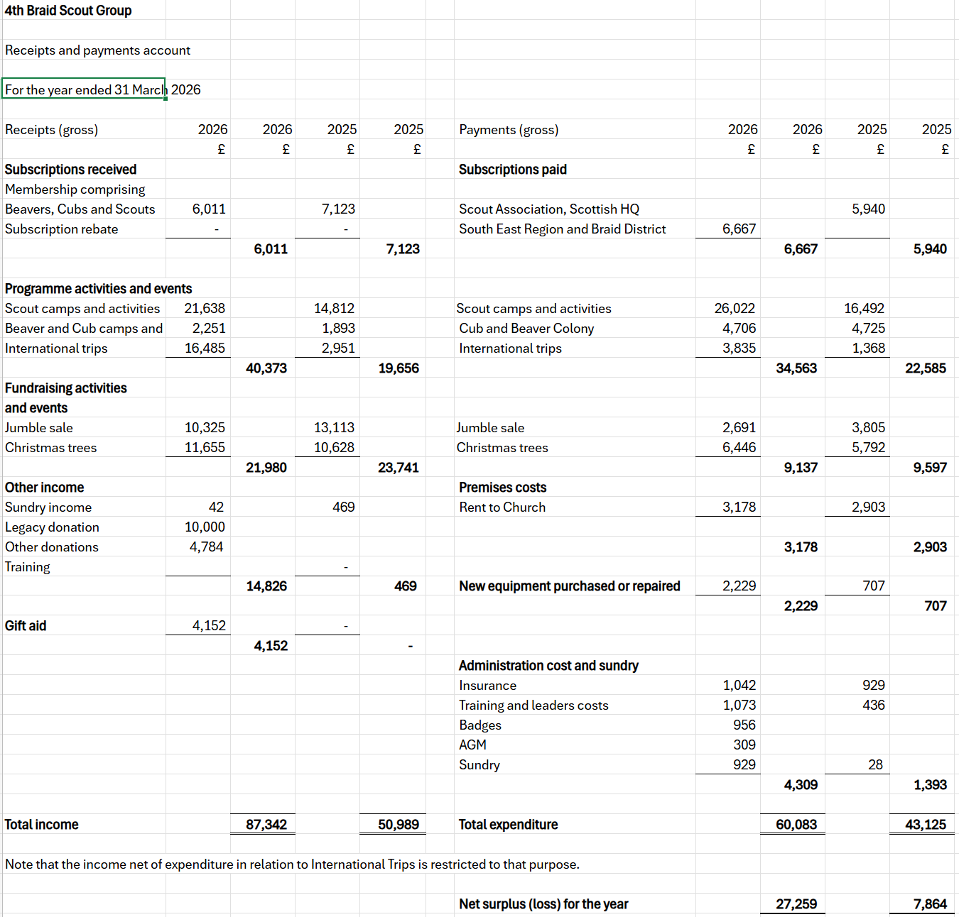

STATEMENT OF BALANCES

As at 31 March 2026

 | 2026 |  | 2025
 | £ |  | £
Bank and cash in hand
Treasurer’s Account | 45,847 |  | 17,177
Expense/Float Account | 514 |  | 1,926
 |  | 46,362 |  | 19,103
Represented by
Opening balances | 19,103 |  | 11,240
Surplus (loss) for the year | 27,259 |  | 7,863
Closing balances |  | 46,362 |  | 19,103
Reserves
Unrestricted reserves | 33,712 |  | 19,103
Designated reserves | 12,650 |  | 0
Total reserves |  | 46,362 |  | 19,103

Approved by the Trustees on 2026 and signed on their behalf by the following: -

James McTernan
Treasurer

th May 2026

The notes on page 9 form part of these accounts

4th BRAID SCOUT GROUP

NOTES to the ACCOUNTS

For the 12 months ended 31 March 2026

- Statement of Accounting Policies

Accounting Convention
The accounts have been prepared in accordance with the Charities and Trustee Investment (Scotland) Act 2005 and the Charities Accounts (Scotland) Regulations 2006.

Funds structure
Unrestricted funds comprise those funds which the Trustees are free to use for any purpose in furtherance of the charitable objects. Designated funds are those funds held for the Scout Group Jamboree trip to Denmark in the summer of 2026.

Governance costs
Governance costs are those costs associated with meeting the constitutional and statutory requirements of the charity. The only such items during the year were in connection with the independent examination which was carried out free of charge.

- Trustees’ Remuneration

No Trustees received any remuneration or expenses acting in their capacity as Trustees from the charity during the year.

- Related Parties

There were no transactions with related parties during the year.

