Dysart Trust
Trustees’ Annual Report and Accounts for the year ended 31 December 2025
Scottish Charity Number SC033137

Current Trustees

Mr. Kenneth P Robertson
Mrs Sheena Graham
Mrs Gillian Baillie

Contact address
c/o Gillian Baillie 5 Rectory Lane KY1 2TP

Recruitment and appointment of Trustees

All of the Association’s Trustees are appointed by the members at our annual general meeting which is held in January each year.

Governing document

The Trust is a charitable unincorporated association and the purposes and administration
arrangements are set out in our constitution.

Charitable purposes

The object of the Trust is to collect, preserve and generally make known the history and working of Dysart. To administer the premises owned by Fife Council known as Dysart Town Hall, Tolbooth and St Serf’s Tower all situated within Dysart and to watch over future development of Dysart and to make representations for this purpose.

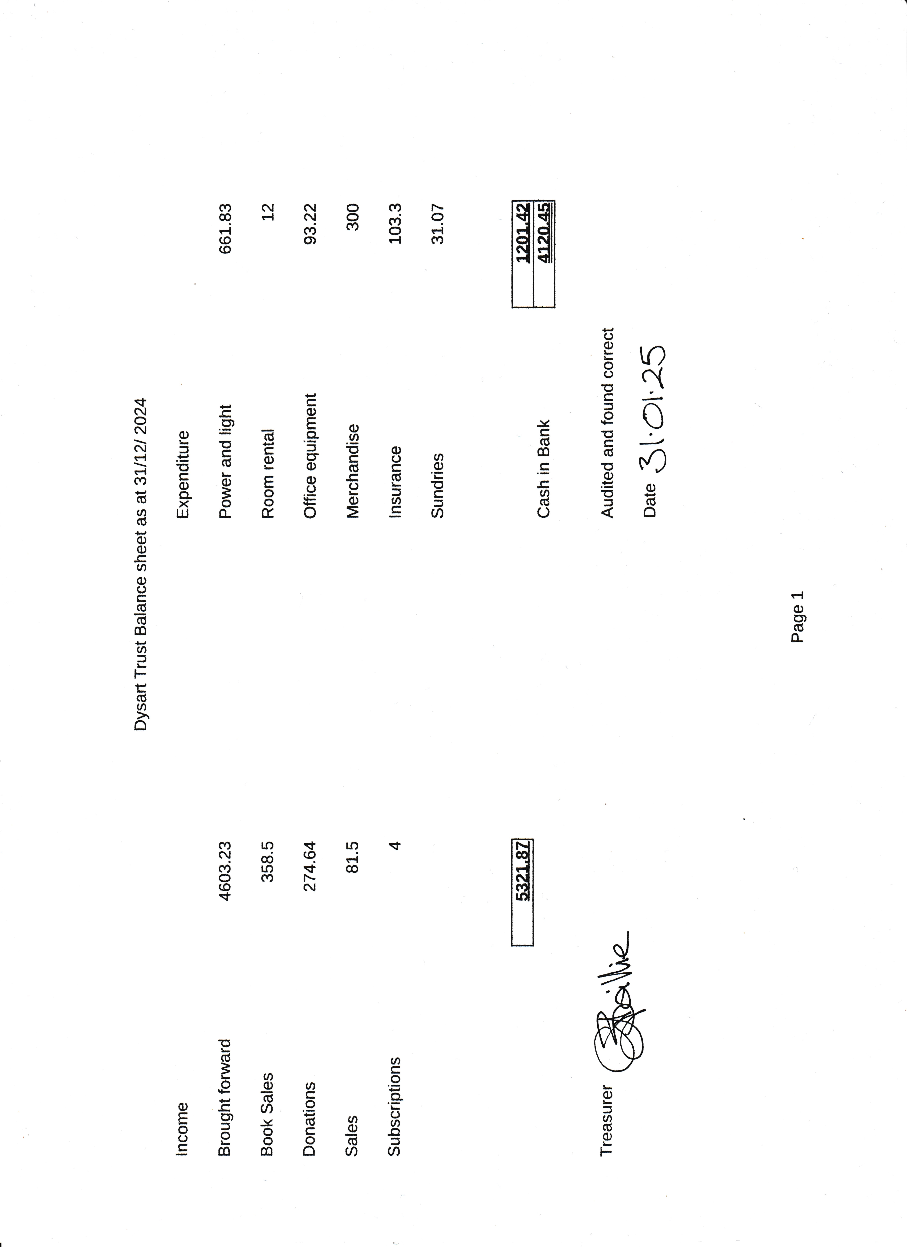
x

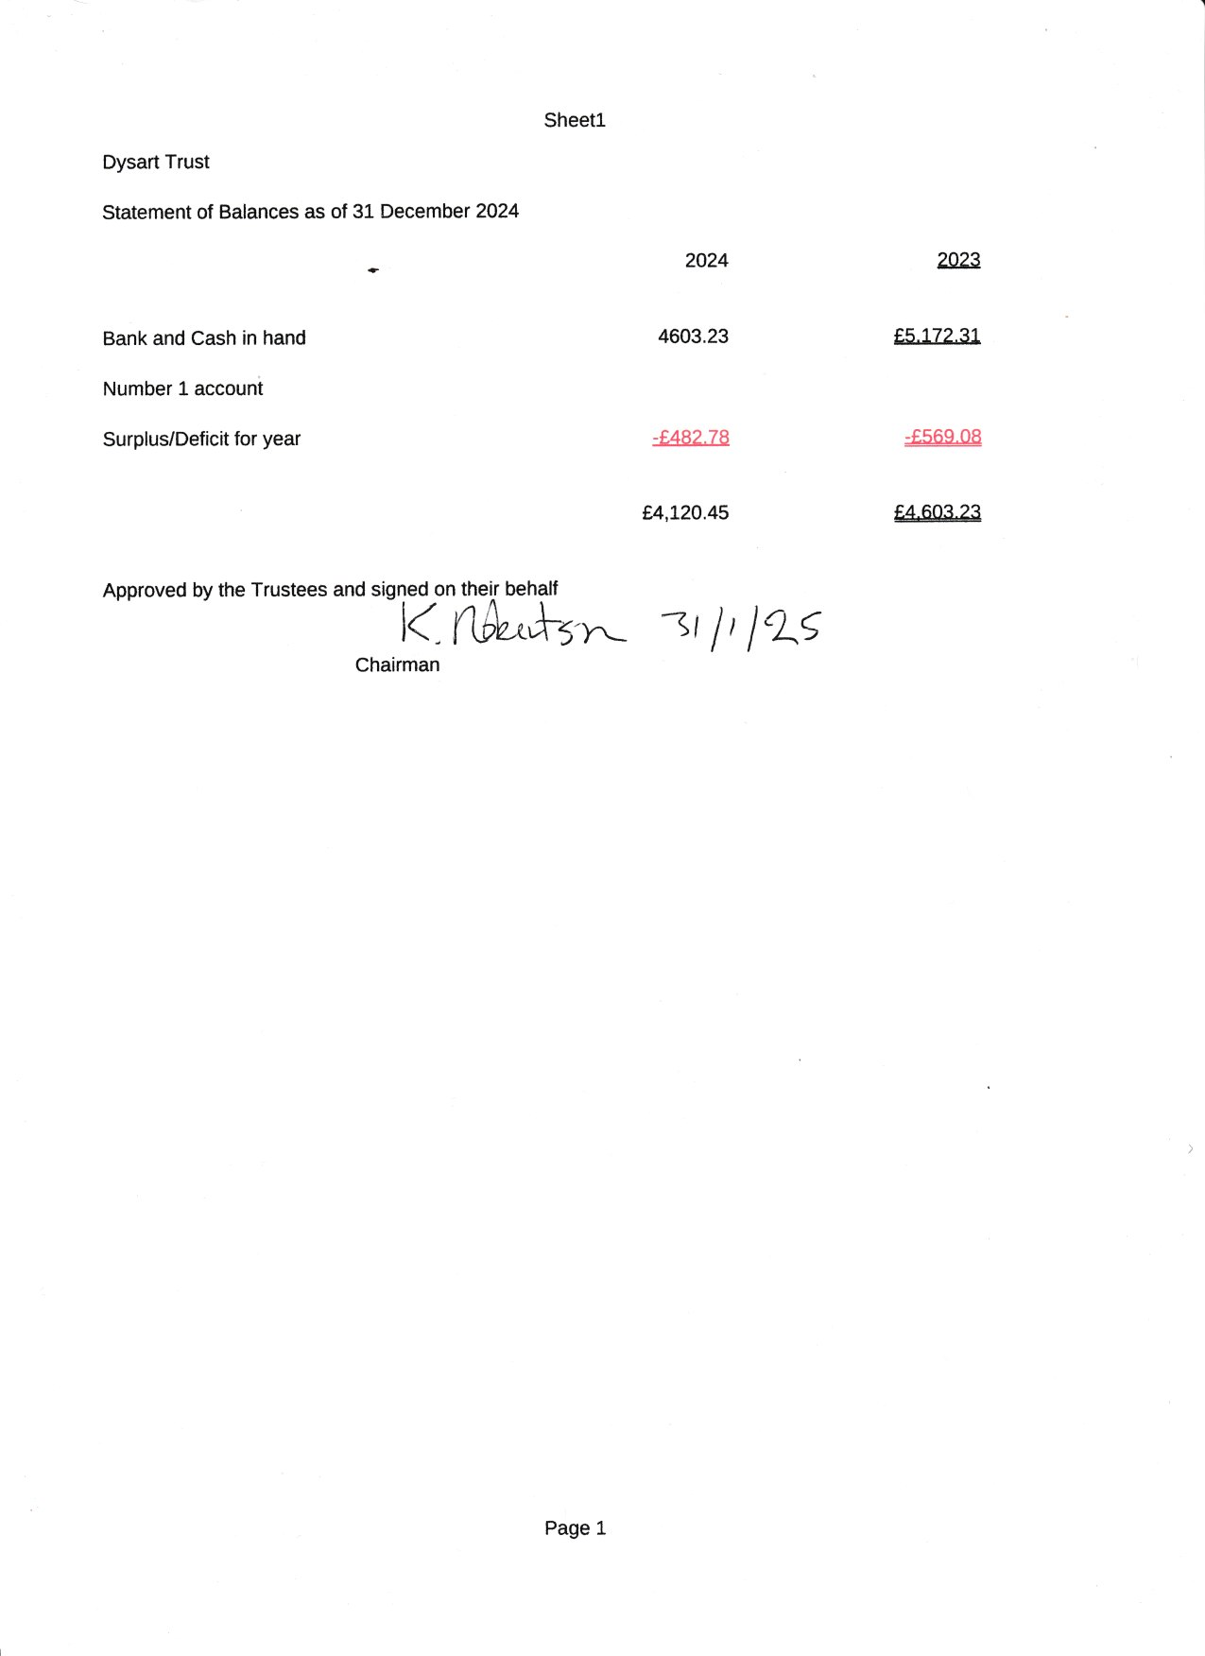
x

 | Dysart Trust Receipts Payment Account for year ended 2024
 |  |  |  |  | 2024 |  | 2023
Receipts
Book Sales |  |  |  |  | £358.50 |  | £124.00
Donations |  |  |  |  | £274.64 |  | £220.07
Membership Subscriptions |  |  |  |  | £4.00 |  | £5.00
Sundry Sales |  |  |  |  | £81.50 |  | £55.50
Total receipts |  |  |  | £ | £718.64 | £ | £404.57
Payments
Power and Light |  |  |  |  | £661.83 |  | £403.71
postage,stationery |  |  |  |  | £0.00
Public Liability Insurance |  |  |  |  | £103.30 |  | £89.60
Sundries |  |  |  |  | £31.07 |  | £95.02
room rental |  |  |  |  | £12.00 |  | £12.00
merchandise |  |  |  |  | £300.00 |  | £93.69
office equiptment |  |  |  |  | £93.22 |  | £279.63
Total payments |  |  |  | £ | £1,201.42 | £ | £973.65
Surplus/(deficit) for year |  |  |  | £ | -£482.78 | £ | -£569.08
All funds are unrestricted

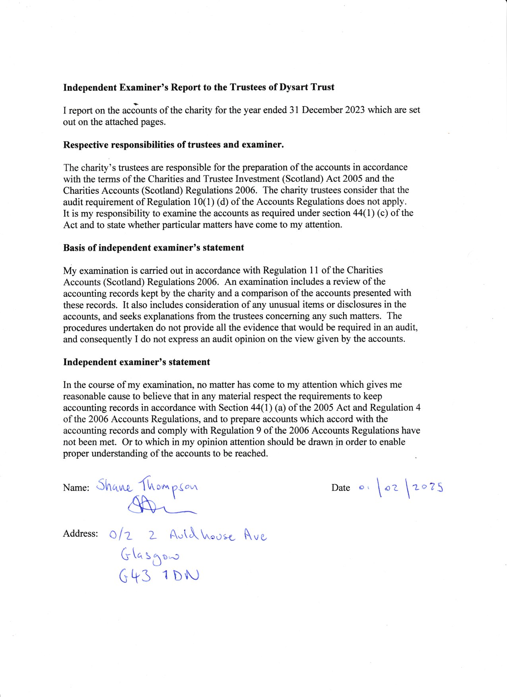
X



