
Petty and Ardersier
Community Heritage
SCIO

Trustees’ Annual Report
1st September 2024 – 31st May 2026
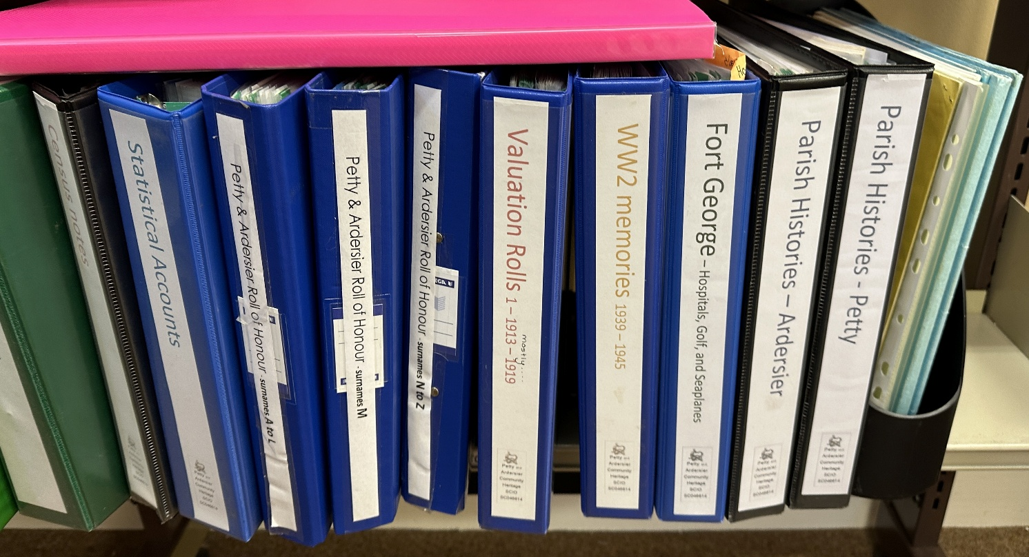
Some of our local heritage info in Ardersier Public Library.

Charity contact information
Our charity is in the process of being dissolved as we cannot recruit new trustees, but until this happens, we remain as before:
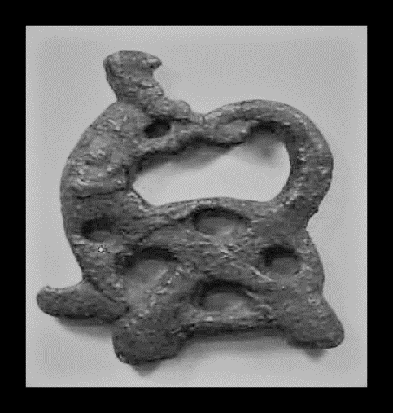
Petty and Ardersier Community Heritage SCIO
Scottish Charity Number: SC046614


oldardersier@gmail.com


https://www.facebook.com/oldPettyandArdersier

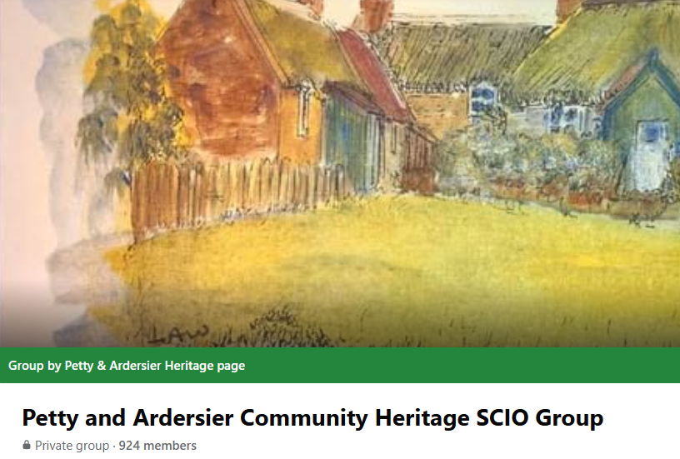
Objectives and activities
A local history interest group started meeting informally in 2013, and in 2016 Petty and Ardersier Community Heritage SCIO was set up to constitute the group so that the collection could belong to the group and community, and provision could be made to make it public and keep it safe. Our aims meet the OSCR charitable purposes of the advancement of education, heritage and culture. To meet these purposes, we aim to:
- research, record and promote the preservation of local heritage relating to the Parishes of Petty and Ardersier, Inverness-shire
- create a publicly accessible archive of local heritage information
- facilitate and develop individuals’ and community groups’ learning, sharing and understanding of the area’s heritage.

Our 9th year as a constituted group we had face-to-face meetings again, for a blether, tea and local heritage chat.
Our Facebook group grew and has over 900 followers, and more photos and stories of ‘the old days’ in Petty and in Ardersier. Thank you to all who contribute and follow the group – you make it happen.

Outcomes from P+ACH Activities include:

- curating a local Archive
  - a shelf in the local library of heritage information
  - in storage and available by request
  - digital back-up of documents, videos and images
- networking and new contacts with similar interests
  - other local heritage groups
  - other community groups in our area
- raising awareness of local heritage within and out with the community
- being a point of contact for other groups, local historians and people researching their family history
  - via social media and email – responding to requests about heritage, memories and genealogy, and posting about the same.

Structure, governance and management

Charity Trustees
Our members elect a board of trustees to administer the group and take care of the archive. We currently have three trustees:
- Christine Wood
- Laura McRobbie
- Lorna Morrison

Type of governing document
The Constitution of Petty and Ardersier Community Heritage sets out the purpose and structure of the organisation, membership, and describes how its trustees are elected, how decisions are made, and the administrative duties of trustees and members.

Trustee recruitment and appointment
The Trustee recruitment process is set out within the Constitution. Every year, at the members’ AGM, the serving trustees stand down and the members vote in a board of trustees for the following year. Trustees are recruited from within the membership, and membership is open to all.
This is our 9th annual report, and the same three trustees have stayed in post throughout this time to set up and administer the SCIO. Our current Trustees have interests and experience in genealogy, archaeological studies, and local events of the past.

Achievements and performance
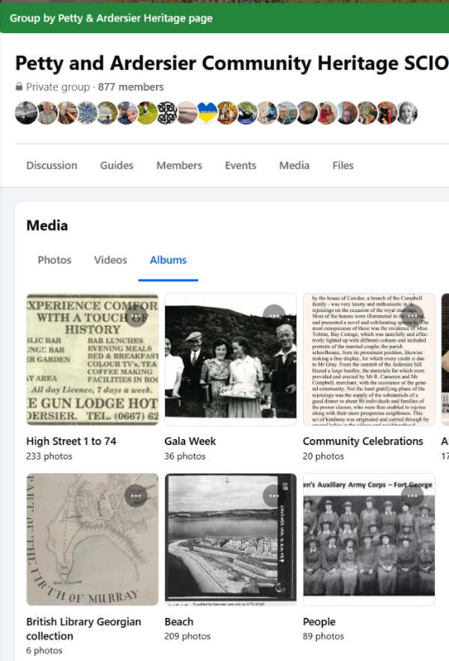
Files and photos in Facebook

During 2024-2025, group activities included:
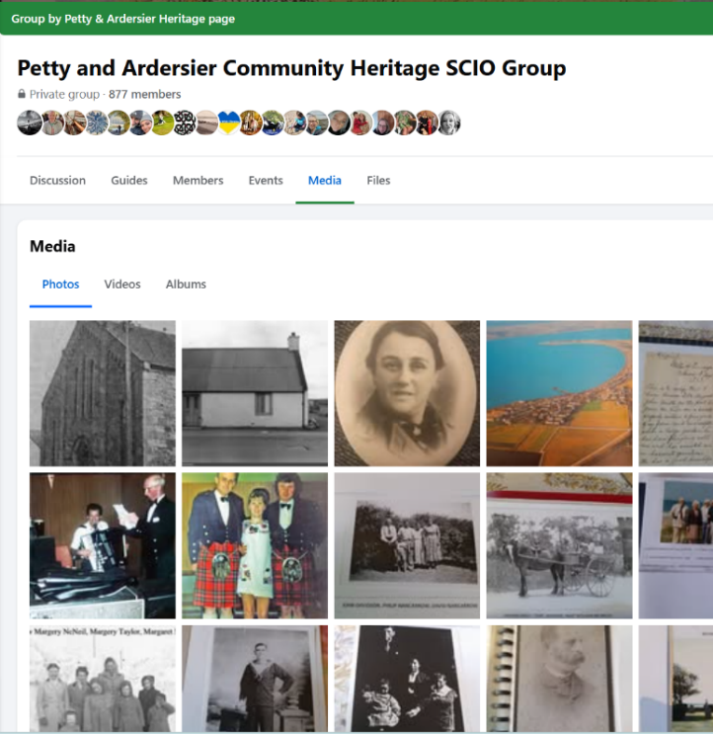
Printing off some of our digital files and adding them to the local public library collection. Maintaining a small but successful Facebook group – responding to queries, assisting with genealogy enquiries, and sharing information about the area and its heritage. https://www.facebook.com/oldPettyandArdersier/

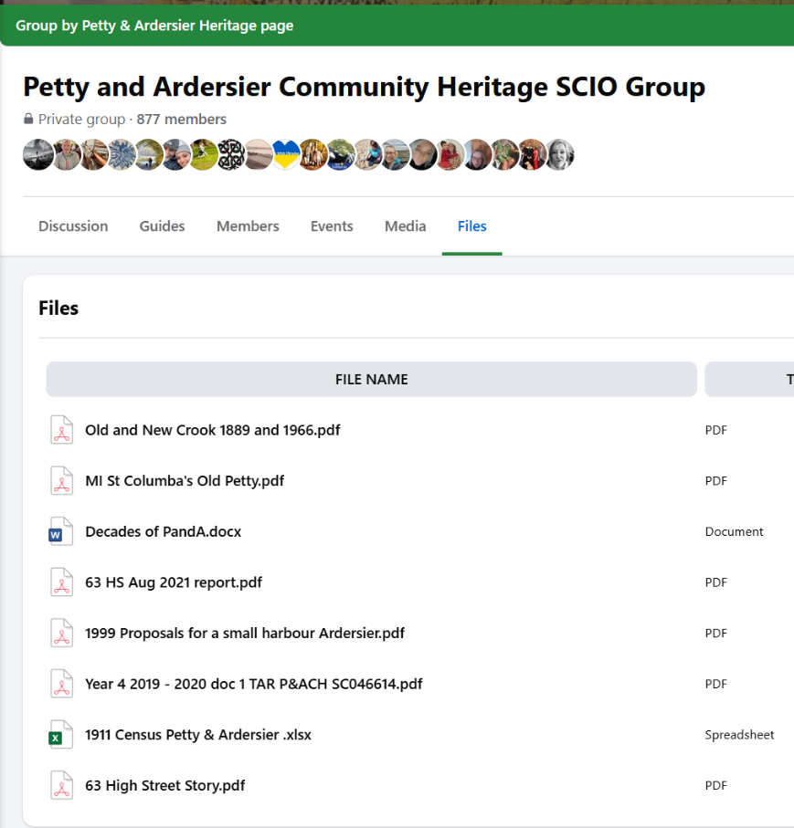
During 2024-2025 we have helped folk in a few different ways:
- Adding documents to our new shelf of heritage info in the local library to enable access offline
- Signposting resources such as NLS maps, local photogrammetry
- Discussions on local landmarks
- Lots of old photos and the discussions they generate
- House histories and finding lost placename locations
- Genealogy searching and chat
- Cemetery research and photos
- Sharing local history ads for events
- Highlighting work by local archaeologists and heritage organisations

Financial review
Statement of the charity’s policy on reserves
Use of reserves is solely for the fulfilment of the aims and charitable purposes of Petty and Ardersier Community Heritage. At the end of this financial year, we have funds of £182.21.
Details of any deficit: There is no deficit.

Future plans
Sadly, the three trustees have to stand down due to family and health commitments. There was no response to requests for new trustees on our Facebook page and in local meetings, and so we must dissolve the SCIO charity. The decision to do this was made over discussions and meetings during the end of 2025 and beginning of 2026, and the request to dissolve sent to OSCR in May 2026. We will use our Facebook group to keep folks updated.

Declaration
Signed on behalf of the charity trustees:
Lorna Morrison
LoLLrna Morrison Lorna

Print name LORNA MORRISON

Designation TRUSTEE and TREASURER
19 May 2026
Date

