

REGISTERED CHARITY NUMBER: SC053247
REPORT OF THE TRUSTEES AND
UNAUDITED FINANCIAL STATEMENTS
FOR THE YEAR ENDED 30 APRIL 2025
FOR
BRIDGE OF DON SKATEPARK DEVELOPMENT GROUP

BRIDGE OF DON SKATEPARK DEVELOPMENT GROUP

CONTENTS OF THE FINANCIAL STATEMENTS FOR THE YEAR ENDED 30TH APRIL 2025

PAGE
REPORT OF TRUSTEES 3
INDEPENDENT EXAMINERS REPORT 4
RECEIPTS AND PAYMENTS ACCOUNTS 6
STATEMENTS OF BALANCES 7
NOTES TO THE FINANCIAL STATEMENTS 8

The trustees present their report and financial statements of the charity for the year ended 30th April 2025.
Legal and administrative information is set out on the Information Page.
Objectives
The Bridge of Don Skatepark Development Group charity was set up to raise support and funding towards the design and building of a purpose-built skatepark. The aims of our charity are as follows:
- Raise funding and support for the community skatepark.
- Promote wheeled sports in our community.
- Support all age groups and abilities participation in skatepark use.
- Work with the community to ensure the provision aligns with demand and suitability for our area.
Structure governance and management
The group is constituted as a Scottish Charitable Incorporated Organisation, incorporated on 29 March 2024. The charity is governed under a constitution which established the objects of the charitable organisation.
Trustee recruitment and appointment
The trustees who serve during the period are listed on the information page. It is the charity’s policy to seek to appoint trustees who have a specific interest in its objectives or whose skills can complement those already in place.
Achievements and performance
Work has been ongoing for maintenance of the skatepark with bench painting with help from the wider community. The group has hosted their annual quiz night and also their annual skatepark jam. Two major achievements in this calendar year were our successful charity application and a successful land lease application.
Financial Review
The charity has made a net profit of £767.51 in the year with £3965.33 held in cash and bank balances at the year end. The level of reserves held will be sufficient to pursue the charitable objectives in the coming year. The committee are planning fund-raising events in 2025 to improve the bank balance.
Plans for Future Periods
Looking ahead the group are planning their annual quiz night and jam events for the summer months and they are committed to planning some more charity work within the community.
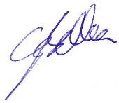
Signed on behalf of the charity trustees.

…………………………………………………26.05.26
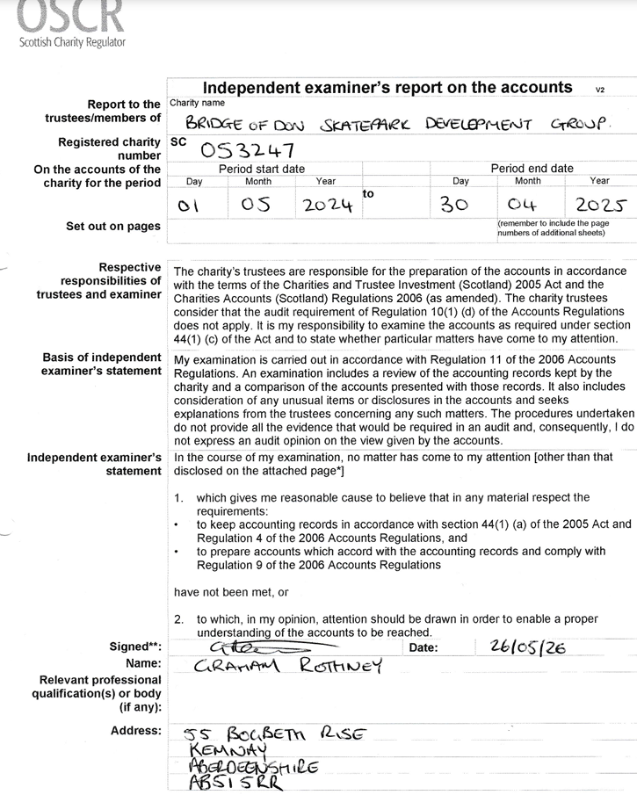

REFERENCE AND ADMINISTRATIVE DETAILS
Registered Charity number
SC053247
THE BRIDGE OF DON SKATEPARK DEVELOPMENT GROUP
Registered office
119 Jesmond Avenue
Bridge of Don
ABERDEEN
AB22 8UE

Trustees
Glenn Belka (Chair Appointed)
Kirsten Dickson (Minutes Secretary Appointed)
Kaleb Belka (Vice Chair Appointed)
Holly Elliott (Treasurer Appointed)
Neil Taylor (Secretary Appointed)

Independent Examiner
Graham Rothney
55 Bogbeth Rise
Kemnay
Aberdeenshire
AB51 5RR

Bankers
Bank of Scotland
79 Ellon Road
Bridge of Don
Aberdeen City
AB23 8BY

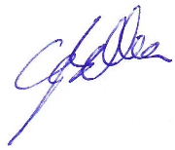
Approved by order of the board of trustees on ............26.05.26............................. and signed on its behalf by:

.................................................................
Glenn Belka - Trustee - Chair

BRIDGE OF DON SKATEPARK DEVELOPMENT GROUP

RECEIPTS AND PAYMENTS ACCOUNTS
FOR THE YEAR ENDED 30th APRIL 2025

 |  | Unrestricted | Restricted | 2025
 |  | Funds | Funds | Total
 |  | £ | £ | £
NOTES | Receipts:
2 | Grants | 0 |  | 0
3 | Receipts from fundraising | 1776.93 |  | 1776.93
 | Total receipts | 1776.93 |  | 1776.93
 | Payments:
4 | Charitable activities | 171 |  | 171
5 | Building costs | 0 |  | 0
6 | Leveraged funding | 0 |  | 0
7 | Payments for funding activities | 838.42 |  | 838.42
 | Total Payments | 1009.42 |  | 1009.42
 | Net Receipts (Payments) | 767.51 |  | 767.51
 | Transfer between funds | 0 |  | 0
 | Surplus for the period | 767.51 |  | 767.51

BRIDGE OF DON SKATEPARK DEVELOPMENT GROUP

STATEMENT OF BALANCES
AS AT 30th APRIL 2025

 |  | Unrestricted | Restricted
 |  | Funds | Funds | Total
 |  | £ | £ | £
Cash funds:
Cash and bank balances at the start of the year |  | 3197.82 |  | 3197.82
Surplus / (deficit) shown on receipts and payments accounts |  | 767.51 |  | 767.51
Cash and bank balances at end of year |  | 3965.33 |  | 3965.33

BRIDGE OF DON SKATEPARK DEVELOPMENT GROUP

NOTES TO THE ACCOUNTS FOR YEAR ENDED 30th APRIL 2025

- Accounting Policies

The financial statements have been prepared on the cash receipts and payments basis

- Grants

None for this year

- Receipts from funding

Funding from our quiz night event and various donations made via our sum up account from the public.

- Charitable activities payments

Event insurance and public licensing fees for our Jam event in summer.

- Building costs

None

- Leveraged funding

None for this year

- Payments for funding activities

Food and refreshments for our quiz night as well as £625 cash banked from petty cash.

