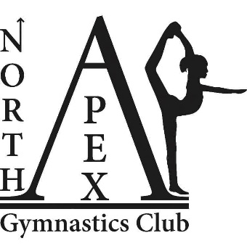

North Apex Gymnastics Club
Trustees’ Annual Report
July 2024 to June 2025

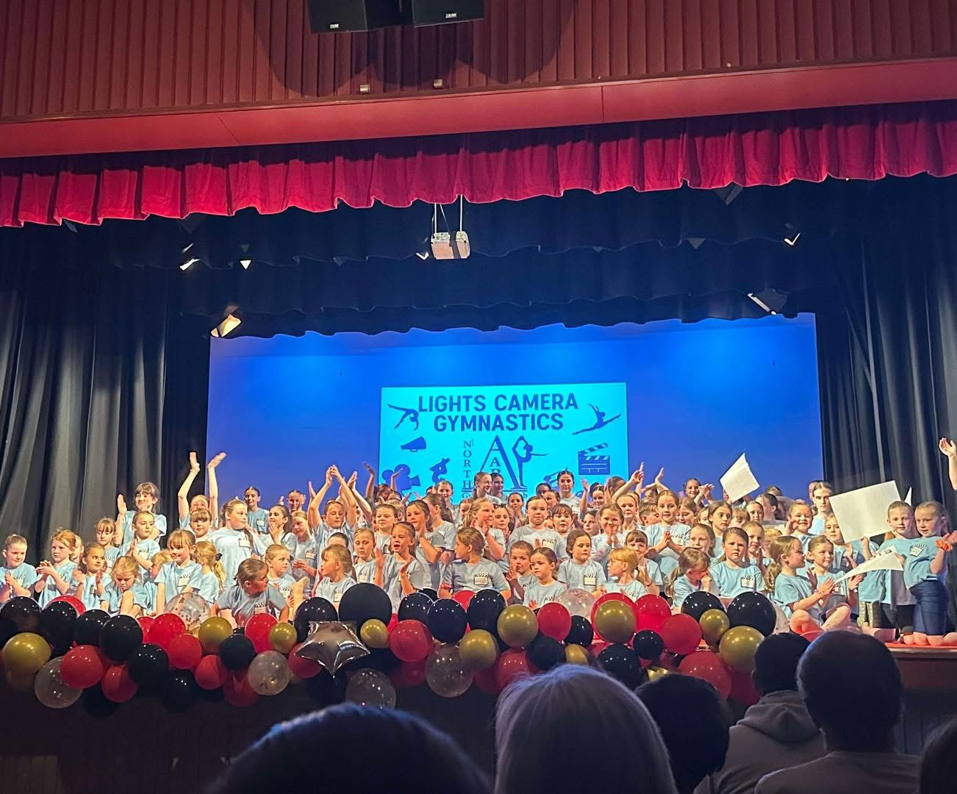
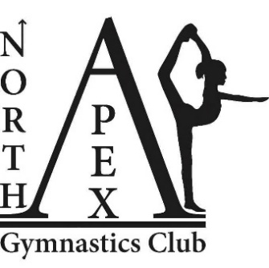

Charity contact information
North Apex Gymnastic Club
Scottish Charity Number: SC049379
Address – 49 Seaforth Avenue, Wick
Postcode - KW1 5NE

Telephone number - 07487713723
Email address – apexgymnasticswick@gmail.com
Facebook - North Apex Gymnastics Club

Charity Trustees

- Somer Malcolm – resigned 27/11/2024
- Tina McBeath – resigned 19/11/2024
- Claire Polson – resigned 30/06/2025
- Rona Gill – resigned 16/06/2025
- Jennie Simpson
- Ashley Miller
- Gail Simpson – resigned 24/11/2025
- Yvonne Richard
- Alison Mackay – appointed 30/06/2025
- Corinne Macmillan - – appointed 30/06/2025
- Diane Sinclair– appointed 30/06/2025
- Lauren Mackay – appointed 08/12/2025
- Leah Sinclair – appointed 08/12/2025
- Sophie Burr – appointed 08/12/2025
- Sophie Levack – appointed 08/12/2025
- Suzanne Bain – appointed 08/12/2025

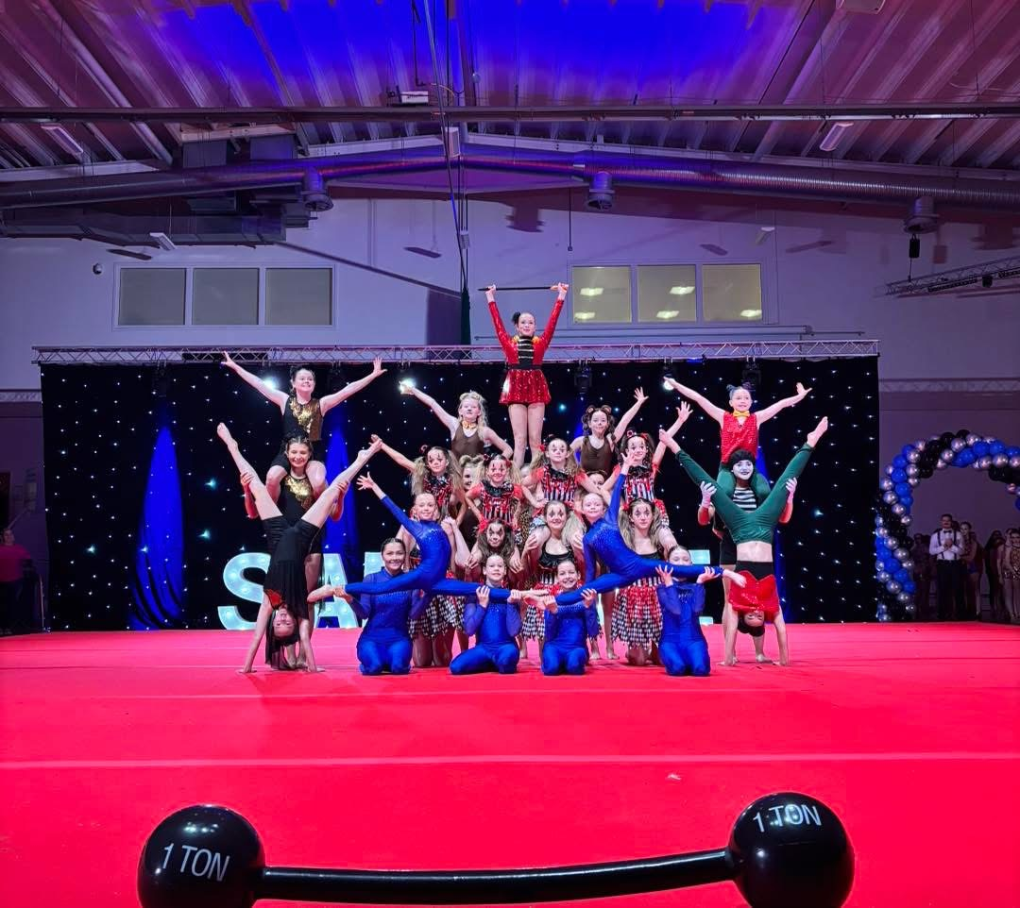

Objectives and activities
North Apex Gymnastic was formed with the intention to encourage public participation in the sport of gymnastics by young persons of all abilities, particularly in Wick and the surrounding areas, by providing gymnastics facilities, activities and training to improve the fitness, health and well-being of the persons for whom the activities are intended. So, in less formal terms our coaches wanted to create an inclusive club to teach gymnastics to the youth of Wick and the surrounding areas.
Our amazing coaches work so hard to provide a varied programme of gymnastics from our base at Wick Community Campus. They provide extensive training and fun sessions to our members.

Structure, governance and management
Constitution of North Apex Gymnastics Club
Updated and approved by OSCR on 8 December 2025.
Trustee recruitment and appointment
Within this year we had 4 trustees resign and 3 new trustees appointed. The trustees that have resigned and been appointed to date is also detailed within this report.
Achievements and performance
Throughout the year the club continued to grow in participation, community presence and achievement, offering a wide range of opportunities for gymnasts of all ages and abilities. Our Young Leaders continued their involvement in the Highlife Highland leadership programme.
In July, our Display Team visited Fyrish Gymnastics Club to prepare for the upcoming Sapphire Festival. The club ran a Braeside Retreats raffle and hosted a fundraising stand at the local county show. Gymnasts from our Squad class performed at the Wick Gala coffee afternoon, and volunteers supported gala marshalling duties.
During July and August, the club delivered an open summer programme for both members and non-members, including preschool sessions. This programme was very well attended, with 770 bookings from across the local community.
In August, the club held a bingo fundraiser with generous donations received from the local Tesco store. Preschool classes were also added to the club programme on a permanent basis rather than ad-hoc, contributing to an increase in membership to nearly 250 gymnasts.
In September, our Display Team travelled to Blackpool, performing their “Girl Boss” routine in the iconic Blackpool Tower Ballroom. The club was named a finalist for Scottish Gymnastics Club of the Year 2024, and members supported Tesco bag packing for additional community fundraising.
In October, the club ran a Fun Day with classes and fundraising stalls to support Display Team costs. New equipment began arriving for Preschool and TeamGym. TeamGym classes were launched, and the club was named a finalist for Scottish Women in Sport – Community Champion of the Year.
In November, the Display Team attended the Sapphire Birthday Festival for the second time, delivering an excellent performance of “Girl Boss” and winning the award for Best Use of Floor. The club also received major recognition, winning Scottish Women in Sport – Community Champion of the Year, and finishing as runners-up for Scottish Gymnastics Club of the Year. Our competitive gymnasts attended the Highland Competition in Inverness, returning with numerous medals. Miya successfully passed her Women’s Club Judge qualification, and Iona commenced her Level 1 General Gymnastics coaching course.
In December, we held our second annual Christmas Club Competition, open to all members, with over 100 gymnasts participating. Awards were presented for 1st–3rd on floor, vault and overall within each class, alongside special trophies for Highest Score, Maximum Effort and Performance of the Day. The event also included fun activities and a Display Team performance. Trials for 2025 Squad, Development and Display classes were completed.
In January, the club was named a finalist for British Gymnastics 2026 Community Club of the Year (under 250 members).
In February, Squad, TeamGym and Development gymnasts attended a joint training day at Fyrish Gymnastics Club.
In March, Kelsey and Roni attended their General Level 1 coaching course. Our competitive team of 31 gymnasts took part in the Fyrish Floor & Vault competition in Alness, winning multiple medals. A further 17 gymnasts represented the club at the North District Floor & Vault competition in Aberdeen, also returning with medal success.
In May, Squad and Development parents attended an educational judging-information evening. Summer Camp for 2025 was officially launched.
In June, the club hosted its second annual Summer Showcase, themed “Lights, Camera, Gymnastics!”, receiving excellent feedback from gymnasts, families and the wider community. Nineteen gymnasts attended the Summer Extravaganza competition, again achieving medal placings. The club also performed at Halkirk Galafest (Squad, Development, Display and Junior Display) and Wick Harbour Day (Squad & Development). Iona successfully passed her Level 1 coaching qualification.

Financial review
Statement of the charity’s policy on reserves
North Apex Gymnastics do not have a policy on the reserves that we can hold. As we are a charity we use the fee charged for classes to pay for Coaches, rent, insurances etc. Any money donated in the form of grants is used for the purpose the grant was intended for. For example new equipment or tracksuits for competitions.
Details of any deficit
North Apex Gymnastics do not currently have any accounts in deficit.
Donated facilities and services
North Apex Gymnastics do not have any donated facilities or services.
Future plans
Our future plans include:
- A summer camp in July & August 2025, open to both members and non-members
- Bingo fundraising night in August 2025
- Coaches attending their level 3 general modules course
- Adults gymnastics classes
- Coaches attending their level 2 teamgym course
- Coaches attending the preschool add-on module course
- Sapphire gymnastics annual birthday festival
- NAGCs annual Christmas club competition
Declaration
Signed on behalf of the charity trustees:

LAUREN MACKAY

Print name
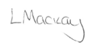
Designation

Date 30/03/2026

