THE CHURCH OF SCOTLAND
Millisle Kirk

Congregation Number 070433
Scottish Charity Number 010621
Trustees Annual Report. Page 1.

Year Ended 31 ^{st}. December 2025
The trustees present the annual report and accounts for Millisle Kirk (Church of Scotland ) for the year ended 31 ^{st} December 2025

Reference and Administrative Information
Charity Name: | Millisle Kirk
Charity Registration Number | sc 010621
Congregation Reference No. | 070433
Contact Address | Mrs. J. McKay,  The Snaid, Broughton Mains, Sorbie, Newton Stewart
DG8 8HD.

TruStees
The following are Members of the Kirk Session: Mrs J. McKay, Mrs B Cloy
Mr. W. Johnston, Mr. T. Simpson, Mrs A Gorman , Mr G Houston. Dr John McDonald, Mr Nonie McIntosh, Mrs Agnes Adams, Mrs Jean Whittaker, Mr Tom Galloway
Principal Office- Bearers
Interim Moderator | Rev. Eric Boyle
Minister( Locum) | Rev Steve Fulcher
Session Clerk: | Mrs Jean McKay
Church Treasurer: | Mrs Lynn Fisher
Gift Aid Convenor: | Mrs Anne Gorman
Independent Examiner
Name: Mrs Josephine Wallace
Airyhassen Farm Whauphill
Newton Stewart.
Banker
Name: Virgin Money
43 Alloway Street, Ayr, KA71SP
Structure, Governance and Management Governing Document
The Church is administeæd in accordance with the terms of the Deed of Constitution
Page 2
Recruitment and Appointment of Trustees.
All members of the Kirk Session are the charity trustees. The Kirk Session Members are the elders of the church and are chosen from those members of the church who are considered to have the appropriate gifts and skills. The Minister, who is a member of the Kirk Session, is elected by the congregation and inducted by Presbytery.
Organisaüonal Structure.
The Kirk Session, which is moderated by the Interim Moderator, meets at need and is responsible for spiritual affairs within the church
Objectives.
The Church of Scotland is Trinitarian in doctrine. Reformed in tradition and Presbyterian in
Policy. It exists to Glorify God and to work for the advancement of Christ's Kingdom throughout the world. As a national church, it acknowledges a distinctive call and duty to bring the ordinances of religion to the people in every parish in Scotland through a territorial ministry.
It co-operates with other churches in various ecumenical bodies in Scotland and beyond.
At a local level, Millisle Kirk which is now a Union with Kirkinner, seeks to work together with its linked parish of Mochrum to serve the people of Sorbie, Garlieston, Kirkinner ,Mochrum and the surrounding district.
Achievements and Performance.
This year has been a very enjoyable year , with Rev. Steve Fulcher, who has worked hard to pull the parishes together. We have had Café Churches in Mochrum and Kirkinner and Bring and Share Lunches
In the two churches The local schools have attended church for their end of term Services
A very successful coffee afternoon was held in Whauphill Hall ( Half-way between parishes ) As usual our Cruggleton Service took place in September and was very well attended.
Unfortunately Rev. Fulcher, for various reasons , decided to retire at end of 2025 so we are now in a Team Ministry situation while we await the decision of Presbytery as to the way forward.
Donations were made to. Poppy Scotland & Riverside Day Centre.
Financial Review
The Church receives its main income from weekly offerings and Gift Aid , up from 2024.
Gift Tax rebate claim•was £2530.64 Fabric repairs were £5444.18 which was drawn down from the Fabric Fund held by General Trustees in Edinburgh.
There was a findraising event (coffee afternoon) which raised £1313. The after service teas raised £287
Income from Funerals & Weddings was £800. Pulpit supply was £7422.79 .

Reserves Policy
It is the Trustees' policy to hold reserves of six months expenditure including designated funds. At this year end the Church held unrestricted cash funds of £82,201.40 Approximately £4149.47 is held by Church of Scotland General Trustees in Fabric revenue account
The Trustees are aware of the need to•continually have reserves for repairing and maintaining the Church
The Market Value of Consolidated Fabric Fund is £352,389.23

Statement of Trustees' Responsibilities
The members ofthe Kirk Session must ensure finaricial statements which give sufficient detail to enable an appreciation ofthe transactions of the Church during the financial year.
The members of the Kirk Session are responsible for making sure proper accounting records are kept , which , on request , must reflect the financial position of the Church at that time.
This must be done to ensure that the financial statements comply with the Charities and Trustee
Invesffnent(Scotland) Act 2005, the Charities Accounts (Scotland) Regulations 2006 and the Regulations Anent Congegational Finance approved by the General Assembly of the Church of Scotland in 2007
They are also responsible for safeguarding the assets of the Church and must take reasonable steps for the prevention and/or detection of fraud and other irregularities.

Approved by the Trustees and signed on their behalf
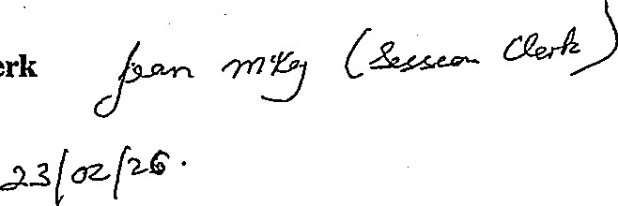
Session Clerk
Date

 | Millisle Kirk

 |  | Receipts and Payments Account
 |  | Year ended 31st December 2025
 |  | Note | Unrestricted  Funds 2025 | Restricted  Funds 2025 | Endowment  Funds 2025 | Total 2025 | Total 2024
Receipts |  | Note
Donations |  | 3 | £13,162.14 | £0.00 | £0.00 | £13,162.14 | £13,079.65
Activities for Generating Funds  Bank Interest |  |  | £1,313.00  £869.29 | £0.00 | £0.00 | £1 ,313.oo | £243.39
 |  |  | £1,313.00  £869.29 | £0.00 | £0.00 | £869.29 | £972.76  £6078Ä
Deposit Interest C of S |  |  | £38.91 | £0.00 | £0.00 | £38.91 | £972.76  £6078Ä
Funds drawn from Church of Scotland |  |  | £17,274.11 | £0.00 | £0.00 | £17,274.11 | £5,520.56
 |  |  | £32,657.45 | £0.00 | £0.00 | £32,657.45 | £19,877.20  Éióô.ó-o
Rental of Premises |  |  | £800.00 | £0.00 | £0.00 | £800.00 | £19,877.20  Éióô.ó-o
Sale of Hall |  |  | £35,471.40  £0.00 | £0.00 | £0.00  £0.00 | £35,471.40  £0.00 | £0.00
Electricity Refund |  |  | £35,471.40  £0.00 | £0.00 |  | £35,471.40  £0.00 | £154.69
Earl Haig Collection |  |  | £0.00 | £0.00  £0.00 | £0.00 | £0.00 | £121.30  £2,000.00
Sorbie Church |  |  | £0.00 | £0.00  £0.00 | £0.00 | £0.00
Kirkinner Church  Total Receipts |  |  | £0.00 | £0.00 | £0.00 | £0.00 | £15,778.01
 |  |  | £68,928.85 | £0.00 | £0.00 | £68,928.851 £38,631.20
Payments |  | 4
Costs of generating funds |  |  | £67.80 | £0.00 | £0.00 | £67.80 | £120.54
Charitable Activities  Governance Costs |  |  | £20,292.36  £0.00 | £0.00  £0.00 | £0.00 | £20,292.36 | £19,593.78
 |  |  |  |  | £0.00 | £0.00 | £0.00
Total payments |  |  |  | £0.00 | £0.00 | £20,360.16! £19,714.32
 |  |  |  |  |  | £48,568.69 | £18,916.88  £0.00
Excess of Receipts over Payments
for the year before transfers |  |  | £48,568.69 | £0.00 | £0.00
Transfers |  |  | £0.00  É48,568.É9 | £0.00 | £0.00 | Èò.oö
Excess of Recei ts over Pa ments
Excess of Recei ts over Pa ments |  |  |  | £0.00 | £0.00 | £0,568.69 | £1à,9f6.Ê8
for the ear
Millisle Kirk
Statement of Balances
At 31 December 2025
Unrestricted Restricted
Funds Funds |  | Total 2025 |  | Total 2024
Note  Bank & Deposit Balances  Bank & deposit Balances |  |  |  | Total 2024
brought forward  Movement in Year  Excess of Receipts over Payments | £33,632.71 | £0.00 |  | £14,715.83
for the year  Bank & deposit balances | £48,568.69 | £0.00 |  | £18,916.88
carried forward  Investments at market value Church of Scotland Funds  Assets  Liabilities | £82,201.40  £352,389.23 | £0.00 |  | £33,632.71
These accounts were approved by the Kirk Session and Financial Board on  For and on behalf of the Kirk Session and Financial Board |  |  | oz .26
 Session Clerk
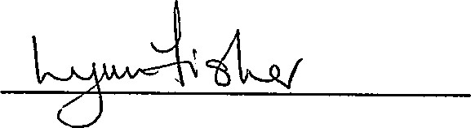 Treasurer
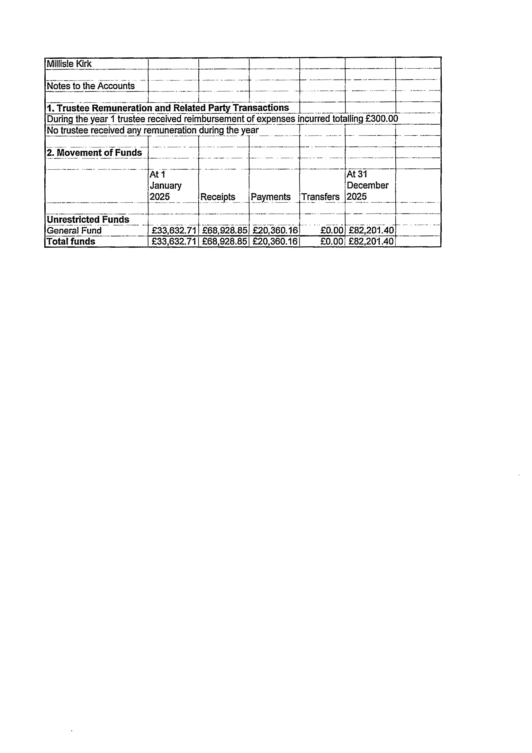

 |  |  |  | Unrestricted  Funds 2025 | Restricted  Funds 2025 | Endowment  Funds 2025 | Total 2025 | Total 2024
3.AnåIysis óf Donations
WFO Scheme
 |  |  |  | £67.00 | £0.00 | £0.00 | £67.00 | £189.50
Gift Aid Donations |  |  |  | £7,806.00  £2,530.64  £2,608.Ža  £150.2? | £0.00 | £0.00 | £7,806.00  £2,530.64  £2,608.žà | £6,731.20
Tax Recovered on Gift Aid Donations |  |  |  | £7,806.00  £2,530.64  £2,608.Ža  £150.2? | £0.00  £0.00 | £0.00  £0.00 | £7,806.00  £2,530.64  £2,608.žà | £1,999.15
Ordinary Offerings  Other Offerings, Donations etc |  |  |  |  |  |  |  | £3,081.80
 |  |  |  |  | £0.00 | £0.00 | £150.27 | £1,078.00
4. Analysis of Payments |  |  |  | £13,162.14 | £0.001 £0.001 £13,162.141 £13,079.65
Costs of Generating Funds
Offering Envelopes
 |  |  |  |  |  |  |  | £120.54
 |  |  |  | £67.80 | £0.00 | £0.00 | £67.80 | £120.54
 |  |  |  | £67.80 | £0.00! £0.00 | £67.801 £120.54
Charitable Activities
Giving to Grow  Presbytery Dues |  |  |  | £1,800.00  £435.06 | £0.00 ïo.-oo | £0.00 | £1,800.00  È435.õ6 | £2,126.00  £342.oö
 |  |  |  |  |  | Èo.o-o | £1,800.00  È435.õ6 | £2,126.00  £342.oö
Other Staffing Costs  Pulpit Sup ly/TraveI |  |  |  | £1 ,020.oo  £7,422.79 | £0.00  £0.00 | £0.00 | £1 ,020.oo | £11030.00
 |  |  |  |  |  | £0.00 | £7,422.79 | £2,902.91
Fabric Repairs & Maintenance |  |  |  | £5,444.18 | £0.00 | £0.00 | £5,444.18 | £5,136.21
Council Tax/Water |  |  |  | £0.00 | £0.00 | £0.00 | £0.00 | -£200.01
Heat & Light  Insurance |  |  |  | £1788.22  £1 ,945.69 | £0.00 | £0.00 | £1788.22  £1 ,945.69 | £2,240.43
 |  |  |  |  | £0.00! £0.00 |  | £1788.22  £1 ,945.69 | 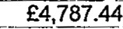  £320.00
Organ E¥penses Popp Scotland |  |  |  | £0.00 | £0.00 | £0.00 | £0.00  £0.00
 |  |  |  | £0.00 | £0.00 | £0.00 | £0.00  £0.00 | £125.00
Hall  PO | Sale Expenses y Wreaths |  |  | £0.00  £76.20 | £0.00  £0.00 | £0.00  £b.Óo | £0.00  £76.2ó  £360.22 | £451.20
£112.60
£220.ob
Other Expenses |  |  |  | £360.22 | £0.00 | £0.00 |  | £112.60  £220.ob
 |  |  |  | £20,292.36 | £0.00i £0.00 £20,292.36] £19,593.78
5.Ministers Stipend
All Church of Scotland congregations contribute to the National Stipend Fund which bears the cost of all ministers' stipends and employer's national insurance, pension and housing and loan fund.
Ministers' stipends are paid in accordance with the national stipend scale, which is related to years of service. For the year under review minimum stipend was £32433 and the maximum stipend (in the fifth and subsequent years) £39856
6.Collections for Third Parties | 2025 | 2024
Riverside Centre | £225.00 | £255.00
Earl Haig | £100.00 | £125.00
Total | £325.00 | £380.00

APPENDIX

FUNDS HELD ON BEHALF OF THE CONGREGATION BY CHURCH OF SCOTLAND GENERAL TRUSTEES
DEPOSIT FUND | 2025 | 2024
Organ Fund | £880.00 | £880.00
McEachran Trust for Church Grounds | £765.54 | £680.65
Growth Fund - McEachran Trust at Market Value | £2,758.88 | £2,558.38
Ministerial Fund  CONSOLIDATED FABRIC FUND  REVENUE ACCOUNT | £640.94 | £613.68
Credit Balance  CONSOLIDATED FABRIC FUND  CAPITAL ACCOUNT | £4,149.47 | £5,566.01
At Market Value | £352,389.23 | £55,644.48
Temporary Account | £0.00 | £313,535.25

Millisle Kirk
sc 010621
Report of the Independent Examiner
Respective responsibilities of the trustees and examiner
The charity trustees consider that an independent examination is needed under section 44 ( 1 ) ( c ) of the Charities and Trustee Investment (Scotland) Act 2005. It is my responsibility to examine the accounts under section 44 ( 1 ) ( c ) of the act and state whether particular matters have come to my attention.
Basis of independent examiner's statement
An examination includes a review of the accounting records kept by the charity and a comparison of the accounts presented with those records. It also includes consideration of any unusual items or disclosures in the accounts, and seeking explanations from the trustees concerning such matters. The procedures undertaken do not provide all the evidence that would be required in an audit, and consequently I do not express an audit opinion on the accounts.
Independent examiner's statement
In the course of my examination of the statement of account for the year ended
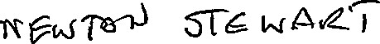
31st December 2025 no matter has come to my attention
- Which gives me reasonable cause to believe that in any material respect:
. accounting records have not been kept in accordance with Section 44 ( 1 ) ( a ) of the Charities and Trustee Investments (Scotland) Act 2005 and Regulation 4 of the Charities Accounts (Scotland) Regulations 2006.
. the accounts do not accord with those records.
. the statement of account does not comply with any of the requirements of Regulation 9 of The Charities Accounts (Scotland) Regulayions 2006.
- To which, in my opinion, attention should be drawn in order to enable a proper understanding of the accounts to be reached.
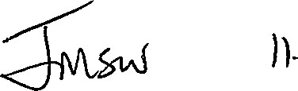2 2b
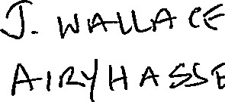"BJ •F.-{ì-twx

Budget 2026

Expenditure
Giving to Grow | £2,000.00
Insurance | £1,600.00
Council Tax | £0.00
Heat & Light | £2,500.00
Locum | £7,500.00
Travel | £3,000.00
Organ Service | £350.00
Presbytery Dues | £350.00
Staffing Costs | £1,000.00
Fabric Repairs | £3,000.00
Upkeep of Grounds | £200.00
Other Costs  Income | £200.00  £21700.00
WFO Scheme | £100.00
Gift Aid Donations | £7,900.00
Tax Rebate | £2,500.00
Ordinary Offerings | £2,600.00
Donations | £150.00
Rental of Premises | £800.00
Fundraising | £250.00  £14,300.00

