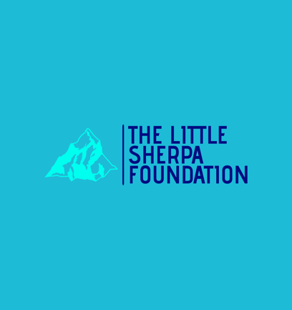

Little Sherpa (Scotland)
Trustees’ Annual Report
01.08.24 to 31.07.25

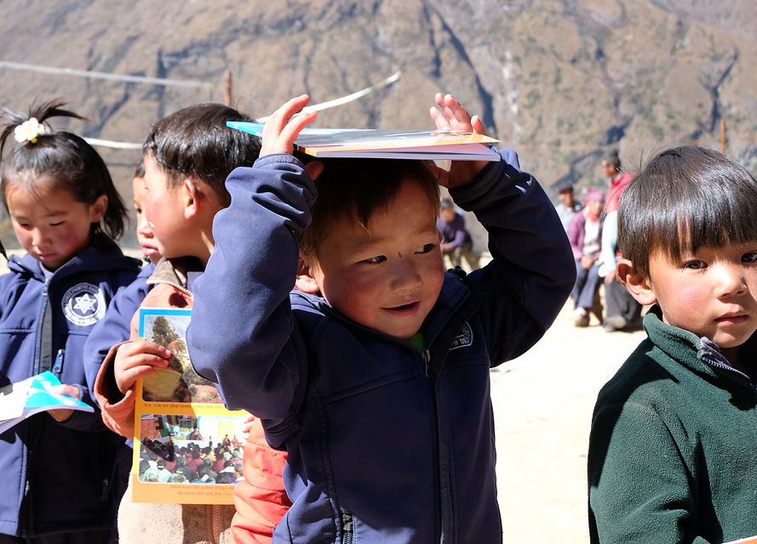

07925 880264
littlesherpascotland@gmail.com


Little Sherpa (Scotland)
Scottish Charity Number: SC047634
Bridge House
Perth Road
Little Dunkeld
PH8 0AA

07925 880264
littlesherpascotland@gmail.com
www.littlesherpafoundation.com

Charity Trustees

- James Lamb
- Karen Lamb
- Richard Else

Objectives and activities

Initially the charity was set up to support victims of the avalanche and earthquake in Nepal in 2014/15 through a network of residents in the village of Phortse. It has since developed into supporting and preserving the lives and culture of the Sherpa people via building projects, health care projects and educational support in the Solu Khumbu and raising awareness of the Sherpa culture across the globe.
Structure, governance and management
Type of governing document
Constitution

Trustee recruitment and appointment
I trustee left (Glen Campbell) and another was appointed (Richard Else). Richard has worked extensively with the charity since its inception 10 years ago. In that time, he has become well acquainted with the aims and philosophy behind Little Sherpa. This enabled a smooth transition to becoming a trustee.
Achievements and performance
- The monks at Tengboche Monastery (the principal one in the Khumbu region) requested new robes for all 55 monks. Tashi Lama organised the manufacture of the robes in Kathmandu and the transportation up to the monastery.
- The concept of building a polytunnel began last year when work was completed on the rebuilding of retaining walls and the purchase of building materials in Kathmandu. This year saw all the materials being flown up to the Khumbu and carried by yak to the site of the polytunnel in the village of Phortse. Local builders were employed to complete the construction. This has led to an increase in the amount and variety of fruit and vegetables which can be grown and an increase in the length of the growing season. A manager was appointed to ensure the crops were shared equitably. The success of this venture has resulted in the villagers requesting another polytunnel.
- The volume of visitors to the Khumbu area has escalated greatly in recent years. Sadly, this has led to a noticeable increase in refuse along the main trekking areas. Several village committees asked if we could supply refuse bins for recycling and landfill. These must be manufactured in Kathmandu and flown up to the Khumbu. This has had a marked effect on the cleanliness and attractiveness of the area which the locals greatly appreciate.
- Money and awareness of the charity are raised by presentations given across the country. One of these was to Headway Perth & Kinross (a brain injury association). As a result of this talk, I was asked to consider leading a group of traumatic brain injured people to Everest Base Camp. The team were fortunate enough to meet with First Minister, John Swinney, to discuss their undertaking and what it meant to them. As well as the huge opportunity for the people attempting this, it will raise the profile of the charity and a documentary (The Everest Dream) will be made to show at various presentations and film festivals, raising finances for the charity.
- Phortse has a great number of community initiatives: creche groups, singing groups, Buddhist teaching groups, English classes, volleyball games and coffee and lunch get togethers. These all took place in the community hall until early 2024 when it became too dangerous to use as the walls and ceiling were collapsing. The dampness levels were also a concern. The whole building was brought up to the required standard by local builders and treated for damp.

These projects comply with the charity’s aims of supporting and preserving the lives and culture of the Sherpa people in the Solu Khumbu.

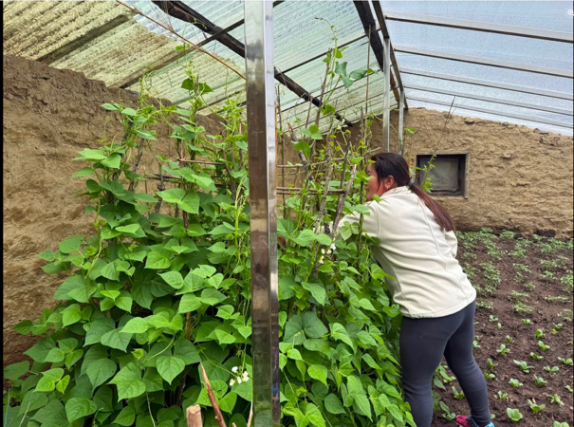
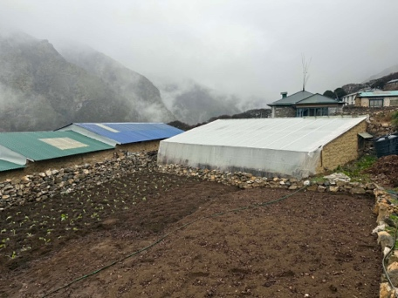
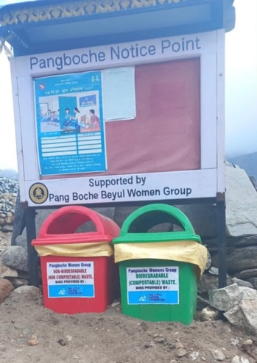
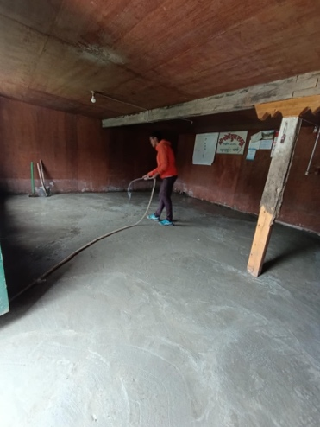

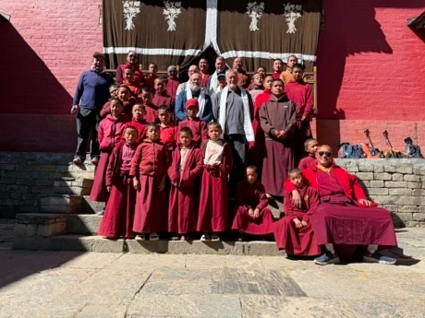
Financial review

Statement of the charity’s policy on reserves
Having been involved in supporting communities in adverse situations like avalanches, earthquakes and floods, we have decided to aim to have £25000 in reserve so we can help immediately.

Details of any deficit
None

Donated facilities and services
None

Future plans
In a remote and unpredictable environment like the Khumbu, all plans are subject to alteration.
- Build a second polytunnel
- Provide furnishings for the community hall
- Introduce refuse bins to more villages
- The documentary, The Everest Dream, will hopefully be shown at various film festivals across the globe, raising awareness of the charity
- Provide suitable clothing for those in need
- Employ a nurse for Phortse clinic
- Increase number of school scholarships
- Support for the elderly in any of the traditional Sherpa villages by facilitating a “meals on wheels” project

Declaration
Signed on behalf of the charity trustees:


James Lamb

Chairperson

08.08.2026

