LITTLE DROPS CHARITY TRUST
COMPANY LIMITED BY GUARANTEE

FINANCIAL STATEMENTS/
ANNUAL ACCOUNTS

Charity Number SC028069

LITTLE DROPS CHARITY TRUST

COMPANY LIMITED BY GUARANTEE
FINANCIAL STATEMENTS
YEAR ENDED 30 JUNE 2025

CONTENTS PAGE
Members of the board and professional advisers 1
Trustees annual report 2
Independent examiner's report on the unaudited accounts 5
Statement of financial activities 6
Balance sheet 7
Notes to the financial statements 8

LITTLE DROPS CHARITY TRUST
COMPANY LIMITED BY GUARANTEE

MEMBERS OF THE BOARD AND PROFESSIONAL ADVISERS

Registered charity name Little Drops Charity Trust
Charity number SC028069
Company registration number SC186943

Registered office 10 Cairnlee Crescent North
Aberdeen
Aberdeenshire
AB15 9TY

Trustees Mrs. Lakshmi Manivannan, MSc. - Director
Dr Jayanthi Murali - Treasurer

Secretary Dr Indrani Manoharan

Independent Examiner David Minett, CA

Bankers Bank of Scotland
48 Upperkirkgate,
Aberdeen
AB10 1BA

The Royal Bank of Scotland
Branch office: St Nicholas(A)
Cartsdyke Avenue, Cartsburn East,
Greenock, PA15, 1EF

The Royal Bank of Scotland
749 Ormskirk Road
Pemberton
Wigan
WN5 8AS

Virgin Money
Jubilee House
NE3 4PL

LITTLE DROPS CHARITY TRUST

COMPANY LIMITED BY GUARANTEE
TRUSTEES ANNUAL REPORT

YEAR ENDED 30 JUNE 2025

The trustees, who are also directors for the purposes of company law, have pleasure in presenting their report and the unaudited financial statements of the charity for the year ended 30 June 2025.

REFERENCE AND ADMINISTRATIVE DETAILS
Reference and administrative details are shown in the schedule of members of the board and professional advisers on page 1 of the financial statements.

The trustees
The trustees who served the charity during the period were as follows:

Mrs. Lakshmi Manivannan. MSc.
Dr Jayanthi Murali

STRUCTURE, GOVERNANCE AND MANAGEMENT
Little Drops Charity Trust was constituted as a company limited by guarantee and does not have a share capital by Memorandum and Articles of Association on 19 June 1998. The liability of the members is limited to £1 each. As of 30 June 2025, there were 3 members.
All of the charity's trustees are appointed or reappointed by the members at our annual general meeting.

OBJECTIVES AND ACTIVITIES
a) To advance education in preventative medicine for the benefit of people living in developing countries of the world.
b) To both preserve, protect and further the health of people living in developing countries of the world by seeking to improve the quality and effectiveness of existing health services in those countries.
As ancillary, the company shall endeavour -
i) to heighten the awareness among policy makers, professionals and the public in the importance of preventative medicine.
ii) to identify, support and implement medical research activities in developing countries and to promote the dissemination of the useful knowledge gained by such research.

LITTLE DROPS CHARITY TRUST

COMPANY LIMITED BY GUARANTEE
TRUSTEES ANNUAL REPORT (continued)

YEAR ENDED 30 JUNE 2025

ACHIEVEMENTS AND PERFORMANCE
This year we have supported a new project, to help the victims of child sexual abuse in Tamil Nadu, India. Protection Of Children from Sexual Offences (POCSO) Act came into effect on 14th November 2012 which was enacted in consequence to India’s ratification of the UN Convention on the Rights of the Child in 1992. Of all the registered crimes against children across the country in 2021, 4% were from Tamil Nadu (6,064). The state stands at the 10th position, in terms of percentage share of the total crimes committed against children during 2021 in the country.
With the help of the registered charity ICWO (Indian Community Welfare Organisation), we were able to help 4 such children for their health checkups and to pay for their boarding school fees and by their school uniform. We were also able to support their families with legal and counselling support.
Student development centres have been established in rural villages in Kollapally. These are currently 5 centres as tuition centres for school age children. We can see improvement in the children's school performance and their ability to apply for university. There are plans to increase the number of centres.
We are also providing school bags, uniforms and study materials for school children from poor family backgrounds in the district of Dharmapuri.
We continue our support for destitute children in St Jospeh social centre, in Chennai.
Few years ago, we started supporting Shravana, the audiology project at Hyderabad, India, which helps to identify, rectify and rehabilitate children with deafness. This project is going strong and is making steady progress. This project is helpful in early identification of the children born with defective hearing and thus helping to integrate them into mainstream school by the time they are school age.

FINANCIAL REVIEW
We hold £ 55,200.90 in a high interest account in Virgin Money directed towards the education of children at St. Joseph Centre, India. A small deficit balance in 24-25 shows our commitment to spend our reserves when needed.

RESPONSIBILITIES OF THE TRUSTEES
The trustees are responsible for preparing the Trustees Annual Report and the financial statements in accordance with applicable laws and regulations.

Company law requires the trustees to prepare financial statements for each financial year. Under this law, the trustees have elected to prepare the financial statements in accordance with United Kingdom Generally Accepted Accounting Practice. The financial statements are required by law to give a true and fair view of the state of affairs of the charity and of the surplus or deficit of the charity for that period.

LITTLE DROPS CHARITY TRUST

COMPANY LIMITED BY GUARANTEE
TRUSTEES ANNUAL REPORT (continued)

YEAR ENDED 30 JUNE 2025

In preparing these financial statements, the trustees are required to:
- select suitable accounting policies and then apply them consistently;
- make judgments and estimates that are reasonable and prudent;
- prepare the financial statements on the going concern basis unless it is inappropriate to presume that the charity will continue in operation.

The trustees are responsible for keeping proper accounting records which disclose with reasonable accuracy at any time the financial position of the charity and which enable them to ensure that the financial statements comply with Companies Act 2006. The trustees are also responsible for safeguarding the assets of the charity and therefore for taking reasonable steps for the prevention and detection of fraud and other irregularities.
This report has been prepared in accordance with the special provisions of Part 15 of the Companies Act 2006 relating to small companies.

Independent Examiner
Independent examination of the accounting records kept by the charity was carried out by

Mr David Minett
-------------------------------------------------------------------------------------

Registered office: Signed by order of the trustees
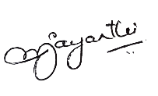
10 Cairnlee Crescent North
Aberdeen
Aberdeenshire
AB15 9TY

Dr. JAYANTHI MURALI
Company Treasurer

ttle Drops Charity Trust
Scottish Charity Number SC028069

Receipts and Payments Account
for the year ended 30 June 2025

 | 2025 | 2024
 | £ | £
Receipts
Donations | 19987 | 20212
Fund raising | 35867 | 60501
Investment income | 2266 | 1771
Total receipts | 58120 | 82484
Payments
Project work | 53107 | 64862
Fund raising cost | 8656 | 7070
Administrative expenses | 1382 | 808
Total payments | 63145 | 72740
(Deficit)/surplus for the year | -5025 | 9744

All funds are unrestricted.

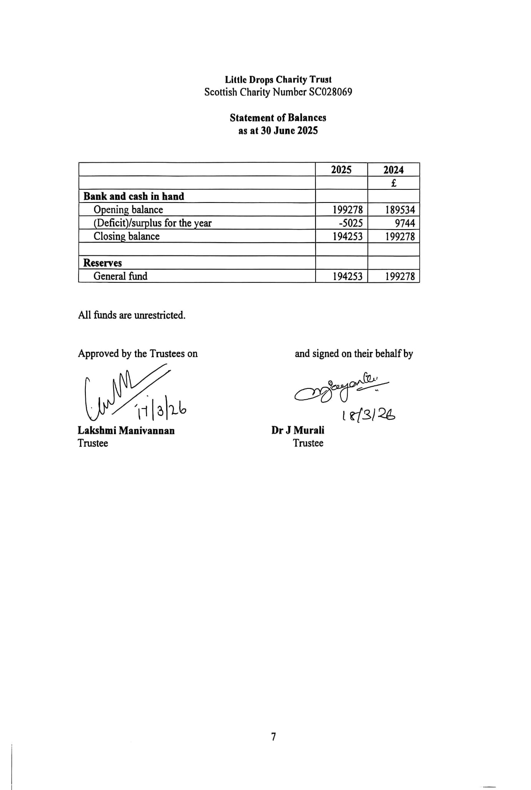

LITTLE DROPS CHARITY TRUST

COMPANY LIMITED BY GUARANTEE
NOTES TO THE FINANCIAL STATEMENTS

YEAR ENDED 30 JUNE 2025

1. ACCOUNTING POLICIES

Basis of accounting
The financial statements have been prepared under the historical cost convention and in accordance with FRS102 (issued in September 2015 for accounts from 1 January 2016) The Financial Reporting Standard applicable in the UK and Republic of Ireland.
Cash flow statement
The trustees have taken advantage of the exemption in Financial Reporting Standard No 1 (revised) from including a cash flow statement in the financial statements on the grounds that the charity is small.
Receipts
Receipts comprise of donations, fundraising, investment income and income from all other sources classified under the headings to which they are directly attributable in accordance with the SORP.
Donations and fundraising income are credited to the statement of financial activities (the "SOFA") in the year which they are received. Investment income and other sources of income are included on an accruals basis and brought in when they fall due.
Payments
Payments are accounted for on an accruals basis and have been classified under headings, to which they are directly attributable, in accordance with the SORP.
During the year, grants totalling £53,107 (2024: £64,862) were made for the benefit of 6 (2024: 6) institutions as follows:

Shravana children hearing Centre £30,563
St. Joseph social service Centre £6,514
ICWA (Indian Community Welfare Organisation) £4,634
Little drops Chennai £4,408
Grace Vision Centre £3,109
Koodu Social education £3,879

Administrative costs
It consists of the costs of the accounts preparation and any expenditure incurred in compliance with the legal requirements of the charity.
Taxation status
The company has charitable status and is exempt from taxation. The company is not registered for VAT and accordingly any irrecoverable VAT is included in the expenditure concerned.

LITTLE DROPS CHARITY TRUST

COMPANY LIMITED BY GUARANTEE
NOTES TO THE FINANCIAL STATEMENTS

YEAR ENDED 30 JUNE 2025

2. RELATED PARTY TRANSACTIONS

During the year, the company donated £4,408 to its associated company, Little Drops Charity Trust, Chennai. Dr. Jayanthi Murali is also one of trustees of the Little Drops Charity Trust, Chennai.

3. COMPANY LIMITED BY GUARANTEE

Little Drops Charity Trust is a company limited by guarantee. The liability of each member is limited to £1. If any property remains upon the winding up or dissolution of the company after all its debts and liabilities are met, this will not be paid to or distributed among the members of the company. Instead, however, it shall be given or transferred to some Charitable Institution having objectives similar to the objectives of the company.

