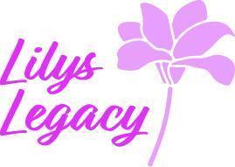Trustees’ Annual Report

Lily’s Legacy
SCO52112
42 Uist Place
Perth
PH1 3BY

Trustees:
Jane Douglas
Kenneth McLeod
Kirsty Robertson

Lily’s Legacy is a Scottish Charitable Incorporated Organisation (SCIO)

Charitable Purpose:
The purpose of the Charity is based on the wishes of Lily Douglas who whilst battling terminal cancer for 5 years with Ewing’s Sarcoma wanted other children to benefit from similar help that she had received from charities and to help bring awareness to rare childhood cancers. Our purpose is to:

Raise funds and provide practical, useful, fun items for the following groups:
- Children with life threatening and or terminal illnesses and their families and or close support groups
- Families following the tragic, unforeseen loss of a child
- Families with children whilst going through cancer treatment; up to two years after treatment ceases; or the loss of a child from cancer

To raise funds to establish a retreat, proposed to be called ‘Lily’s Lodge’, to provide free respite for those mentioned above.

Applicants for support from the charity can be from anywhere in the United Kingdom.

Charity Achievements:

Lily’s Legacy continues to build networks and relationships and secure donations to support the charity.
Donations received as at 31 October 2025 total £42’697, an increase of £8,629 since last years return. To date the charity has not yet made any purchases. Fundraising for Lily’s Lodge continues, the charity is planning to register with larger charity events and encourage our supporters to raise sponsorship on behalf of the charity.

While the Charity continues to grow and develop Trustees have been attending befriending sessions such as

- Book launch
- Dance Events

Donated facilities and services:
Lily’s Legacy would like to thank and acknowledge McLeod Glaziers of Perth who provide free use of their boardroom for meeting purposes. The Charity also thanks Major Golf Events for their continued support and donations. This year the charity has also been supported by Iain Ruttledge who has represented Lily’s Legacy at White Collar Boxing events, showing fight and dedication to Lily’s Legacy.

Other information
Lily’s Legacy is grateful for the support received to date from the Dance Community and honoured to see that Lily’s legacy is recognised at these events and awards are given in her memory.

The Committee and the Charity is looking forward to the upcoming national Dance Competition in Lily’s name and our calendar of events taking shape.

Trustee Signature:
Jane Douglas 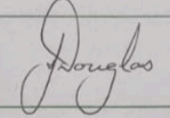
Treasurer/Secretary:
Tina Brander 

