Scottish Charity Number – SC048590
Annual Report and Financial Statements
For the year ended 31 July 2025



OSCR |  |  | Trustees’ Annual Report for the period
OSCR |  | Period start date |  |  |  | Period end date
OSCR |  | Day | Month | Year |  |  | Day | Month | Year
OSCR | From | 31 | 7 | 2024 |  | To | 31 | 7 | 2025
Office of the Scottish Charity Regulator

Reference and administration details

Charity name |  | Lifestars SCIO
Other names charity is known by |  | N/A
Registered charity number |  | SC048590
Charity’s principal address |  | 19 Rugosa Circle
 |  | Newmachar
 |  | Aberdeenshire
 |  |  | Postcode: AB21 0NJ

Names of the charity trustees on date of approval of Trustees’ Annual Report

 | Trustee name | Office (if any) | Dates acted if  not for whole year | Name of person  (or body) entitled to  appoint trustee (if any)
1 | Neve McPherson |  | Whole Year
2 | William McPherson |  | Whole Year | Neve McPherson
3 | Barry Duncan |  | Whole Year | Neve McPherson
4 | Neil McKinnon |  | Whole year | Neve McPherson
5 | Cerri MacDonald |  | Whole Year | Neve McPherson
6 | Sunny Harper |  | Whole year | Neve McPherson
7 | Harvey Smith |  | Whole Year | Neve McPherson
8 | Lynette McPherson |  | Whole Year | Neve McPherson

Reference and administration details

Names of all other charity trustees during the period, if any, (for example, those who resigned part way through the financial period)

Name | Dates acted if not for whole year
N/A | N/A

Structure, governance and management

Constitution
The Charity is a Scottish Charitable Incorporated Organisation (a SCIO). It was registered in its current legal form on 31 July 2018. It has a single tier structure and as such the trustees are the members of the charity. The structure of the organisation consists of the charity trustees who are also the organisation’s only members and comprise the organisation’s board.
Trustee Recruitment and appointment
The recruitment of trustees is based upon the benefit in which they may bring to the charity itself. The decision to register a trustee is made at board meetings of which are held monthly. Any person, nominated individual or body who/which wishes to become a Charity Trustee must sign a written application for Charity Trusteeship which includes their personal details. The Board may, at its discretion, refuse to admit any person, nominated individual or corporate body. The minimum number of trustees is three and the maximum is ten.

Objectives and activities

Charitable Purposes
The organisation is established for charitable purposes only, and in particular, the objects are:
To organise recreational activities with the object of improving the conditions of life for children and young people with additional support needs.
To advance the education of children and young people with additional support needs through activities which develop life skills.
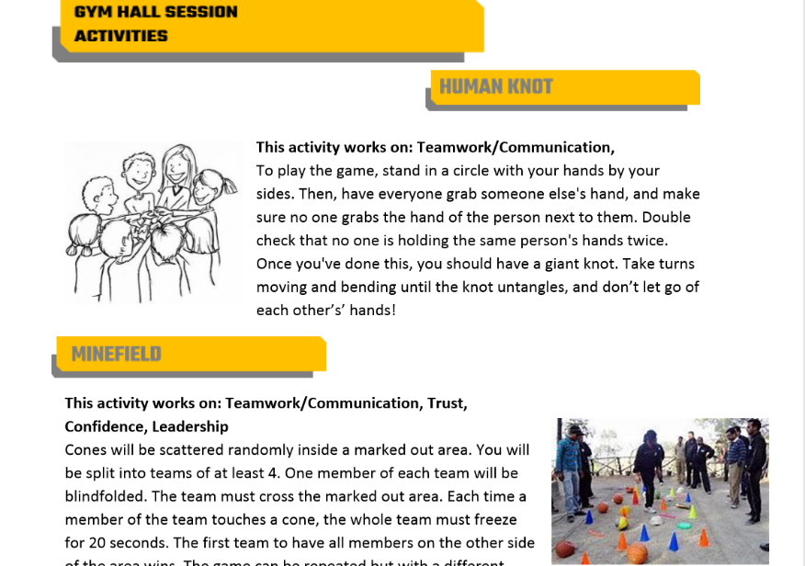
Activities which address these purposes
Lifestars Life Skills programme aims to teach children with additional support needs five key skills: leadership, communication, trust, pride and confidence. As well as holding lunchtime clubs in schools, these children get the opportunity to utilise these skills we teach in a wider setting by attending events on the SportAberdeen additional support needs calendar.
We further their learning and educational experience by providing them with trips that the school and/or their parents may not be able to afford without our support. For example, trips to residential activity centres, educational centres etc.
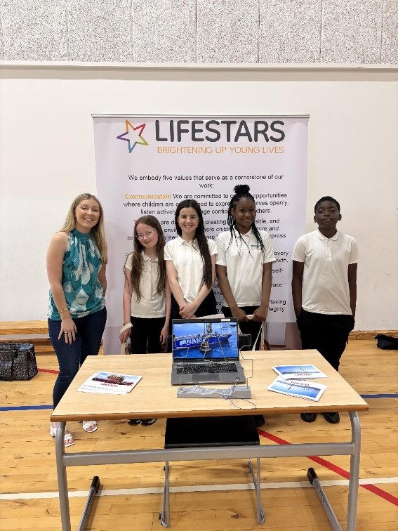
Achievements and Performance
This year saw the introduction of Bridge of Don Academy to the Lifestars family. Our skills programme is now up and running there and is adding beneficial development to the senior and junior pupils who take part. We have also provided them with several trips to enhance their learning experience and utilise the skills learned in the sessions.
At Dyce Academy our skills sessions saw the opportunity for pupils to embark on two fantastic resilience days which included gorge walking and coasteering along local coastlines.
We continue to work very closely with Hanover Street Primary School creating many opportunities for their pupils throughout the year. For example, P7enjoyed a trip to Hazelhead park for a picnic and games as part of their end of year activities, as well as an amazing day out at Lochter Activity centre where they tested their limits rock climbing, zip-lining and go karting. We continue to run weekly sessions at Hanover to develop key life and social skills.

We continue to deliver our primary school career fairs, which continues to breed a wealth of knowledge to the children we work with and open their minds to the world of work around them. We aim to offer this to more primary schools in the following years.

Financial review

Our main source of funding this year has been through corporate donations. We have also had a few fundraisers which enhanced our ability to deliver a successful skills programme to pupils, transport them to and from sporting events and provide specialist equipment.
Reserves Policy
The charity trustees agree that £2,500 is reserved in order to meet commitments and to cover any unexpected expenditure. We believe this is an appropriate amount but is reviewed at quarterly board meetings to monitor the situation

Other Optional Information

Plans for future
We aim to introduce 2 more schools into the Lifestars family next year.
It is also planned that next year we deliver a playground overhaul for Hanover Street Primary School which will see a more educationally engaging space for all pupils.

Declaration

The trustees declare that they have approved the trustees’ report above.

Signed on behalf of the charity’s trustees

Signature(s) | 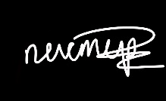
Full name(s) | Neve McPherson | William McPherson
Position (e.g. Chair) | Founder | Trustee
Date | 13/03/26 | 13/03/26

Statement of Receipts and Payments for the year ended 31 July 2025
Receipts
 | Unrestricted Funds | Restricted Funds | Year Ended 31/7/25 | Previous year  31/7/24
Donations | £12,964 | - | £12,964 | £9,040.71
Fundraising | £10,412.68 | - | £10,412.68 | £3,154.61
Total receipts | £23,376.68 | - | £23,376.68 | £12,195.32

Payments
 | Unrestricted Funds | Restricted Funds | Year Ended 31/7/25 | Previous year  31/7/24
Fundraising costs | £6,299.40 |  | £6,299.40 | £1,350
Payments relating directly to charitable activities | £13,145,26 |  | £13,145.26 | £6,389.83
Governance costs | £2,925.69 |  | £2,925.69 | £1,167.23
Total payments | £22,370.35 |  | £22,370.35 | £8,907.06
Surplus/deficit for year | £1,006.33 |  | £1,006.33 | £3,284.26

Statement of Balances - As at 31 July 2025
 | Unrestricted Funds | Restricted Funds
Cash and bank balances at start of year | £14,376.24 | £0
Surplus / (deficit) shown on receipts and payments account | £1,006.33 | £0
Cash and bank balances at end of year | £15,382.57 | £0
Previous Year 31/7/24
£11,087.98
£3,288.26

£14,376.24
The charity has zero investments, other assets, liabilities or contingent liabilities.

Signed by NEVE MCPHERSON on behalf of all the trustees.
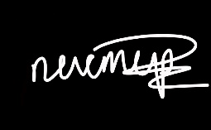
Signed 13/03/26

Notes to the accounts - for the year ended 31 July 2025
These accounts have been prepared on the Receipts and Payments basis in accordance with the Charities & Trustee Investment (Scotland) Act 2005 and the Charities Accounts (Scotland) Regulations 2006 (as amended).

Nature and purpose of funds
The majority of funds held by the charity have been obtained through either corporate donations or charitable donations. These donations are unrestricted. Any other funds held by the charity have been obtained through fundraising activities, again all of which are unrestricted. The purpose of these funds are to enable the charity to improve the lives of children with additional support needs and enhance education through teaching life skills. The majority of the charities funds this financial year have gone towards exactly this, with the rest ensuring the running of the charity itself.

No remunerations were paid to trustees or people with connections to any trustee.
No expenses were paid to trustees or people with connections to any trustee.

Donations
 | Unrestricted Funds | Restricted Funds | Year Ended 31/7/25 | Previous year  31/7/24
Individual Donors | £709.50 | - | £709.50 | £0
Corporate Donations | £12,254.50 | - | £12,254.50 | £9,040.71
Total donations | £12,964 |  | £12,964 | £9,040.71

Receipts relating directly to charitable activities

 | Unrestricted Funds | Restricted Funds | Year Ended 31/7/25 | Previous year  31/7/24
Fundraising at charity activities | £10,412.68 | - | £10,412.68 | £3,154.61
Total | £10,412.68 |  | £10,412.68 | £3,154.61
Total receipts | £23,376.68 |  | £23,376.68 | £12,195.32

Cost of charitable activities
 | Unrestricted Funds | Restricted Funds | Year Ended 31/7/25 | Previous year 31/7/24
Postage/administration expenses | £594.42 | - | £594.42 | £105.84
Travel/meeting expenses | £40 | - | £40 | £320
School equipment/children donations | £544.64 | - | £544.64 | £1,379.77
Activity Costs | £11,966.20 | - | £11,966.20 | £13,523.84
Total | £13,145.26 | - | £13,145.26 | £15,329.45

Governance Costs
 | Unrestricted Funds | Restricted Funds | Year Ended 31/7/25 | Previous year 31/7/24
Financial Records System  Office Technology | £216  £2,108.07 | -  - | £216  £2,108.07 | £201.60  £501.79
Other information | £601.62 |  | £601.62 | £463.84
Total cost | £2,925.69 |  | £2,925.69 | £1,158.42

