

Legal and Administrative Information

Charity Name Kindness Homeless Street Team Glasgow SCIO

Charity Registration No. SC050935

Principal and Registered Office 417/419 London Road
Glasgow
G40 1AG

Trustees Laura McSorley
Carol Cairns
Sinead Brady

Leadership Team Laura McSorley - Chair
Carol Cairns - Secretary
Sinead Brady – Treasurer

Accountant Ms Myra McKinnon, ACMA,CGMA
27 Northbank Road
Kirkintilloch
G66 1EU
Contact no 07901651983
Myra.mckinnon@yahoo.co.uk

Bankers Bank of Scotland
Teviot House
41 South Gyle Crescent
Edinburgh
EH12 9DR

The Trustees present their report and the financial statements of the charity for the year ended 31st December 2025. This is our 5th Annual Report and our fourth year of reporting. Our charity has gone from strength to strength and due to further developing close relationships with local businesses, who support us both financially and by supplying food, essential supplies and offering their time to volunteer, we have now extended our services to reach out and support more people who need our help.

Objectives and Activities
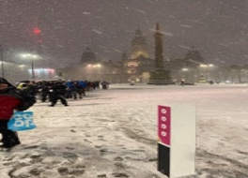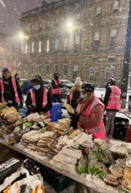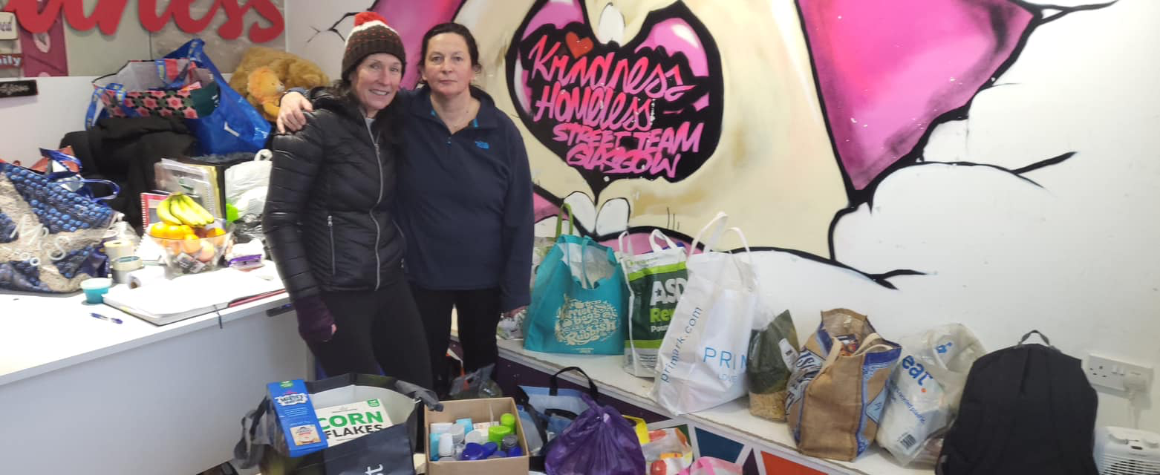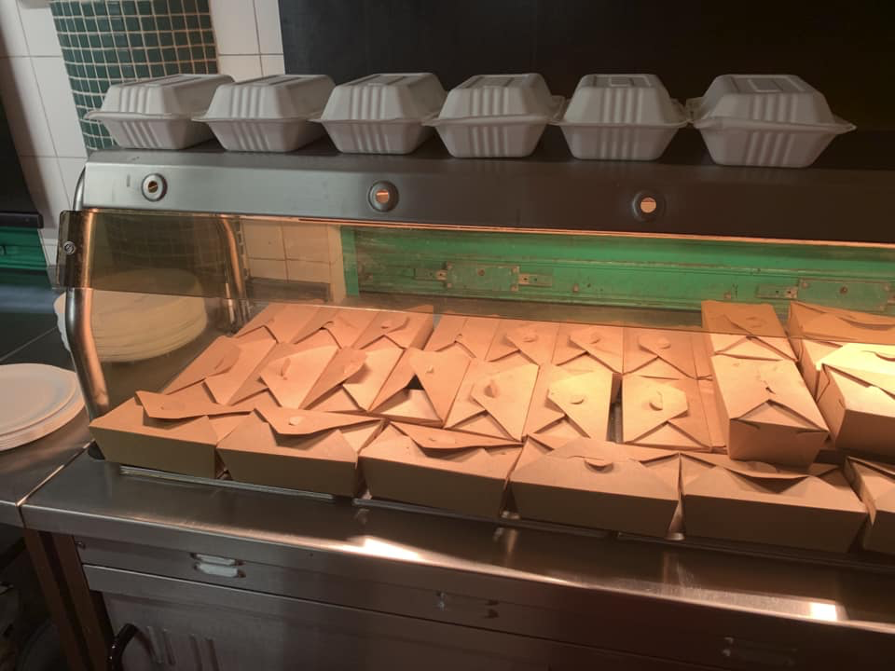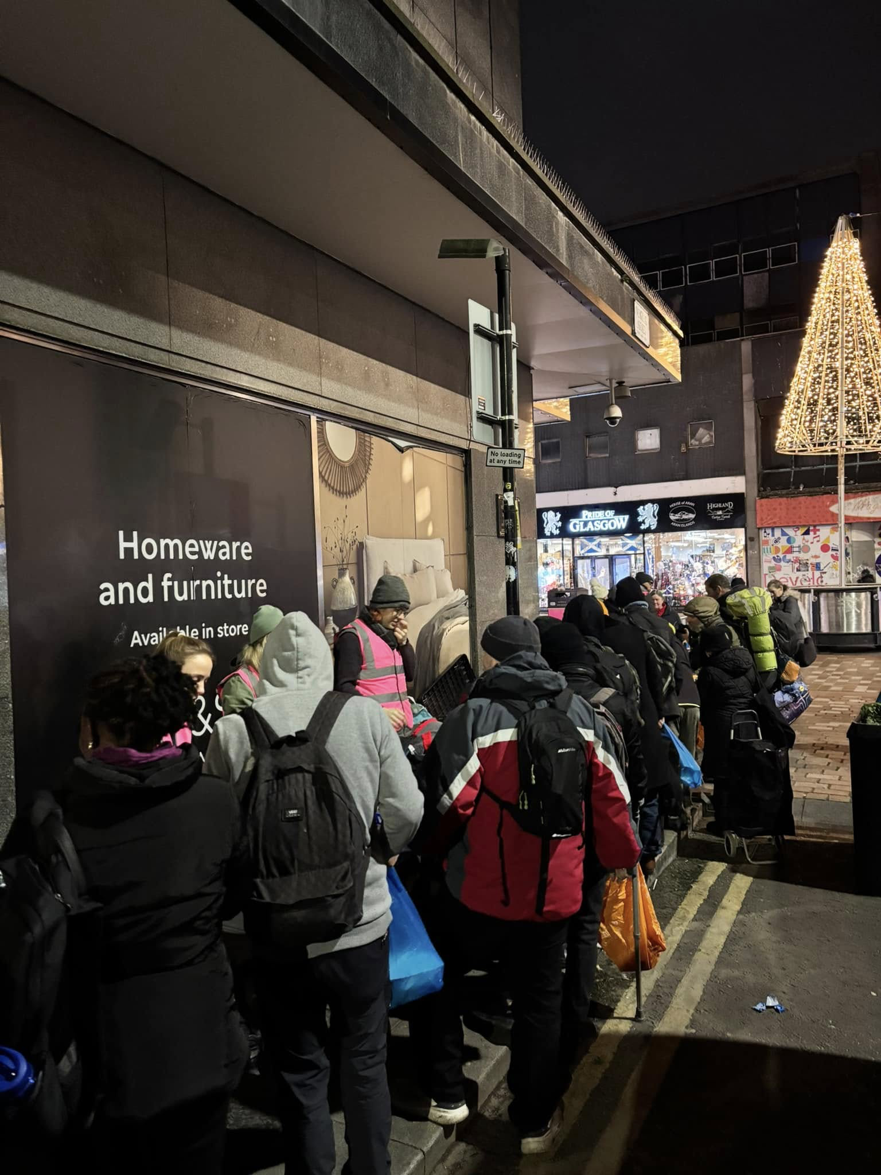
Kindness Homeless Street Team Glasgow SCIO is a charity dedicated to supporting people affected by homelessness, poverty and those vulnerable people of Glasgow and the surrounding area.
We have a pop-up soup kitchen at Marks & Spencer, Argyll Street, 2 evenings/week, our donation centre providing food, clothing, and essentials 3 days/week and our community centre & café Mon-Fri. We also help our service users in their temporary/permanent accommodation by providing furniture and everything needed to turn their empty flats into homes.

In addition to all the services mentioned in our annual return last year we have grown our services since November 2023 when we took over Cadder Community Hub, 110 Tresta Road, Glasgow, G23 5AE.
Our ‘A Little Cup of Kindness’, the Café of Kindness Homeless Street Team Glasgow moved here in November 2023 and we continue offering low cost and free meals to those that need a helping hand. Our menu at the cafe also offers affordable meals and we have a ‘pay it forward’ campaign where people can donate to buy tokens at £4/token then those that are struggling financially can take a token to pay for their meal without embarrassment or any questions asked.

Our vision in Running the Cadder Hub in partnership with Cadder Housing Association has allowed us to be able to offer extra facilities on top of our café, soup kitchens, food bank and clothing centre. Within this new facility we offer wellbeing events including free haircuts, massages, beauty treatments and drop-in sessions for a chat and a general catch up to talk about any help we can offer including referrals that may help them with any mental health issues, addiction problems and we try our best to support everyone that needs our help and point them in the right direction to access support.

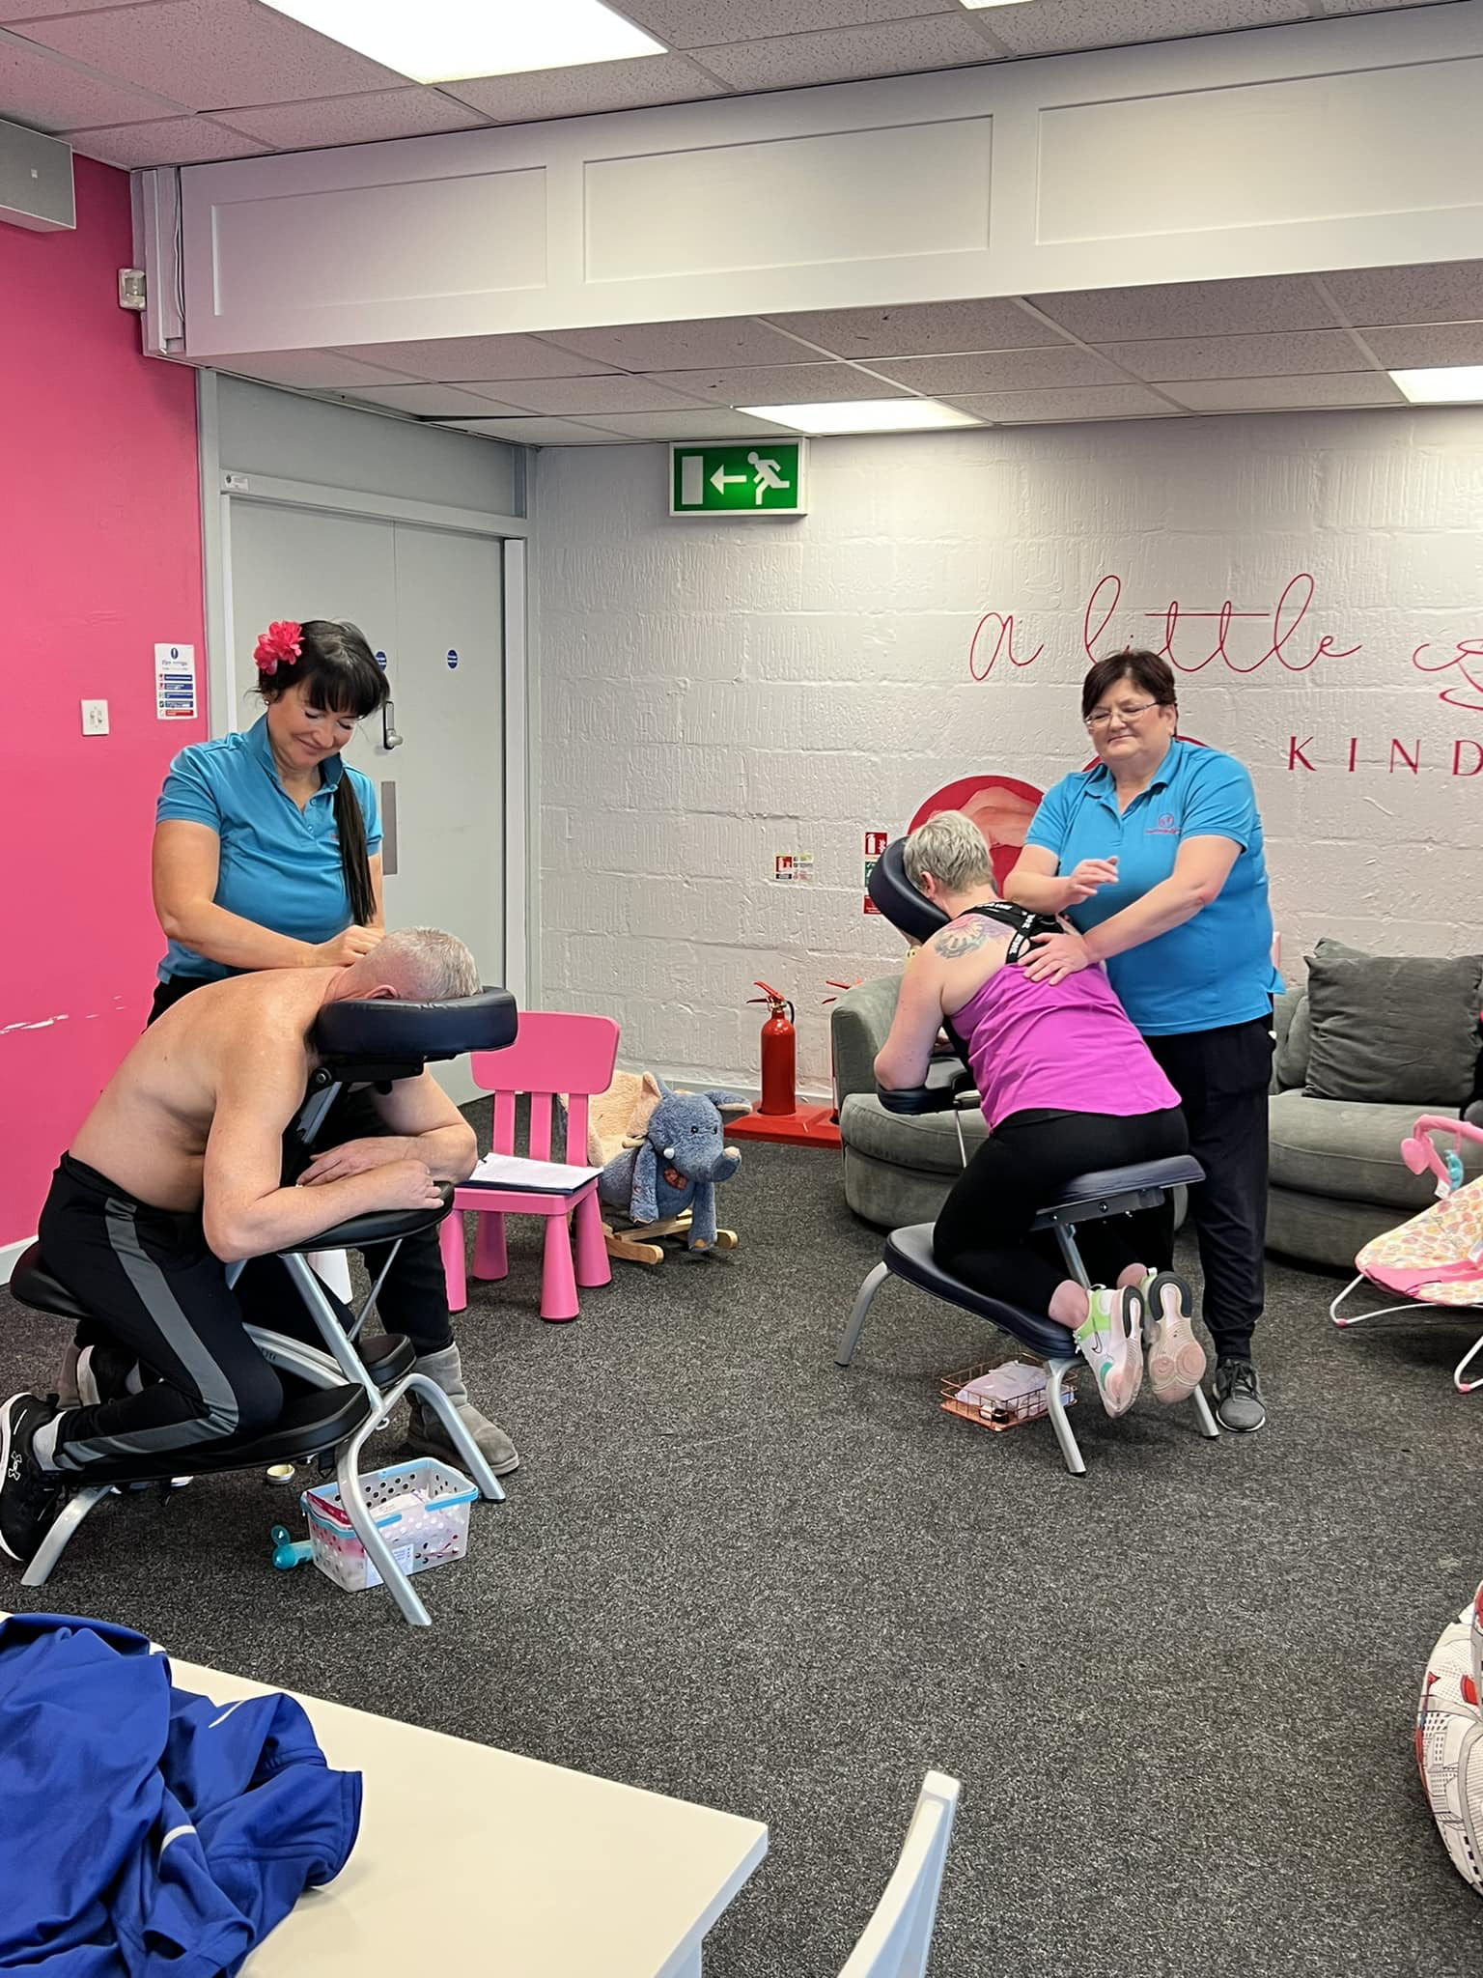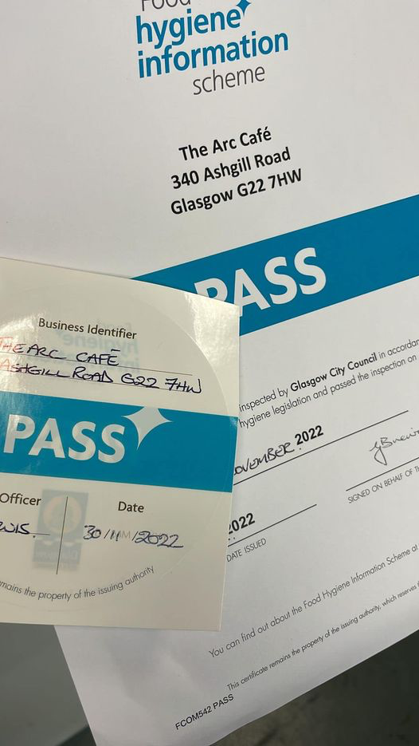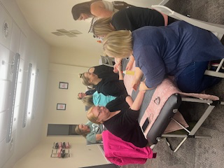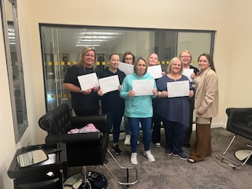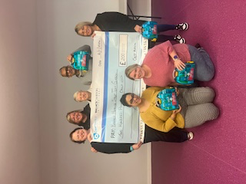

In our Cadder facility we offer lots of extra services to encourage inclusion of all within our community regardless of background or beliefs. Our monthly elderly event also helps combat loneliness and isolation and we put on a free 3 course meal or afternoon tea, live entertainment and a few games of bingo. Our elderly events are well attended, and we also offer a free pick up/drop off service to those that need it. We welcome between 45/50 people, who need a little bit of kindness in their lives, at every inclusion event we host.
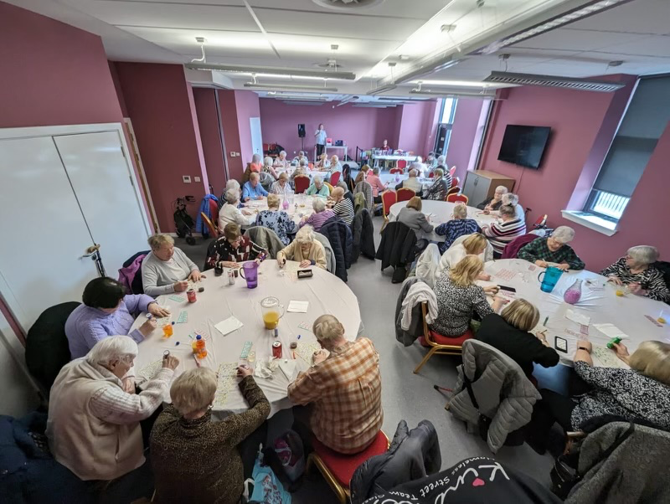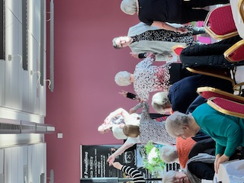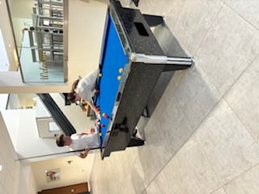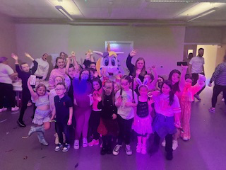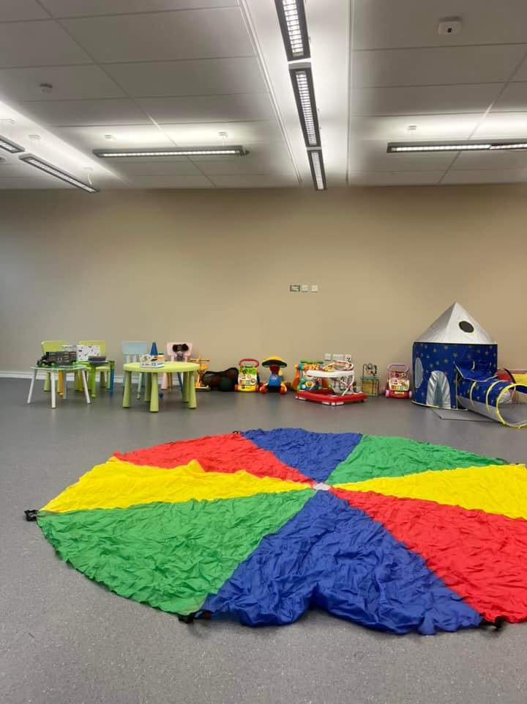
Although seeing the smiles on the children’s, parent’s and every service user’s face is priceless it costs us around £20/head to run each event so every little donation is very much appreciated.
https://www.justgiving.com/kindnessglasgow

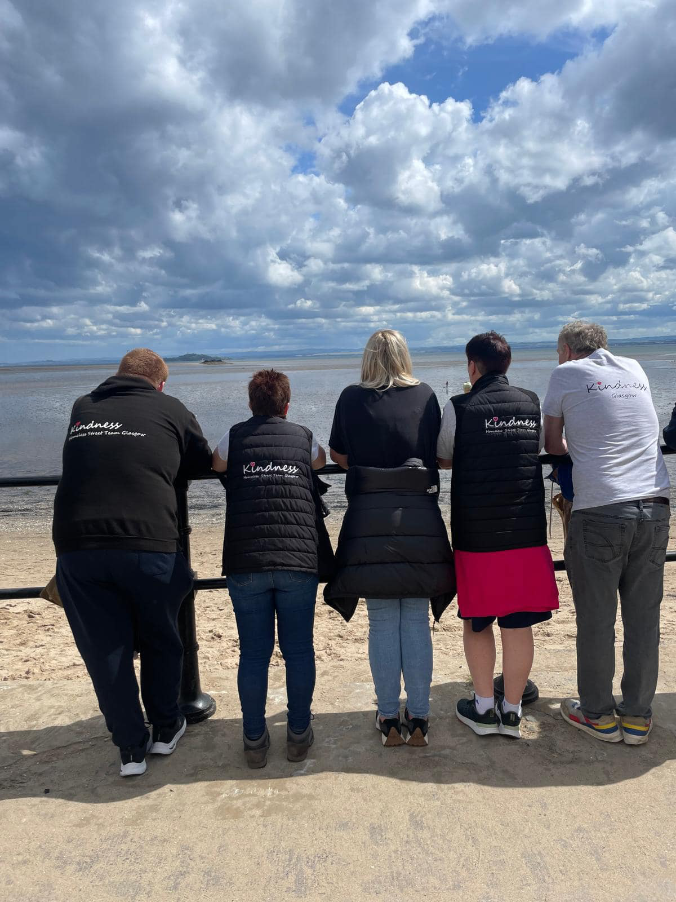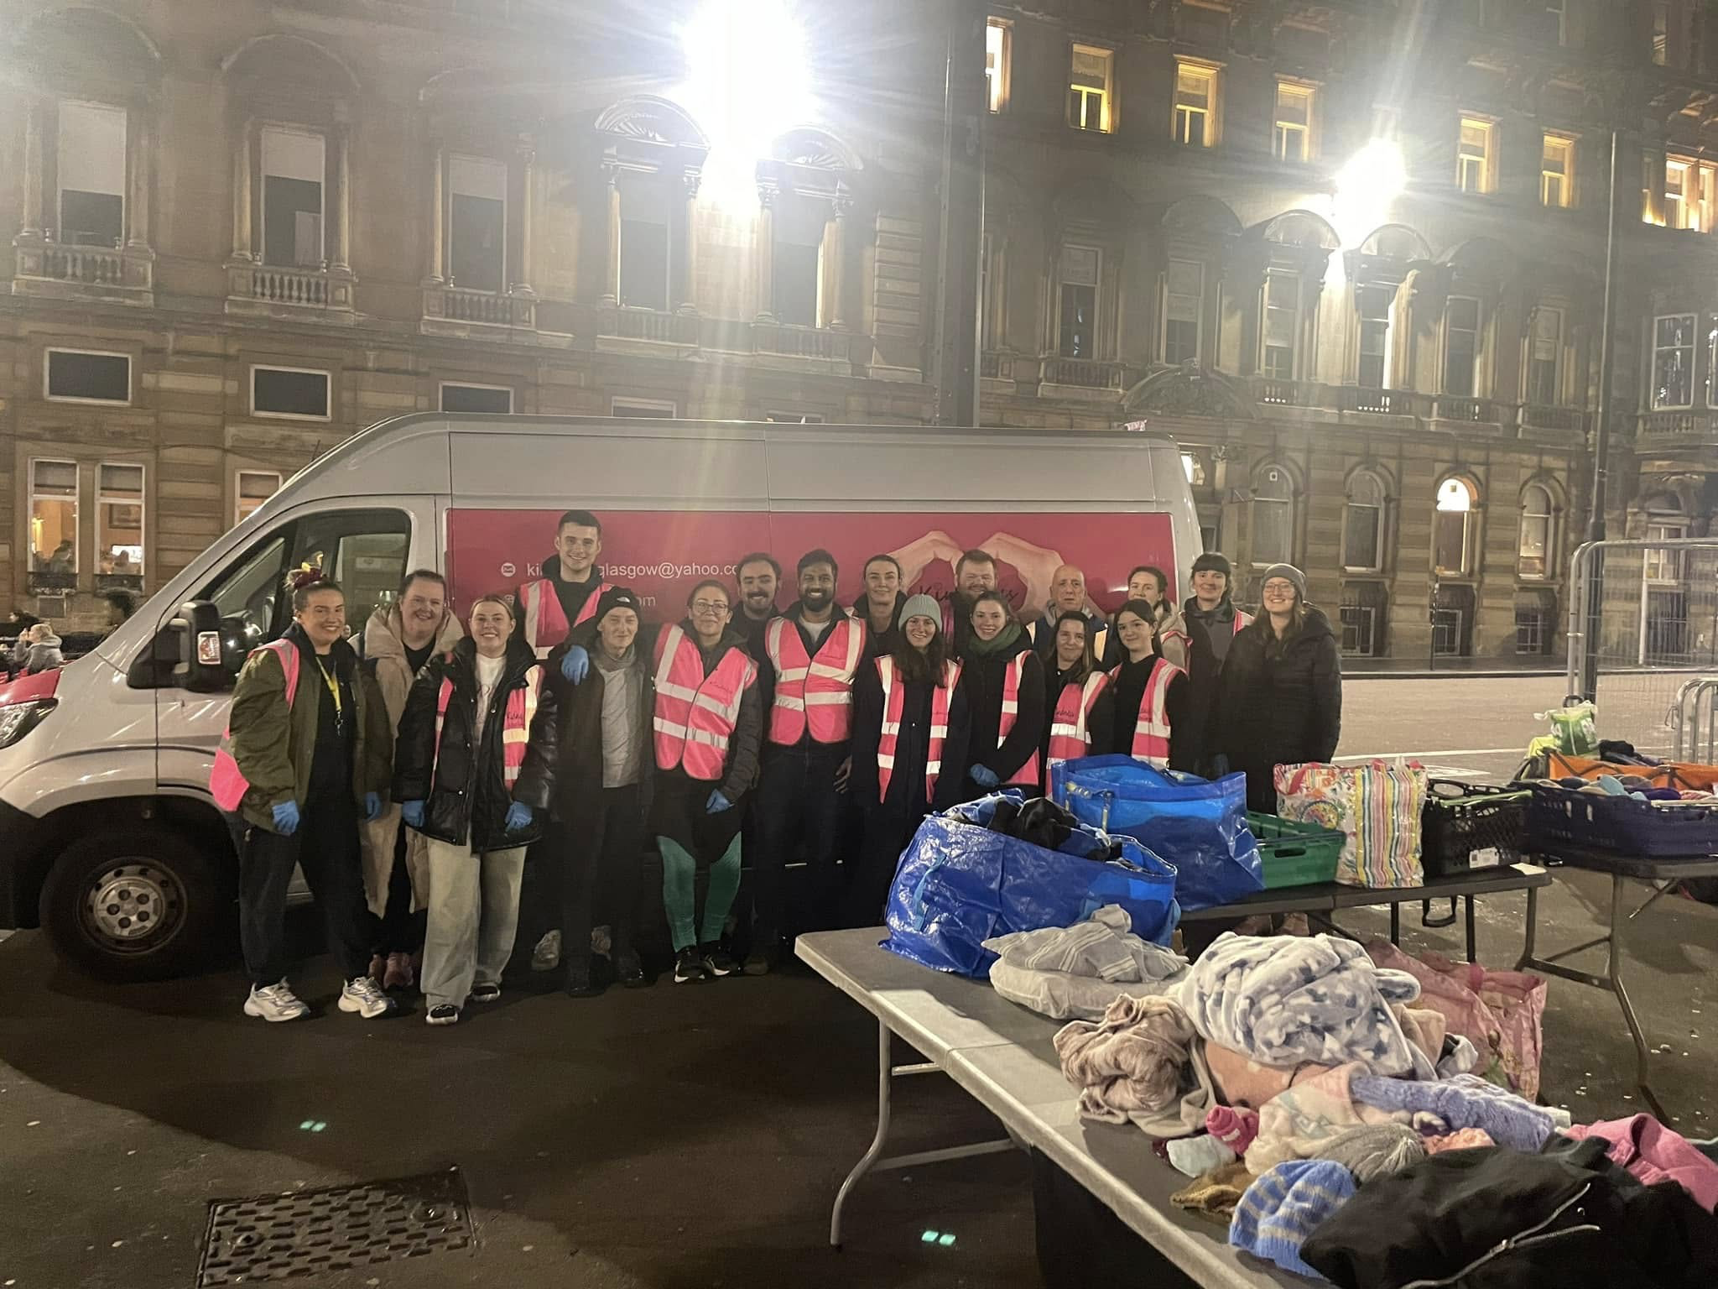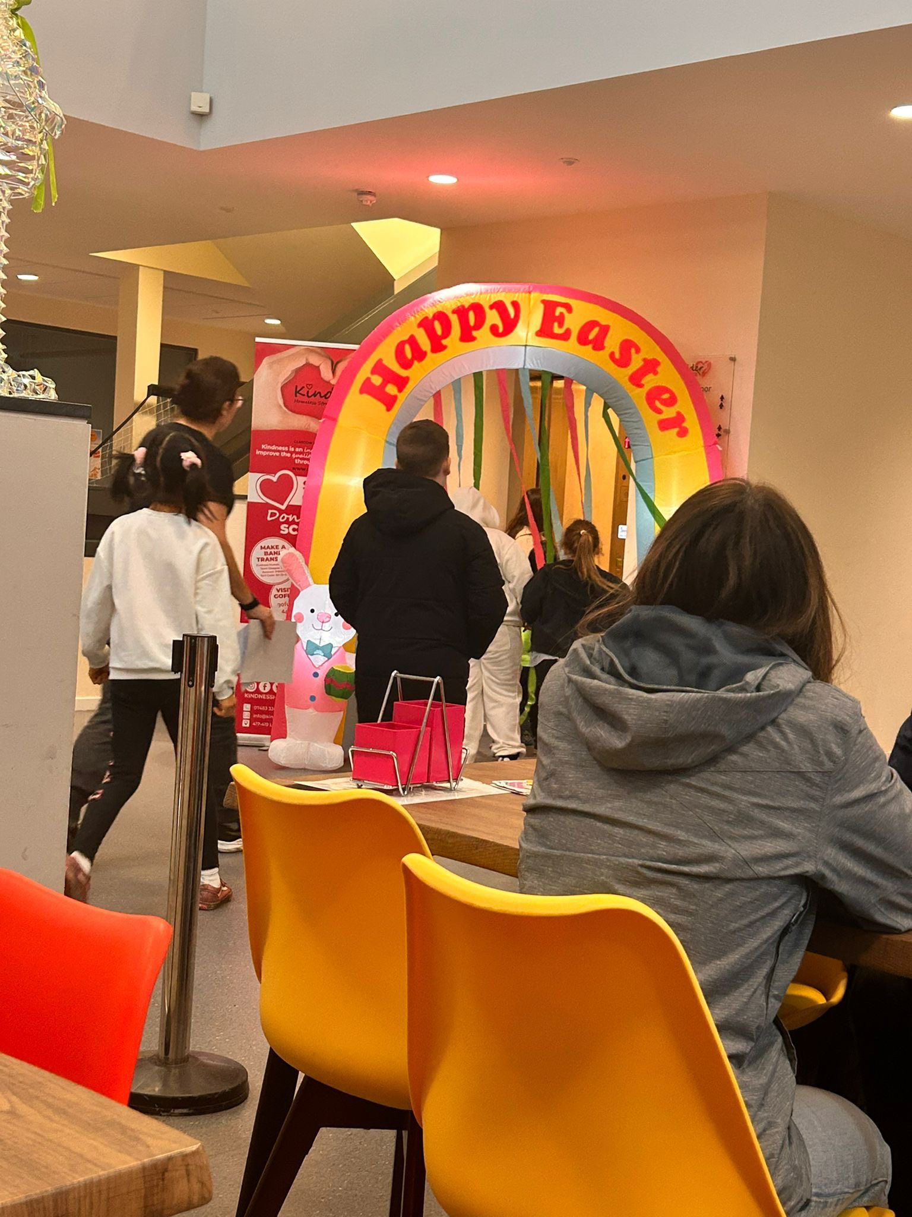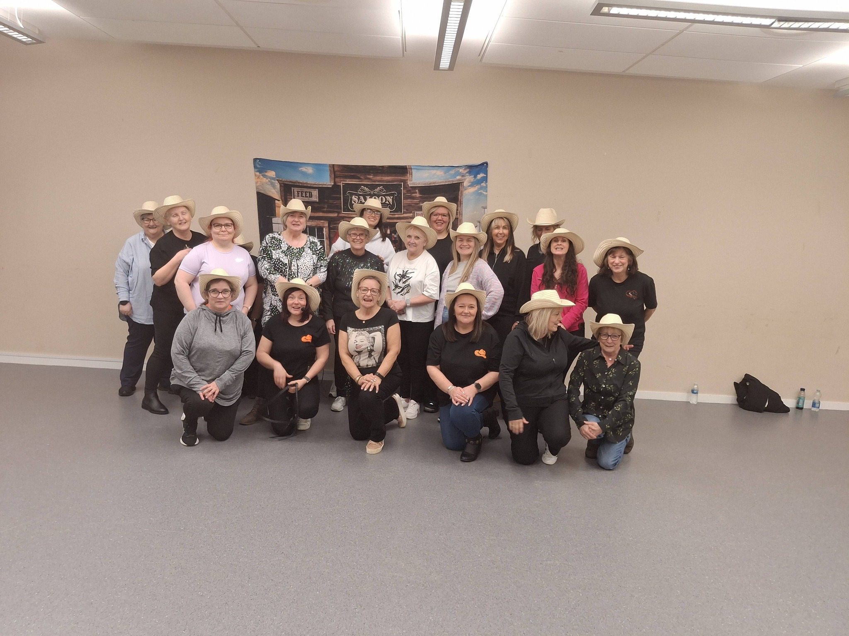
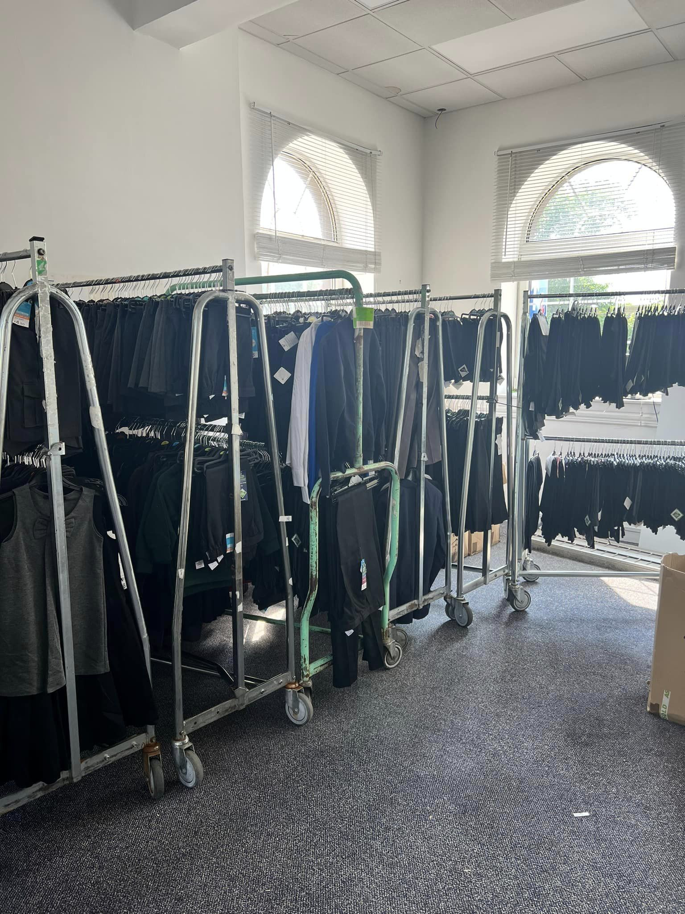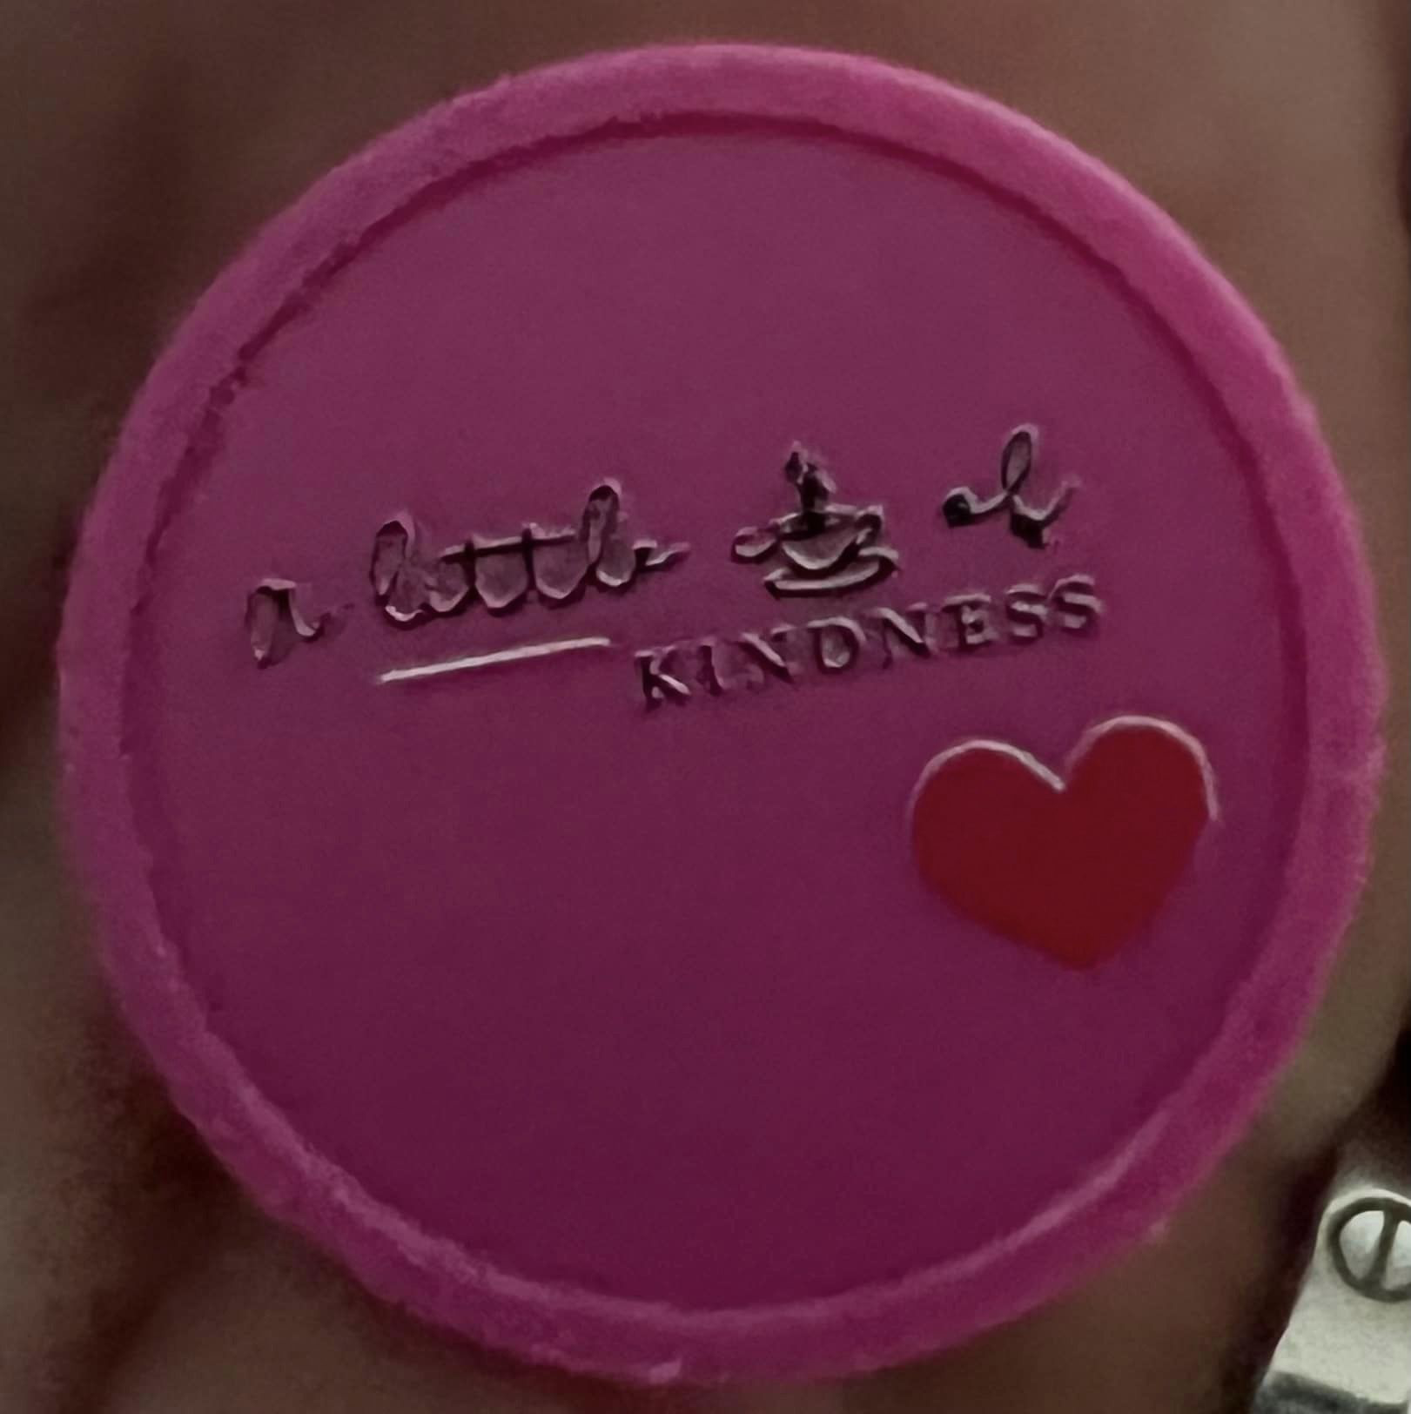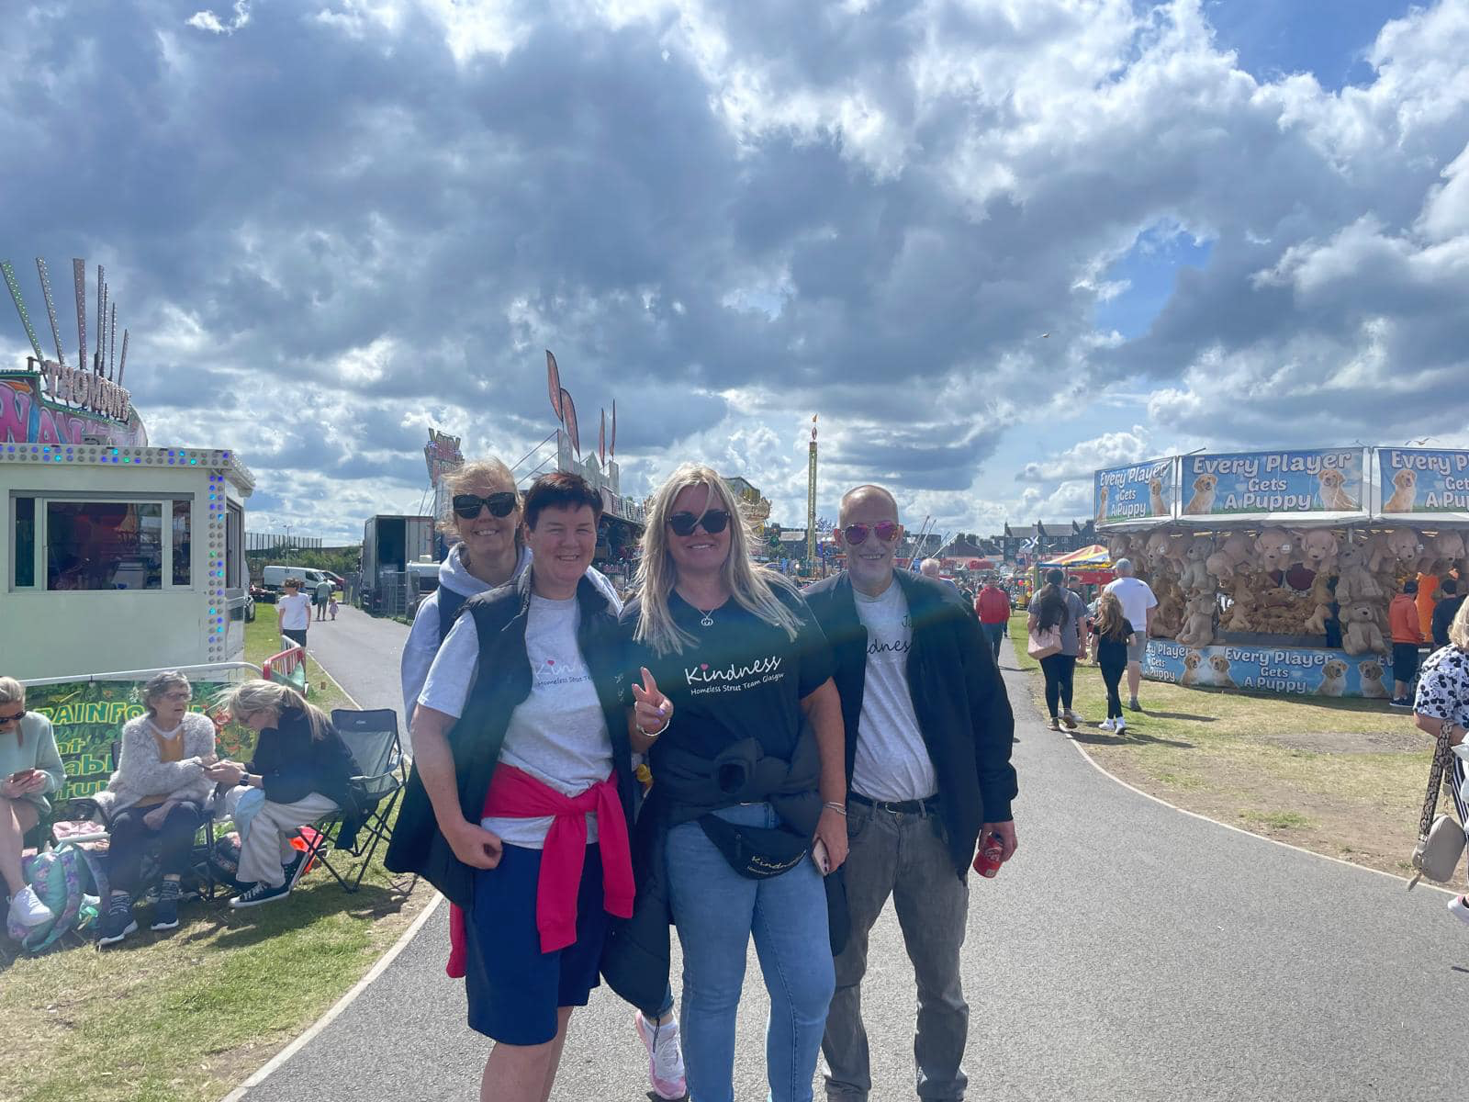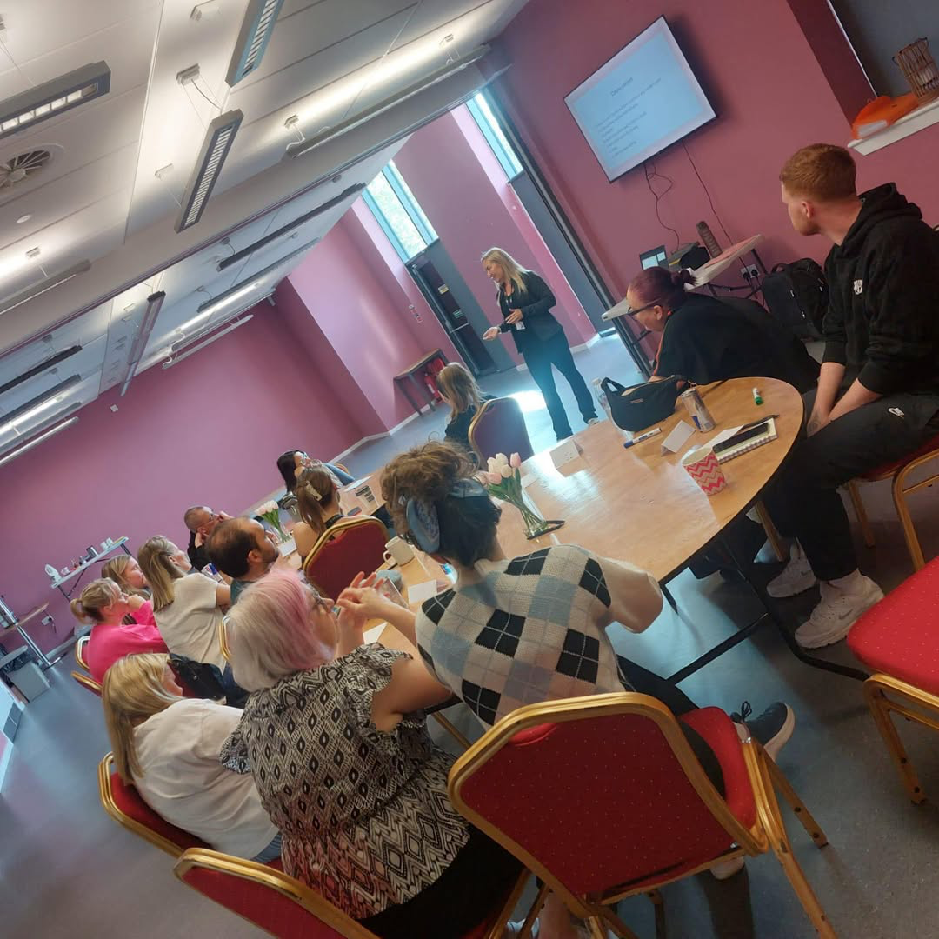

We also offer well-being events at Cadder hub including many courses including dealing with and overcoming anxiety and first aid. We run cooking classes providing all ingredients and recipes showing our service users how to cook on a budget.
At the Community hub we also have boxing classes, keep fit/circuit training in a fully equipped gym, dancing classes, pensioners club, line dancing and lots more. We also have a church using the facility every Sunday and we have lots more ideas to offer community the local community many new services from the Hub and we are excited to see how many more people will benefit from these additional services provided. We launched a Bike library with the help of a grant from Get Active Glasgow and bought 30 children’s bikes of varying sizes so we can engage in community involvement and allow children who do not have a bike an opportunity to join in with our cycling events and bike lending library.
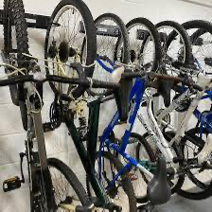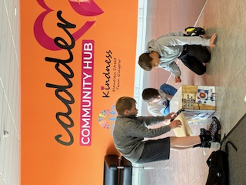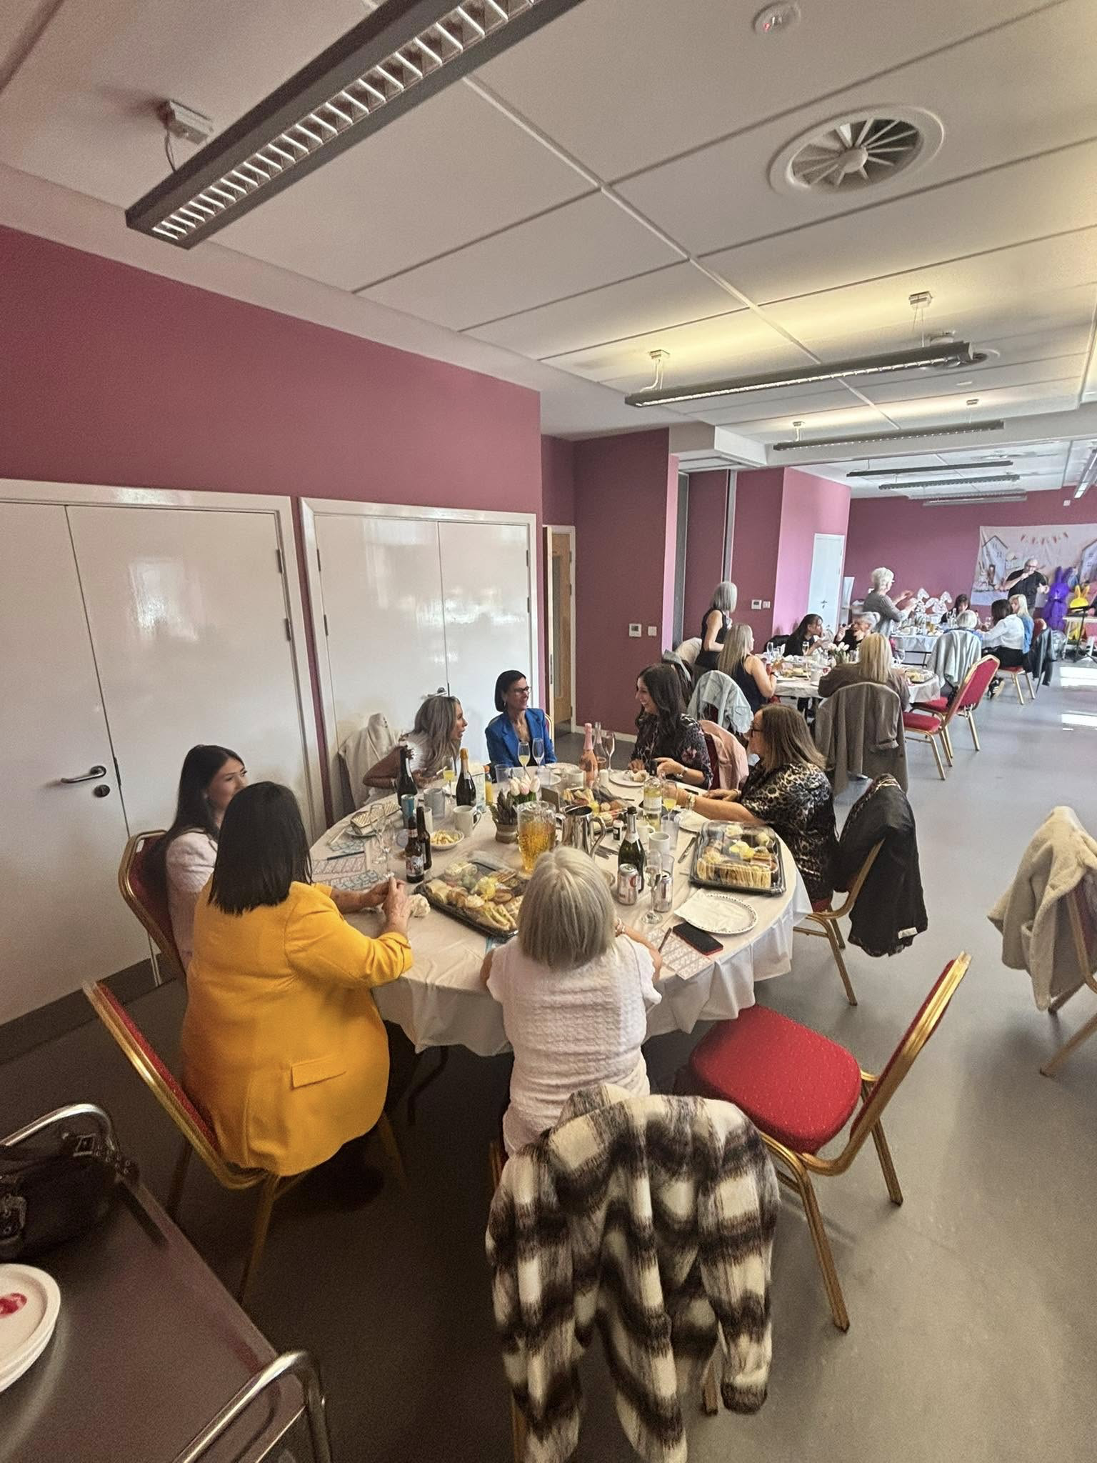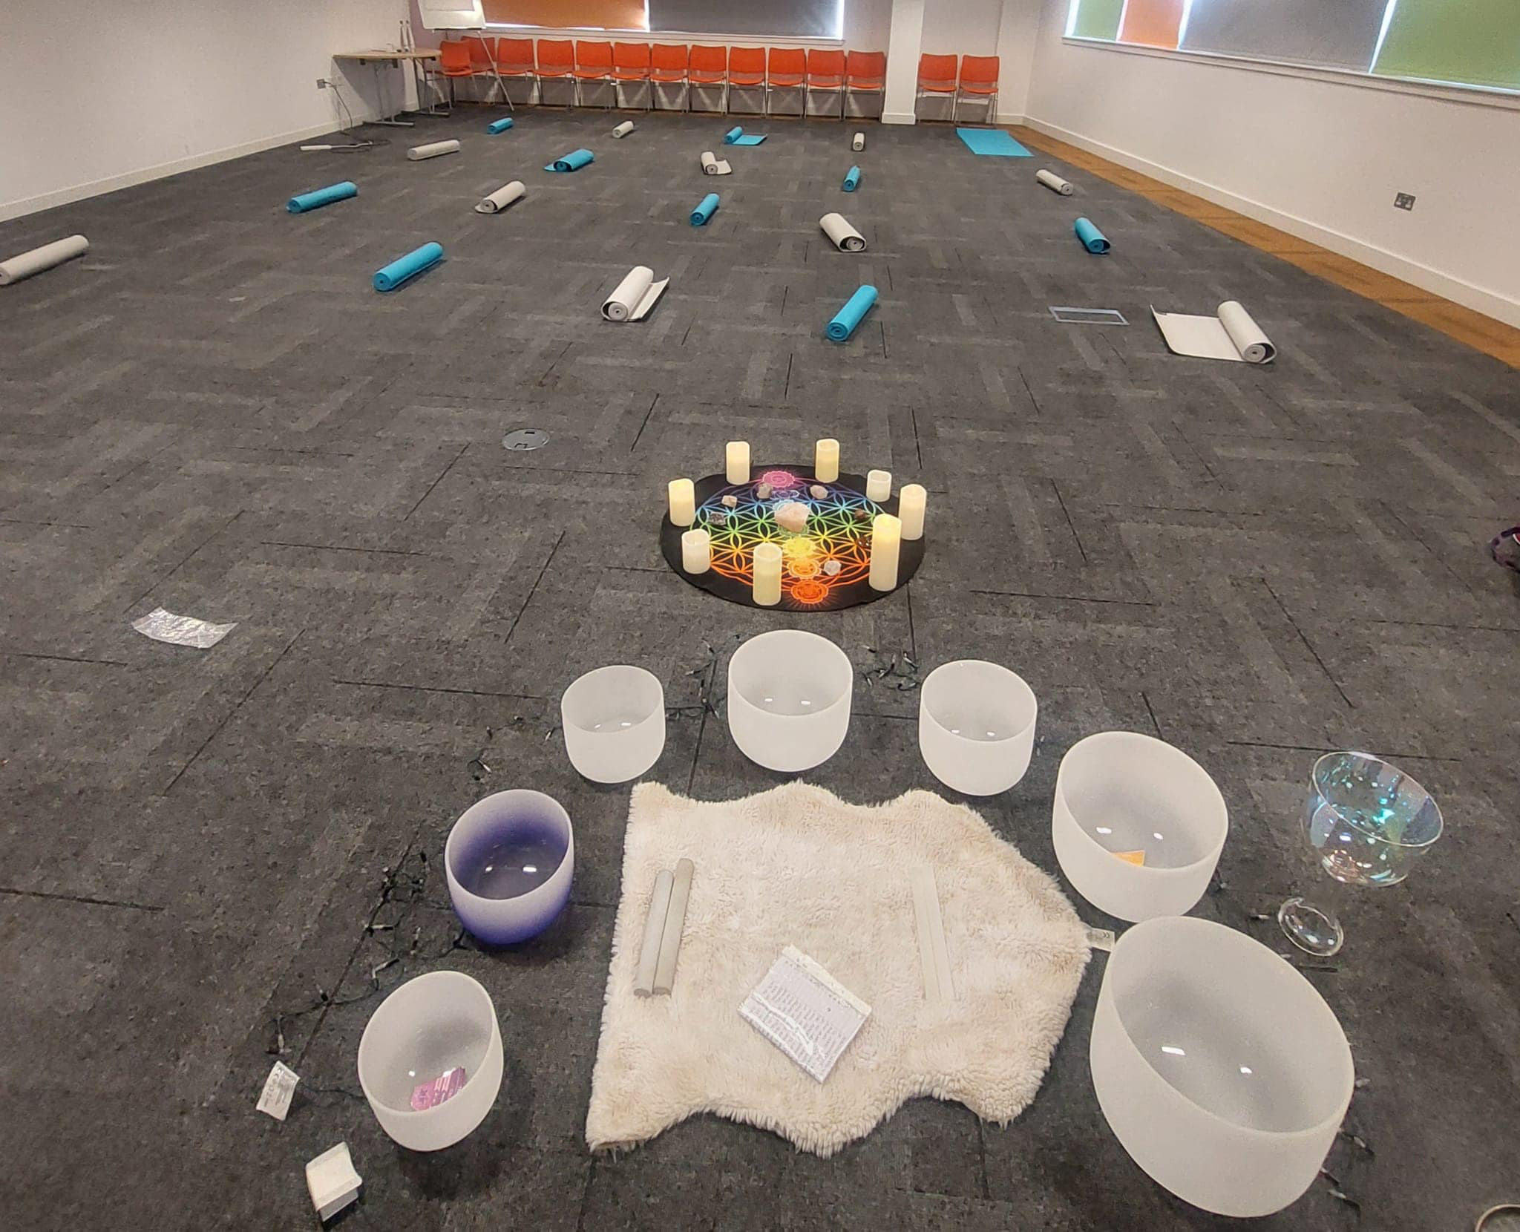

Vision Statement
To continue to serve and support our homeless and vulnerable people of Glasgow with compassion and professionalism.

Strategies employed to realise our vision

Fundraising
To develop and implement short, medium and long term fundraising opportunities and strategies to help us maximise our fundraised income.

Partnerships
To continue to partner up with other organisations, for the benefit of our service users, offering rehabilitation centres, visiting recovery cafes, promoting mental health awareness, offer well-being classes.
To work in partnership with our service users to improve and grow our services.

Effectiveness
To further expand our services provided by volunteering.
Enhance frameworks for measuring outcomes for service users.
To maintain and further develop our training, health and safety, well-being of both service users and volunteers.
To secure finance and resources for future continuation of services.
To maintain a motivated volunteer base and to grow our volunteer family.

Plans for the Future

Continued Support from our local community is paramount

We have had tremendous support from local businesses in the form of sponsorship and below are some businesses that we are lucky to have sponsoring us. Going forward we are looking to develop relationships with more local businesses in this way and are open to anyone interested to contact us directly at kindnessglasgow@yahoo.com or call 07483330918 to begin a partnership with us. People can also donate directly via bank transfer and details can be provided or follow link https://www.justgiving.com/kindnessglasgow
For anyone who wants to get involved or just to see what we do check out our website www.kindnessglasgow.co.uk , they can also follow us on social media https://m.facebook.com/KindnessHST/

Review of 2025 Finances
Along with the challenging economic climate that we are all finding ourselves in, generating vital fundraising income to continue the amazing work we do is presenting to be very challenging.
As we were awarded charity status in April 2021, applying for fundraising grants is still a growth area for us, however, we have expanded in this area and increased our corporate support over the last 12 months and have had a few successes including a 3-year grant being awarded to us by Robertson Trust again this year. They have awarded us £10,000 each year for the last 3 years and our third and last instalment for this grant was awarded in September 2024.
In December 2025 we have just secured another 3 year grant this year from Robertson Trust of an increased amount of £15,000 each year and we will receive our first instalment of £15,000 in the early part of 2026.
This area of fundraising and creating partnerships with local businesses will help us greatly to generate more financial funds going forward it is an area we are committed to continue to put our time into to hopefully generate more successes going forward.
We have been looking at our accounts and we are averaging monthly financial donations, including fundraising activities, of £11,811 per month which pretty much covers our average monthly expenses of £11,865, therefore, we feel going forward that we are in a healthy position, to not only continue to provide our current services to our street friends, but to expand our ideas so we can reach out to help more of the vulnerable people of Glasgow as we have a healthy end of year bank balance of £142522. We also have the additional £15,000 per year for the next 3yrs from Robertson Trust.
There has been a substantial increase again this year in demand for support from our soup kitchen where we feed about 250/300 people each week and our food parcels demand has dramatically increased again this year.
Our bank account is sitting healthy as at 31/12/25 as we had a closing balance of £142,522.04 and our reserve account at 31/12/25 is £40,447.77 so the total of both accounts as of 31/12/25 is £182,969.81.

Reserves
We have looked at our average expenditure to run our charity each month and the average monthly amount we spend is £11,811. As our reserve account has a balance of £40,447.77 this covers more than 3 months expenses within our reserves, in line with OSCR guidance of holding 3 months expenditure in reserves. This will only be used during any time that we feel we have a lack of financial donations to help us meet the demands of our expenditure in any one month.
Our Statement of Trustees Responsibilities
The Trustees are responsible for preparing the Trustee's Report and Financial Statements as per OSCR guidelines.
The Trustees are responsible for keeping adequate accounting records that are sufficient to show and explain the charity’s transactions and to show with reasonable accuracy, at any time, the financial position of the charity.
The Trustee's will ensure that the financial statements comply with the Charities and Trustee Investment (Scotland) Act 2005 and the Charities Accounts (Scotland) Regulations 2006.
The Trustees are also responsible for safeguarding the assets of the charity and for taking reasonable steps for the prevention and detection of fraud and other irregularities.
Any changes to our Board Of Trustees
Within our last accounting period there have been 2 changes to the board of our charity Kindness Homeless Street Team Glasgow SCIO.
Carol Murray stood down on 31/12/25 due to increased family commitments but is still actively involved with the charity in a volunteering capacity.
Nicola Clyde stood down on 4/1/26 due to a higher workload in her employment and therefore cannot commit any time towards our Kindness charity for now.
These annual accounts for the period ending 31st December 2025 were jointly compiled by the remaining Trustees and give a true and fair view of our vision statements, aims, views and objectives and our future for the success of our charity Kindness Homeless Street Team Glasgow SCIO.

Signed by Laura McSorley………………………………………………………………. Date……………………

Signed by Sinead Brady……………………………………………………………………. Date……………………

Signed by Carol Cairns……………………………………………………………………… Date……………………

