Huntly ASDitude - SC047934
Trustee Report

December 2024 – November 2025

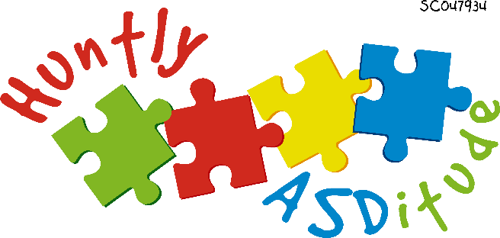

Awareness | Inclusion | Understanding | Acceptance

Huntly ASDitude | Huntly_ASDitude@outlook.com

1. TRUSTEES
NAME | DATE APPOINTED | ROLE END | POSITION
ANNIKA LOTHE | MAY 2017 | ONGOING | CHAIRPERSON
JACKIE DYAS | AUGUST 2023 | ONGOING | TREASURER/TRUSTEE
SHELL COWE | NOV 2022 | ONGOING | SECRETARY /TRUSTEE
LESLEY LOTHE | SEPT 2017 | ONGOING | TRUSTEE
KAYLEIGH NICHOLLS | SEPT 2023 | ONGOING | EVENTS & FUNDRAISING TRUSTEE
AMILIA LOTHE | SEPT 2023 | ONGOING | EVENTS & FUNDRAISING TRUSTEE

2. OBJECTIVES & ACTIVITIES

Huntly ASDitude is a local, parent led charity. We support neurodivergent children & their families within our local community.

We organise and facilitate Groups, Events & Activities that are 'Multi Support Needs' friendly, providing social opportunities and experiences in a safe, accepting, non-judgmental environment.

OUR AIMS:
- Promote inclusion, equality and diversity
- Facilitate MSN friendly social events, groups & opportunities
- Support parents, carers, siblings & wider family members
- Connect with the local community
- Signpost to other agencies
- Advocate for Autism, AD(H)D & Multi-Support Needs (MSN)

The aims and Charitable Purpose of Huntly ASDitude shall be to:
Provide recreational facilities and organise recreational activities with the objective of improving the conditions of life for children & families affected by Autism, AD(H)D and other related conditions who live in the Huntly area.

  - Promote inclusion and provide social opportunities for local Children and Families. Kids Activities & Clubs – e.g Lego Group, Stay & Play sessions, Swimming, Drop In sessions, parties, events & outings etc.

  - Support Parents, Carers & Children affected by Autism, AD(H)D and/or other related conditions, who reside within the Huntly area.
Support Group - somewhere to seek and share advice, stories, ideas and anything else.

  - Connect with the local community and raise Autism awareness.
Facilitate community events and activities – e.g Training Seminars, distribute leaflets, etc

  - And any other activities deemed to be in furtherance of the above purposes.

3. ACHIEVEMENTS AND PERFORMANCE

We have continued to provide groups and activities for our members to use.
For example;

- Online Peer Support group for parents and carers, consisting of 181 members.
- 1:1 ‘Keeping in Touch’ Support Programme for parents/carers. Contact info available to link members to contact a volunteer for support, chat etc due to pressures of isolation & caring responsibilities etc.
- Online Book Club for parents and carers.
- Silent Disco (postponed)
- Signposting to other agencies

We have organised and hosted fundraising events including;

- Monthly Pub Quiz Nights. Thanks to the ongoing support from Charlie Wood and staff at the Crown Bar.

The events and activities that we provide for our members are always planned using our ethos of: “Awareness – Inclusion – Understanding – Acceptance”
With this in mind, we have developed a strategy of ‘Reverse Inclusion’ meaning that whilst all of our events are designed and organised to be enjoyed by children with additional support needs, ALL children are welcome to attend, helping to spread this philosophy into the wider community. An example of this is our annual HOGMANAY HOOLIE. It is 'Additional Support Needs Friendly' but open to all children and families! Children with and without additional support needs enjoy this event, which is aimed at bringing families together who might usually struggle to socialise due to the difficulties experienced by their neurodivergent loved one. The children are able to socialise together, make friends, and have fun in a safe, non- judgmental environment.

4. FINANCIAL REVIEW
The charity started this Financial Year (01 December 2024) with
Opening balance: £995
During the year fundraising efforts raised: £2130
No funds were spent in this financial year. This was due to the events and meet ups arranged incurring no expenses. Our social event was also postponed this year due to lack of availability of venues and clash of dates. All monies have been carried forward to the new financial year to fund future activities.
We ended our financial period (Dec 2024 – Nov 2025) with:
Closing balance: £3125

Our financial objectives over the next year will remain the same; to raise funds to cover the running costs of our events and activities.

PRIORITIES FOR 2026
Many of our priorities for the coming year remain the same.
- Encourage more Volunteers, Committee Members and/or Trustees to the board
- Develop additional Groups based on members’ needs
- Explore sustainable income options
- Host additional events during school holidays e.g Tubing and Fundays
- Offer talks and presentations in schools and workplaces
- Continue our fundraising efforts
- Strengthen our community and commercial relationships

COMPLETED BY: DATE: 01/06/2026 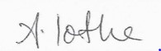

Annika Lothe - Chairperson

