
Harmeny Athletic Club
Trustees’ Annual Report
September 2024-August 2025

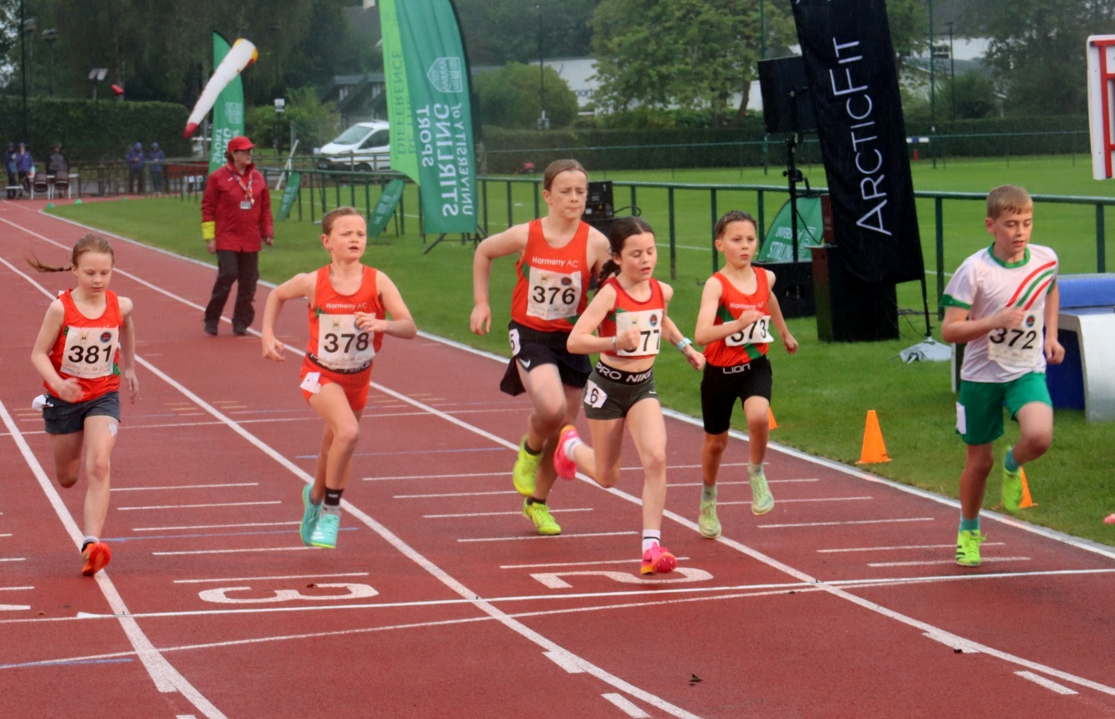

Charity Contact information
Harmeny Athletic Club
Scottish Charity Number: SC048917
10 Kirkgate
Currie
Edinburgh
EH14 6AN
secretaryharmeny@gmail.com
Website harmenyac.org

Charity Trustees -

- Phil Holden – Chair
- Hin Lee- Treasurer
- Susan Irwin - Secretary
- Craig Stewart – Junior Section
- Kirsty Stoddart – Adult Section
- Nicola McGuire – Membership Secretary
- Susan Ross - Board Member
- John Pringle – Board Member

Objectives and activities
The Club will operate as a non‐profit distributing charity whose principal objectives are:
- The advancement of public participation in Athletics as a sport;
- To provide recreational facilities and/or organise recreational activities, available to members of the public at large, with the object of improving the conditions of life;
In furtherance of the above shall:
- Provide a base for successful competitive track and field athletics and country running and to develop the full potential of each member.
- Encourage enthusiastic instructors, coaches, officials and administrators within the club and provide opportunity for qualification and experience; and
- Provide a base for non‐track and field runners and those wishing to run as a recreational activity or to improve their general fitness.

Structure, governance and management
Type of governing document
In 2018 the club members voted to accept a new club constitution which had been written with the support of a Scottish Athletics funded lawyer. In parallel to this, the club applied to the OSCR to become a Scottish Incorporated Charitable Organisation (SCIO). The application was accepted on 9th December 2018.
The Board of Trustees currently numbers 8. The constitution allows for between 5 and 12 members. The core roles of the Board are: Chairperson, Secretary and Treasurer. The Board also currently contains an Adult Section Lead, Junior Section Lead, Membership Secretary plus 2 other Board members.
The affairs of the running sections are overseen by the Runners Council consisting of an Adult Runner’s Rep and Junior Section Rep.
In August 2023, a new sub-committee was constituted as per clauses 105-109 of the Harmeny constitution. The ‘Facilities’ sub-committee was created in order to discuss and negotiate all matters with regards to the improvement of track facilities for the club and especially the proposed special purpose vehicle (‘SPV’), which would involve Harmeny, to take on a long-term lease of Saughton enclosure. It was agreed that this sub-committee would be created, and Nicola McGuire and Craig Stewart would represent and report to the board on progress at each board meeting, and more regularly where required. The proposal is that the sub-committee should have delegated authority up to £2,000 in line with other delegations to the junior and senior sections of the club. All decisions that would have a higher financial, reputational, or contractual impact on the club would continue to be brought back to the board for agreement.
Trustee recruitment and appointment
Kirsty Stoddart was asked to join the Board of Trustees in May 2024.
Jen Beattie and Naomi Head are the Welfare Officers for the Club but have chosen not to take a place on the Board of Trustees.

Achievements and performance
1. Facilities
Progressing a project to improve the facilities at Saughton continues to be slow, however
Two new and promising proposals have been made to us this year:
i) The first involves Edinburgh Leisure working in partnership with Harmeny AC, Corstorphine AC and Hutcheson Vale FC to fund, via prudential lending and the council, the replacement of the track and field facilities and then later improving the football facilities in the Saughton Enclosure. Edinburgh Leisure are writing a business case and seeking quotes with a view to this being approved in 2025 and work starting in spring 2026.
ii) The second is an exciting proposal from a local sporting business to invest more widely in Saughton Park to make it a ‘Sporting Village’ for the West of Edinburgh. There are legal obstacles surrounding the transfer of ownership of the park into private hands meaning this proposal, while exciting, may take a number of years to come to fruition.
We continue to work with the leadership of both proposals.
The progression of the ‘SPV’ proposal has taken a back seat while the above 2 proposals remain our priorities.
2. Competition
We continued to compete on 6 league fronts this year: YDL, CSSAL, FVL and SNAL track and field leagues in the summer and SAIL and EDXC and we excelled in all 6, cementing ourselves as one of the top 6 clubs for juniors in Scotland.
During the winter it was our older juniors who excelled with comfortable XC league wins for the U15/17 Women (for the first time) and U17 Men while both U13 teams were narrowly beaten into 2nd place. We also had great performances in the indoor league with 8 of our 10 teams qualifying for the final (having only ever had one team qualify over our previous years in the league). Sadly, league finances meant the final didn’t take place this year, but we look forward to a new management team launching the league for the 2025/26 season.
The summer leagues were no less successful as we once again stormed to success by winning the very enjoyable CSSAL Division 2 where parents and older members contributed almost much as our juniors, while also enjoying our best ever finishes in FVL (4 th ) and YDL (5th and qualifying for the final).
Many thanks go to our fantastic Team Managers Heather, Graeme, Susan, Kyle, David, Stephen, Steven for their efforts again this year.
3. Off-field Achievements
The biggest challenge this year was facing into the new laws around regulated work with children, introduced by the Scottish Government in the summer. Clubs, events and leagues around Scotland are struggling to meet the demand to have more or less everyone involved in putting events on PVG’d. However, due to the sterling work of our Child Welfare Officers Naomi Head, Jen Beattie and previously Angela Lawson, the club now has 113 volunteers that are PVG’d, meaning that we are able to meet our obligations to leagues and events while also ensuring we keep our children safe.
We continue to recognise that having a strong coaching team is key to improving the club. We have continued to recruit a mix of students from Heriot-Watt Uni, young athletes and parents onto the coaching team. We have seen a degree of attrition in coaching support this year, but overall numbers remain steady due to new recruitment and courses.
- 2 older athletes have taken their Coaching Assistant qualifications and help out on a regular basis.
- We have recruited another coach from the Heriot Watt University athletics team.
- Long-time member Darren Cavaroli hung up his truncheon and joined as a Club Together Officer in January.
- Allan Smith has recently resigned as Club Together Officer and recruitment for a replacement is underway.
- Nick Green left the club during this year, and we thank Nick for performing the role of Officials Co-ordinator. Unfortunately, we haven’t yet recruited a replacement and as a result no further officials have been recruited this year. This is something that needs to be addressed.



We hosted a number of events for junior athletes again this year:
1. SuperSaturday acted as the usual curtain raiser to the track and field season
2. Harmeny co-hosted Regional Superteams at Meadowbank
3. Club Championships in September which overcame the difficulties in recruitment of helpers that was presented to us due to the new PVG rules introduced in the summer.
4. Social events have been organised by Susan McFarlane this year where we again had our Annual Awards Night in February which followed a Xmas celebration night in November. Lots of fun was had, many thanks to Susan Ross’s effort.

Finally, recruitment of athletes continues to rise and the introduction of the Tuesday sessions, run by Stephen Buchan and Dan McGuire, has helped the membership numbers rise again – peaking at around 275 junior members in June.
In Numbers:
- Around 270 junior members (+/-)
- 25 separate sessions each week
- 29 coaches, 5 helpers

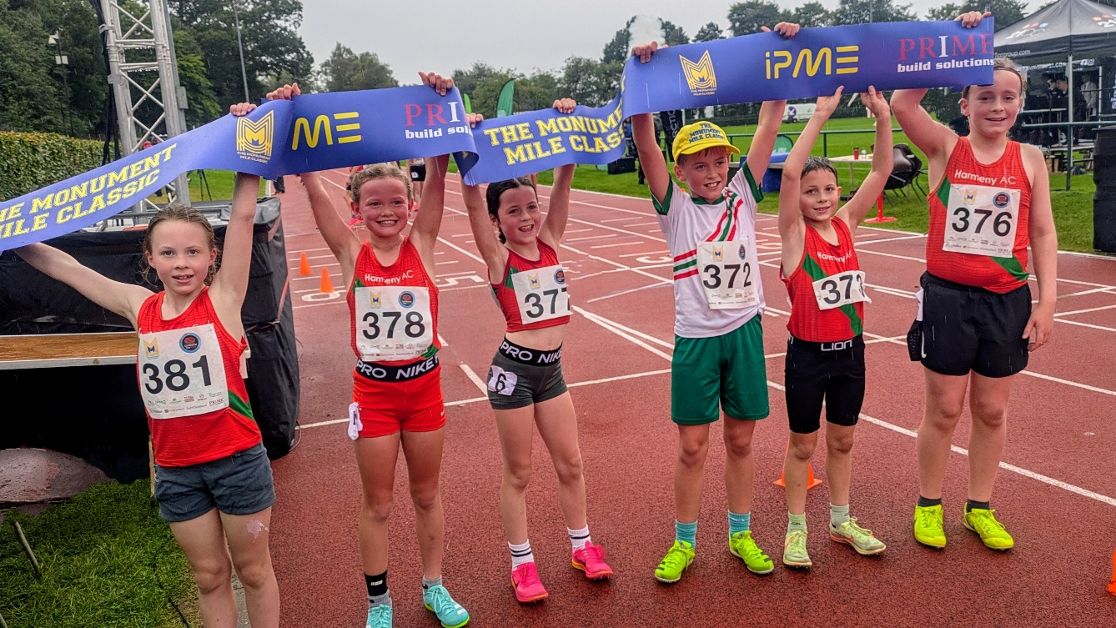

Track & Field
Scottish Athletics Indoor Championships

U13 Boys
- 60m Hurdles – Christopher Watt – Gold
- 800m – Blake Burchill – Gold
- 200m – Luke Brodie – Bronze
- Pentathlon – Blake Burchill – Gold
- Pentathlon – Luke Brodie – Bronze
- Pentathlon Team – Gold
- 4x200m Relay – Luke Brodie, Blake Burchill, Rohan Bullock, Ben Silver – Gold

U13 Girls
- Pentathlon Team Silver
- 4x200m Relay – Gold - Reeva Grant, Zoe Coull, Ella Reid, Cadha McCluskey

East District championships

U13 Boys
- 1500m – Fynlay McVey – Bronze
- 100m – Ben Silver – Bronze
- 200m – Ben Silver – Silver
- Long Jump – Ben Silver – Gold
- Long Jump – Rohan Bullock – Bronze
- Javelin – Samuel Head – Gold
- Shot Putt – Rohan Bullock – Gold
- 75m Hurdles – Christopher Watt – Gold
- 75m Hurdles – Matthew Earl – Silver

U13 Girls
- Shot Putt - Eloise Leslie – Silver
- Long Jump – Reeva Grant – Silver
- 70m Hurdles – Cadha McLuskey – Gold
- 100m – Cadha McLuskey – Bronze
- 800m Ava Whyte – Silver
- High Jump – Cadha McLuskey – Bronze

U15 Girls
- 80m Hurdles – Holly Finlayson – Silver
- Javelin – Maya Buchan – Gold
- Javelin – Darcey Hill – Javelin

U15 Boys
- High Jump - Douglas Veitch – Bronze
- Javelin – Josh Lee – Gold
- 1500m – Rory Beattie – Silver
- Javelin – Douglas Veitch – Bronze

U17 Boys
- Javelin – Evan Louca – Silver
- Discus – Evan Louca – Silver
- 400m – Danny Convery – Bronze

U17 Girls
- Shot Putt - Alex Waterston-Law – Gold
- Javelin – Alex Waterston-Law – Bronze

National Combined Events Championships

- U13 Girls Pentathlon – Cadha McLuskey Silver
- U13 Boys Pentathlon – Christopher Watt Gold

National Track Relay Championships

- U13 Boys Gold Medley – Christopher Watt, Ben Silver, Blake Burchill, Rohan Bullock

National T&F Championships

U13 Girls
- 800m Bronze – Ava Whyte
- 70m Hurdles Gold – Cadha McLuskey
- Long Jump Silver – Cadha McLuskey
- 100m Gold - Cadha McLuskey

U13 Boys
- 75m Hurdles Gold – Christopher Watt
- 200m Silver – Blake Burchill
- Javelin Bronze – Samuel Head
- 800m Gold – Blake Burchill

U15 Boys
- 1500m Bronze – Rory Beattie

U15 Girls
- Discus Bronze – Maya Buchan

U17 Women
- 1500m Silver – Rachel Caves

U20 Women
- 1500m Silver – Rachel Caves (as an U17)
- 100m Hurdles Bronze – Ella Jones

Junior on-field achievements
Off-Track (Cross Country, Road, Hill and Trail)

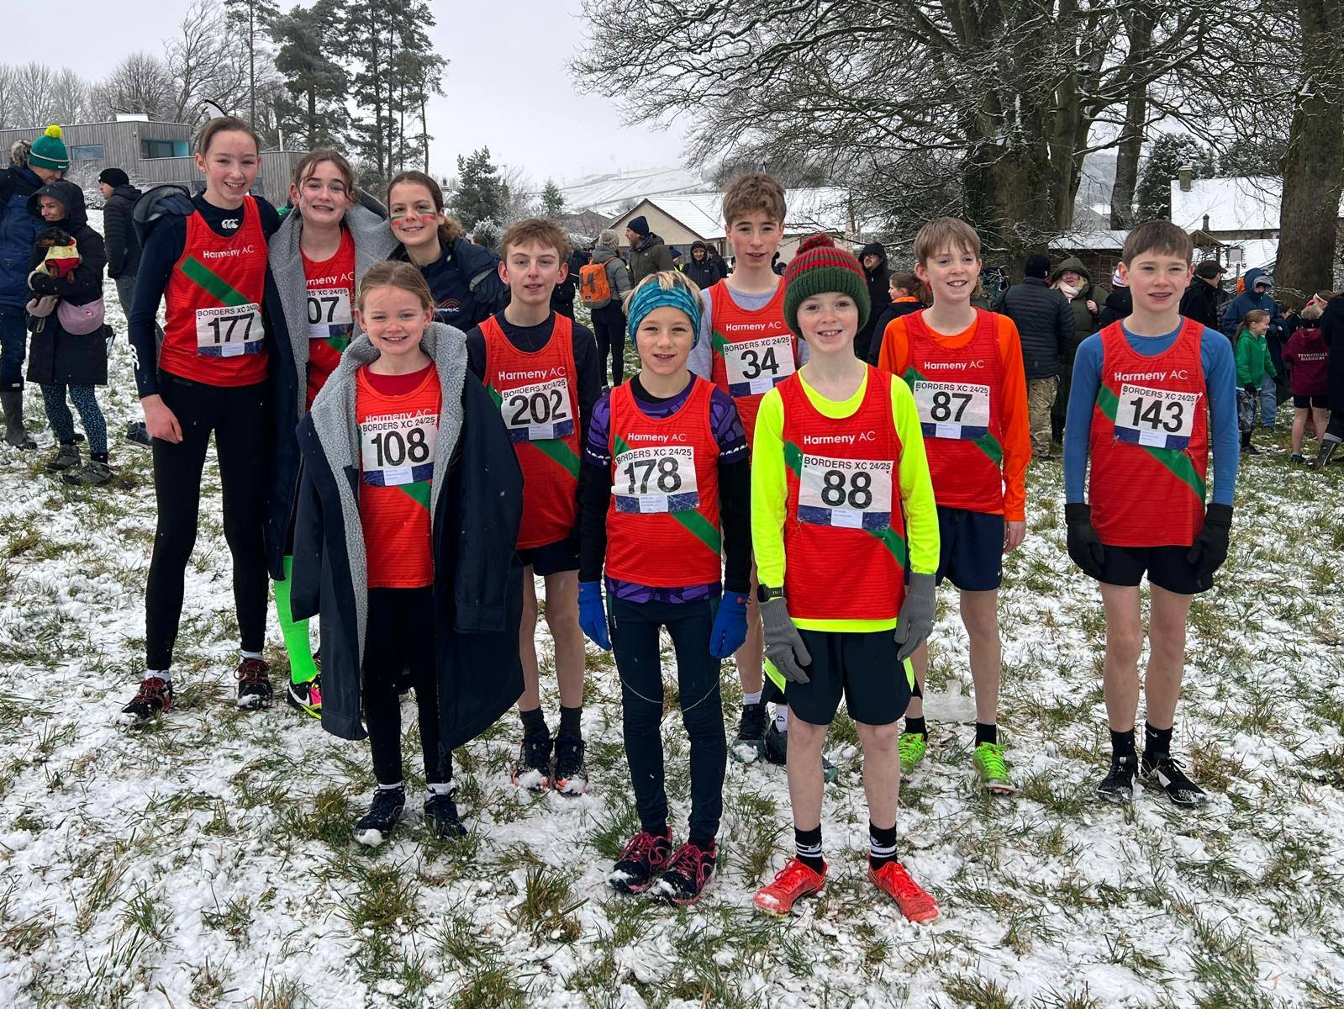

East district relay XC Championships
Junior Girls Silver (Aria McFarlane, Rachel Caves, Natsai Nyabadza)

Scottish Short Course XC Championships
U15 Girls Bronze Rachel Caves
U17 Women Team Bronze (Nancy Corrie, Natsai Nyabadza, Skye Marshall)
U17 Men Team Silver (James Wotherspoon, Kieran Hardie, Matthew Holden)

East District XC Championships
U13 Boys Team Bronze - Sam Oliver, Toby Lam, Blake Burchill
U13 Girls Team Silver - Aria MacFarlane, Tessa Golding, Luciana Starkey
U17 Girls Team Gold - Nancy Corrie, Natsai Nyabadza, Leah Buchan
U17 Men Team Silver – Kieran Hardie, Sam Beattie, Dan McGuire

18 Selections for East of Scotland
representation at Inter District Championships:
U13 Girls: Aria MacFarlane
U13 Boys: Sam Oliver, Toby Lam, Blake Burchill, Cilean Morrison, Andrew Watson
U15 Girls: Rachel Caves
U15 Boys: Rory Beattie
U17 Boys: Kieran Hardie, Sam Beattie, Dan McGuire, Matthew Holden, Ewan Mitchell,
James Wotherspoon
U17 Girls: Nancy Corrie, Natsai Nyabadza, Leah Buchan, Skye Marshall

East District league
U15/17 Girls Champions
U17 Men Champions

National XC
U15 Girls Bronze - Rachel Caves
U13 Boys Team Bronze – Toby Lam, Andrew Watson, Sandy Cameron, Stanley McKerrow
U13 Girls Team Bronze – Aria MacFarlane, Tessa Golding, Isobel Patterson, Luciana
Starkey
U15 Girls Team Bronze – Rachel Caves, Amber Cunningham, Carys Melton, Kate Riches
U17 Men Team Gold - James Wotherspoon, Kieran Hardie, Sam Beattie, Ewan Mitchell

Young Athletes Road Races
U15 Girls Bronze - Rachel Caves
U17 Girls Team Bronze – Nancy Corrie, Leah Buchan, Lara Brechin
U15 Girls Team Bronze – Rachel Caves, Amber Cunningham, Carys Melton

London Mini Marathon
Team Scotland Selection – Nancy Corrie, Rachel Caves

Scottish Athletics Junior Hill Running

Nancy Corrie was selected for Scotland for European Hill Running Champs in Slovakia.

Ethan Lorimer and Nancy Corrie were selected for Scotland for the Junior Hill
International in Wales.
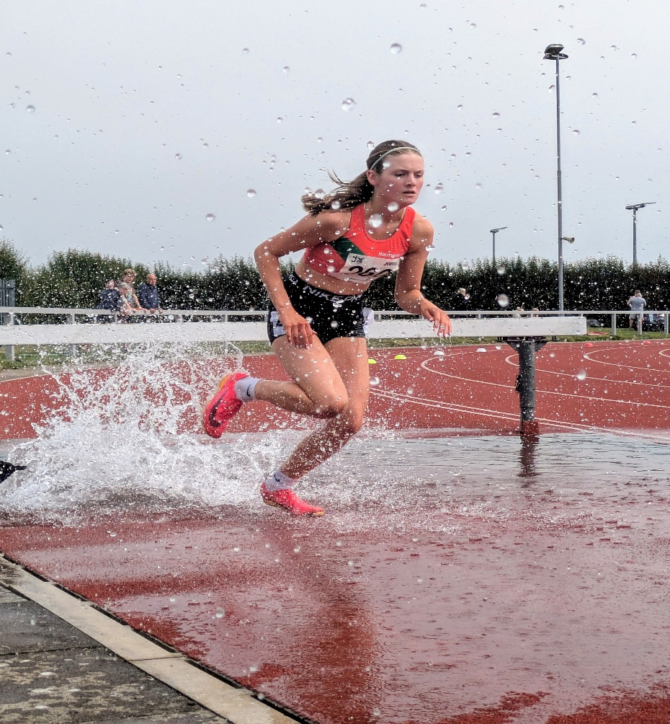

Outdoor Club Records

Event | Age | Record Holder | Time/Distance
70mH | U13G | Cadha McLuskey | 11.88s
75m | U13G | Reeva Grant | 10.62s
150m | U13G | Cadha McLuskey | 20.75s
1200m | U13G | Isobel Patterson | 4.00.85s
High Jump | U13G | Cadha McLuskey | 1.42m
Medley Relay | U13G | Ella Reid, Cadha McLuskey, Zoe Coull, Reeva Grant | 4m 50.85s
Pentathlon | U13 G | Cadha McLuskey | 2206pts
4 x 300m | U15G | Zoe Forrester, Maya Buchan, Heidi Little, Darcy Hill | 3m 06.43s
Discus | U15G | Maya Buchan | 21.06m
800m | U17W | Rachel Caves | 2:15.15
3000m | U17W | Rachel Caves | 9:43.72
SP | U17W | Alex Waterston-Law | 9.03m
1500m | U17W | Rachel Caves | 4m 32.01s
1500m S/C | U17W | Nancie Corrie | 5m 23.73s
100m | U20W | Ella Jones | 12.82s
100mH | U20W | Ella Jones | 15.34s
1500m | U20W | Natsai Nyabadza | 4.49.15s
Mile | U20W | Natsai Nyabadza | 5.04.66s
3000m | U20W | Natsai Nyabadza | 10.20.37s
1500sc | U20W | Skye Marshall | 5.40.97s
2000sc | U20W | Skye Marshall | 8.01.59s
3 X 800m | U20W | Natsai Nyabadza, Iona Bremner, Skye  Marshall | 7m 34.00s
200m | U20W | Ella Jones | 26.42s
75mH | U13B | Christopher Watt | 11.92s
75m | U13B | Christopher Watt | 10.59s
150m | U13B | Christopher Watt | 20.64s
800m | U13B | Blake Burchill | 2:09.91s
1000m | U13B | Blake Burchill | 2:47.61s
HJ | U13B | Christopher Watt | 1.42m
Discus | U13B | Blake Burchill | 22.34m
Medley Relay | U13B | Christopher Watt, Ben Silver, Blake  Burchill, Rohan Bullock | 4m 26.28s
Pentathlon | U13B | Christopher Watt | 1681pts
4x300m | U15B | Josh Lee, Aidyn Agh-Atabay, Toby Lam,  Coben Walker | 2m 59.44s
Javelin | U15B | Josh Lee | 31.58m
100mH | U17M | Evan Louca | 15.76s
SP | U17M | Evan Louca | 11.14m
Pentathlon | U17M | Evan Louca | 2439pts
800m | U17M | Fergus Ross | 1:53.37
200m | U20M | Euan Laird | 23.23s
400m | U20M | Dair Alexander | 51.84s
100m | U20M | Euan Laird | 11.60s

Indoor Club Records

Event | Age | Record Holder | Time/Distance
60mH | U13G | Cadha McLuskey | 10.48s
HJ | U13G | Cadha McLuskey | 1.37m
Pentathlon | U13G | Cadha McLuskey | 1815pts
4 x 200m relay | U13G | Cadha McLuskey, Reeva Grant, Zoe Coull, Ella Reid | 2m 00.75s
4 x 200m Relay | U15G | Daubney, Maya Buchan, Evana Chan, Finlayson | 1m 56.88s
200m | U17W | Anna Matheson | 27.68s
300m | U17W | Georgie Bruce | 43.89s
800m | U17W | Georgie Bruce | 2m 20.31s
1500m | U17W | Rachel Caves | 4m 36.36s
60m | U20W | Ella Jones | 8.22s
60mH | U20W | Ella Jones | 9.76s
200m | U20W | Ella Jones | 27.71s
400m | U20W | Iona Kealy | 69.30s
800m | U20W | Lara Brechin | 2m 20.16s
1500m | U20W | Natsai Nyabadza | 4m 50.36s
LJ | U20W | Evana Chan | 4.65m
60mH | U13B | Christopher Watt | 9.91s
200m | U13B | Blake Burchill | 26.52s
600m | U13B | Blake Burchill | 1m 38.22s
800m | U13B | Blake Burchill NATIONAL RECORD | 2m 11.62s
1200m | U13B | Blake Burchill | 3m 42.51s
SP | U13B | Blake Burchill | 7.80m
LJ | U13B | Blake Burchill | 4.95m
HJ | U13B | Ben Silver | 1.40m
HJ | U13B | Blake Burchill | 1.40m
Pentathlon | U13B | Blake Burchill NATIONAL RECORD | 2014pts
4 x 200m Relay | U13B | Luke Brodie, Blake Burchill, Rohan Bullock, Ben Silver NATIONAL RECORD | 1min 51.24s
HJ | U17M | James Anderson | 1.85m
SP | U17M | Evan Louca | 9.94m
60mH | U17M | Evan Louca | 9.85s
60m | U20M | Euan Laird | 7.61s
LJ | U20M | Oran Brown | 5.83m
HJ | U20M | Oran Brown | 1.75m
3000m | U23M | Finlay Ross | 8m 48.63

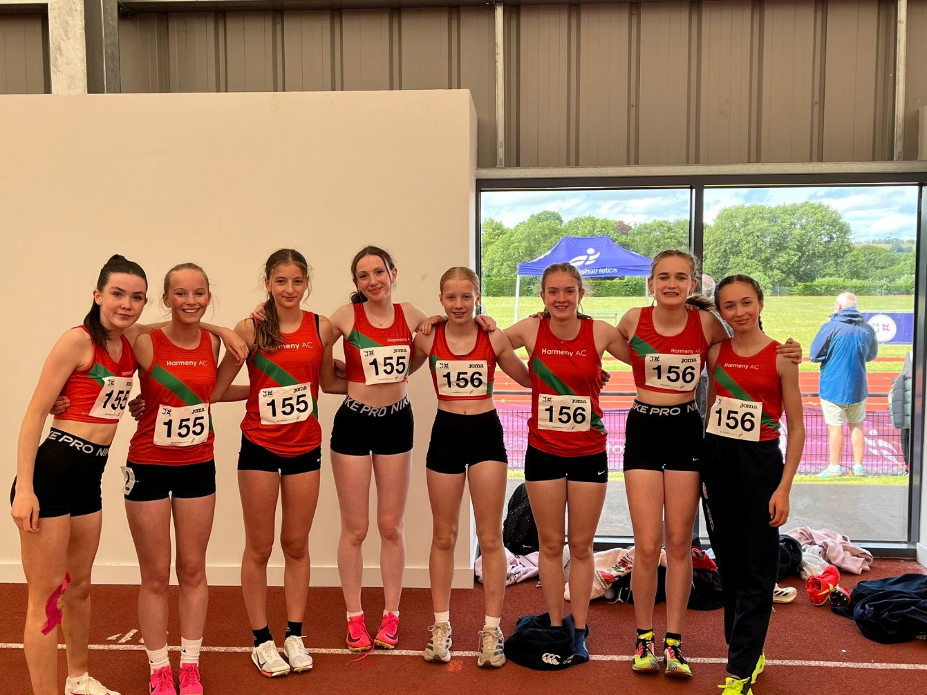

Club records can all be found here: Club Records – Harmeny AC
Once again, our athletes excelled with 75 club records set over the course of the year.

Club Awards (2024)
Female Athlete of the Year: Holly Finlayson
Male Athlete of the Year: Blake Burchill
Endeavour Award: Euan Mitchell
Competitor of the Year: Lara Brechin
Field Performance U11-U15: Cadha McLuskey
Field Performance U17+: Alex Waterson-Law
Sprint Performance U11-U15: Luke Brodie
Sprint Performance U17+: Ella Jones
Endurance Performance U11-U15: Rachel Caves
Endurance Performance U17+: Dan McGuire

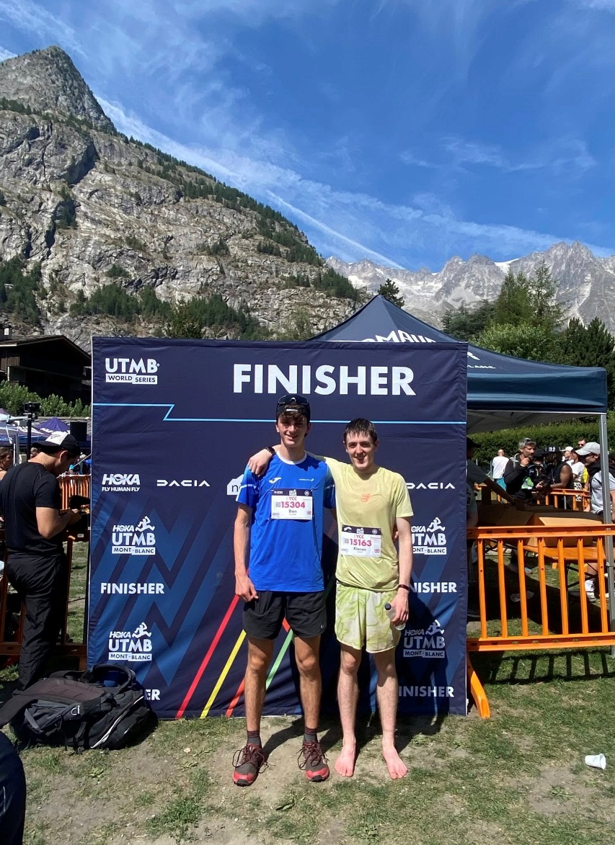

Membership Statistics
We have seen a 6% increase in overall membership between 2023/24 and 2024/25. We continue to see new member interest generated by word of mouth and offer some taster sessions before requesting fee payment and access to our Facebook page. There has been a steady increase in the number of Juniors joining us, up 18% over prior year. Our ability to grow the junior membership is dependent on availability of additional Level 1, 2 and 3 coaches and track availability.

Membership Groups | 2024/25 | 2023/24 | 2022/23 | 2021/22
Members
Senior Members | 203 | 214 | 241 | 210
2nd Claim | 1 | 1 | 3 | 4
Active Junior Members | 262 | 222 | 205 | 218
Inactive Junior Members (left during the year) | 112 (not included in  the total | 82 (not included in  total) | 86 (Not included  in total) | 77 (Not  included  in total)
Total | 466 (up 6%) | 437 (down 3%) | 449 (up 3%) | 432 (up  10%)

Our coaching, officials and helper community continues to grow, with continued commitment from coaches and officials to gain additional levels of qualification over time. Some of our junior athletes have also committed their time this year to qualify as Assistant Officials and give time at events in addition to their training and racing commitments.
Coaches & Officials | 2024/25 | 2023/24 | 2022/23 | 2021/22
Level 3 (Event Group) | 5 | 6 | 7 | 6
Level 2 (& CIRF) | 10 | 12 | 7 | 6
Level 1 (Coaching Assistant) | 11 | 15 | 13 | 15
Jog Scotland Leaders | 6 |  | 10 | 11
Jog Scotland Volunteers |  |  | 9
Other/Helpers |  | 8 | 22 | 14
Officials – Qualified | 25 | 11 (+6 pending) | 11 | 7
Assistant Officials |  | 2 | 5 | 3
Assistant Officials (Junior) | 4 | 14 | 16

Adult Achievements
The club continues to offer a wide range of training opportunities for adults. A typical week at the club is summarised in the programme below:

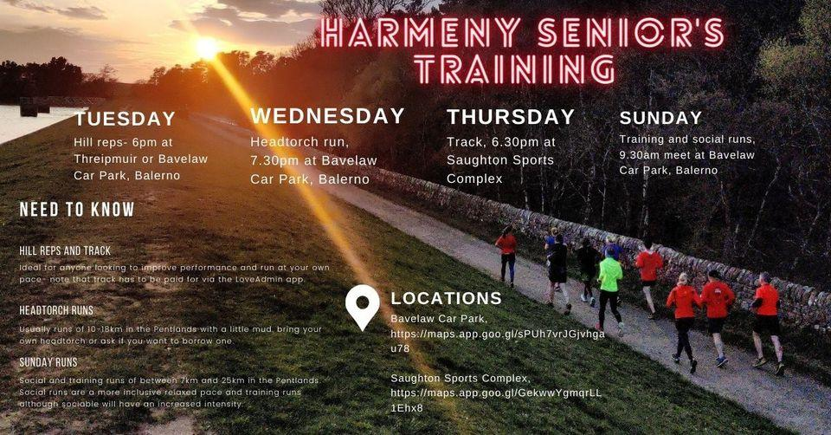

Wednesday nights and Thursday track sessions continue to be popular and a large of people enter races both locally and across the world, always wear the Harmeny colours with pride
A Seniors Steering Group was created to help progress, engage and develop more around the senior’s training programmes and despite some early progress this will need to be developed further in the year ahead.

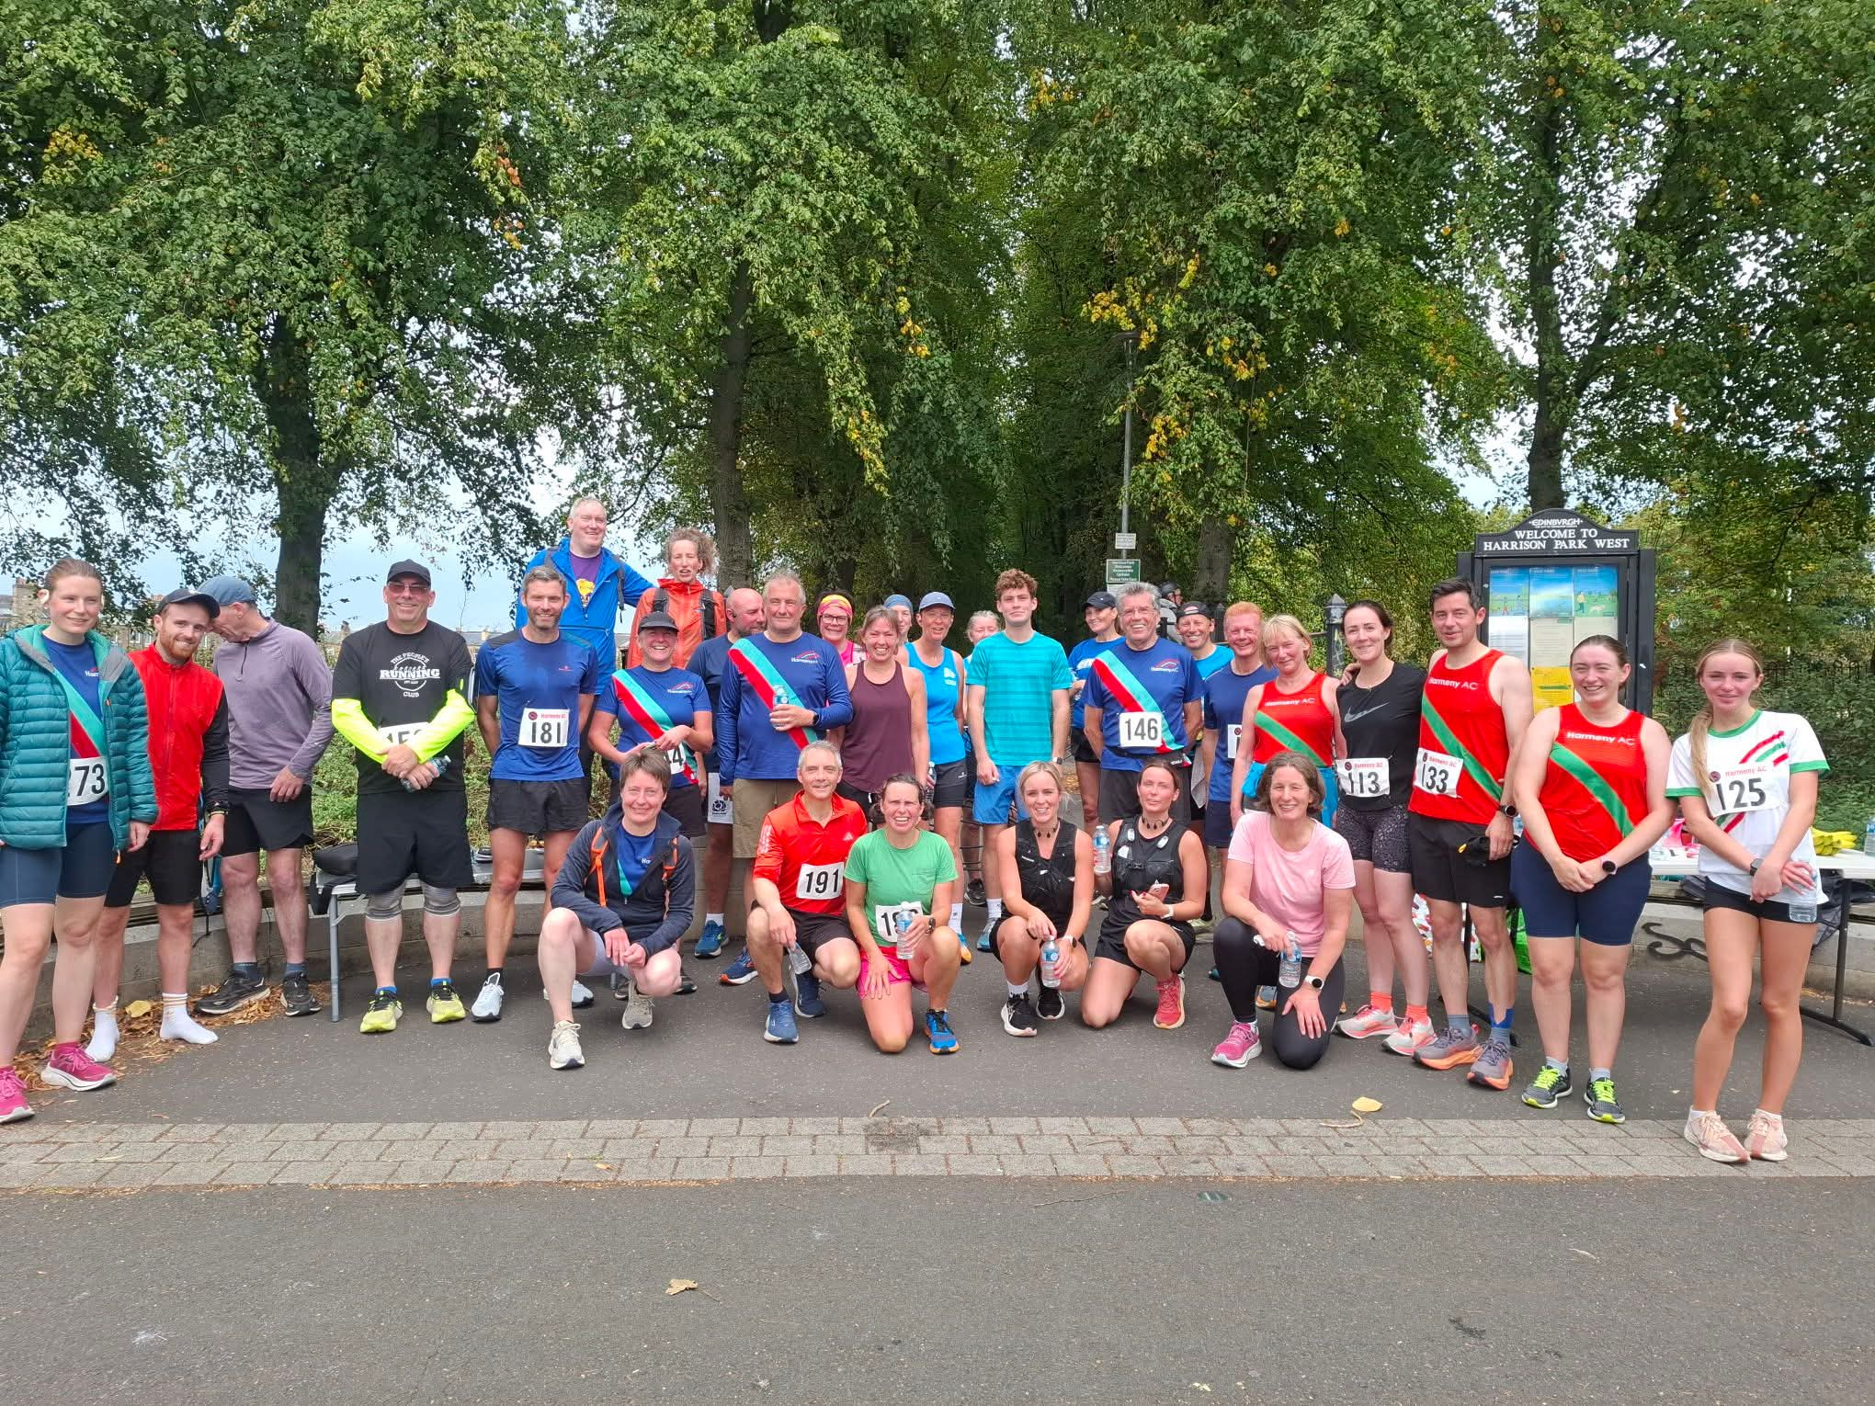

Our Seniors at the 2025 Handicap Race

Performance: Standard Distances from September 2024 to end of June 2025
Special thanks to Darren Cavaroli for keeping track of all performances.

Fastest times over recognised distances achieved in this year:

Marathon – Male – 2:40:48 Murray Duff Baxters Loch Ness 24

Half Marathon – Male 35 – 1:15:26 Murray Duff Alloa 2025
Half Marathon – Female 55 – 1:46:39 Seona Burnett Great Scottish Oct 24

10k – Male 75 – 1:15:02 Peter McGavigan Great Scottish Oct 24
10k – Male 35 – 0:35:51 Murray Duff Strathaven Nov 2024
10k – Male 50 – 0:37:05 Darren Cavaroli Doddie Weir Cramond 2025

10k – Female 55 – 0:47:44 (1st) Margie Leitch Linlithgow Sept 2024
10k – Female 55 - 0:50:35 (3rd) Susan Ross Stirling Sept 2024
10k – Female U35 - 0:40:11 Jane Gormley Barry Buddon Sep 24
10k – Female U20 - 0:46:34 (1st ) Carys Melton (U20) EMF 2025
10k – Female U20 - 0:48:52 (2nd ) Halszka Musialowicz (U17) EMF 2025

5k – Male – 00:14:52 Fraser Holman (U23) Armagh Int&#39;l Feb 2025
5k – Male – 0:15:22 Kieran Hardie (U20) Sri Chinmoy Champs May 2025

5k – Female 55 – 0:21:45 (1st) Seona Burnett Blast Meadows July 2024
5k – Female 55 – 0:23:29 (3rd) Margie Leitch Edinburgh Parkrun Feb 25
5k – Female U20 - 0:17:01 (1st) Nancy Corrie Sri Chinmoy Silverknowes May 25
5k – Female U20 - 0:17:10 (2nd) Rachel Caves Sri Chinmoy Silverknowes May 25

Ultra Running Achievements: to 12th August 2025
Special thanks to Donald Sandeman and Allan Price for keeping track of all ultra races. Donald has now officially handed over these responsibilities to Allan and we would like to thank Donald for doing this role for so long.

Our club members have had a number of achievements in ultra-marathons over the year and a full download of their results and those from previous years can be found at:
https://www.facebook.com/groups/pentlandrunners/permalink/10162294531342968/

Rigg Race
175 runners took part in the race on 19th May including 9 Harmeny members who all performed well. Rachel Caves set a new Female course record in a time of 35:03. A huge thank you to everyone who volunteered to help make the event happen and to Steven Brown for manging it all as the Race Director.

7Rs
A record 117 completed the tricky terrain in December in ideal weather conditions for December in Scotland. £2500 was raised and shared between Friends of the Pentlands, Youth Vision, Harmeny AC and Pentland Hills Regional Park. A huge thank you to Rachel Shannon and Dougie Porteous the Race Directors and to all our volunteers.

Club Handicap Race September 2025
Another very successful and well attended Club Handicap Race on September 7th with over 30 club members and friends tearing down the Water of Leith and along the canal to Harrison Park. Well done to all who took part and in particular to the 1st male Allan Irwin and 1st female Hannah Walsh. Fastest male was Murray Duff with a time of 36.40 and fastest female was Ruby McClay with a time of 51.00. Many thanks to John Pringle for organising the event and all of the volunteer marshals and timekeepers.

Cross Country
The club saw some fantastic turnouts and performances across all the National and East District events from October to February. The new season will soon be upon us, and it will be great to see as many people get along as possible.

Thanks!!! Many thanks once again to the incredible number of volunteers and coaches who, together, make Harmeny the incredible club that it is…
Junior Coaching  Derek Johnstone  Andy Ross  Stephen Buchan  Phil Holden  Craig Stewart  Grainne Morrison  Marco Lam  Beth Campbell  Liam Clark  Kevin Kealy  David Alexander  Allan Hardie  Louise McKay  Euan Laird  Toni Clarke  Anne Currie  Gareth Denny  Finlay Menzies  Dan McGuire  Gail Burchill  Andrew Finlayson  Fraser Holman  Adam Irving  Ian Veitch  Karen Robertson  Yoana Bogdanova  Fergus Ross  Callum Ferguson  Darren Cavaroli  Helpers  Ashley Gnanadoss  Marian Caves  Heather Grant  Kieran Hardie  Susan McFarlane | Senior Coaching  Darren Cavaroli  Adam Irving  Website, SAL, Club  Records, Race  Results, Welfare,  Waiting List  Susan Ross  Damien O’Looney  Ian Smith  Darren Cavaroli  Karen Marshall  Lesley Rowand  Jen Beattie  Naomi Head  Sarah Corrie  Adult Race/Event  Directors  Dougie Porteous  Steven Brown | Officials  Nick Green  Lyndsay Holden  Karen Marshall  Susan Ross  Sarah Corrie  Joe Melton  Stephen Buchan  Stephen Burchill  Dave Law  Carole Hardie  Mike Walker  Hin Lee  Lesley Rowand | Adult Steering Group Members  Elaine Walker  John Pringle  Dougie Porteous  Kim Buckley  Coline Davidson  Anne Douglas  Fiona Walker  Gill Menzies  Graham Harper  James Archer  Kirsty Stoddart  Sarah Douglas  Team Management  Heather Grant  Graeme Bullock  Susan McFarlane  Kyle McFarlane  David Alexander  Stephen Buchan  Steven Burchill  Craig Stewart  Board  Susan Ross  Nicola McGuire  Dougie Porteous  John Pringle  Craig Stewart  Susan Irwin  Hin Lee  Phil Holden

Financial review/Treasurer’s Report
A full, audited set of accounts to be completed with the club’s end of year report for the OSCR.
The accounts have been prepared in a Receipts and Payments Basis (no accruals). Income and payments are accounted for at the time of presentation.
In summary, last year’s accounts to August 2024 showed a surplus of £4,501. This year we have a surplus of £10,594. The bank balances are still at a healthy £74,378 at this year-end.
Receipts up circa £22K.
● This is mainly due to the higher membership fees (~ 1.5k), training fees (~ 15k) and grant payment (~3.5k).
● Donations - in 2024 we received about £3.7k in donations. This year we have
received £4,717 as follows: Gift Aid £2,639, Foundation Scotland £1.5k and £578 of miscellaneous donations.
● The 7R’s and Rigg races both made a profit this year of £2,717 and £1,742
respectively and we made £2,581 of donations to charities including Friends of the Pentlands, Youth Vision and Balerno Children’s Gala.
● The 50:50 lottery raised £1.2K for our Assisted Membership Fund and latterly the new fund set up athlete financial assistance.
Payments up Circa £16K
● Facilities costs fees are up by £14k as there was increased use of Saughton, Meadowbank and Firrhill School this year.
● We spent £1.5k on coaching courses in 2024/25. Included in this are charges for courses to become track officials, a starter and timekeeping courses.
● Coaching wages stand at £18.2k including £12.5k paid to Scottish athletic from which we will receive back £3.5k from the lottery.
● Equipment expenses are up this year by £1.2k.
The reserves are higher, and it has been a very successful year, and this will help to fund the potential upgrade of the facilities at Saughton in the future.
As at the end of August, we have a reserve amount of £70k and a working capital of £4k.

Statement of the charity’s policy on reserves

In 2020 the Board agreed to hold a £10,000 reserve. It was felt this number would comfortably cover any costs associated with the cancellation of one of our flagship races and extraordinary one-off costs. This amount is being held in a separate bank account.

Harmeny AC Financial Statements - 12 months to 31st August 2025

Income and Expenditure Account
 |  |  |  |  |  |  | Full Year
 | Item | HAC | HPR | Prize 50/50 | Savings a/c | Year to 31/8/2025 | Year to 31/08/24
Receipts |  |  |  |  |  | £ | £
 | Membership | 12,077.45 |  |  |  | 12,077.45 | 10,592.44
 | Training Fees | 46,154.88 |  |  |  | 46,154.88 | 30,553.87
 | Race/Track Fees | 1,484.23 |  |  |  | 1,484.23 | 1,384.36
 | Kids Camps | 1,951.36 |  |  |  | 1,951.36 | 2,172.92
 | Kids Socials | 672.77 |  |  |  | 672.77 | 257.38
 | Grants | 3,500 |  |  |  | 3,500 | -
 | Clothing | 1,418.90 |  |  |  | 1,418.90 | 2,703.49
 | Prize Fund/ 50:50 Lottery | 933.79 |  | 308 |  | 1,241.79 | 1,281.69
 | Adult Socials | - |  |  |  | - | -
 | Easy Fundraising | 186.35 |  |  |  | 186.35 | 372.61
 | Donations | 4,717.48 |  |  |  | 4,717.48 | 3,699.85
 | Assisted Membership | - |  |  |  | - | 363.99
 | Savings Track | - |  |  |  | - | -
 | Interest received |  |  |  | 1401.86 | 1,401.86 | 203.23
 | Misc | 1,638.83 |  |  |  | 1,638.83 | 512.09
 | Rigg Race |  | 2,343.00 |  |  | 2,343.00 | 1,966.05
 | 7R's |  | 3,831.50 |  |  | 3,831.50 | 4,263.50
 | Total: | 74,736.04 | 6,174.50 | 308 | 1401.86 | 82,620.40 | 60,327.47
Payment
 | League/SAL Fees | 11,019.50 |  |  |  | 11,019.50 | 7,382.50
 | Coaches Wages | 18,240.13 |  |  |  | 18,240.13 | 13,628.80
 | Coaching Course | 1,490.00 |  |  |  | 1,490.00 | 3,591.40
 | Facilities | 28,901.40 |  |  |  | 28,901.40 | 14,375.75
 | Training Fee Refunds/Camps 200 |  |  |  |  | 200 | 30
 | LZ Charges | - |  |  |  | - | 185.95
 | Kids Socials | 686.94 |  |  |  | 686.94 | 411.26
 | Assisted Membership |  |  |  |  | - | -
 | Financial Support |  | - |  |  | - | -
 | Donations to Charity | 2,2581.97 |  |  |  | 2,2581.97 | 2,250.02
 | Equipment/Medals | 4,164.11 |  |  |  | 4,164.11 | 3,380.98
 | Sports Clothing | 1,285.43 |  |  |  | 1,285.43 | 3,738.93
 | Adult Socials | - |  |  |  | - | 790.80
 | Postage/Stationery | 225.48 |  |  |  | 225.48 | 270.77
 | Prize Fund/50:50 Lottery | 444.00 |  |  |  | 444.00 | 566.00
 | Rigg Race | 600.33 |  |  |  | 600.33 | 776.90
 | 7R's | 1,114.18 |  |  |  | 1,114.18 | 876.21
 | Web/Adverts | 101.80 |  |  |  | 101.80 | 101.80
 | Race Fees | 308.62 |  |  |  | 308.62 | 2,554.09
 | Misc | 226.48 | 25.50 |  |  | 251.98 | -
 | Membership Refund 80 |  |  |  |  | 80.00 | 491.50
 | Total: | 72.000.37 | 25.50 |  |  | 72.025.87 | 55,825.68
Surplus/(deficit) for year |  | 2735.67 | 6,149.00 | 308 | 1401.86 | 10,594.53 | 4,501.79
Balance Sheet |  |  |  |  |  | Year to 31/8/25 | As at 31/08/24
 |  |  |  |  |  | £ | £
Cash at Bank and in Hand 31/8/25 |  | 4,891.23 | 9,256.26 | 105.85 | 60,125.09 | 74,378.43 | 63,783.90
 |  |  |  |  |  | 74,378.43 | 63,783.90
Represented by:
Retained surplus/deficit brought forward 2,735.67 |  |  | 6,149 | 308 | 1,401.86 | 10,594.53 | 4,501.79
Surplus/Deficit for year
 |  |  |  |  |  | 74,378.43 | 63,783.90

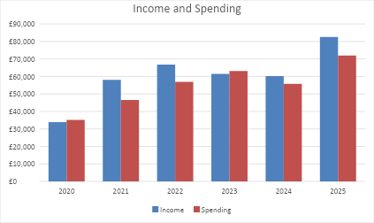

Future plans
From a junior/track & field/cross country perspective, the goals and objectives for 2024-25 remain much the same as last year with ongoing focus on the facilities issues faced at Saughton.
We will continue to grow the club by:
- Embedding the new Junior Working Group to with a view to building on the success of recent years
- Reviewing the athlete pathways to ensure we can support athletes to progress through age groups and development phases from RunJumpThrow, to Development groups and into specialisation

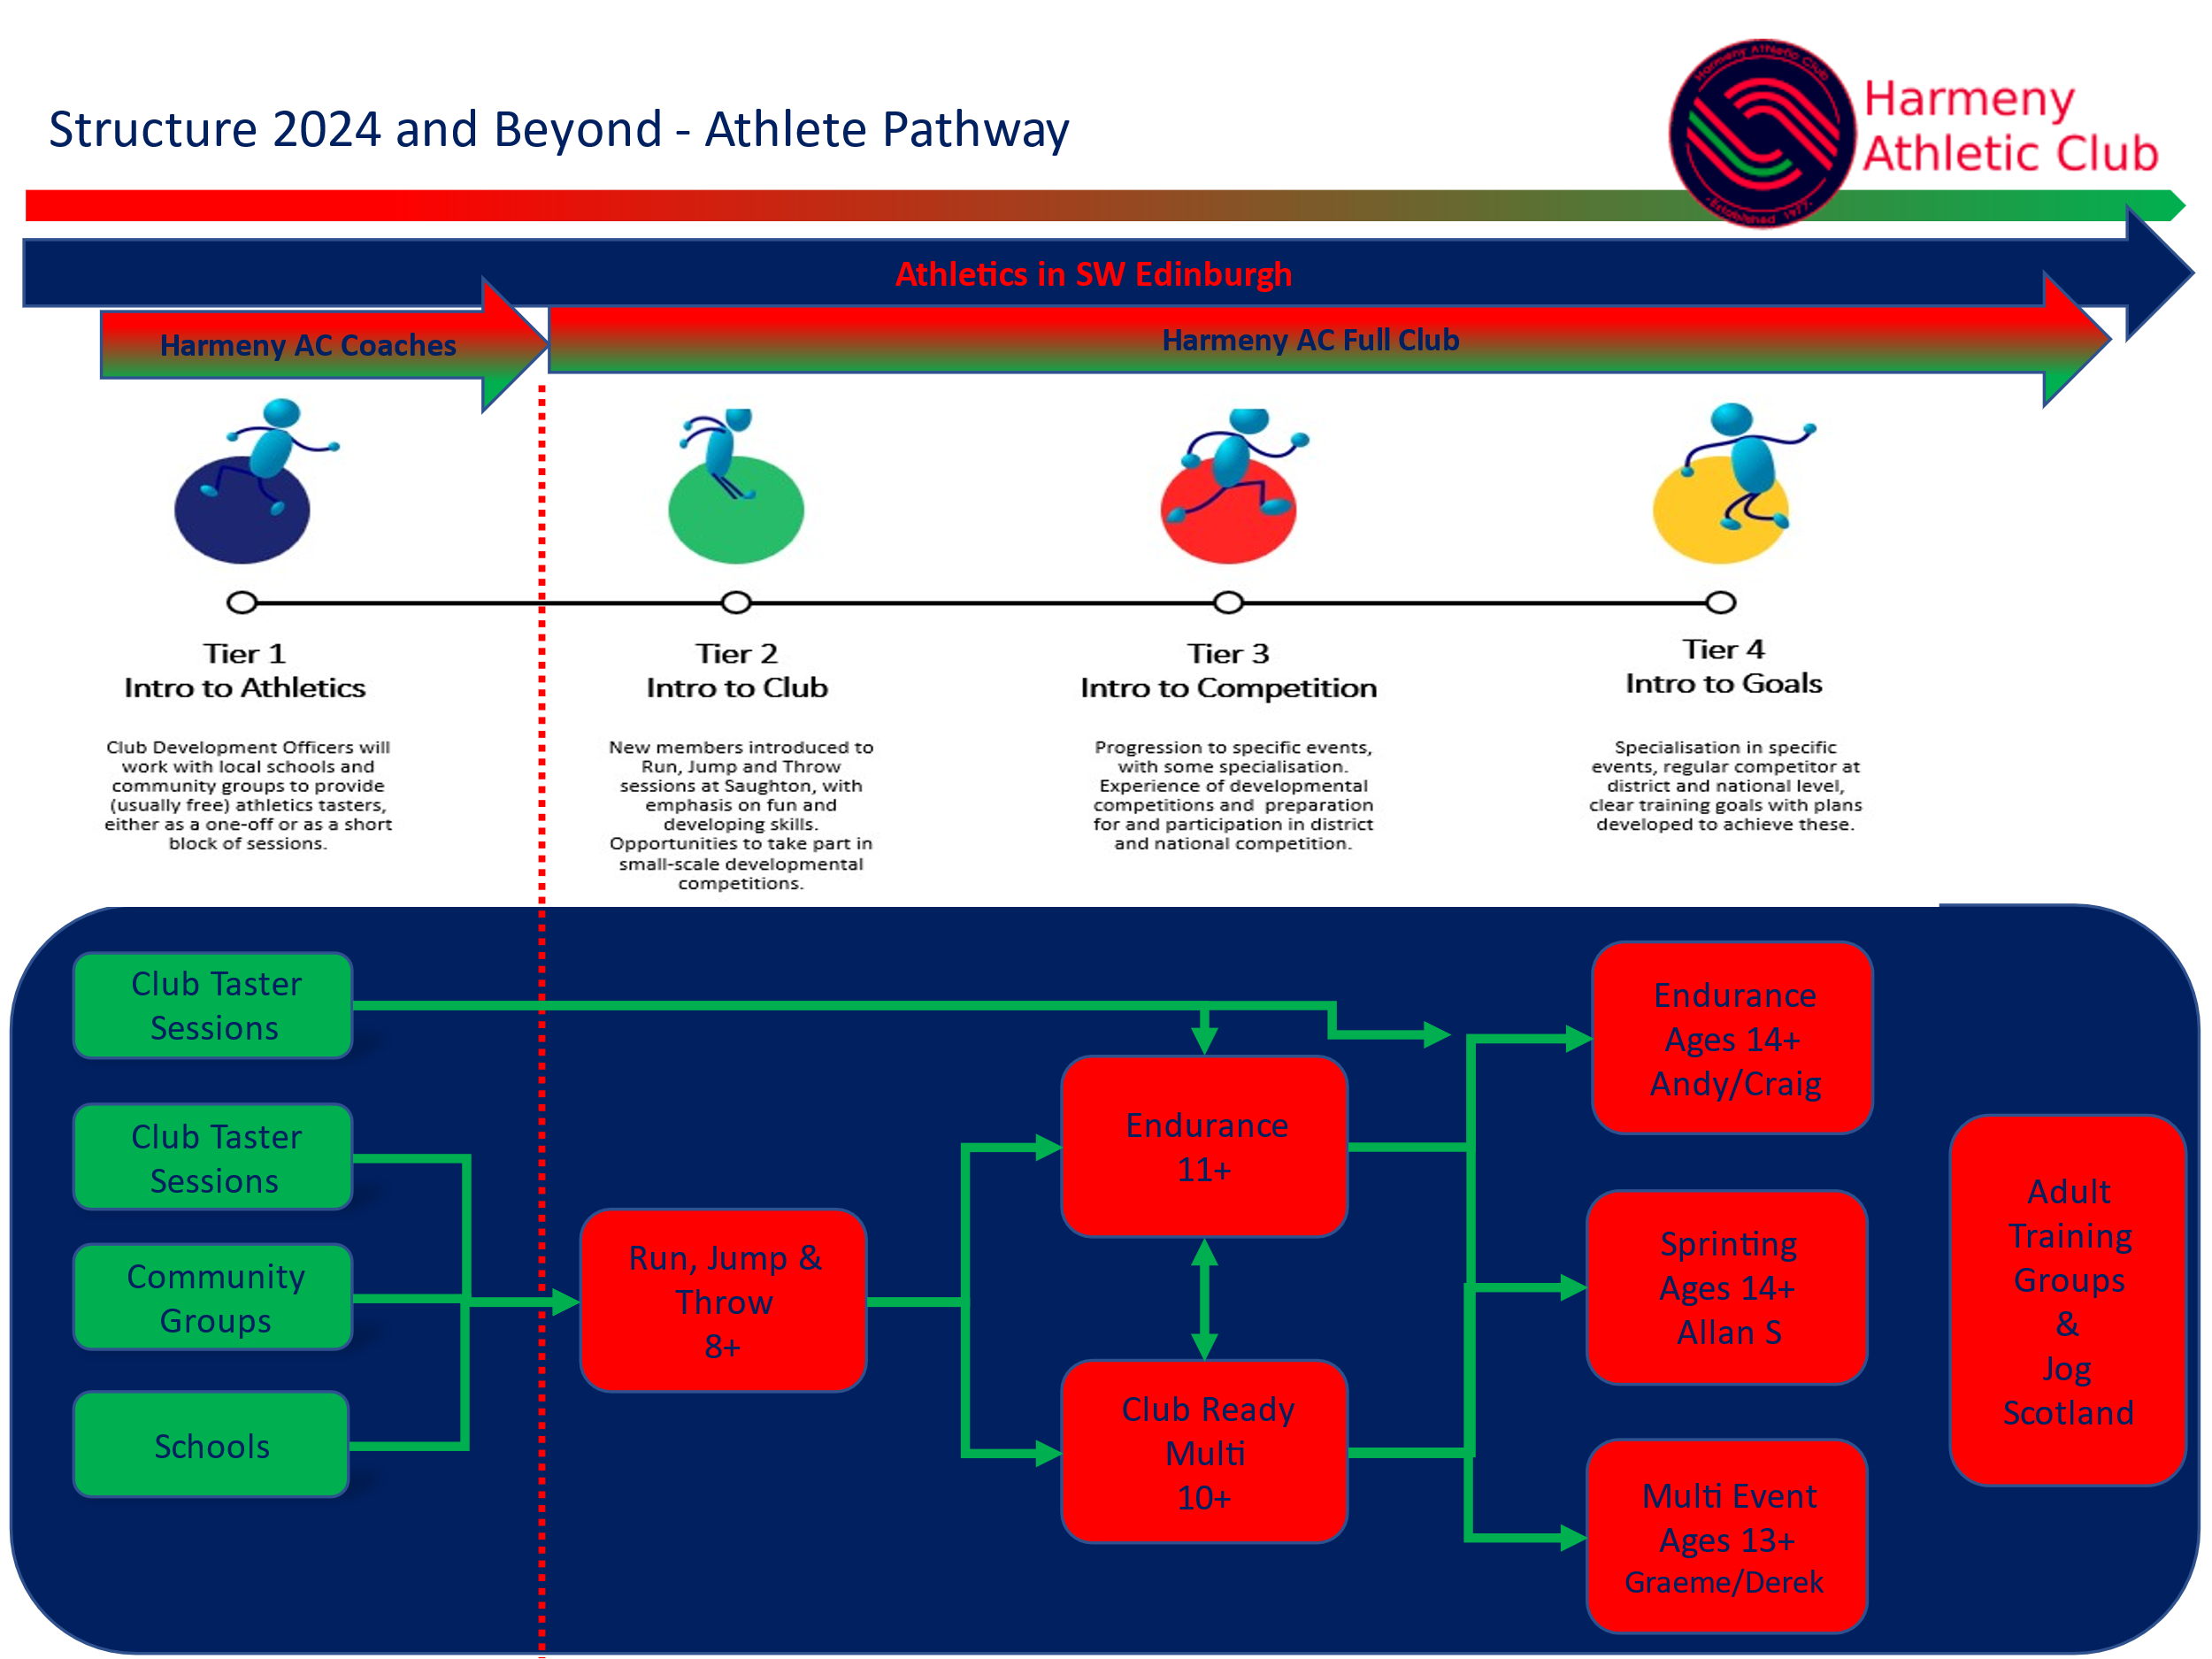
- Evolving the coaching group set up to support the revised pathways
- Increasing engagement with athletes, parents and externally including through more social media presence
- The adult steering group will continue to listen to the needs of the adult runners and provide activities that engage them.

Declaration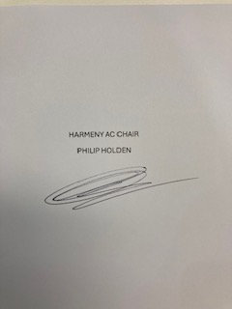
Signed on behalf of the charity trustees:

PHILIP HOLDEN
Print name
HARMENY AC CHAIRPERSON
Designation

